**a)** - - - - - - - - - - - - - - - - - - - - - - - - - - - - - - - - - - - - - - - - - - - - - - - - - - - - - - - - - - - - - - - - - - - - - - - - - - - -

**SELECT** **name**, telegram_contact

**FROM** student

**WHERE** city = 'Москва'

**OR** city = 'Казань'

**ORDER** **BY** name **DESC**

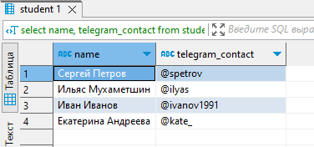

**b)** - - - - - - - - - - - - - - - - - - - - - - - - - - - - - - - - - - - - - - - - - - - - - - - - - - - - - - - - - - - - - - - - - - - - - - - - - - - -

**SELECT** ('университет: ' || **name** || '; количество студентов: ' || **size**)

**AS** "полная информация"

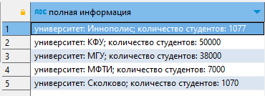 **FROM** college

**ORDER** **BY** "полная информация"

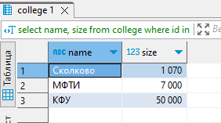**c)** - - - - - - - - - - - - - - - - - - - - - - - - - - - - - - - - - - - - - - - - - - - - - - - - - - - - - - - - - - - - - - - - - - - - - - - - - - - -

**SELECT** **name**, **size**

**FROM** college

**WHERE** id **in** (10, 30, 50)

**ORDER** **BY** **size**, **name**

**d)** - - - - - - - - - - - - - - - - - - - - - - - - - - - - - - - - - - - - - - - - - - - - - - - - - - - - - - - - - - - - - - - - - - - - - - - - - - - -

**SELECT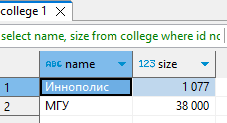 name**, **size**

**FROM** college

**WHERE** id **NOT IN** (10, 30, 50)

**ORDER BY** **size**, **name**

e) - - - - - - - - - - - - - - - - - - - - - - - - - - - - - - - - - - - - - - - - - - - - - - - - - - - - - - - - - - - - - - - - - - - - - - - - - - - -

**SELECT** **name**, amount_of_students

**FROM** course

**WHERE** is_online

**AND** amount_of_students **BETWEEN** 27 **AND** 310

**ORDER** **BY** **name** **DESC**, 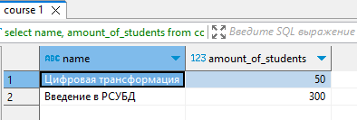amount_of_students **DESC**

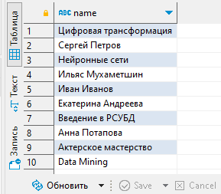f) - - - - - - - - - - - - - - - - - - - - - - - - - - - - - - - - - - - - - - - - - - - - - - - - - - - - - - - - - - - - - - - - - - - - - - - - - - - -

**SELECT** **name**

**FROM** course

**UNION**

**SELECT** **name**

**FROM** student

**ORDER** **BY** **name** **DESC**

**g) - - - - - - - - - - - - - - - - - - - - - - - - - - - - - - - - - - - - - - - - - - - - - - - - - - - - - - - - - - - - - - - - - - - - - - - - - - -**

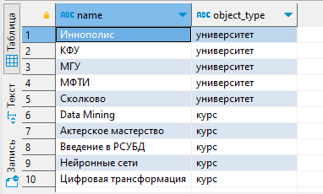**SELECT** **name**,

'университет' **AS** object_type

**FROM** college

**UNION ALL**

**SELECT** **name**,

'курс' **AS** object_type

**FROM** course

**ORDER** **BY** object_type **DESC**, **name**

**h)- - - - - - - - - - - - - - - - - - - - - - - - - - - - - - - - - - - - - - - - - - - - - - - - - - - - - - - - - - - - - - - - - - - - - - - - - - -**

**SELECT** **name**, amount_of_students

**FROM** course

**ORDER** **BY**

**CASE**

**WHEN** amount_of_students = 300 **THEN** 1

**ELSE** amount_of_students

**END**

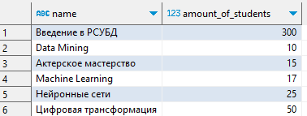

**i)- - - - - - - - - - - - - - - - - - - - - - - - - - - - - - - - - - - - - - - - - - - - - - - - - - - - - - - - - - - - - - - - - - - - - - - - - - -**

**INSERT** **INTO** course(id,**name**,is_online,amount_of_students,college_id)

**VALUES**(60,'Machine Learning',**false**,17,20)

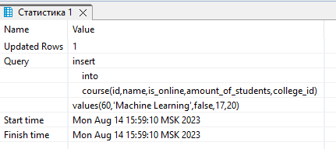

**j)- - - - - - - - - - - - - - - - - - - - - - - - - - - - - - - - - - - - - - - - - - - - - - - - - - - - - - - - - - - - - - - - - - - - - - - - - - -**

**SELECT** id

**FROM** ((**SELECT** id **FROM** course

**EXCEPT**

**SELECT** course_id **FROM** student_on_course)

**UNION**

(**SELECT** course_id **FROM** student_on_course

**EXCEPT**

**SELECT** id **FROM** course)) **AS** symmetryc_difference

**ORDER BY** 1



**k)- - - - - - - - - - - - - - - - - - - - - - - - - - - - - - - - - - - - - - - - - - - - - - - - - - - - - - - - - - - - - - - - - - - - - - - - - - -**

**SELECT** student.**name** **AS** student_name,

course.**name** **AS** course_name,

college.**name** **AS** college_name,

student_on_course.student_rating

**FROM** college **INNER JOIN** student

**ON** college.id = student.college_id **INNER JOIN** student_on_course

**ON** student.id = student_on_course.student_id **INNER JOIN** course

**ON** student_on_course.course_id = course.id

**WHERE** student_on_course.student_rating > 50 **AND** college.**size** > 5000

**ORDER BY** 1, 2

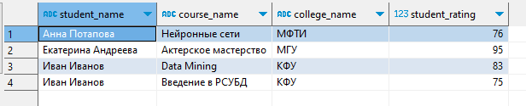

**l)- - - - - - - - - - - - - - - - - - - - - - - - - - - - - - - - - - - - - - - - - - - - - - - - - - - - - - - - - - - - - - - - - - - - - - - - - - -**

**SELECT DISTINCT** s.**name** **AS** student_1, s2.**name** **AS** student_2, s.city

**FROM** student s

**CROSS JOIN** student s2

**WHERE** s.**name** > s2.**name** **AND** s2.city = s.city

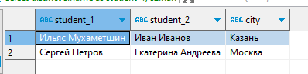

**m)- - - - - - - - - - - - - - - - - - - - - - - - - - - - - - - - - - - - - - - - - - - - - - - - - - - - - - - - - - - - - - - - - - - - - - - - - - -**

**SELECT**

**CASE**

**WHEN** student_rating < 30 **THEN** 'неудовлетворительно'

**WHEN** student_rating >= 30 **AND** student_rating < 60 **THEN** 'удовлетворительно'

**WHEN** student_rating >=60 **AND** student_rating < 85 **THEN** 'хорошо'

**WHEN** student_rating >=85 **THEN** 'отлично'

**END**

**AS** оценка, **count**(*) **AS** "количество студентов"

**FROM** student_on_course

**GROUP** **BY** 1

**ORDER** **BY** 1

/*не использовал JOIN в данном запросе, поскольку не было необходимости во второй таблице*/

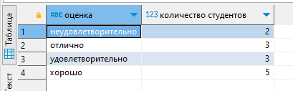

**n)- - - - - - - - - - - - - - - - - - - - - - - - - - - - - - - - - - - - - - - - - - - - - - - - - - - - - - - - - - - - - - - - - - - - - - - - - - -**

**SELECT** course.**name** **as** "курс",

**CASE**

**WHEN** student_rating < 30 **THEN** 'неудовлетворительно'

**WHEN** student_rating >= 30 **AND** student_rating < 60 **THEN** 'удовлетворительно'

**WHEN** student_rating >=60 **AND** student_rating < 85 **THEN** 'хорошо'

**WHEN** student_rating >=85 **THEN** 'отлично'

**END**

**AS** оценка, **count**(*) **AS** "количество студентов"

**FROM** student_on_course **LEFT** **JOIN** course

**ON** student_on_course.course_id = course.id

**GROUP** **BY** 1, 2

**ORDER** **BY** курс, оценка

