String for width: Rejected with error message.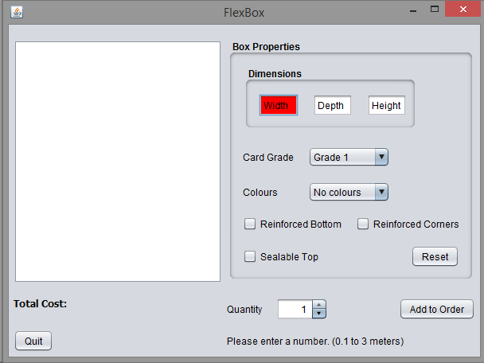

Negative width: Rejected with error message.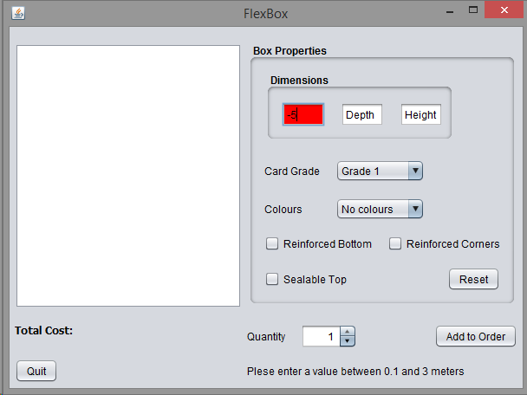

Width too large: Rejected with error message.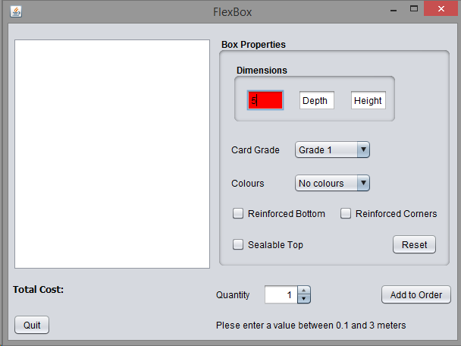

Grade 1 card, 2 colours. Reinforced Bottom and Corners: Invalid Combination filtered out.