Group Member Responsibility Certification

This form is required for group assignments to certify each member’s participation in the process and the final product.

If there are not enough places to list all the group members, you can add more lines in the relevant sections of the form.

**Group number:**

**• James Barnett**

**• Elijah Jackson**

**• Andrew Stoumbos**

**• Caleb Sanciangco**

**Team Member Certification.** (add more lines if necessary to list all names). **By signing below, I agree that I performed the work listed as my responsibilities and that I did the percentage of the work listed below, and that all other group members did the work they listed, and that I agree that their share of the work was the percentage listed below.**

* **Team Member 1:** Responsibilities: scope_check.c  
    
   Percent of the work done: 25%  
   Signature:
* **Team Member 2:** Responsibilities: scope_check.c, scope.c, and symtab.c  
    
   Percent of the work done: 25%  
   Signature: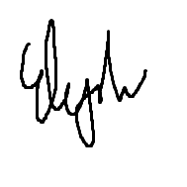
* **Team Member 3:** Responsibilities: spl.y  
    
   Percent of the work done: 25%  
   Signature:
* **Team Member 4:** Responsibilities: scope_check.c  
    
   Percent of the work done: 25%  
   Signature: