**Project Synopsis**

Semester: 7th

**1. Project Title**: A unified application for Real-Time club activities updates

**2. Project Type:** Mobile Application Development.

**3. Project Overview/ Abstract:** This project aims to develop a unified mobile and web application that provides students with real-time updates on all college club activities and notices. The platform enables students to collaborate, share updates, and engage with various club initiatives from a single interface. Additionally, it integrates a competitive coding leaderboard that automatically fetches data from platforms like LeetCode and GeeksforGeeks, allowing students to monitor their progress and achievements. The app promotes active participation, transparency, and motivation among students while simplifying communication and recognition across all clubs.

**4. Problem Statement:** In most colleges, club activities, event updates, and coding achievements are scattered across multiple platforms such as WhatsApp groups, Google Forms, emails, or social media. This fragmentation makes it difficult for students to stay informed about upcoming events, collaborate efficiently, or track their coding progress.

Additionally, students who actively participate in competitive programming often struggle to gain recognition for their efforts, as there is no unified system to display coding performance from platforms like LeetCode and GeeksorGeeks.

**5. Objective:**

**Core Features**

* **Centralized Updates:** A single platform for students to receive real-time updates on all club activities, events, and notices.
* **Enhanced Collaboration:** Seamless communication tools for students and club members, including discussion boards, chats, and media sharing.
* **Competitive Coding Recognition:** An integrated coding leaderboard that connects with platforms like LeetCode, GeeksforGeeks, and CodeChef to track and compare progress.
* **Event Management:** Tools to facilitate event scheduling, manage RSVPs, and send automated reminders to participants.

**User Engagement and Motivation**

* Foster a competitive yet collaborative environment by recognizing and rewarding achievements in both coding competitions and general club participation.

**Administrative Capabilities**

* **Simplified Administration:** An efficient dashboard for admins and club heads to manage clubs, post updates, and monitor user engagement.

**Technical Specifications**

* **Accessibility and Scalability:** A cross-platform mobile app developed using React Native CLI, supported by a scalable MERN stack backend to ensure smooth performance across all devices.

**6. Methodology:**

**Frontend**

* Framework: React Native CLI
* Purpose: Develop an interactive and cross-platform mobile UI for real-time updates, collaboration, event management, and displaying the coding leaderboard.

**Backend**

* Framework: Node.js + Express
* Purpose: Build RESTful APIs to handle user authentication, perform CRUD operations for clubs, events, and posts, and integrate leaderboard data.

**Database**

* Technology: MongoDB
* Purpose: Store all application data, including user profiles, club information, events, posts, and competitive coding statistics.

**Real-Time Communication**

* Technology: Socket.IO or Firebase
* Purpose: Facilitate instant notifications and live updates for posts, event changes, and leaderboard rankings.

**Third-Party API Integration**

* Purpose: Fetch and synchronize user coding performance data from external platforms like LeetCode, GeeksforGeeks, and CodeChef.

**Authentication & Security**

* Method: JWT (JSON Web Tokens)
* Features: Secure user authentication and implement role-based access control for admins, club heads, and students.

**Deployment & Scalability**

* Platform: OnRender and Mongodb atlas.
* Goal: Ensure smooth performance, high availability, and seamless cross-platform accessibility for all users.

**7. Flow Chart/DFD/ER Diagram:**

ER Diagram:

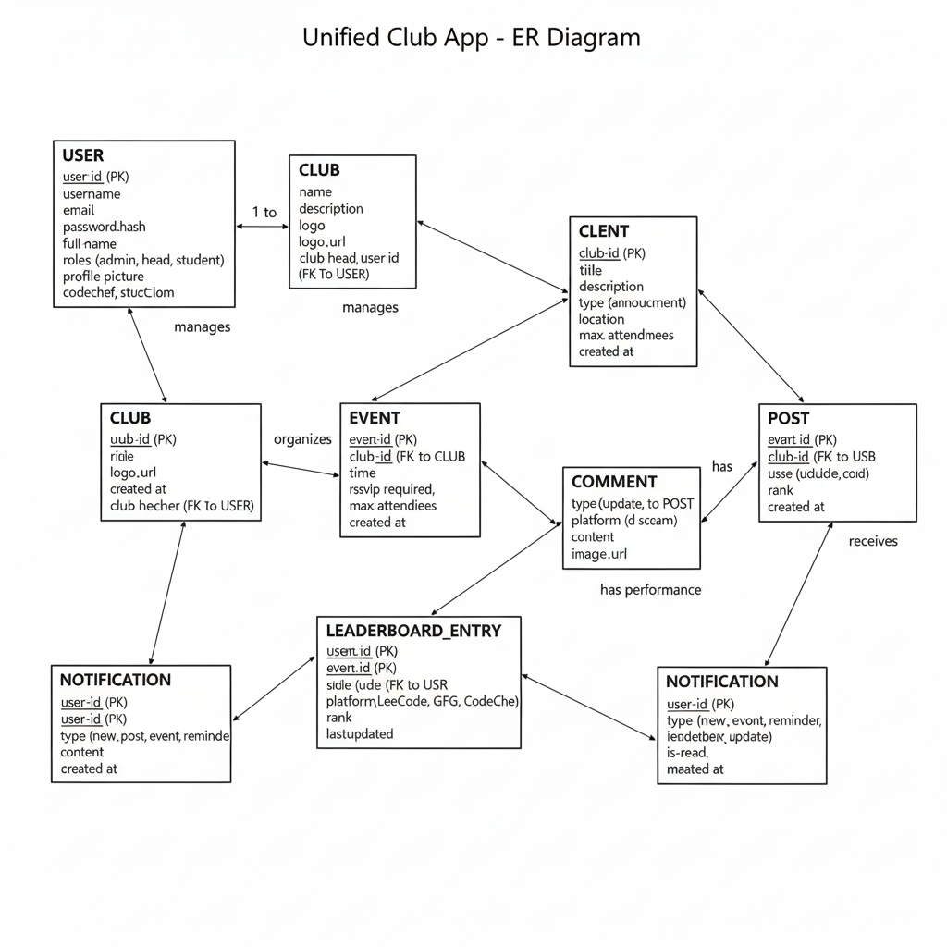

Fig1. ER Diagram

Flowchart :

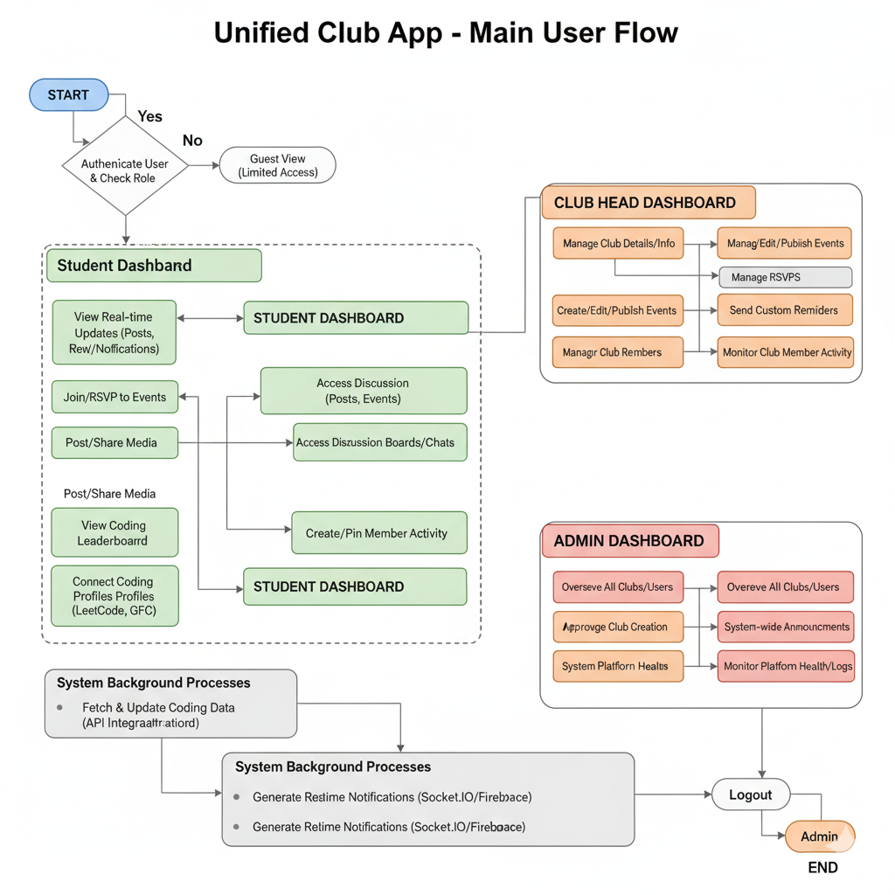

Fig2. Flowchart

**8.Technical Details:**

* **Languages & Frameworks:** React Native CLI, Node.js, Express.js, MongoDB, JavaScript**Real-Time & APIs:** Socket.IO/Firebase (real-time updates), LeetCode/GFG APIs (leaderboard)
* **Authentication & Security:** JWT, Role-based access (Admin, Club Head, Student)
* **Hosting & Deployment:** AWS, Heroku, DigitalOcean
* **UX Features:** Responsive mobile UI, push notifications, dark mode, interactive feeds

**9. Team Members:**

|  |  |  |  |  |
| --- | --- | --- | --- | --- |
| SN | Name of Projectee | Enrollment | Univ. Roll No. | Email |
| 1. | Ashish Kuamr Sharma | CB8371 | 301302222073 | ashishvsharma10@gmail.com |
| 2. | Tanish | CB8453 | 301302222075 | tanishkumar11@gmail.com |
| 3. | Shivam Goswami | CB8376 | 301302222140 | Shivamg95551@gmail.com |

**Guide Project Coordinator**

Prof. Sharadha Sonkalihari Asst. Prof. Shweta Bhandekar

**Head of Department**

Dr. Tripti Sharma