DSA 107
Data Science and Analytics Laboratory
Lab 2 report

Summarising one variable then two
Andrei Tiniakov
Student ID: 26022121102
7 October 2026

Objective
The aim of the lab was to create a notebook that summarises one categorical variable, compares two categorical variables using counts and rates, and summarises quantitative variables.

Data description
The dataset we used is called titanic.csv (raw source, GitHub repo: mwaskom/seaborn-data), which stores information about passengers aboard the RMS Titanic. Each row represents one passenger, and each column describes something about that passenger (survived, pclass, sex, age, sibsp, parch, fare, embarked, class, who, adult_male, deck, embark_town, alive, alone).
The dataset contains 891 rows and 15 columns. The pclass column is categorical because the numbers 1, 2 and 3 represent passenger classes rather than measurements. Age and fare are quantitative variables.
The dataset has 688 missing values in deck, 177 in age, and two each in embarked and embark_town. The notebook leaves these values unchanged. Missing ages are excluded from the age statistics and histogram, so those summaries are based on the 714 passengers with recorded ages.

Methodology
The lab breaks the process into four main stages.
First stage
In the first stage, we load the data from the URL using read_csv and show the first five rows using .head(). We then inspect the dataset using .shape and .info() to check its size, columns and data types. To assess data completeness, we call .isna().sum() and sort the missing-value counts in descending order. We also calculate the proportion of missing values in a column by dividing its missing-value count by the total number of rows. This helps us identify columns that need care in later analysis.
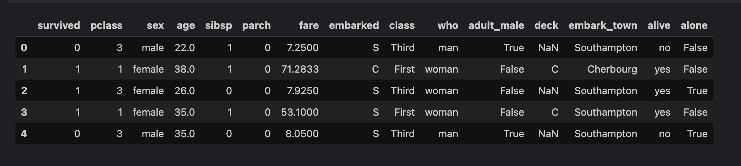
Table 1. First five rows of the Titanic dataset.

Table 2. Missing values by column, sorted from highest to lowest.
Second stage
Here, we start working with categorical variables, whose values represent groups, and quantitative variables, for which summaries such as the mean are meaningful. First, we count the passengers in each pclass using a dictionary and sort the counts by class number. We then express these counts as proportions and check that they add up to 1. Finally, we create a bar chart to visualise the differences in the number of passengers in each class.
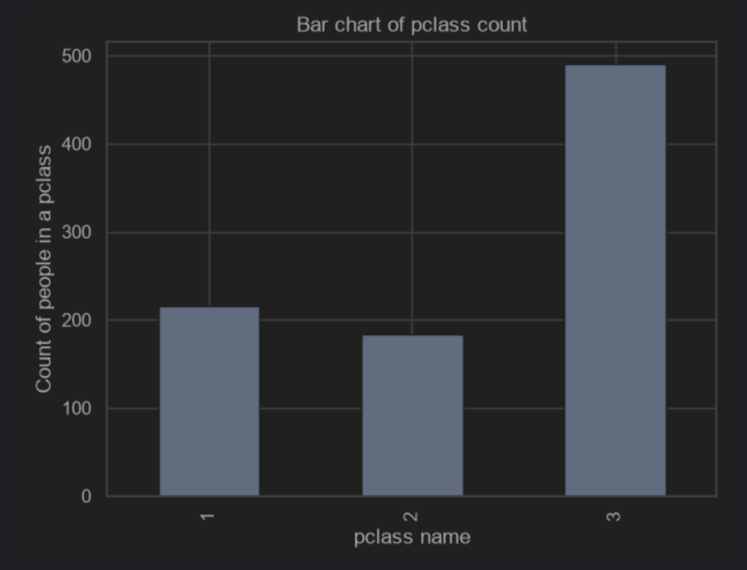
Figure 1. Number of Titanic passengers in each passenger class.
Third stage
In the third stage, the goal is to examine the association between two variables in the dataset. We use the pclass and survived columns to see how survival rates differ by passenger class. We create a cross-tabulation using pandas and check that its counts add up to the total number of rows in the dataset. We then create another cross-tabulation with normalize="index" to show the conditional distribution of survival within each class. We check that the proportions in each row add up to 1. Finally, we create a bar chart with two bars for each class, labelled "Died" and "Survived", to compare the proportions within each class.
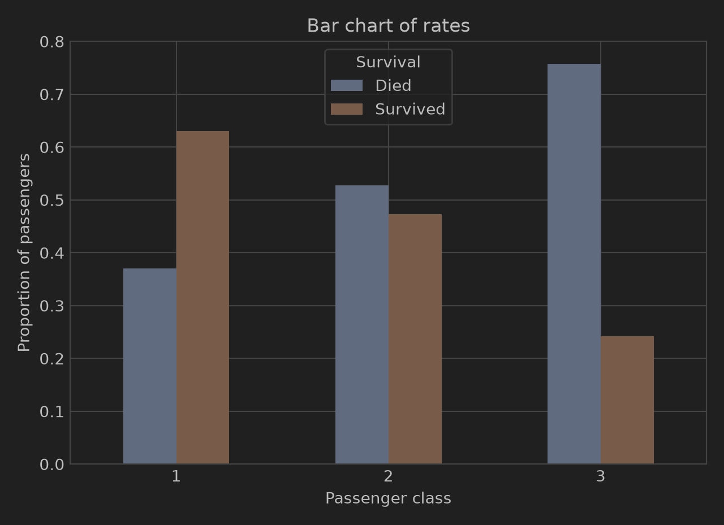
Figure 2. Survival and death proportions within each passenger class.
Fourth stage
In the last stage, the goal is to work with histograms. A histogram is useful here because it groups ages into intervals and shows their distribution. Instead of drawing a separate bar for every age, we use bins such as 0 to under 10, 10 to under 20, and so on. The final part of the fourth stage is to calculate summary statistics, including the mean, median, standard deviation and maximum, for the age and fare columns.
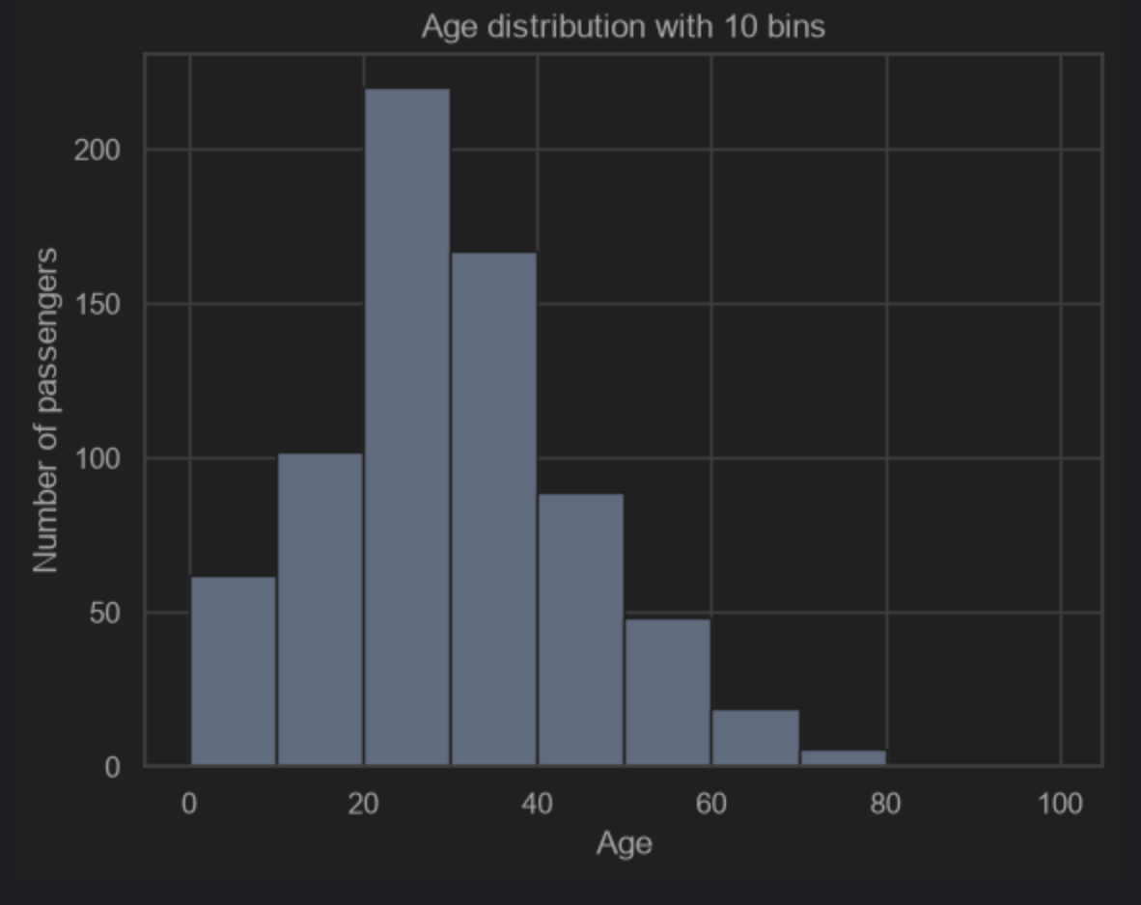
Figure 3. Age distribution of the 714 passengers with recorded ages.

Results
Figure 2 shows that death rates were 37.0% in first class, 52.7% in second class, and 75.8% in third class. Third class had the highest death rate, although this does not prove that passenger class caused the difference.
Figure 3 shows that the largest age group was 20 to under 30 years old, with 220 passengers. Among the 714 passengers with recorded ages, the mean age was 29.70 years, the median was 28 years, and the standard deviation was 14.53 years.
Fare had a mean of 32.20, a median of 14.45, and a maximum of 512.33. The mean being higher than the median is consistent with a distribution skewed towards high fares, where high values pull the mean upward.

Discussion
The passenger classes have different sizes: 216 passengers in first class, 184 in second class, and 491 in third class. Raw death counts alone do not account for these differences. Death rates divide the deaths in each class by the total number of passengers in that class, allowing comparisons between classes of different sizes.
The results show an association between passenger class and survival, but do not establish causation. This analysis did not compare survival within sex or age groups, so it does not account for possible differences in these characteristics between classes. The 177 missing ages also limit the age analysis because its statistics and histogram describe only passengers with recorded ages. A useful next step would be to compare survival rates within sex and age groups.

Reflection
I have learned how to work with bar charts, cross-tabulations and histograms, and reviewed how to round numbers in Python. I also realised that a pattern in the data does not necessarily show causation. This made me think about Simpson's paradox and the importance of checking how groups are compared.

