 | 
GEBZE TECHNICAL UNIVERSITY
Faculty of Sciences · Department of Data Science and Analytics
DSA 107 DATA SCIENCE AND ANALYTICS LABORATORY
LABORATORY REPORT No. 3

Groups and two quantitative variables
Auto MPG dataset
Student Name | Andrei Tiniakov
Student ID | 26022121102
Instructor | Salih Sarp, PhD
Lab Session | Week 3 · w/c 12 October 2026
Report date | 18 October 2026
Gebze, Kocaeli · Academic Year 2026–2027

1 Objective
The goal of the third lab is to create a notebook that works with a car dataset and performs operations like groupby, as well as draws a new kind of figure, a box plot. We also use boolean masks and compare weight and mpg with scatter plots and correlation.

2 Data description
We used a dataset called mpg.csv from the mwaskom/seaborn-data GitHub repository [1], which stores information about cars. Each row represents a car model sold in the USA between 1970 and 1982. It has 398 rows and 9 columns. Table 1 describes the columns and their uses; Table 2 shows the first five rows.
Column | Type and meaning | Use in this lab
mpg | Quantitative, miles per gallon | Masks, summaries and figures
cylinders | Discrete numeric, engine cylinder count | Grouping with origin
weight | Quantitative, car weight in pounds | Scatter plots and correlation
origin | Categorical, USA, Europe or Japan | Filtering, grouping and plot colour
horsepower | Quantitative, engine power in horsepower, hp | Correlation matrix; 6 values missing
Other columns | displacement: quantitative, cubic inches; acceleration: quantitative, seconds from 0 to 60 mph; model_year: discrete year code, 70 = 1970; name: text, car model | Loaded and inspected; not needed for the assigned comparisons
Table 1. Dataset columns, units and analytical roles.
The only missing values are six in horsepower; all other columns are complete. No values were filled in or changed, and no rows were removed from the dataset. All 398 rows were used for the masks, group summaries, figures and the correlation between weight and mpg. Correlations involving horsepower use 392 complete pairs, so those six missing values do not affect the main weight and mpg comparison.
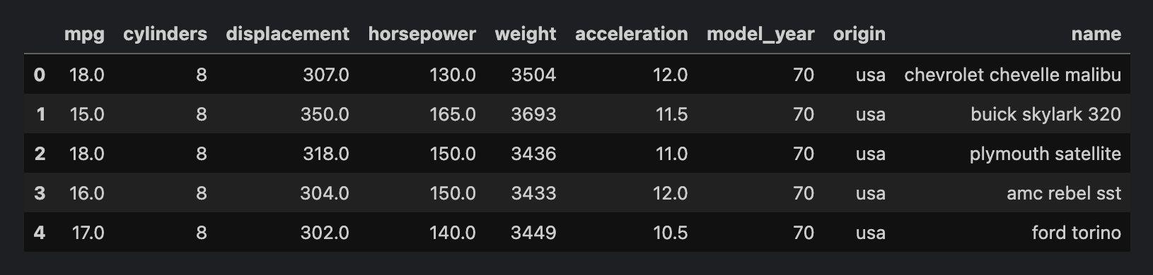
Table 2. First five rows of mpg.csv, showing all nine columns.

3 Methodology
The notebook [2] uses Python with pandas, Matplotlib and seaborn. This lab has four main stages.
First stage. Boolean masking. Here we learn what boolean masking is and how to use it. It works as a filter that lets us take the dataset, filter it as we need to and get statistics about the subset. We use sum to count cars with mpg at least 30, mean to get their fraction of all 398 cars, and len to count the Japanese subset.
Second stage. Working with groups using groupby. The groupby function allows us to split the dataset into groups by a column. We grouped by origin to get the mean mpg and number of cars for each group separately. Counting the complete mpg column gives row counts, which we checked against len(cars). Then we grouped by origin and cylinders, and used unstack to make the result look like a table.
Third stage. Comparing two quantitative variables. Here our goal was to see the correlation between weight and mpg. We used a scatter plot where each dot represents a car, the x-axis is weight and the y-axis is mpg. Then we drew another scatter plot, marking each origin group with its own colour using hue. We also calculated a Pearson correlation table and selected the weight and mpg value.
Fourth stage. The box plot. Here we learn a new type of figure called the box plot. The bottom and top of the box mark the 25th and 75th percentiles, and the line inside shows the median. Whiskers reach the lowest and highest observations within 1.5 interquartile ranges below the lower quartile or above the upper quartile. Points beyond them are outliers. This helps us compare each origin through the median, box location, spread and outliers [3].

4 Results
There are 92 cars where mpg is greater than or equal to 30. This is 92 out of 398 cars, or a fraction of 0.231, about 23.1%. Filtering by origin gives 79 cars from Japan. Table 3 gives the counts and mean mpg for each origin.
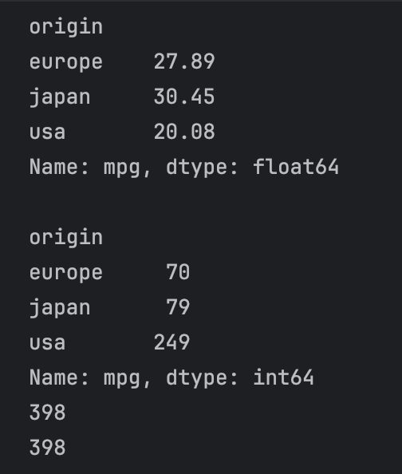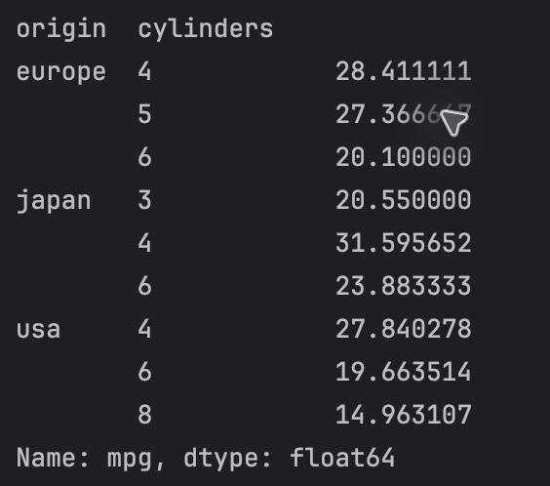
Table 3. Left: mean mpg and car counts by origin. The last two values verify the total of 398 cars.
Table 4. Right: mean mpg for each origin and cylinder group before unstacking.
Out of 398 cars, 70 are from Europe, 79 from Japan and 249 from the USA. The counts sum to 398, matching the dataset size. Japan has the highest mean mpg and the USA has the lowest. The difference between their displayed overall means is 10.37 mpg.
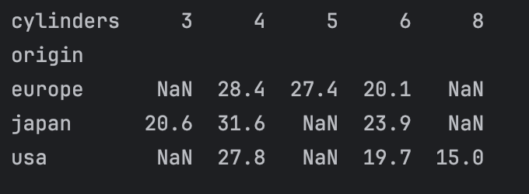
Table 5. Mean mpg after unstacking, rounded to one decimal place. NaN means no cars in that combination.
We found mean mpg for every origin and cylinder combination in Tables 4 and 5. Among 4-cylinder cars, the displayed Japan and USA means differ by 3.8 mpg. Only the USA has 8-cylinder cars, with a mean of 15.0 mpg.
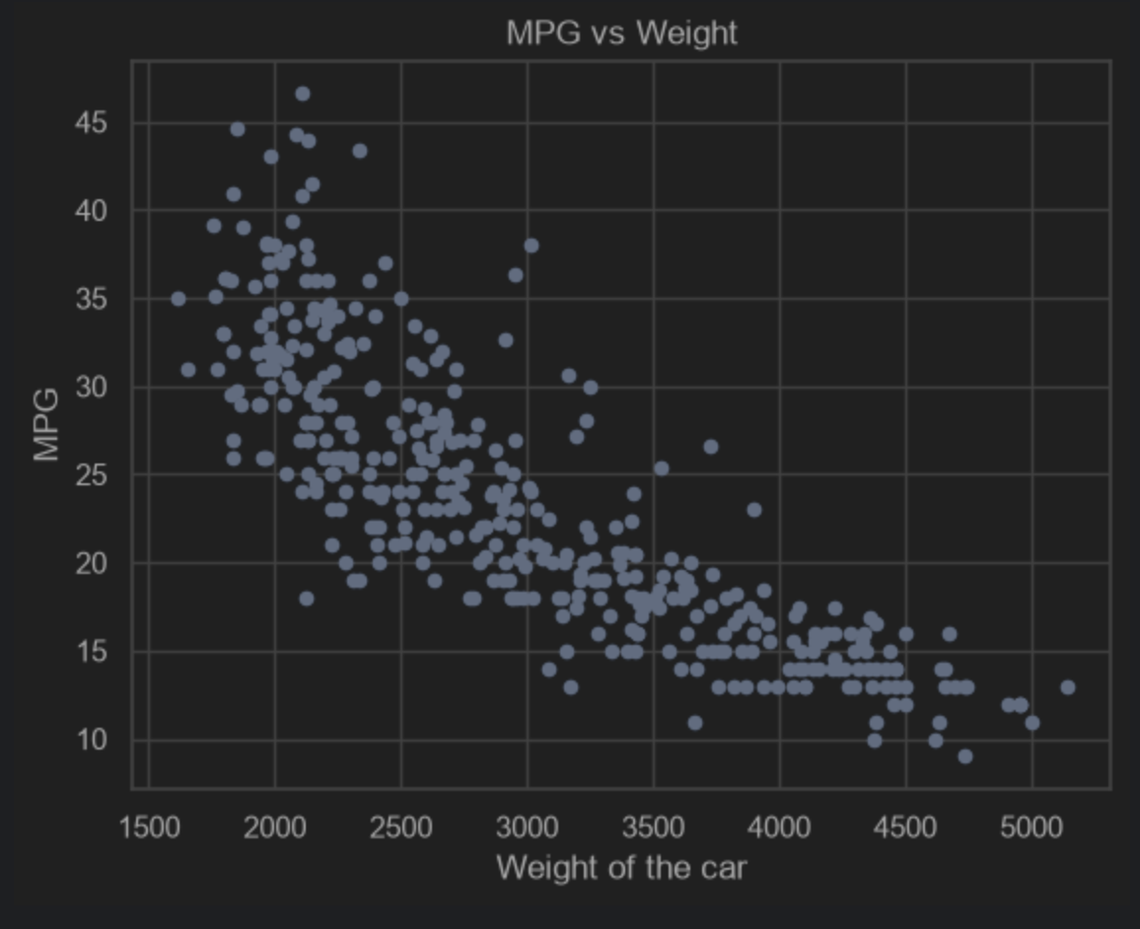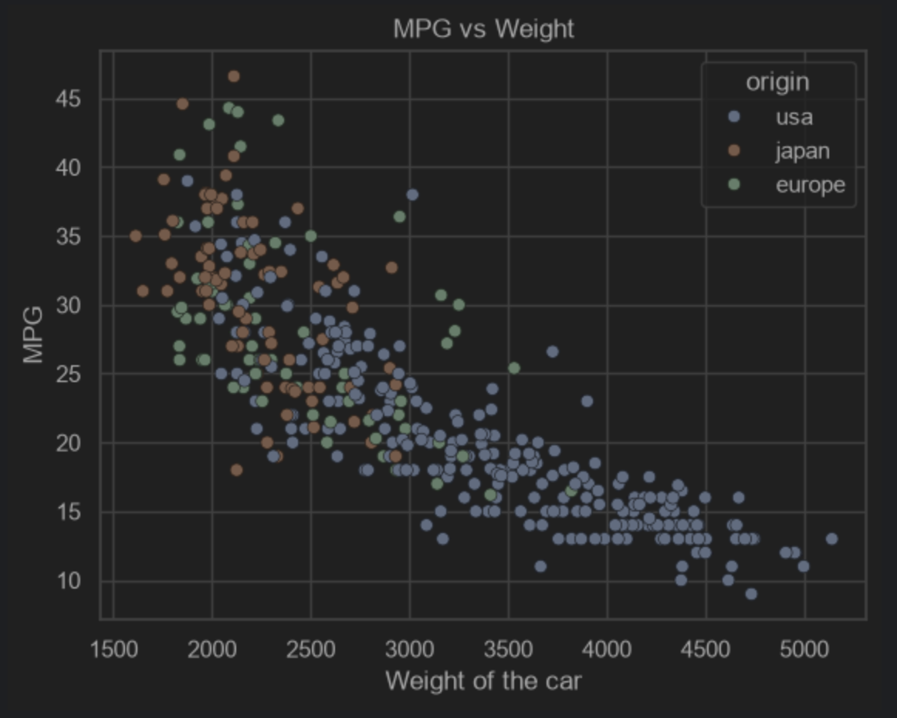
Figure 1. Weight and fuel efficiency of 398 cars. The left plot uses one colour; the right plot colours the same cars by origin. Weight is in pounds and mpg is miles per gallon.
The left plot in Figure 1 shows a clear relationship between weight and mpg. As weight grows, mpg tends to go down. The correlation is r = -0.83 for 398 complete pairs, a strong negative linear association. In the right plot, USA cars tend to be heavier and have lower mpg than cars from Japan and Europe, although the groups overlap.

4 Results continued
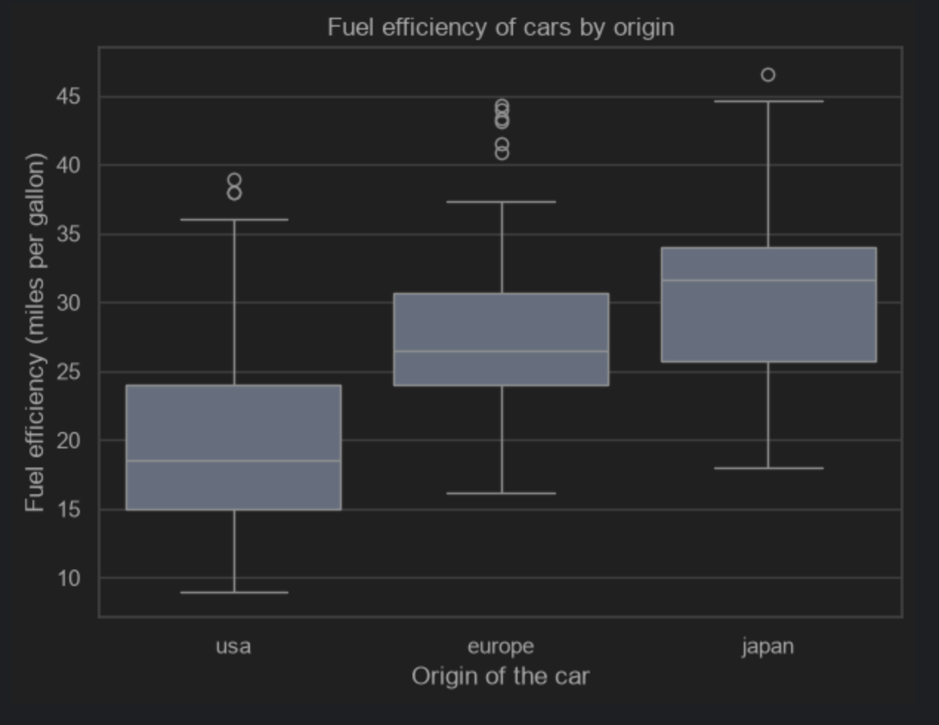
Figure 2. Fuel efficiency by origin. The box plot uses 249 USA, 70 European and 79 Japanese cars. Boxes show the middle 50% of values, with the median inside; separate points are outliers.
In Figure 2, Japan has the highest median mpg, around 31 to 32 mpg. Europe has the shortest box, meaning the middle half of its values has the smallest spread. Europe also has the most outliers, all with unusually high mpg. The distributions overlap, so some USA cars are more fuel efficient than some Japanese cars.

5 Discussion
The results help us understand how a car's origin is associated with its properties and how different properties are related. The overall mean alone can hide the mix of cars within each origin. The smaller gap among 4-cylinder cars, and the fact that only the USA has 8-cylinder cars, show that cylinders are mixed into the origin comparison. We cannot say that being made in the USA causes lower mpg. The scatter plots and r show association, not causation.
One limitation is the dataset size and coverage. It contains only 398 car models sold in the USA between 1970 and 1982. Expanding it to other years or cars might give different results. The groups also have different sizes. A useful next comparison would keep cylinders and model year similar before comparing origins.

6 Reflection
At first it was not obvious how a box plot works, but reading the explanation made it clearer. After I looked at the existing code and the result, I understood how the median, box and outliers fit together. Also, while drawing a scatter plot, I forgot how to colour each dot differently based on origin, but the documentation helped me recall it. I reused mean_mpg for the two groupings, which replaced the first result and confused my comparison. Next time, I would use different variable names for different groups of results, so I can check my comparisons more easily.

7 References and notebook
[1] Waskom, M. mpg.csv, mwaskom/seaborn-data.
https://github.com/mwaskom/seaborn-data/blob/master/mpg.csv
[2] Tiniakov, A. DSA 107 Lab 3 notebook.
https://github.com/AndrewTinyakov/dsa107-labs/blob/main/03/Lab03_Andrei_Tiniakov.ipynb
Repository: https://github.com/AndrewTinyakov/dsa107-labs
[3] seaborn.boxplot documentation. https://seaborn.pydata.org/generated/seaborn.boxplot.html

8 AI assistance disclosure
I used ChatGPT with high reasoning for hints and checks on groupby, correlation and scatter plots. I used OpenAI Codex to refine the report, tables, figure presentation, captions and layout. The notebook conversation and report editing record are included in the separate AI assistance log.

