List all the files:

Readme.docx

Admin.php

goodChecking.php

processing.php

managerProcess.php

home.php

register.htm

login.htm

mlogin.htm

buying.htm

customerChecking.php

logout.php

loginChecking.php

buyongProcess.php

logout.htm

goods.xml

listing.htm

customer.xml

manager.txt

Instruction:

Starting from the home screen, user will be given 3 options: sign in as administrator, sign in as user and register for new user

When choosing to register, user will be asked to input some information. The input information is then validated and sent to server. If there is any error, the pop up message will appear. If successful, it will show a link to buying page

When choosing to login as user, user will be asked to input email and password. The input information is then validated and sent to server. If there is any error, the pop up message will appear. If successful, it will show a link to buying page

When choosing to login as administrator, user will be asked to input user name and password. The input information is then validated and sent to server. If there is any error, the pop up message will appear. If successful, it will show a link to administrator page

In buying page, a list of items will be show and user can click on “Add to cart” to add items and the system will display a cart. In the cart, user can remove item, confirm purchase or reset cart

In the admin page, will be given two pages. The “listing” page allows user to add items to the “goods.xml” file. The “processing” page allows users to clear sold items and remove items with quantity on hold and available quantity equal to 0

The “log out” link will be available in buying page, listing page and processing page. Upon clicking log out link, a thank you message will be displayed and a link to home page will appear

(I test this app with Apache server using XAMPP version v3.2.2 and Google chrome browser and the adding function is working fine. However, when I try with mercury server, it shows some error

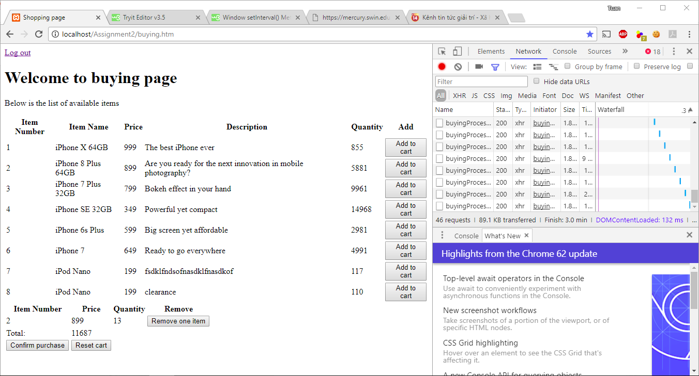

Testing with Mercury server

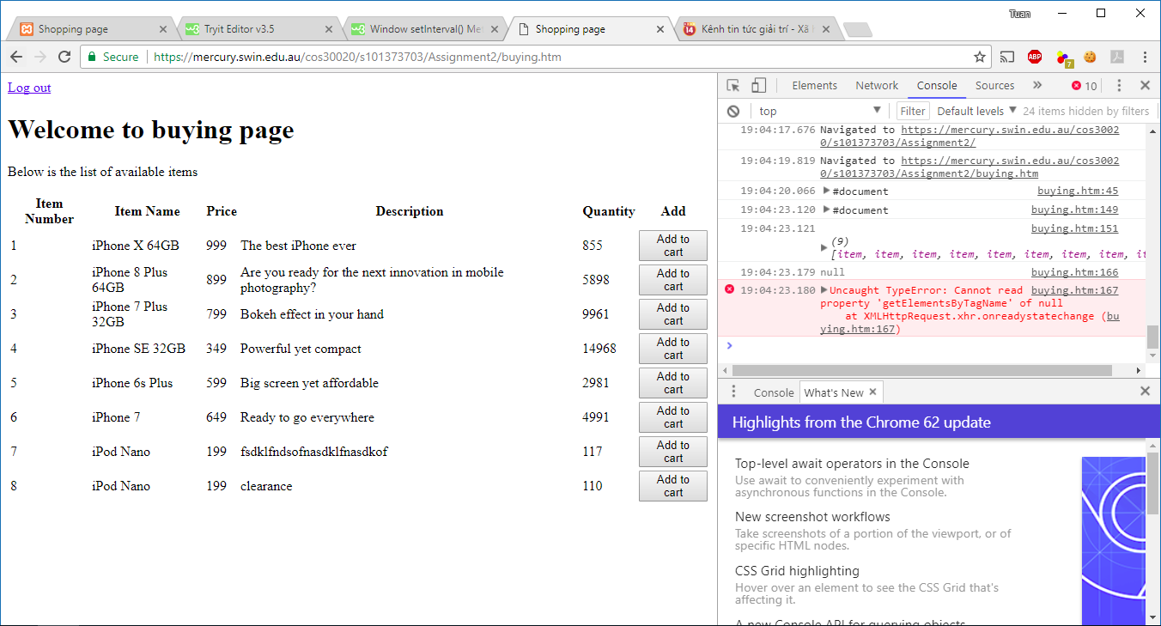

It seems that comments was responsible for this problem)