Models for the within-host dynamics of bacterial infections

Andrew Tung Yep

16 March 2017
Summary 1
Introduction 2
Materials and methods 6
Model assumptions and limitations 8
Results 9
pDiGi replication in vitro 9
In vivo 11
TIMER fluorescence ratios 17
Discussion 23
pDiGi experiments 23
TIMER application 25

Summary
In order to further understand the dynamics of replication of Salmonella typhimurium in macrophages, a proof of concept model was constructed in R to simulate the changes in fluorescence distribution among a population using two fluorescence dilution (FD) techniques (TIMER and pDiGi). These models allowed experiments from Claudi et al. 2014 and Helaine et al. 2010 to be reproduced in silico, testing different hypothesis of population dynamics to find those which match data from the papers. The results of the models indicated a significant biased loss in addition to replication events from the intracellular Salmonella population (either by bacterial death or macrophage lysis) between 14 and 22 hours after phagocytosis by a bone marrow derived macrophage. Similar evidence was not found for immortalised RAW 246.7 macrophages. The model also allowed comparison between the two FD techniques in the context of the same experiment. Due to the short time frame of the experiment and the response lag of the TIMER system, it was concluded that in this case the pDiGi system was likely to be more useful in future testing.

Introduction

Traditionally, bacterial populations are monitored in vivo by homogenization of a tissue followed by serial dilution and inoculation onto growth media. This measures the concentration of colony forming units as a proxy for population size. However, this method only reveals net growth or decline of a population, giving little information of growth and death rate or any potential heterogeneity of these factors between sub populations. In addition, sub-populations in different physiological states may be more or less likely to form a colony, meaning the same population size may be estimated differently depending on the states of the bacteria. Methods for detailed population dynamics evaluation are especially important in vivo as individual replication events cannot be monitored easily by microscopy.
A number of related techniques have therefore been developed in order to more closely study the population dynamics of bacteria. This may allow greater understanding of problems such as antibiotic resistance and immune clearance of bacteria.
One such technique (called distributed cell division counting(DCDC)) is used in Myvold et al. 2015. In the study, a growing population of bacteria each containing one inert, discretely segregating particle at the start of the experiment are observed at time intervals. The gross population growth rate can be calculated by comparing the proportion of bacteria with a particle still inside after a period. If every bacterium in the population divides on average once, the proportion with a marker should reduce by half as a marked bacterium will only transfer the marker to one daughter in a division. Death rate in the population can be inferred by combining the net population growth (if known) and the gross population growth.
To achieve this E. coli were transformed with an arabinose inducible plasmid containing an operon for a self-assembling fluorescent phage-like particle. With the correct time under arabinose induction, most of the exposed cells would contain exactly one assembled fluorescent particle. Those which did were separated and used as the test population. When used in an in vivo setting (in the gut microbiota) the bacteria being studied were distinguished by a constitutively active green fluorescent protein gene inserted into the chromosome.
This method however, is unable to determine the replication history of individual bacteria, only groups of bacteria, making it hard to distinguish different behaviour in sub populations, especially if they are not spatially separated.
Other studies have used a similar principle to monitor population dynamics at an individual cell level. Instead of segregation of a single particle during cell divisions, a population of marker molecules present in the parent cell are segregated between the daughters. This is most commonly done using fluorescent proteins and is therefore referred to as fluorescence dilution (FD). Stable fluorophores in a cell will be diluted during the replication cycle due to the increase in total biomass volume. Unlike in DCDC the concentration of fluorophores can be used to estimate the number of divisions an individual cell has undergone since the introduction of the fluorophores rather than the average number of divisions across an entire population.
An interesting variation of FD is the use of TIMER fluorophores to record recent division history of the cell being studied (Claudi et al. 2014). TIMER fluorophores mature into either red or green fluorophores (or a colourless species) but the rate of formation of the green species is much faster than red species formation (via a colourless intermediate, see figure 1). As a result, expression of TIMER produces a green colour which progressively becomes more red. Both types of fluorophores form tetramers and due to fluorescence resonance energy transfer (FRET) between subunits, mixed colour tetramers appear orange, amplifying the green to red shift in emission. This fluorophore was expressed constitutively in Salmonella typhimurium, a mouse model of the human pathogen Salmonella typhi, in vivo. In quickly dividing cells, the older orange fluorophore tetramers were diluted into the descendants of the cells which produced them while the newer green fluorophores were still at a high concentration giving the cells a greener colour. Slow dividing cells, on the other hand, will have relatively undiluted orange fluorophore tetramers so will be closer to an orange colour. The TIMER fluorophores change colour over a 6-9 hour period (dependant on oxygen partial pressure), meaning the colour of a given cell is representative of the rate of replication over the last several hours.
The population dynamics of Salmonella typhimurium have also been investigated using a FD method in Helaine et al. 2010. In the experiments, mouse macrophages are infected with a transformed strain of the pathogen. The bacteria contain one of two plasmids. Both encode a red fluorophore on an arabinose inducible promotor and either a green fluorophore on a constitutive (pDiGc plasmid) or an isopropyl β-D-thiogalactoside (IPTG) inducible (pDiGi) promotor. The bacteria are grown with the inducers to build a baseline level of fluorophores and at time zero of the experiment, the arabinose promotor is removed. The second fluorophore allows greater accuracy of measurement by the ratio between fluorophore intensity, accounting for differences in protein expression between cells. Using the pDiGi plasmid, some information of the timing of the division events can be gained by removing the IPTG partway through the experiment when the concentration of the red fluorophore becomes too low to measure in the fastest dividing cells. The second inducible fluorophore can also be used as a test for protein synthesis in otherwise inactive cells.
The aim of this project is to create a model which incorporates many of the key processes involved in these FD techniques using plausible parameters. The experiments run using these scripts can explore the potential effects of different patterns of division on the fluorescence distributions of the populations. This data will inform the formation of hypotheses about the processes contributing to the phenomena seen during a salmonella infection. It will also act as a proof of concept paving the way for more complicated and accurate models which may be able to aid in the development of treatments for the human disease. In addition, in the construction of these models, areas requiring further investigation can be identified which will deepen the understanding of the experimental system.
Specifically, these FD models are intended to address:
- The replication dynamics involved in the generation of heterogeny within the intramacrophage populations of Salmonella typhimurium
- The comparative benefits and downsides of the TIMER and pDiGi systems when investigating populations inside macrophages

Materials and methods
The project was conducted using the package and language R, using RStudio as the interface. R is a statistical language specialising in the use of matrices and vectors, allowing fast computation of the vector based model as well as easy statistical analysis and graph plotting of the data.
Scripts were written to represent the experimental systems used in Claudi et al. 2014 and Helaine et al. 2014. Bacterial cells are represented as entries in data frames with some columns encoding characteristics of the cells such as numbers of fluorophores and chance or frequency of division. Other columns record information on the division history of the bacterium.
The scripts update the table of the bacterial population in discrete time steps. Within a timestep, fluorophores can be “synthesised” or “change colour” (in the TIMER model only) changing the numbers in the fluorophore columns. In addition, informative (do not affect the model running) columns change values. A timestep can also introduce a division event in some bacteria in the table.
When bacteria divided in the model, offspring generally inherit the characteristics of the parent such a division frequency/division chance as well as informative columns being transferred and updated.
The fluorophore numbers are treated slightly differently in a division. Bacterial cells are modelled as having natural variation in biomass partition between the two daughter cells (Yu and Margolin 1999), normally distributed. For each division event, a biomass ratio between the two daughters is sampled from the normal distribution. Fluorophores, which are assumed to be evenly distributed throughout the cytoplasm are segregated between the daughter cells binomially according to the biomass ratio.
In the model for Helaine et al. 2014 the red fluorophore is never replenished, as the first timestep represents the moment that the red fluorophores cease to be induced and therefore will not be transcribed so in subsequent divisions, the concentration of red fluorophore roughly halves every division. The green fluorophore concentration is topped up every timestep. If the green fluorophore synthesis is switched on, the rate of green production is directly proportional to the frequency/rate of division to keep the levels on average to a steady state. If the green production is switched off (RiGi strain without IPTG inducer), the green fluorophore behaves in exactly the same way as the red.
In the model of the TIMER FD system the fluorophores are modelled as being either in a red or green state. Fluorophores, when synthesised, are always in the green state but every green fluorophore in every timestep has a fixed probability of spontaneously turning into a red fluorophore. However, this model is a simplification of the real reaction pathway (figure 1). This simplification was made because the rate limiting step in this reaction pathway is the conversion of the colourless intermediate and the red fluorophore. In addition, because of the FRET effect of the mixed colour tetramers, tetramers of green and colourless fluorophores emitting green light are replaced by mixed red and green fluorophores emitting mostly red light, producing a similar effect to the in-model of conversion of green to red fluorophores.
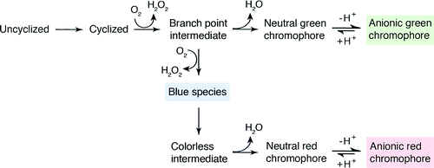
Figure 1: Scheme depicting reaction pathway of TIMER fluorophore. Figure taken from Strack et al. 2010

Scripts for both models are available on GitHub at https://github.com/AndrewTungYep/Models-for-the-within-host-dynamics-of-bacterial-infections

Model assumptions and limitations
The model makes a number of assumptions and simplifications about the system of cells.
- Due the lack of information in the literature, it is unclear how many fluorophores are present in the cells while they are in active production in the experiments so arbitrary numbers are used depending on the experimental requirements.
- The standard deviation of the distribution of cell division biomass partition is taken as 1.3% of the total cell volume, taken from Yu and Margolin 1999. However, this study was done using E.coli in an in vitro setting. A similar study for Salmonella could not be found so this figure serves as a plausible approximation rather than an exact figure. Probability of a fluorophore partitioning into a given daughter cell is assumed to be entirely dependent on the relative volumes of the daughter cells. A normal distribution was chosen because cell division asymmetry will depend on the influence of a number of random factors which will tend to approximate a normal distribution.
- Fluorophores are assumed to never break down or egress from cells. It was not mentioned on the literature if there was any loss of fluorophores over time but it is plausible that this may happen and this process is not included in the model.
- Creation of fluorophores, both at the start of the model and after a cell division is determined by Poisson distribution around a mean value. Normal distribution may be more appropriate for a multi factorial biological system but would involve the selection of an arbitrary standard deviation.

Results

pDiGi replication in vitro
In order to test the accuracy of the model for the pDiGi strain, it was tested against data from Helaine et al 2010 (Figure 2).
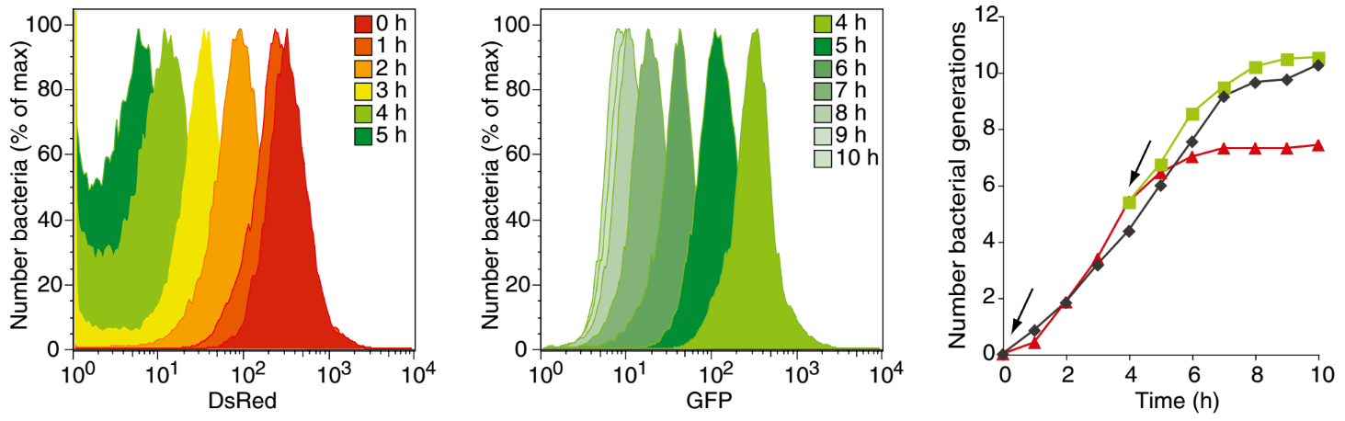
Figure 2: Change in distribution over time of fluorophores in in vitro colonies. arabinose was removed at hour 0 (allowing GFP to be diluted) and IPTG at hour 4 (allowing DsRed to be diluted). Figure taken from Helaine et al 2010.
The initial distribution was reproduced in 1000 modelled cells and modelled for 100 timesteps. The replication time was set so each cell on average divides the same number of times as in the experiment. See Figure 3.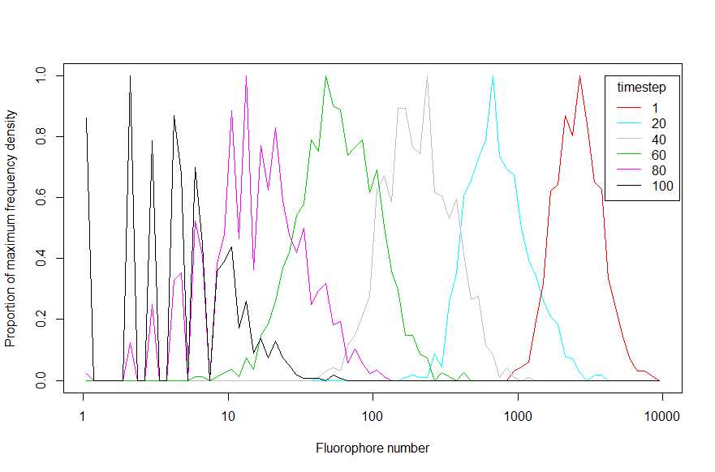
Figure 3A: Modelled distribution of red fluorophores over the course of the experiment
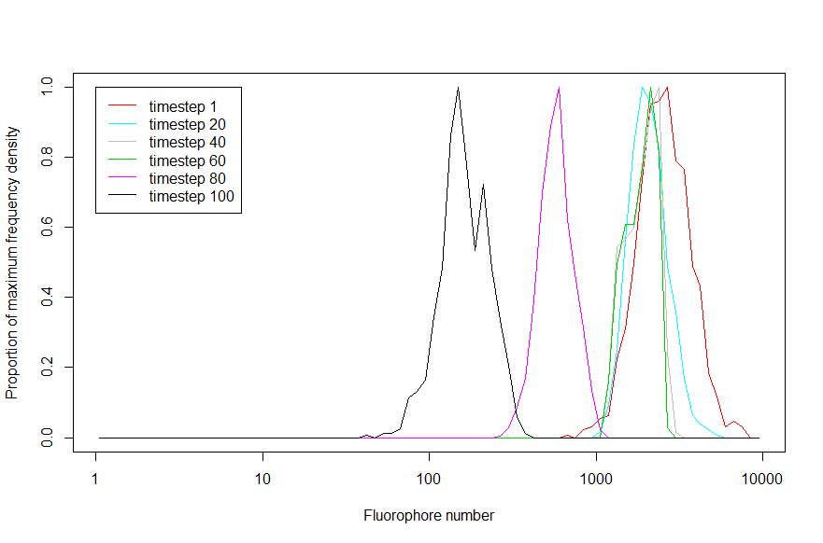Figure 3B: Modelled distribution of green fluorophores over the course of the experiment. Production stopped at timestep 62 (representative of the time of removal in the study), representing the removal of IPTG inducer
Qualitatively, the model is able to mimic the behaviour of the biological system meaning it can be used to determine make a plausible estimation of the system’s behaviour in vivo situations. It also demonstrates that with the current starting fluorophore distribution, the number of generations can be roughly estimated up to 6 generations by the fluorophore concentration.

In vivo
In another experiment, pDiGi salmonella were also allowed to be consumed by macrophages derived from healthy bone marrow (BM) and a mass-produced line from tumour cells (RAW264.7). The two macrophage types produced significantly different profiles of red fluorescence (figure 4) in the first 22 and 12 hours after inoculation respectively.
Figure 4: The fluorescence distributions over time of Salmonella typhimuium in BM (left) and RAW 264.7 (right) macrophages. Recording was probably stopped at 12 hours for the RAW264.7 macrophages because the concentration of DsRed would be too dilute to convey useful information about replication after 12 hours
The profile of the population inside both types of macrophages begins as a normal distribution (on a log scale) identical to those found in in vitro culture (as this is the source of the bacteria). In BM macrophages this distribution widens and develops a negative skew. Eventually, it splits into a series of peaks with shallow troughs in-between. At 22 hrs, the entire range from the starting mean to zero DsRed is populated. Interestingly, while the proportion of cells maintaining their original fluorescence initially declines, it increases again in the interval between 14 and 22 hours. In the RAW 264.7 macrophages on the other hand, the distribution is translated largely unchanged in shape to the left (decreasing fluorophore concentration) as time passes. A side peak forms at zero when the main peak reaches very low values in the 12 hour post infection trace. In this way, the distribution is very similar to that of the in vitro experiments. However, a small proportion of the bacteria maintain a peak at the original mean value, showing a non-replicating population. This peak decreases in population proportion as the other bacteria replicate and increase in number.
Clearly both types of macrophage induced some degree of heterogeny in the rate of division of the bacterial populations within them. Several distributions of division rate were tested in the model to recreate the in vivo fluorescence distributions (see figure 5). The model was run with an initial population of 1000 and for 50 timesteps
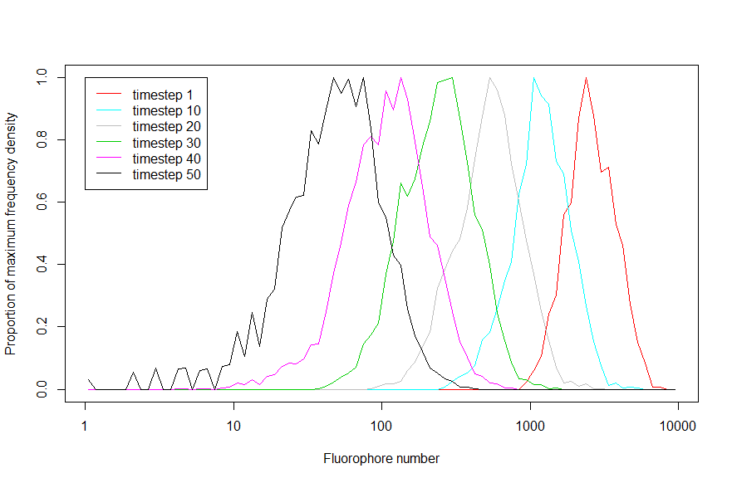 Figure 5A: As a control, the division time distribution of this population is normal (mean 10, SD 1). The behaviour, as expected is very similar to the in vitro population.
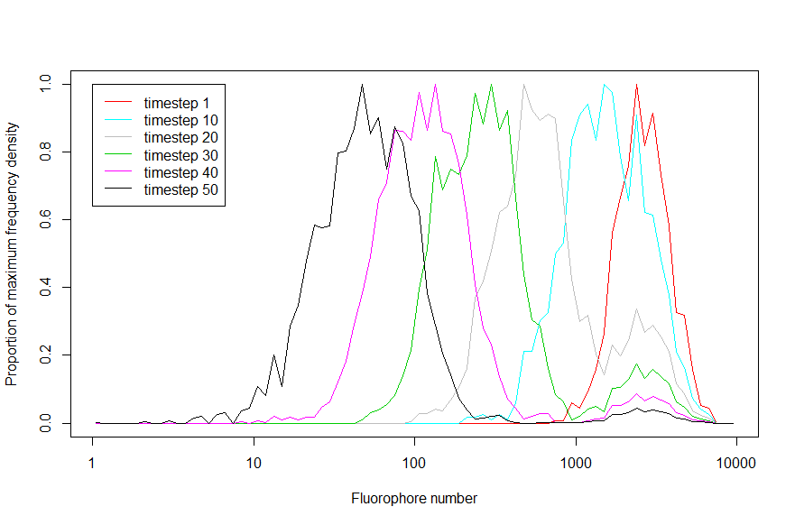 Figure 5B: The division time distribution of the initial population in this plot is evenly split between a normal distribution (mean 10, SD 1) and non replicators.
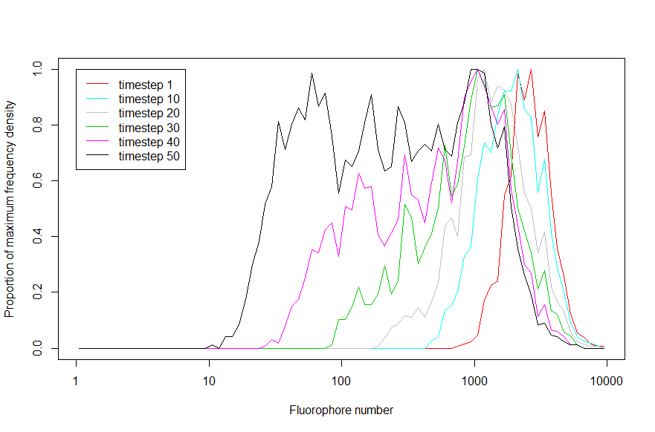Figure 5C: Division time in the initial population follows a uniform distribution between 7 and 75, in practice meaning that by the end of the experiment, the bacteria have divided between 0 and 7 times.

When compared to the in vivo experiments, figure 5B shows the most similarity with the population in RAW264.7 macrophages. The peak fluorescence of the replicating subpopulation decreases roughly geometrically (appears linear on the log scale graph) while the non-replicating group decrease in proportion of the population, shrinking the peak over time.
In many respects, figure 5C resembles the population in the BM macrophages, the peak widens and slowly decreases in mean value as well as developing the negative skew seen in vivo. As more time passes, the distribution splits into many overlapping peaks with no gaps in frequency density. However, one important feature of the in vivo distribution is not retained, the significant peak at the starting mean. In vivo, this peak decreases in proportion of the total population before increasing again. As this peak represents a subpopulation which has not reproduced since loss of DsRed induction, the peak height increase implies a significant effect of bacterial loss from the population on the final distribution as well as a bias towards loss of faster replicating bacteria.
One possibility to explain the loss of bacteria from the intra macrophage population is
Lytic killing by defence mechanisms of the macrophage. To investigate this possibility, a probability of death every timestep was introduced in the vulnerable dividing population (50% of total), the other half of the population consisted of non-replicators with no chance of death. The fluorescence distribution of this run is shown in figure 6.
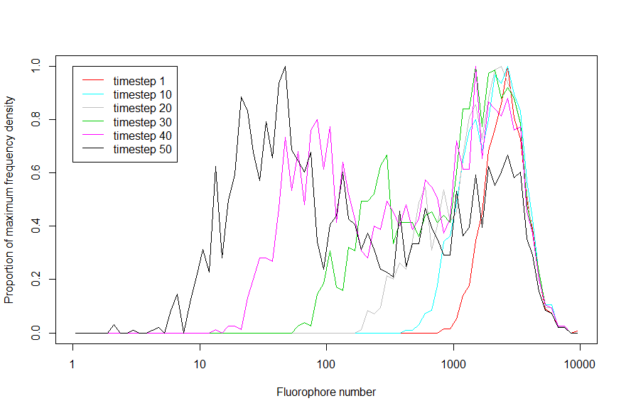
Figure 6: Attempt at modelling Salmonella growth inside macrophages including death processes.
Figure 6 is closer to the in vivo trace of the BM macrophage population. There is a prominent peak at the starting mean indicating a significant remaining non replicator population. However, unlike the in vivo trace, this peak declines in proportion of the population throughout the run, albeit more slowly than figure 5C.

TIMER fluorescence ratios
In the TIMER FD paper, bacteria grown in vitro at a constant rate of growth were found to reach a stable equilibrium ratio between emission of green and red. The emission ratio was found to depend both the rate of growth of the bacteria in the bacterial colony (see figure 7).
Figure 7: relationships between G:R ratio and division rate in a chemostat colonies. Chemostat are a piece of equipment allowing precise regulation of an in vitro culture growth rate through limiting nutrient supply. Figure taken from Claudi et al. 2014.
These real world results were used to tweak the model to qualitatively mimic the experimental setup (see figure 8).
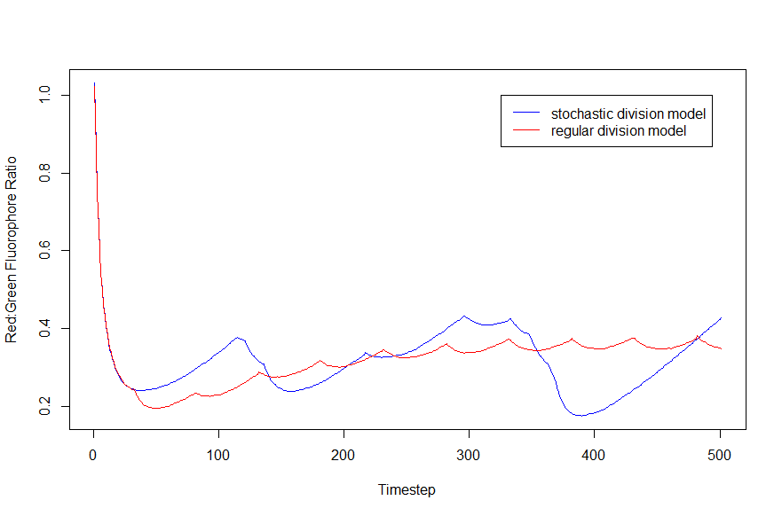Figure 8A: In the first version of the TIMER model the timings of cell divisions were determined stochastically. However, it was found that this aspect of the model was not compatible with the fluorophore ratio stabilisation found in vitro with all parameter values tested. Instead, it was found that a regular timing of divisions created a stable ratio between green and red fluorophores within a handful of divisions from any ratio as a starting point. Each line follows the R:G ratio of a single representative cell over the course of 500 timesteps. The average division frequency is once in every 50 timesteps in both cells.
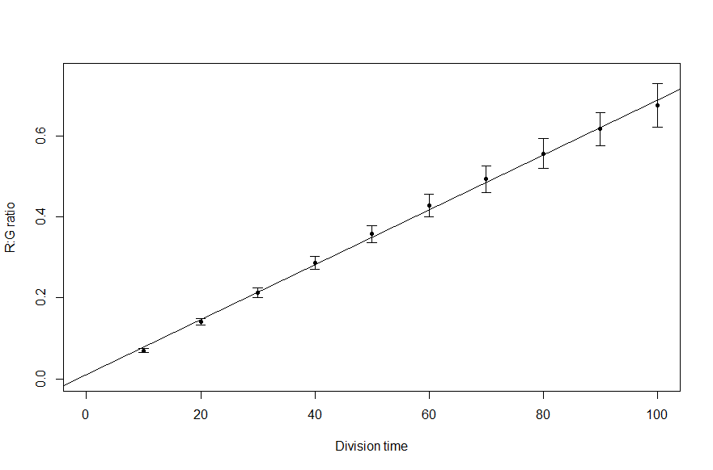
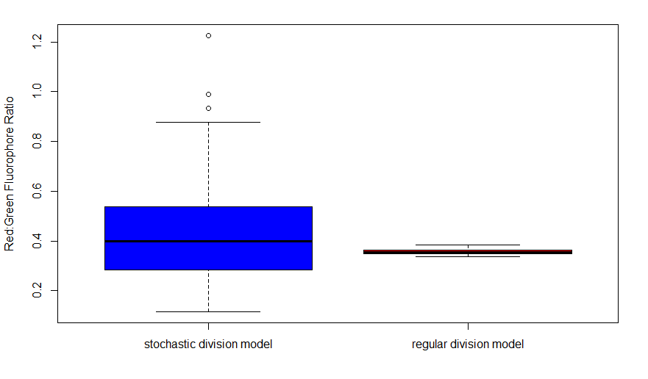Figure 8B: The final ratios of 100 cells of each type after 500 timesteps, showing that the stochastic division timing is the major source of variation in R:G ratio in the stochastic model.
Figure 8C: This plot shows the relationship between division time and mean R:G ratios in the regular division model. The mean ratios were taken from the final timestep of a 500 timestep run with a sample size of 100 cells each. The correlation very close to linear with a regression line of y = 0.00679X + 0.00109, providing an easy conversion between R:G ratio and replication time.
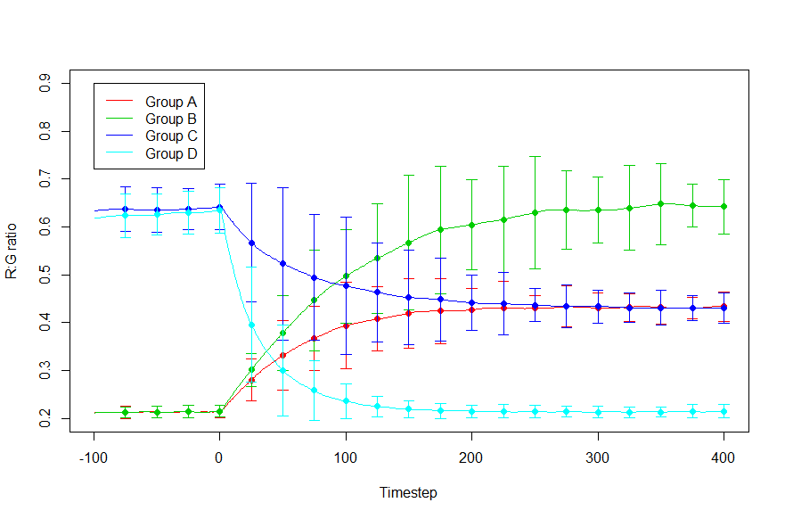Figure 8D: Mirroring one of the experiments done in the study (figure 7), the effect of a change in growth rate was investigated. The experiment followed the R:G ratio of groups of 100 “cells”. Figure 4 shows the average value of each group at each timestep while the error bars show the 95th percentile (assuming normal distribution). The groups consisted of cells changing from a division time of 30 to 60 (A), 30 to 90 (B),90 to 60 (C) and 90 to 30 (D). The model was run for 350 timesteps before changing the division time in order to reach an R:G equilibrium ratio. At time zero the division rates were changed and the model was run for a further 400 timesteps.
Figure 3D allows the size of a timestep to be compared to time in the in vitro experiment. In figure 7, for most of the cell populations, by 12 hours after the change in division rate, the R:G ratio is at or near the equilibrium value reached at 28 hours post change. Similarly, in the model, by 200 timesteps after changing division times, the R:G ratios of the populations are approaching their equilibrium values so it can be estimated that 200 timesteps in the TIMER model with the current parameters roughly equates to 12 hrs in real time.
As the TIMER system is much more accurate in determining replication rates than the pDiGi system, the application of the system in the experiments in Helaine et Al 2010 may provide clearer information on replication rate distribution.
One of the scenarios tested against the pDiGi model (uniform distribution of division time) was also tested with the TIMER model to assess how well the R:G ratio reported division rate within the limited number of generations. For comparison, the division time distribution over the experimental period is also displayed. As there is a linear relationship between division time and R:G ratio, the distribution of R:G ratio should mimic the division time ratio to some extent.
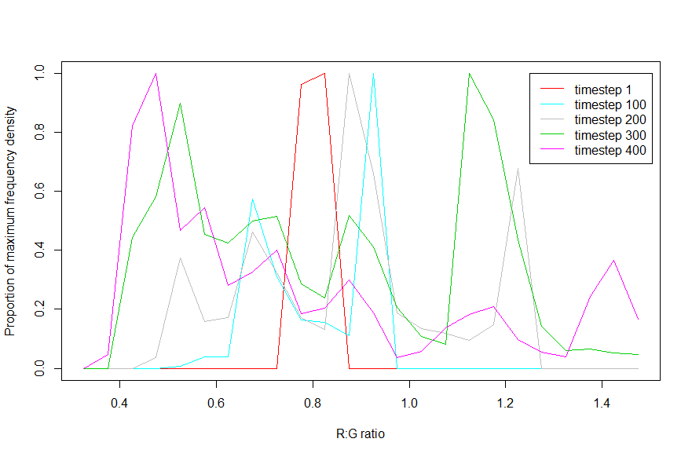
Figure 9A: Change in R:G distribution over time in response to a uniform replication time distribution.
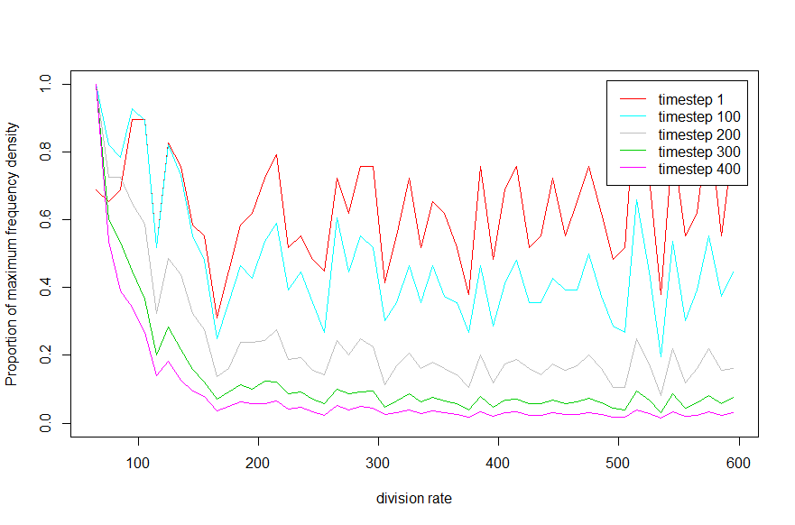
Figure 9B: Changes in the division time distribution of the population over time.
In figure 9A the timestep 1 distribution is a single peak which approximates the distribution from a homogenously grown in vitro population with a single rate of growth. As time passes, the distribution spreads out and splits into a series of lower peaks spreading in both directions. Towards the end of the experiment, in the timestep 300 and timestep 400 traces, the number of bacteria with a low R:G ratio begins to increase and eventually forms the highest frequency peak at around 0.45.
By contrast, figure 9B shows an uneven but level distribution at timestep 1. With each trace, the number of bacteria with low division times increases, flattening the rest of the distribution by comparison. In the last timestep trace, figures 9a and b show some similarity with matching peaks at the low end of their range and a lower flatter distribution over the rest of their range.

Discussion

pDiGi experiments
Based on this set of experiments, the fluorescence distribution of both in vitro population and the RAW 264.7 intramacrophage population can be explained in terms of replication alone. Single rate growth of a population causes the translocation of the existing distribution as seen in figure 5A. If a separate non-replicating sub population is included in the model alongside the productive population, the distribution seen in RAW 264.7 can be recreated (figure 5B). However, none of the division rate distributions modelled satisfactorily recreated the distribution seen on the data for the BM macrophages.
The proportion of the population which had not replicated increases towards the end of the experiment, heavily implying that bacterial loss plays a significant role in shaping the distribution and that this effect is greatest between the 14 and 22 hours. It can be inferred that the probability of a bacterium loss increases with division rate (and therefore metabolic activity) and time spent in the macrophage. This may represent a delayed endocytic killing process such as an oxidative burst or fusion of a lysosomes to the endosome.
Another possibility is that macrophages are being lysed by the bacteria between 14 and 22 hours. Depending on the counting procedure, these now extracellular bacteria may not be counted. This process would remove some non-replicators but would preferentially remove replicators as a macrophage with a fast replicating population is more likely to lyse. Lindgren et al 1996 lends evidence to this hypothesis, showing that 6-14 hours post infection by Salmonella typhimurium a significant proportion of macrophages are terminally damaged and will lyse after this phase. More evidence would need to be gathered on this phenomenon to include it in a model.
The fact that the other scenarios can be explained without a bacterial loss does not rule out the possibility that it does play a significant role. It is possible, for example, that in the RAW 264.7 macrophage, the rate of loss of bacteria is roughly even between the two sub-populations, reducing both peaks and giving the appearance of little or no loss, although current evidence suggests that non replicating bacteria are much more resistant to biological and chemical insult (Silva-Herzog et Al. 2015, Helaine and Krugelburg 2015).
In order to model these processes more accurately, more information would have to be gathered on the extent of bacterial killing as well as replication. Bacterial killing could be measured over time by monitoring the extra bacterial concentration of a marker (e.g. a fluorophore) which is released upon bacterial lysis. Unfortunately, heterogeneous bacterial populations are known to live within the same macrophages (Claudi et Al. 2014), so a release of marker could signify either the lysis of and active bacterium or a non replicator.
Another potential complication to modelling within macrophage dynamics is the possibility of bacteria changing division rate. This process is not addressed in the models but has been shown to occur in infected spleen tissue (Claudi et Al. 2014) (although in this case over a period of days, not hours). This process, will have to be characterised and included in more detailed models. Experimentally quantifying if and how frequently this process may occur will pose a big challenge. Technologies such as TIMER if combined with a marker dilution technique (not pDiGi as the fluorophores from each system would interfere with one another) may be able to offer some indication of a change in division rates. The extent of marker dilution depends almost solely on the number of generations since cessation of marker production whereas TIMER R:G ratio lags a few hours behind changes in division rate. Cells equipped with both systems could detect large changes in division rate by disagreement between the estimated division rate by the two systems. A TIMER overestimate would suggest a decrease in division rate while a TIMER underestimate would indicate an increase.

TIMER application
The modelling of TIMER into a scenario found in Helaine et al. 2010 allowed for direct comparison between the two techniques (figures 5C and 9A) and what information they can show about the experimental system.
Given enough time, TIMER should show, with relative accuracy the distribution of bacterial division rate in a population at a steady state. However, in practice in this situation, the timer fluorophores spent more than half the experiment reaching equilibrium with their bacterium’s division rate, meaning that almost no information can be inferred on the behaviour of the bacteria during this time. In addition, the lag effect will continue to have an impact on the accuracy of the timer distribution if bacteria change division rate significantly.
The pDiGi system on the other hand is able to give an estimate of the number of divisions cells have undergone in real time if the population is under surveillance and therefore an inexact estimate of the distribution of division rates. However, this technology is only effective for short experiments as within a few divisions, the fluorophore is too diffuse to measure so for studies into longer term population dynamics, TIMER may be a better option.
References
- Claudi B, Sprote P, Chirkova A, Personnic N, Zankl J, Schurmann N, Schmidt A, Bumann D. Phenotypic variation of salmonella in host tissues delays eradication by antimicrobial chemotherapy. Cell. 158:722-733
- Helaine S, Holden DW. 2013. Hetrogeny of intracellular replication of bacterial pathogens. Curr Opin Microbiol. 16:184–191
- Helaine S, Krugelburg E. 2014. Bacterial persisters: formation, eradication, and experimental systems. CellPress. 22(7):417-424
- Helaine S, Thompson JA, Watson KG, Liu M, Boyle C, Holden DW. 2010. Dynamics of intracellular bacterial replication at the single cell level. PNAS. 107(8):3746-3751
- Lindgren SW, Stojiljkovic I, Heffron F. Macrophage killing is an essential virulence mechanism in Salmonella typhimurium. Proc. Natl. Acad. Sci. USA. 93:4197-4201
- Myhrvold C, Kotula JW, Hicks WM, Conway NJ, Silver PA. A distributed cell division counter reveals growth dynamics in the gut microbiota. Nat. Commun. 6:10039 doi: 10.1038 ncomms10039
- Silva-Herzog E, McDonald EM, Crooks AL, Detweiler CS. 2015. Physiologic stresses reveal a Salmonella persister state and TA family toxins modulate tolerance to these stresses. PLoS ONE. 10(12):e0141343. doi:10.1371/journal.pone.0141343
- Strack RL, Strongin DE, Mets L, Glick BS, Keenan RJ. 2010. Chromophore Formation in DsRed Occurs by a Branched Pathway. J. AM. CHEM. SOC. 132: 8496–8505
- Yu XC, Margolin W. 1999. FtsZ ring clusters in min and partition mutants: role of both the Min system and the nucleoid in regulating FtsZ ring localization. Mol. Microbiol. 32(2):315-326

