T E C H N I C A L R E P O R T  Customer Loyalty,  Segmentation &  Sentiment Analysis  Customer loyalty analytics for a global games retailer using Python and R to identify spending patterns, predict loyalty points, segment customers, and analyse review sentiment. | TG

Andrew Willacy | October 2025

TOOLS & TECH STACK
  Python  Analysis & modelling |   R  Statistical analysis |   Matplotlib  Visualisation & charts

K E Y B U S I N E S S Q U E S T I O N S
What drives loyalty?  Spending patterns & predictors | Who are the customers?  Segmentation & value groups | What do reviews reveal?  Sentiment & experience themes

CUSTOMER LOYALTY, SEGMENTATION &
SENTIMENT ANALYSIS

Technical Report- Andrew Willacy - October 2025
Executive Summary

This report presents the findings of an end-to-end customer loyalty analysis conducted for Turtle Games, a global games retailer. Using Python for exploratory analysis, predictive modelling, clustering, and NLP sentiment analysis — and R for independent statistical validation — the analysis addressed three core business questions: what drives customer loyalty points, how can customers be meaningfully segmented, and what do customer reviews reveal about the experience.
Key findings: loyalty points are strongly and predictably associated with spending score and income; five distinct customer segments exist with materially different value profiles; and customer sentiment is predominantly positive, with shipping failures and missing product components the dominant sources of negative experience.

Finding | Summary
Dataset | 1x csv file, 2,000 reviews from 782 unique customers
Primary loyalty drivers | Spending score and income - not age, gender, or education
Predictive model | Linear regression R²=0.839–0.844 - robust, business-friendly, recommended for operational use
Customer segments | Five distinct groups (k=5) with clear value and engagement profiles
High-value outliers | 266 customers (13%) with loyalty points ≥3,200 — premium segment requiring VIP treatment
Sentiment | Predominantly positive - shipping failures and missing product components are the dominant pain points

Background & Context

Turtle Games is a game manufacturer and retailer operating globally, with products spanning books, board games, video games, and toys. The company collects customer data in the form of loyalty programme records and customer reviews.
The business is seeking to improve sales performance and asked for analysis to answer three practical questions: how do customers engage with and accumulate loyalty points; can customers be segmented into meaningful groups; and can review analysis be used to inform marketing campaigns.

Data & Analytical Approach

Dataset
The original dataset required cleaning before analysis. This included checking for null values, removing unnecessary columns (language, platform), and renaming others for clarity. The cleaned dataset comprised 2,000 rows by 9 columns, saved as turtle_reviews_clean.csv.

Key Fields | Description
age, income, spending_score | Core predictors used across regression, clustering, and feature importance analysis
loyalty_points | Target variable for predictive modelling
gender, education | Demographic variables examined for segmentation and descriptive analysis
review, summary | Customer-generated text used for NLP sentiment analysis

Note: although there are 2,000 rows, there are only 782 unique customers, each having written multiple reviews. Unique customer analysis used a customer_id column to filter to 782 rows for demographic and segmentation work.

Analytical Approach
Analysis was structured around the three business questions, progressing from exploratory analysis through predictive modelling, clustering, and sentiment analysis. Python was the primary tool; R was used for independent statistical validation of regression results.

Stage | Approach & Tools
Exploratory Data Analysis | Demographic distributions, outlier identification, pairplots, scatter plots - Python (Pandas, Matplotlib, Seaborn)
Regression Analysis | Multiple linear regression (age, income, spending_score predicting loyalty_points) with full diagnostics - Python and R
Decision Trees | Three models evaluated; Model B selected and pruned to max depth=3 - Python (Scikit-learn)
Random Forest | Built on pruned Model B to assess feature importance - Python (Scikit-learn)
K-Means Clustering | Elbow and Silhouette methods used to determine k; two models tested (k=5 and k=6) - Python (Scikit-learn)
NLP Sentiment Analysis | Text preprocessing (lowercase, tokenisation, stop word removal), word cloud, polarity histogram - Python (NLTK, TextBlob, VADER)
R Statistical Validation | Exploratory analysis, multiple linear regression with Shapiro-Wilk, Breusch-Pagan, HC3 robust standard errors, train/test splits reporting RMSE, MAE, R² - R (tidyverse, ggplot2)

Detailed Analytical Approach

2.1 Exploratory Data Analysis
EDA was conducted on the 782 unique customers to understand demographic distributions, variable relationships, and potential outliers before modelling. A ‘customer_id’ column was engineered to enable filtering between the full 2,000-row dataset (used for regression) and the unique-customer view (used for EDA and clustering).
Key findings from EDA:
- Gender: 435 female (56%), 347 male (44%) - broadly balanced
- Education: graduates form the largest group; basic education the smallest
- Age: majority of customers aged 29–40; distribution is right-skewed toward younger customers
- Income: multimodal distribution - majority below £20k but notable secondary peaks around £40k and £70k suggesting distinct income bands
- Loyalty points: right-skewed with a long upper tail - 266 customers (13%) identified as high-value outliers with loyalty points ≥3,200

Figure 1: Customers by gender Figure 2: Customers by education level
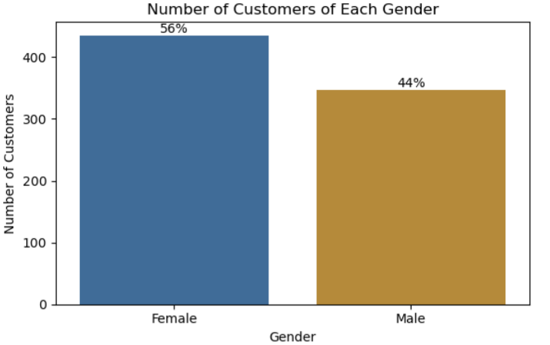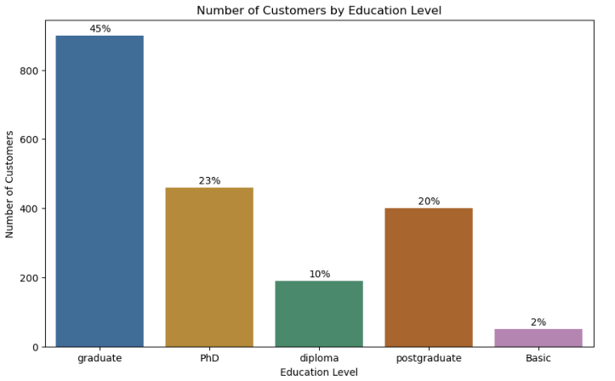

Figure 3: Spending score v loyalty points Figure 4: Income v loyalty points
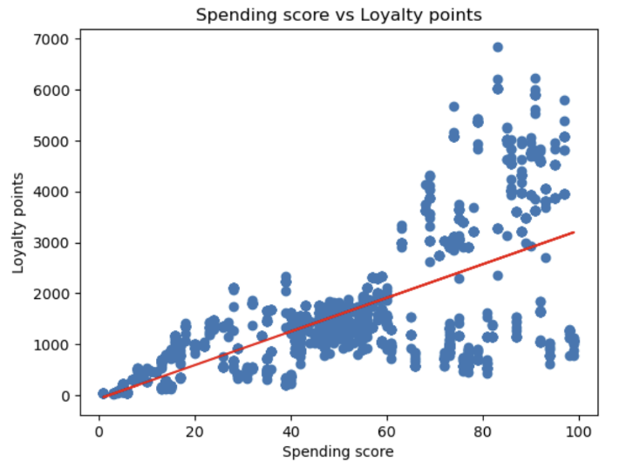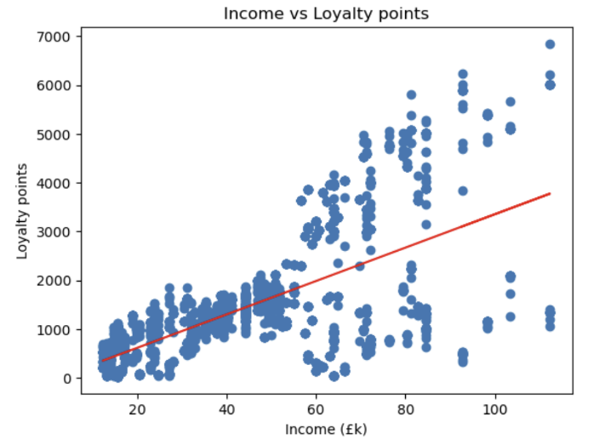

Scatter plots of ‘spending_score’ and ‘income’ against ‘loyalty_points’ showed broadly positive relationships with increasing spread at higher values, suggesting a generally linear relationship with some heteroscedasticity to investigate. A pair plot of all numeric columns confirmed that ‘income’ and ‘spending_score’ had the strongest visual relationships with ‘loyalty_points’, while ‘age’ showed weaker correlation.

2.2 Regression Analysis
The full 2,000-row dataset was used for regression to maximise statistical power. Baseline models were built using ‘age’, ‘income’, and ‘spending_score’ as predictors of ‘loyalty_points’. Multiple predictor combinations were tested before arriving at the final model. Residual plots were examined at each stage to assess model assumptions.

Python diagnostic testing:
- Residual plots showed broadly random scatter around zero, supporting the linearity assumption
- Some evidence of heteroscedasticity was observed at higher fitted values — addressed in R validation
- Final model produced R²=0.839–0.844 across Python and R independently

Figure 5: Residuals v Spending score
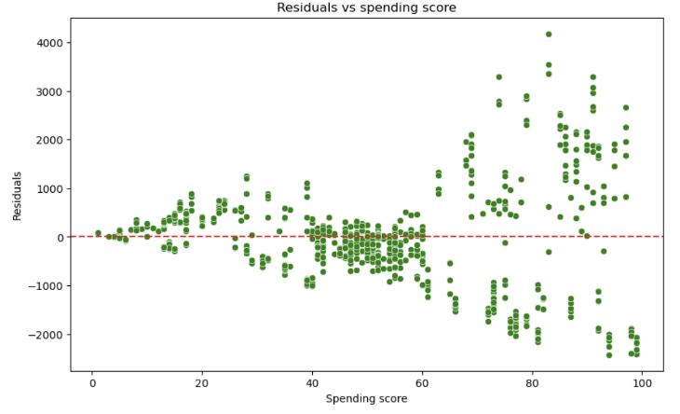

R statistical validation — full diagnostic suite applied:
- Shapiro-Wilk test (normality of residuals): assessed whether residuals followed a normal distribution - a core assumption of linear regression
- Breusch-Pagan test (heteroscedasticity): evidence of heteroscedasticity detected, meaning standard errors required adjustment
- HC3 robust standard errors: applied to correct for heteroscedasticity, producing reliable coefficient estimates and inference despite non-constant variance
- Multicollinearity assessment: confirmed ‘income’ and ‘spending_score’ did not produce problematic multicollinearity
- Train/test split: out-of-sample RMSE, MAE, and R² reported to assess genuine predictive performance rather than in-sample fit

The R validation confirmed the Python findings. ‘Income’ and ‘spending_score’ are the primary drivers of loyalty points. The linear model was selected as the recommended operational model on the basis of its performance (R²=0.839–0.844), interpretability, and diagnostic robustness.
Figure 6: Age, Spending score, Income, Product by Loyalty points – R analysis
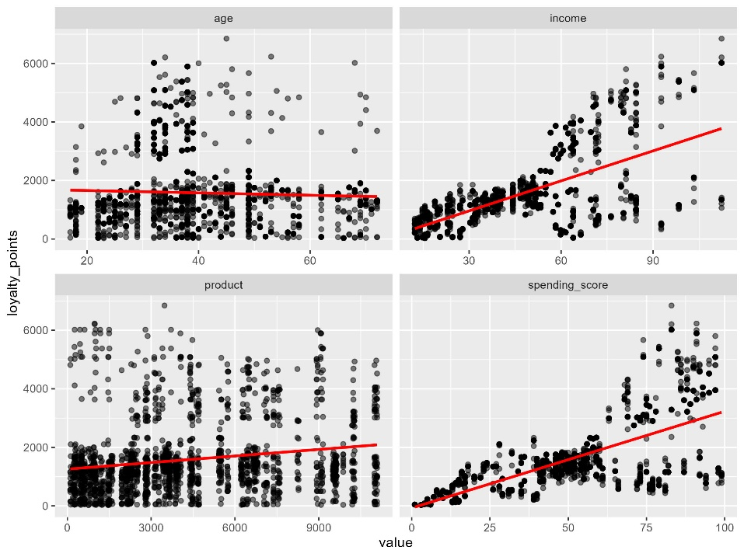

2.3 Decision Trees
Three decision tree models were built and evaluated using varying predictor combinations:
- Model A: ‘age’ and ‘spending_score’, ‘income’, ‘gender’, ‘education’ and ‘product’ as predictors
- Model B: ‘income’, ‘age’ and ‘spending_score’ as predictors
- Model C: ‘income’, and ‘spending_score’ as predictors

Figure 7: Decision tree model results
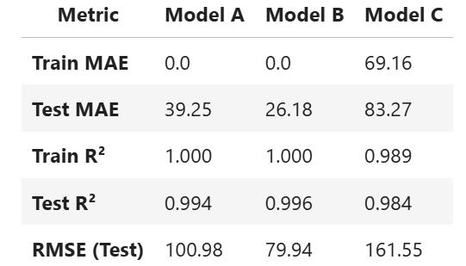

Each model was first trained as an unpruned tree. All three showed overfitting in unpruned form - strong training performance but degraded test performance. Model B was selected as the best all-round performer: the combination of ‘income’, ‘age’ and ‘spending_score’ produced the most stable results with the least overfitting.

Model B was then pruned to control overfitting. A range of max_depth values (2 through 8) were tested, evaluating RMSE on the test set at each depth. Max depth=3 was selected as the
Figure 8: Model B – Unproved v Pruned (What it means)
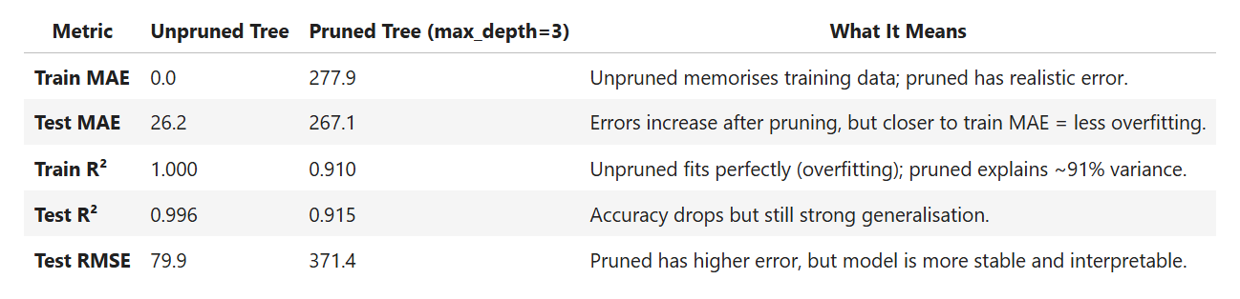

optimal value, thereby reducing overfitting while retaining sufficient complexity to capture the income/spending_score relationship with loyalty_points.

Figure 9: Model B – Unpruned and pruned decision tree
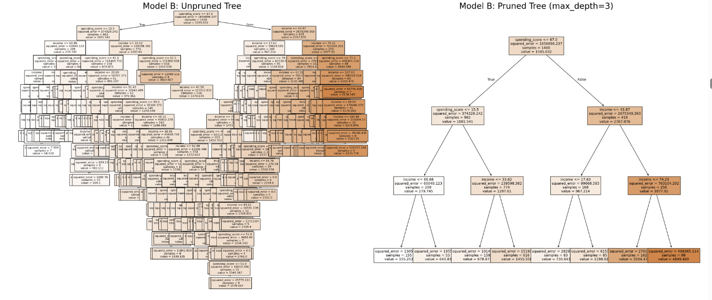

Feature importance analysis of the pruned Model B confirmed ‘income’ and ‘spending_score’ as the two dominant predictors. This is consistent with regression findings. Cross-validation of feature importance across two different model types strengthens confidence in these conclusions.

Figure 10: Feature Importance (the drivers of ‘loyalty_points’)
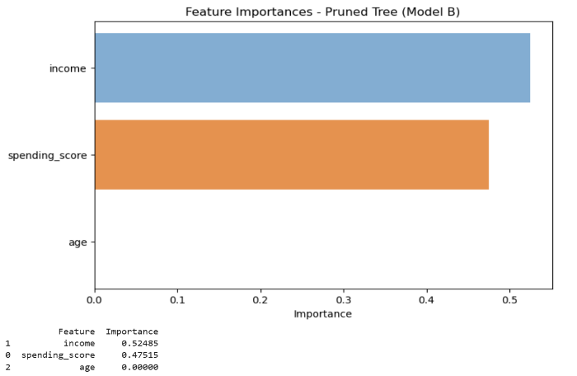
2.4 Random Forest
A Random Forest model was built using the same predictor set as Model B, with ‘age’ reintroduced to assess its contribution at the ensemble level. Random Forest aggregates predictions across multiple decision trees, reducing variance and overfitting risk compared to individual trees.
Key finding: at the ensemble level, ‘age’ emerged as a potentially useful additional predictor - not evident in the single decision tree model. This suggests age may capture non-linear interactions with’ income’ and ‘spending_score’ that simpler models miss. The Random Forest results broadly validated the decision tree and regression findings while adding nuance around age's potential contribution.

Figure 11: Feature importance comparison – Pruned tree vs Random Forest
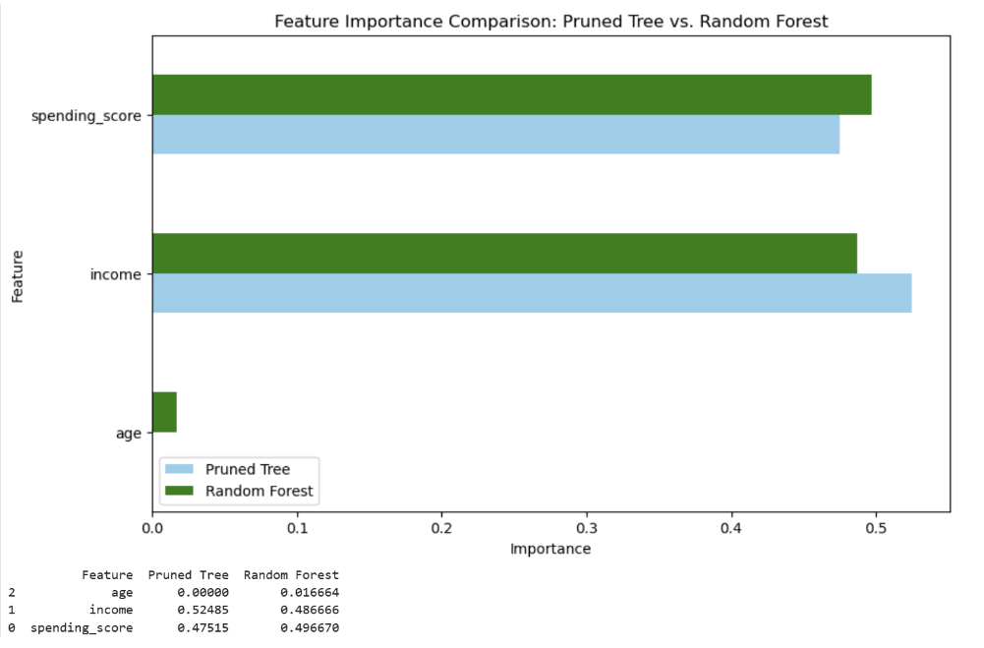
So How do each of the models compare and when should they be used?

Figure 12: OLS vs Decision tree vs Pruned tree vs Random forest
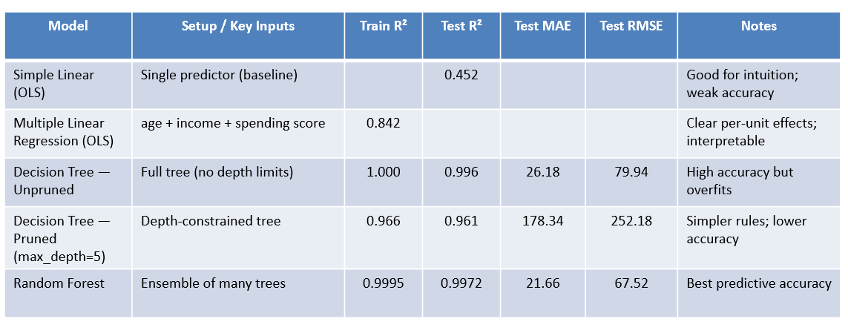

2.5 K-Means Clustering
K-Means clustering was applied in two stages to segment customers into meaningful groups.

Figure 13: Comparison of Elbow and Silhouette methods (k=5)
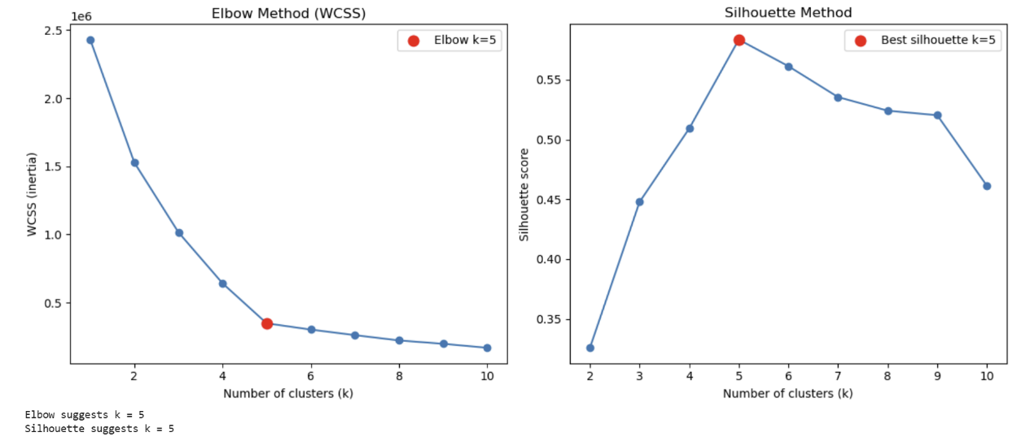
Stage 1: Two-variable model (income + spending_score):
Both the Elbow method (plotting within-cluster sum of squares against k) and the Silhouette method (measuring cluster separation quality) were applied across k values from 2 to 10. The Elbow plot showed a clear inflection point at k=5 and Silhouette scores confirmed k=5 as producing well-separated, meaningful clusters. Five distinct customer segments were identified with materially different ‘income’ and ‘spending_score’ profiles.

Figure 14: Final model showing clusters (k=5) – Income and Spending_score
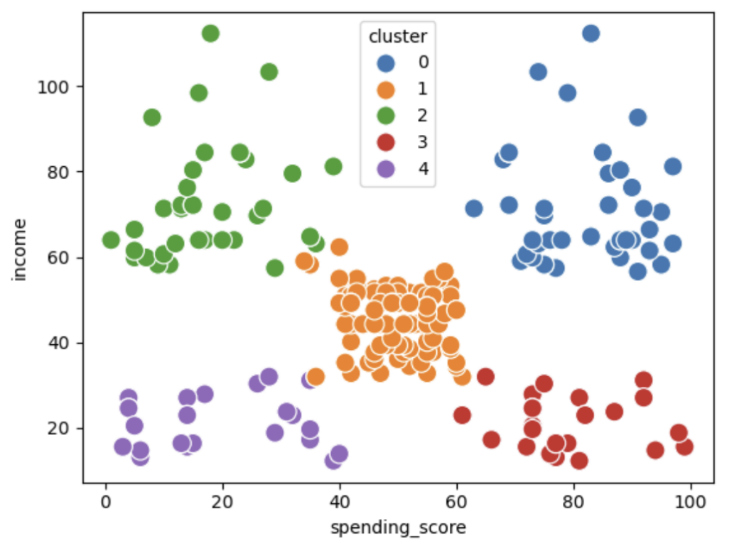

Figure 15: Customer distribution by cluster size
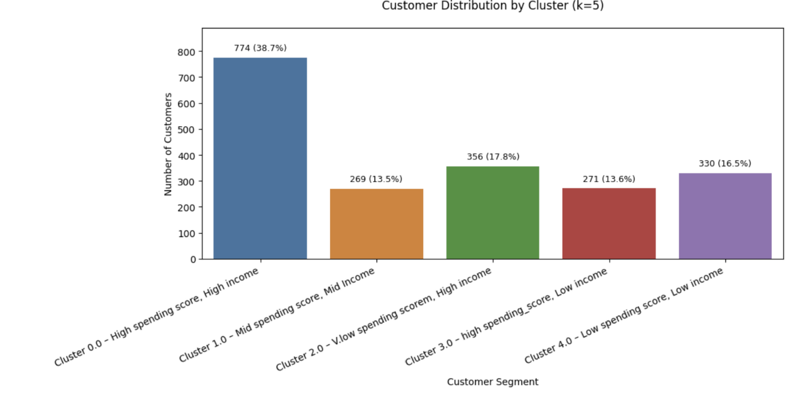

Figure 16: Segments with descriptions and key insights for business
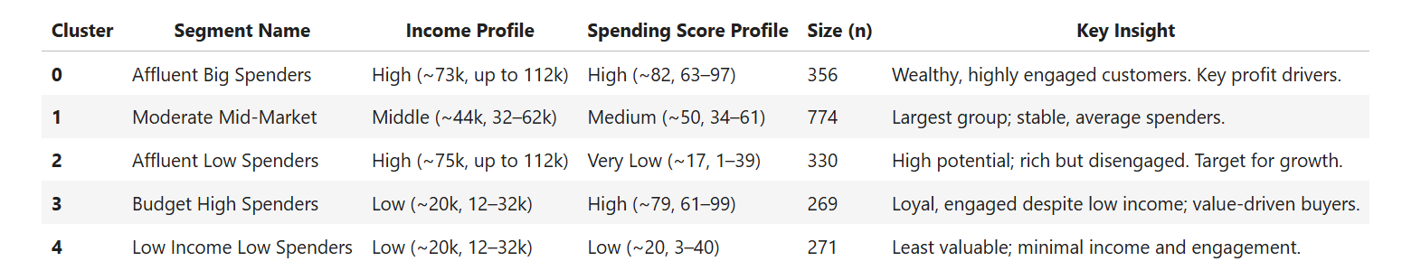

Figure 17: Comparison of Elbow and Silhouette methods (k=6)
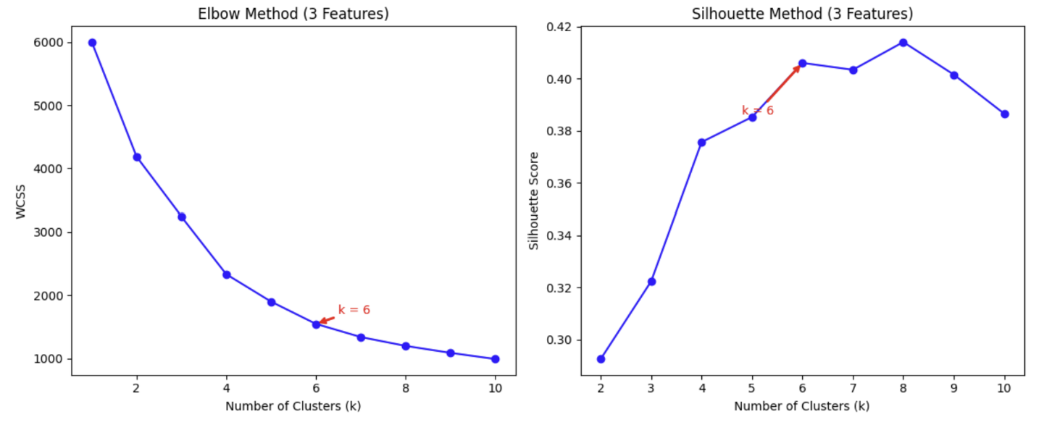

Stage 2: Three-variable model (income + spending_score + age):
‘Age’ was reintroduced as a third clustering dimension, and the Elbow and Silhouette methods reapplied. The optimal k shifted to 6, producing a 3D cluster model. Comparing the k=5 and k=6 models, the additional cluster introduced by adding age provided incremental segmentation detail at the cost of increased model complexity. The k=5 model was recommended for business use on the basis of clarity and actionability.

Figure 18: 3 Dimensions (Age, Income, Spending score) – k=6
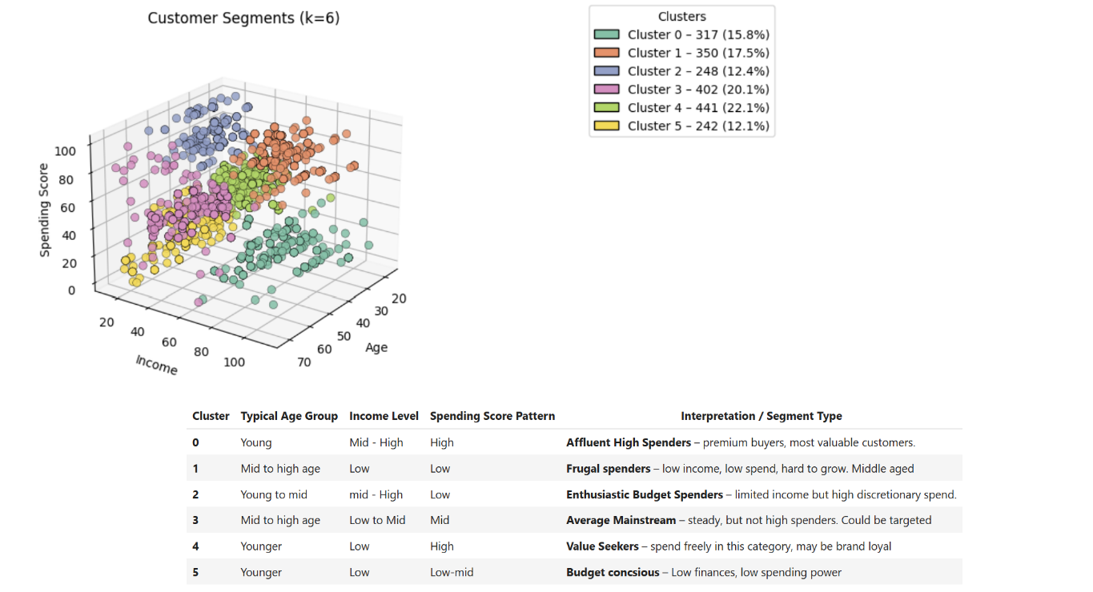

Figure 19: 3 Dimensions (Age, Income, Spending score) – k=5
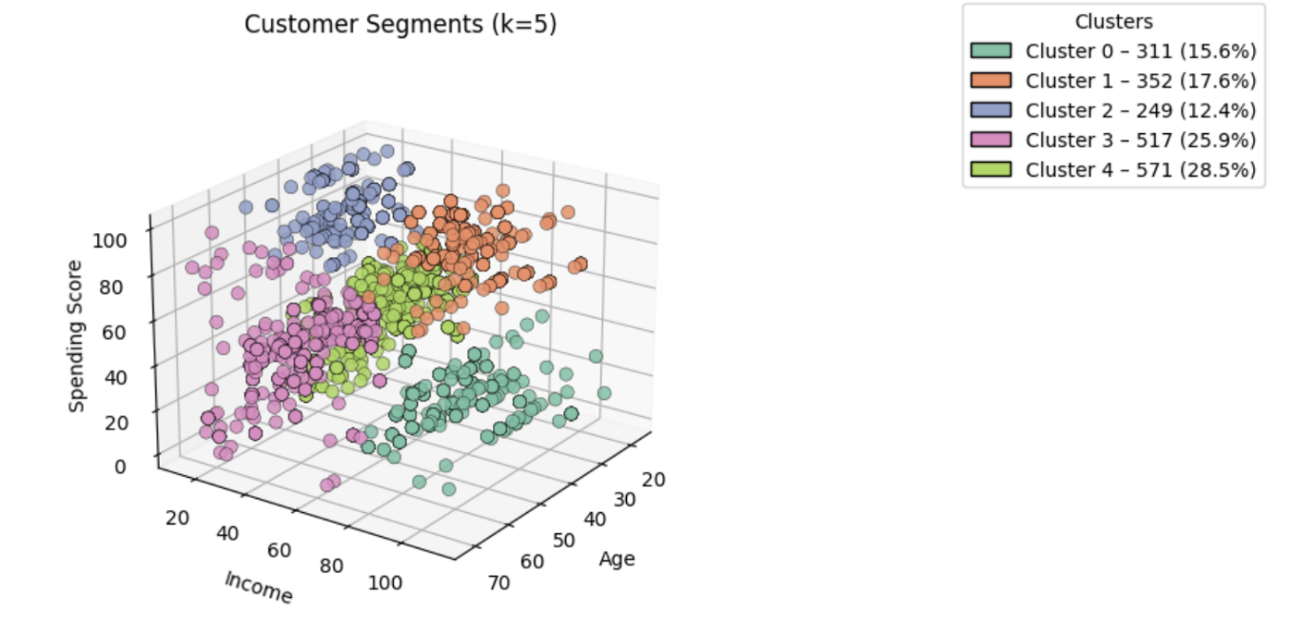

Figure 20: Comparison of k=5 and k=6


2.6 NLP Sentiment Analysis
Sentiment analysis was applied to all 2,000 customer reviews using a standard NLP preprocessing pipeline followed by polarity analysis.

Figure 21: ‘Review’ and ‘Summary’ word clouds – stop words removed
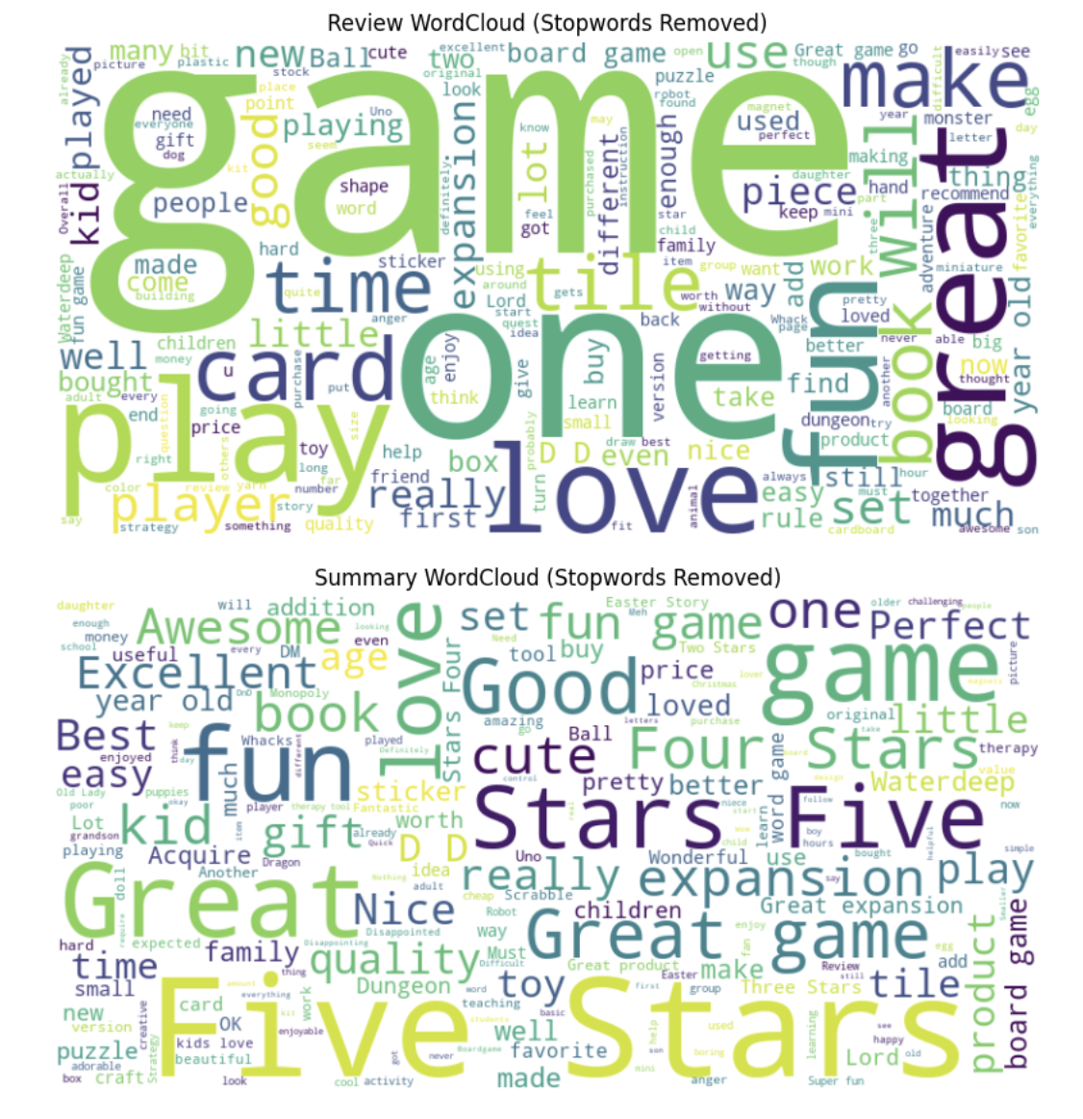
Preprocessing pipeline:
- Text converted to lowercase to standardise case
- Punctuation and numeric characters removed
- Stop words filtered using NLTK's English stop word list
- Text tokenised into individual words for frequency analysis

Analysis outputs produced:
- Word cloud: visual representation of most frequently occurring terms – game, family, fun, quality, and product-related terms dominated
- Most common words: top-n word frequency list identifying the core vocabulary of customer reviews
- Most used positive and negative words: separately ranked to identify specific experience themes
- Sentiment polarity histogram: TextBlob polarity scores plotted for all 2,000 reviews - distribution was right-skewed (skewed positive), confirming broadly satisfied customers

Figure 22: Top 15 most common words in ‘Reviews’ and ‘Summary’
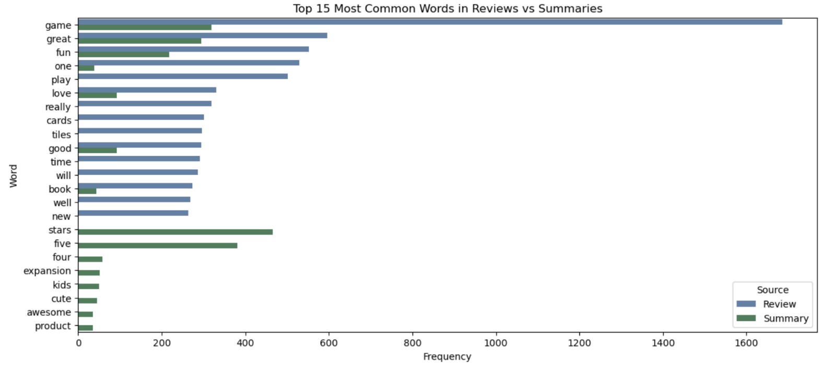

VADER polarity analysis was applied as a cross-check. VADER is specifically designed for social media and short-form text, making it well-suited to customer review data. Both TextBlob and VADER confirmed the predominantly positive sentiment pattern. The dominant negative themes were shipping failures and missing product components which accounted for a disproportionate share of negative polarity scores relative to their frequency, identifying them as the highest-priority operational improvement areas.

Figure 23: Sentiment polarity split
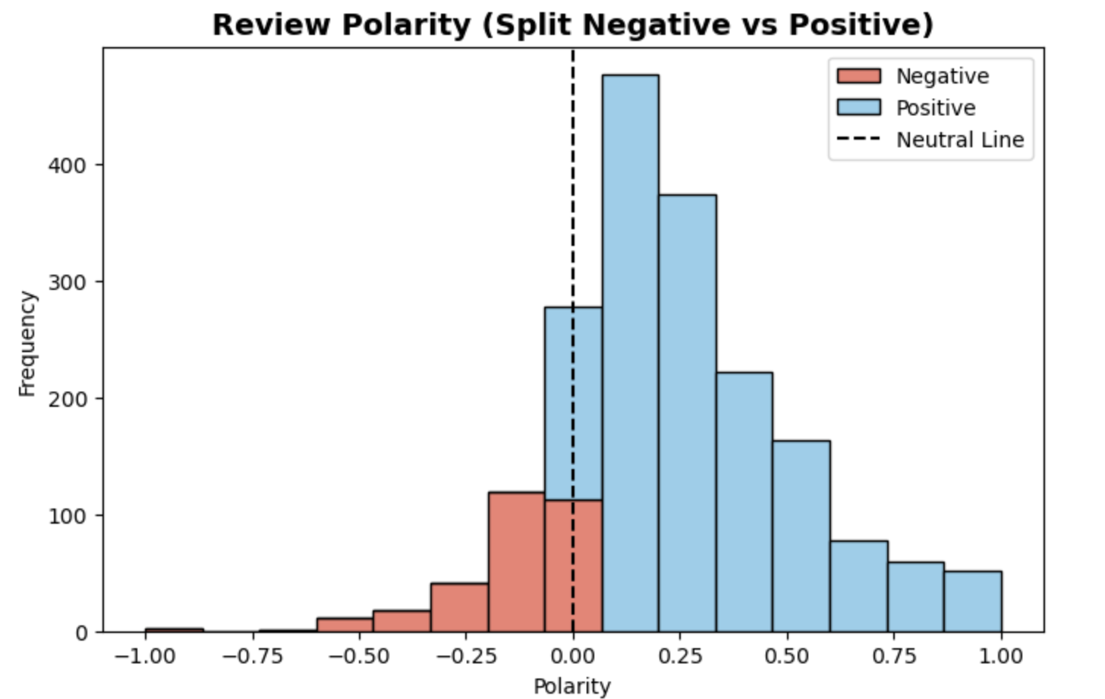

2.7 R Analysis
R was used for two complementary purposes: independent exploratory data analysis to validate and extend the Python findings, and rigorous statistical regression modelling with full diagnostic testing. The R analysis used the tidyverse, ggplot2, corrplot, moments, skimr, DataExplorer, car, lmtest, sandwich, and splines libraries.

Exploratory Data Analysis in R

EDA was conducted using a comprehensive set of visualisations and statistical tests to examine distributions, relationships, and outliers across the dataset.

A correlation matrix (corrplot) confirmed spending_score and loyalty_points as strongly correlated — consistent with the Python analysis — while age showed a weaker relationship, again confirming earlier findings.

Distribution analysis was conducted through histograms of all four numeric variables. The loyalty_points distribution was examined in two stages: the full distribution (right-skewed with a long upper tail) and a filtered view of customers with ≤2,000 points (n=1,735), revealing a more concentrated distribution with mean 1,022 and median 1,122. This two-stage approach surfaced the impact of high-value outliers on summary statistics.

Distributional testing was applied to loyalty_points:
Shapiro-Wilk test: W=0.843, p<2.2e-16 — confirmed the data does not follow a normal distribution
Skewness: 1.46 — confirmed right skew (majority of customers cluster at lower loyalty points with a tail of high-value outliers)
Kurtosis: 4.71 — above the normal distribution value of 3, indicating a heavy tail consistent with extreme outliers

Outlier identification using IQR fencing (1.5×IQR): Q1=772, Q3=1,751, IQR=979, upper fence=3,220. This identified 266 customers (13.3%) as outliers above the upper bound — the high-value segment with loyalty_points ≥3,200, confirmed as a strategically important group.

Demographic breakdowns were produced through boxplots examining loyalty points by education and gender, income and education, spending score by education and gender, and age by education and gender. These confirmed that gender plays a minimal role in loyalty outcomes across all demographic cuts — consistent with the Python analysis. Loyalty was also segmented into three categories (Low ≤Q1, Medium, High ≥90th percentile) with animated plotly scatter plots used to show how income and spending_score interact across loyalty categories.

Multiple Linear Regression in R

An 80/20 train/test split was applied (set.seed(42)) — 1,721 training rows, 279 test rows. The feature set used was: loyalty_points ~ age + income + spending_score.

Model results (MLR):
Intercept: -2,213 (mathematically expected given predictor ranges — loyalty points cannot be negative in isolation but the intercept reflects the model baseline)
spending_score coefficient: +34.17 loyalty points per unit increase (holding income and age constant)
income coefficient: +34.09 loyalty points per unit increase
age coefficient: +11.26 loyalty points per year
All predictors highly significant (p<2.2e-16) | R²=0.839 | RSE=518 points

Multicollinearity check (VIF): age=1.05, income=1.00, spending_score=1.05 — all well below 5, confirming no multicollinearity between predictors. Each predictor is independent of the others.

Diagnostic testing:
Shapiro-Wilk on residuals: W=0.99, p≈0 — residuals deviate from perfect normality. With a large sample (1,721 rows) this test is sensitive to minor deviations; the Q-Q plot and histogram of residuals were used alongside the formal test.
Breusch-Pagan test: BP=41.755, df=3, p=4.52e-09 — heteroscedasticity confirmed. A U-shaped pattern in the residuals vs fitted plot supported this finding, suggesting some non-linearity at the extremes.
HC3 robust standard errors applied to correct for heteroscedasticity. After correction all three predictors remain highly significant: spending_score (t=49.75, p<2.2e-16), income (t=41.14, p<2.2e-16), age (t=12.00, p<2.2e-16). Coefficient estimates are unchanged; standard errors are adjusted.

Spline model comparison:
A natural spline model was fitted (df=4 for spending_score and income; age kept linear) to test whether non-linear relationships would improve performance. Test-set results:
Linear (MLR): RMSE=488.948 | MAE=374.165 | R²=0.843
Splines (df=4): RMSE=488.074 | MAE=378.115 | R²=0.844
The spline model produced a marginal 0.18% improvement in RMSE but was 1.06% worse on MAE and negligibly higher on R². The linear model was selected as the final recommended model — it is substantially easier for non-technical stakeholders to interpret, carries lower overfitting risk, and its diagnostics are fully documented. The spline model does suggest some non-linearity may exist at the extremes of the predictor range, but the additional complexity is not justified at this sample size.

Baseline comparison:
The MLR model was compared against a naive baseline (predicting the training mean for all observations). Side-by-side scatter plots of actual vs predicted values confirmed the regression model substantially outperforms the baseline — the baseline produces a flat prediction line with no discriminative power, while the regression model clusters predictions around actual values, particularly at lower and mid-range loyalty point values.

Persona scenario analysis:
The model was applied to ten persona scenarios combining different levels of age, income, and spending_score to illustrate predicted loyalty points with 95% prediction intervals under realistic customer profiles. Key results:
High roller young (age 23, income £84k, spend 92): 4,048 predicted points → VIP programme
Older high spender (age 58, income £63k, spend 87): 3,532 predicted points → Retention & loyalty perks
Affluent average spender (age 38, income £80k, spend 50): 2,635 predicted points → Upselling & premium bundles
Young high spender (age 23, income £47k, spend 87): 2,593 predicted points → Youth-focused engagement
High income, low spend (age 38, income £80k, spend 13): 1,397 predicted points → Awareness & activation campaigns
Low income, low spend / Frugal older saver: 0 predicted points → Budget-friendly offers & retention

The scenario analysis demonstrates clearly that spending_score is the dominant lever for loyalty points accumulation, with income providing a secondary boost. The high income, low spend scenario — predicting only 1,397 points despite high income — confirms this directly and informs the recommendation to run targeted activation campaigns for this under-engaging segment.

The convergence of Python and R results (R²=0.839–0.844) across independent implementations, full diagnostic testing, and the spline comparison provides high confidence in the linear model's validity, robustness, and suitability for operational deployment.

Key Findings

1. Customer Demographics
The 782 unique customers span a broad demographic range. Gender split is 56% female, 44% male. Graduates form the largest education group; basic education the smallest. Age distribution is concentrated in the 29–40 range, with income spread more widely — a majority below £20k but with notable peaks around £40k and £70k suggesting distinct income bands.
No strong demographic variation was identified in purchasing or loyalty behaviour — income and spending score, not demographic characteristics, are the meaningful predictors.

2. Loyalty Points — Distribution & Prediction
Loyalty points are right-skewed, with 266 customers (13%) classified as high-value outliers with points ≥3,200. This premium segment warrants targeted investment.

Model | Performance & Notes
Linear Regression (Python + R) | R²=0.839–0.844 | RMSE and MAE within acceptable range | Residual diagnostics passed (Shapiro-Wilk, Breusch-Pagan, HC3) | Recommended for operational use
Decision Tree — Model B (pruned) | Max depth=3 | Best all-round performer across three models tested | Income and spending score confirmed as primary feature importance drivers
Random Forest | Built on Model B | Age emerged as a potentially useful additional predictor at ensemble level

The linear regression model is recommended for operational use — it communicates clearly to stakeholders, performs robustly (R²=0.839–0.844 across Python and R independently), and meets all statistical assumptions. The decision tree and Random Forest results support and validate the linear model's findings on feature importance.

3. Customer Segmentation — K-Means Clustering
K-Means clustering was applied using income, spending_score, and age. Elbow and Silhouette methods were used to determine optimal k. Two models were evaluated:
- k=5 (income + spending_score): Five distinct customer segments with clear value and engagement profiles
- k=6 (income + spending_score + age): Six segments in a 3D model — adds age dimension but increases complexity without proportionate insight gain

The k=5 model is recommended for business use. The five segments support differentiated marketing and retention strategies:

Segment Profile | Strategic Implication
High income, high spend | Premium VIP candidates — early access, exclusive events, tiered rewards
High income, low spend | High-potential — activation campaigns to convert income into engagement
Mid income, mid spend (largest) | Core segment (~40% of customers) — loyalty programme backbone, consistent engagement
Low income, high spend | Highly engaged — reward loyalty, protect retention
Low income, low spend | Lower priority for premium investment — monitor for churn signals

4. Customer Sentiment — NLP Analysis
Sentiment analysis was applied to 2,000 customer reviews using NLTK with TextBlob and VADER polarity scoring. Text was preprocessed: lowercased, punctuation and numeric characters removed, stop words filtered, and text tokenised.
Overall sentiment is skewed to the positive side — customers are broadly satisfied with Turtle Games' products. The dominant positive themes centre on quality, fun, and family-friendly experience. The dominant negative themes are:
- Shipping failures — delays, damaged packaging, incorrect deliveries
- Missing product components — pieces absent from board games or toys on arrival
These two pain points are operationally addressable and represent the clearest near-term opportunity to improve customer experience and reduce negative sentiment.

Recommendations

1. Adopt the Linear Model for Operational Use
- The linear regression model (R²=0.839–0.844) is robust, validated across Python and R independently, and communicates clearly to non-technical stakeholders. Implement for loyalty point prediction and customer value management.
- Monitor RMSE/MAE monthly and retrain as new data accrues — particularly if the customer base or product mix changes materially.

2. Activate High-Potential Customer Segments
- Run awareness and activation campaigns specifically targeting high-income, low-spend customers — this segment has the income to engage more but is not currently doing so.
- Introduce personalised bundles, cross-sell recommendations, and milestone rewards for mid-to-high spenders to increase frequency and basket value.
- Create a VIP track for outlier customers (≥3,200 loyalty points) — early access to new products, exclusive events, or tiered rewards to deepen engagement with the most valuable segment.

3. Address the Customer Experience Pain Points
- Prioritise shipping reliability and packaging quality — these are the dominant drivers of negative sentiment and are operationally fixable.
- Introduce quality control checks specifically for product completeness before despatch — missing components are a disproportionate source of negative reviews relative to their cost to prevent.
- Promote the family-friendly, quality-focused brand message in marketing — these are the themes customers most positively associate with Turtle Games.

4. Build on the Segmentation Framework
- Use the five-segment model to personalise marketing communications by segment — different messages, offers, and channels for each value profile.
- Track segment-level sentiment over time to identify whether improvements to shipping and product quality translate into measurable sentiment improvement.

Limitations

Limitation | Impact | Mitigation Applied
Small dataset (782 unique customers) | Limits generalisability of findings to wider customer population | Findings treated as directional; further data collection recommended
Spending score definition unknown | Cannot confirm what the score measures — limits interpretation of models using it as a predictor | Flagged throughout; spending score used as predictor while noting the definitional uncertainty
Loyalty points accrual method unknown | Limits understanding of what drives points accumulation at the transactional level | Analysis focused on patterns rather than mechanisms
Behavioural variables absent | Tenure, promotional exposure, seasonality, purchase frequency not available — likely material predictors | Highlighted as a key gap for future data collection
Product-level data limited | Product numbers in data cannot be decoded to categories — limits product-level analysis | Recommended for future data enrichment
Cross-sectional data only | No time dimension — trends, seasonality, and cohort behaviour cannot be assessed | Analysis scoped to pattern identification at a point in time

Further Analysis

The following extensions would materially improve the analytical value of this work:

- Longitudinal analysis — adding a time dimension to track how loyalty points, spending, and sentiment evolve; assess seasonality and cohort behaviour.
- Product-level sentiment analysis — decoding product numbers to categories to understand which product types generate positive and negative sentiment, and whether loyalty patterns vary by product category.
- Behavioural enrichment — incorporating purchase frequency, tenure, promotional exposure, and channel data to build a more complete picture of what drives loyalty.
- Churn prediction modelling — using the segmentation framework as a basis for identifying customers at risk of disengaging, enabling proactive retention intervention.
- A/B testing framework — testing the impact of targeted campaigns (VIP track, activation campaigns) against control groups to establish causal effectiveness rather than correlational association.
- Spending score definition — clarifying how the spending score is calculated would materially improve the interpretability of all models that use it as a predictor.

Repository Structure

Project files are available at: github.com/AndrewWillacy/Turtle-Games

File / Folder | Contents
turtle_reviews_clean.csv | Cleaned customer dataset (null values removed, columns renamed, customer_id added)
Turtle_Games_Python.ipynb | Python analysis notebook: EDA, regression, decision trees, Random Forest, K-Means, NLP sentiment
Turtle_Games_R.R | R analysis: EDA, multiple linear regression with full diagnostic testing, train/test evaluation
Technical_Report.pdf | This document
metadata.txt | Field descriptions for all dataset columns

andrew.willacy.data@gmail.com | github.com/AndrewWillacy | linkedin.com/in/andrewwillacy-572682347

