EGR 431

CONTROL SYSTEMS

  - Prepared for
  - Project #1 - PI Controller

  - Prepared By
  - Andrew Willis 774959

Instructor: Dr. Jonsup Park
Project Performed on:
March 16, 2026
Report Submitted on:
March 26, 2026
Contents
Objective 3
Introduction and Background Theory 3
Project Requirements and Procedure 4
Theoretical / Simulated / Calculated Data & Discussion 5
Conclusion 10
Appendix A – MATLAB CODE: 10
Appendix B – Hand Calculations: 13

Figure 1 - RL Circuit 3
Figure 2 - Control Diagram 4
Figure 3 - Step Info Results 5
Figure 4 - Percent Overshoot vs. Damping Ratio 6
Figure 5 - Simulink Diagram 7
Figure 6 - Full Scope Step Response Capture 8
Figure 7 - Overshoot Capture 9
Figure 8 - Settling Time Capture 10

Objective
The objective of this project was to design a proportional-integral (PI) controller for an RL circuit such that the closed-loop system meets specific performance requirements. The system was required to achieve a settling time of less than one second and a percentage overshoot of no more than 10% in response to a unit-step input. MATLAB and Simulink were used to model, analyze and validate system performance. Below is the circuit to be modeled:
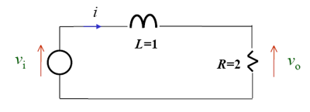
Figure 1 - RL Circuit

Introduction and Background Theory
Control systems are used to regulate the behavior of dynamic systems in order to achieve desired performance characteristics such as stability, speed of response, and minimal overshoot. In this project, a PI controller was designed for a first-order RL circuit. Below is the control diagram:
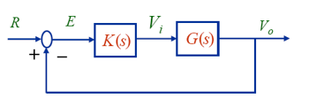
Figure 2 - Control Diagram

The transfer function of the RL circuit is given by, this is through circuit theory analysis:
$$G(s) = R / (Ls + R)$$
With L = 1H and R = 2Ω, this becomes:
$$G(s) = 2 / (s + 2)$$
A PI Controller has the form of:
$$C(s) = Kp + Ki/s$$
When applied in unity feedback, the closed loop transfer function becomes
$$\frac{(s2Kp+2Ki)}{(s^{2}+\left(2+2Kp\right)s+2Ki}$$
The denominator resembles a standard second-order system, which allows approximate performance analysis using damping ratio and natural frequency. However the presence of a zero introduced by the PI controller affects the transient response and must be considered.

Project Requirements and Procedure
Requirements:
- Settling Time Ts < 1 second
- Percent Overshoot $≤$ 10 %
Procedure:
- The damping ratio corresponding to 10% overshoot was estimated.
- The natural frequency was selected based on the settling time requirement.
- Controller gains were determined by matching the characteristic equation.
- MATLAB was used to compute gains and simulate the system.
- Simulink was used to model the system and verify results.
- Additional tuning was applied to compensate for the effect of the controller zero post-estimation

Theoretical / Simulated / Calculated Data & Discussion
Initial calculations using a damping ratio of approximately 0.591 resulted in a controller that produced higher than expected overshoot (~18%). This discrepancy arises because the closed-loop system contains a zero introduced by the PI controller, which is not accounted for in standard second-order approximations.
To compensate, the damping ratio was increased through tuning. This effectively increased $K_{p}$ while keeping $K_{i}$ fixed, reducing overshoot while maintaining acceptable settling time.
Simulation results confirmed that the tuned controller met both design specifications:
- Overshoot $≤$ 10%
- Settling time < 1 second.

Both MATLAB and Simulink results were consistent, validating the design approach. Below is the step info generated using MATLAB:
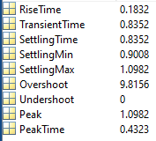
Figure 3 - Step Info Results
The selected point on the percent-overshoot-versus-damping-ratio curve represents the theoretical overshoot predicted by the standard second-order approximation. However, the actual closed-loop system includes a zero introduced by the PI controller, so the simulated overshoot differs from the theoretical curve. For this reason, the final overshoot was verified using the simulated step response and step info, which gave an overshoot of approximately 9.82%. Below is the theoretical selection from hand calculations:

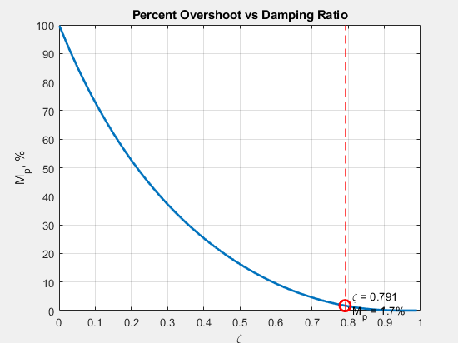
Figure 4 - Percent Overshoot vs. Damping Ratio

Initial simulation results in MATLAB showed that the resulting overshoot exceeded the 10% requirement. This discrepancy occurred because the closed-loop system includes a zero introduced by the PI controller, which is not accounted for in standard second-order approximations. To compensate for this effect, the damping ratio was increased through a tuning parameter, and the controller gains were recalculated. The final tuned values produced a response with acceptable overshoot and settling time. In Appendix A, the MATLAB Code is presented, as well as can be viewed on my personal GitHub: https://github.com/AndrewWillis7/Control-Systems-Projects/tree/main/RLSystem

See Appendix A for Code

Simulink was used to model the closed-loop control system and validate the controller design under more realistic simulation conditions. The system was constructed using a step input, a summation block for unity negative feedback, a PI controller block parameterized by the MATLAB-computed gains $K_{p}$and $K_{i}$, and a transfer function block representing the RL circuit. The output of the system was fed back to the summation block to complete the closed-loop system.
The controller gains were passed from MATLAB to Simulink using workspace variables, ensuring consistency between analytical calculations and simulation. The system response was logged using a “To Workspace” block, allowing the output data to be analyzed in MATLAB after simulation. The simulation was configured with an appropriate solver and time step to ensure sufficient resolution for accurately capturing the transient response. Below is the Simulink Diagram used:
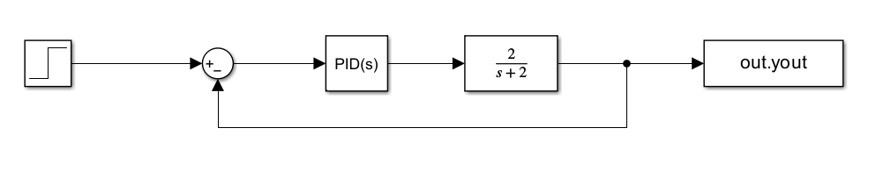
Figure 5 - Simulink Diagram

Figure 6 (Below) shows the complete step response of the closed-loop RL system as observed in Simulink using the Scope block. This plot provides a visual representation of the system’s transient and steady-state behavior in response to a unit step input. The response demonstrates that the system is stable and exhibits a well-damped behavior, reaching a steady-state value of approximately 1, which confirms zero steady-state error due to the presence of the integral term in the PI controller.
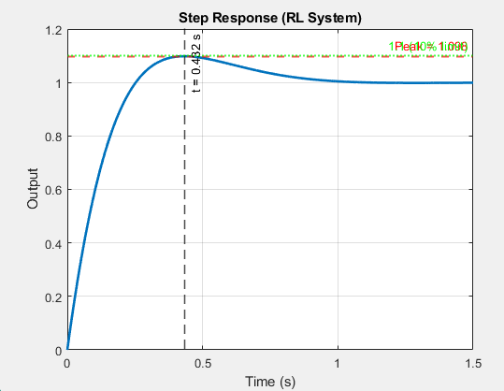
Figure 6 - Full Scope Step Response Capture
Figure 7 highlights the peak portion of the step response, which is used to determine the percent overshoot of the system. The maximum output value was observed to be approximately 1.0982, corresponding to a percent overshoot of about 9.82%. This value was calculated using the relationship:
$$\%OS=\frac{y_{peak}-y_{final}}{y_{final}}×100$$
Since the final value of the system is approximately 1 for a unit step input, the percent overshoot can be directly interpreted from the peak value. The measured overshoot is below the 10% requirement specified in the design criteria, confirming that the tuned controller successfully meets the overshoot constraint. This figure provides direct visual and numerical evidence that the system satisfies one of the key performance specifications. See Figure 7 below:

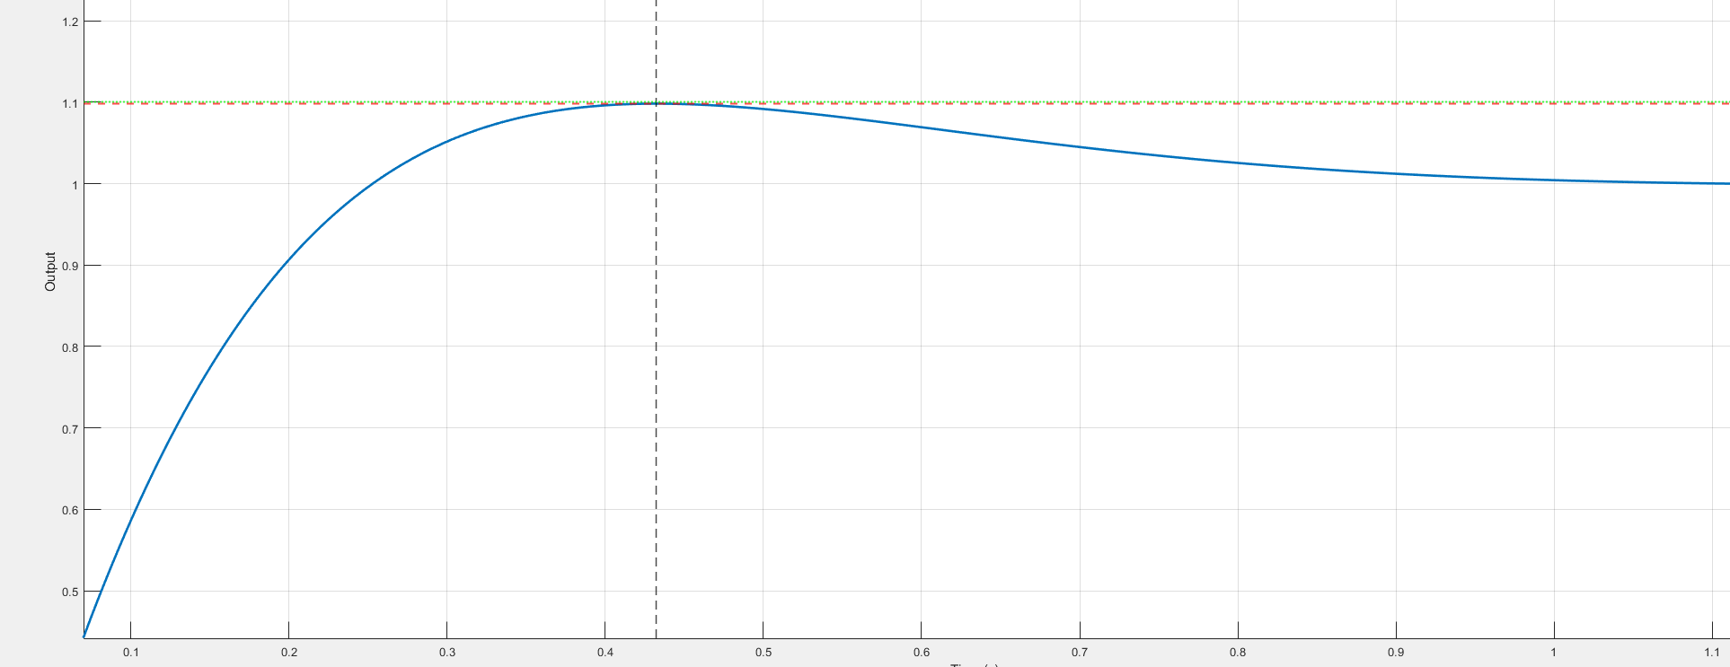
Figure 7 - Overshoot Capture

Figure 8 focuses on the settling portion of the step response and is used to determine the system’s settling time. The settling time is defined as the time required for the response to remain within a specified tolerance band (typically ±2%) around the final value. From the simulation results, the system settles within this band in approximately 0.835 seconds.
This value satisfies the design requirement that the settling time be less than 1 second. The plot demonstrates that after the initial transient oscillations, the system quickly converges to its steady-state value without sustained oscillations. This confirms that the chosen controller gains provide a sufficiently fast response while maintaining stability. Together with the overshoot results, this figure verifies that both primary performance requirements have been met. Below is Figure 8

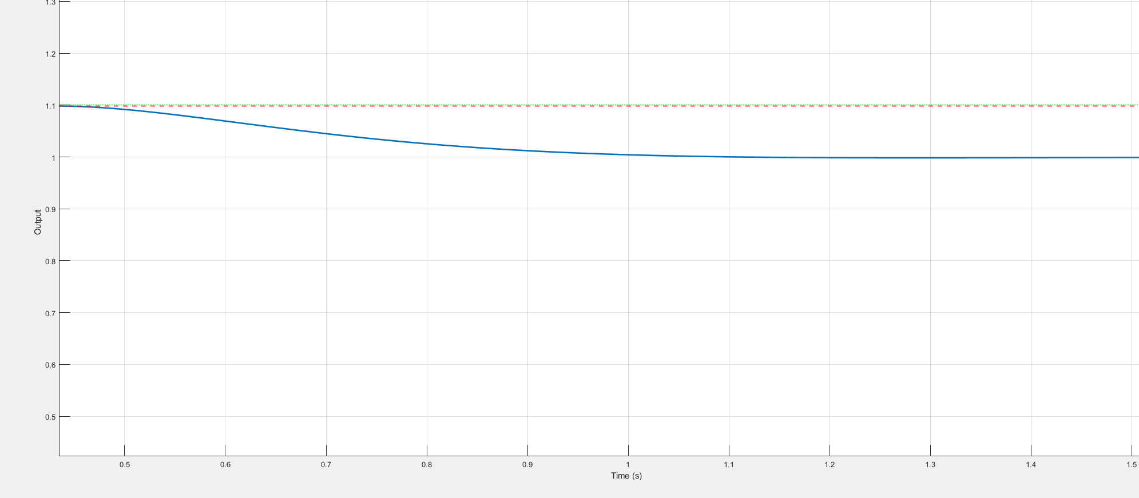
Figure 8 - Settling Time Capture

Conclusion
A PI Controller was successfully designed to meet the required performance specifications for the RL circuit. While theoretical calculations provided a strong starting point, simulation revealed the impact of system zeros on transient behavior. By applying tuning to the damping ratio, the system was adjusted to meet both overshoot and settling time requirements. This project highlights the importance of combining analytical design with simulation-based validation in control system development.

Appendix A – MATLAB CODE:
clc
clear;
close all;

%% RL Circuit tf
% G(s) = Vo(s) / Vi(s) = R / (Ls+R)
L = 1;
R = 2;

%% Design Specs
OS = 10; % Overshoot
Ts_req = 1; % Settling time must be under 1 second
tuning = 0.2; % Additional tuning value to zeta to bring overshoot down

%% Solve for damping ratio from overshoot
zeta = -log(OS/100) / sqrt(pi^2 + (log(OS/100))^2); % This is minimum, I can scale this with a constant gain for tuning
zeta = zeta + tuning;

%% Choose wn to satisfy Ts < 1 sec
% Ts ~= 4/(zeta*wn)
wn_min = 4/(zeta*Ts_req);

% choose a value a bit larger than minimum for margin
wn = 6;

%% PI Controller Design
% Characteristic Equation:
% s^2 + (2 + 2*Kp)s + 2*Ki = 0
% Match with s^2 + 2*zeta*wn*s + wn^2 (Derived from hand-calcs)

Kp = zeta * wn - 1;
Ki = wn^2 / 2;

fprintf('Kp = %.4f\n', Kp);
fprintf('Ki = %.4f\n', Ki);

%% Send Variables to base workspace
assignin('base', 'Kp', Kp);
assignin('base', 'Ki', Ki);

%% Run Simulink
model = 'sim';
disp(['About to simulate model: ', model]);

load_system(model);

% Simulation Time
simIn = Simulink.SimulationInput(model);
simIn = simIn.setModelParameter('StopTime', '5', 'MaxStep', '0.001');
simOut = sim(simIn);

%% Extract Data from Simulink
t = simOut.yout.time;
y = simOut.yout.signals.values;

info = stepinfo(y, t);
disp(info);

%% Plot in Matlab
figure;
plot(t, y, 'LineWidth', 2);
hold on;
grid on;

xlabel('Time (s)');
ylabel('Output');
title('Step Response (RL System)');

%% Find Peak Value
[ymax, idx] = max(y);
t_peak = t(idx);

%% Lines
yline(ymax, '--r', sprintf('Peak = %.3f', ymax), 'LineWidth', 1.5);
xline(t_peak, '--k', sprintf('t = %.3f s', t_peak), 'LineWidth', 1.2);
yline(1.1, ':g', '1.1 (10% limit)', 'LineWidth', 1.5);

%% Zoom to transient
xlim([0 max(1.5, 2*t_peak)]);

hold off;

%% Figure 2 - Theoretical Damping Ratio (10% overshoot)
zeta_range = linspace(0.001, 0.99, 1000);
PO_curve = 100 * exp((-zeta_range .* pi) ./ sqrt(1 - zeta_range.^2));

% selected theoretical point
zeta_sel = zeta;
PO_sel = 100 * exp((-zeta * pi) / sqrt(1 - zeta^2));

figure;
plot(zeta_range, PO_curve, 'LineWidth', 2);
hold on;
grid on;

% Labels
xlabel('\zeta');
ylabel('M_p, %');
title('Percent Overshoot vs Damping Ratio');

% Plot selected point
plot(zeta_sel, PO_sel, 'ro', 'MarkerSize', 10, 'LineWidth', 2);

xline(zeta_sel, '--r');
yline(PO_sel, '--r');

% Add annotation
text(zeta_sel + 0.02, PO_sel, ...
sprintf('\\zeta = %.3f\nM_p = %.1f%%', zeta_sel, PO_sel), ...
'FontSize', 10);

% Match axis limits
xlim([0 1]);
ylim([0 100]);

hold off;

Appendix B – Hand Calculations:
