EGR 431

CONTROL SYSTEMS

  - Prepared for
  - Project #2 – DC Speed Controller

  - Prepared By
  - Andrew Willis 774959

Instructor: Dr. Jonsup Park
Project Performed on:
April 7, 2026
Report Submitted on:
April 10, 2026
Contents
Objective 3
Introduction and Background Theory 3
Project Requirements and Procedure 3
Theoretical / Simulated / Calculated Data & Discussion 3
Conclusion 3
Appendix A – MATLAB CODE: 3
Appendix B – Hand Calculations: 3

Figure 1 - RL Circuit 3
Figure 2 - Control Diagram 4
Figure 3 - Step Info Results 5
Figure 4 - Percent Overshoot vs. Damping Ratio 6
Figure 5 - Simulink Diagram 7
Figure 6 - Full Scope Step Response Capture 8
Figure 7 - Overshoot Capture 9
Figure 8 - Settling Time Capture 10

Objective
The objective of this project was to analyze and compare the performance of an armature-controlled DC motor under both open-loop and closed-loop control configurations. The focus was to evaluate the effect of a disturbance torque on motor speed and to investigate how feedback control can reduce or eliminate this effect. MATLAB and Simulink were used to model the system, simulate its response, and analyze steady-state behavior and disturbance rejection characteristics.

Introduction and Background Theory
Control systems are used to regulate dynamic systems and improve performance in the presence of disturbances. A disturbance is an unwanted input that negatively affects system output. One of the primary advantages of feedback control is its ability to reduce the impact of such disturbances and maintain desired system behavior.
In this project, an armature-controlled DC motor is analyzed. The system consists of both electrical and mechanical dynamics, which are described respectively:
$$Ea​(s)=(L_{a}​s+R_{a}​)I_{a}​(s)+K_{b}​ω_{m}​(s)$$
$$(J_{m}​s+B_{m}​)ω_{m}​(s)=K_{i}​I_{a}​(s)-T_{L}​(s)$$
By eliminating the armature current, the motor speed can be expressed as:
$$ω_{m}(s)=\frac{K_{i}E_{a}(s)-(L_{a}s+R_{a})T_{L}(s)}{(J_{m}s+B_{m})(L_{a}s+R_{a})+K_{i}K_{b}}$$
This system can be separated into two transfer functions:
Voltage-to-speed:
$$G_{v}(s)=\frac{K_{i}}{(J_{m}s+B_{m})(L_{a}s+R_{a})+K_{i}K_{b}}$$
Disturbance-to-speed:
$$G_{d}(s)=-\frac{L_{a}s+R_{a}}{(J_{m}s+B_{m})(L_{a}s+R_{a})+K_{i}K_{b}}$$
In the open-loop configuration, the system operates without feedback, and disturbances directly affect the output. In the closed-loop configuration, feedback is introduced using a sensor and amplifier gain, allowing the system to correct deviations from the desired speed.
The closed-loop disturbance transfer function becomes:
$$\frac{ω_{m}(s)}{T_{L}(s)}=-\frac{L_{a}s+R_{a}}{(J_{m}s+B_{m})(L_{a}s+R_{a})+K_{i}K_{b}+K_{a}K_{s}K_{i}}$$
The additional term in the denominator increases system gain and improves disturbance rejection.

Project Requirements and Procedure

Requirements
- Analyze the effect of a disturbance torque on motor speed
- Apply a step disturbance of 0.1 Nm at $t=2$seconds
- Simulate system response for:
  - Open-loop: $E_{a}=10$, $E_{a}=20$
  - Closed-loop: $ω_{mref}=0$, $ω_{mref}=140$
- Evaluate system performance for different controller gains:
  - $K_{a}=5$, $K_{a}=40$, $K_{a}=100$
- Determine steady-state error due to disturbance
- Compare open-loop and closed-loop performance

Procedure
- The electrical and mechanical equations of the DC motor were derived.
- The armature current was eliminated to obtain a transfer function relating motor speed to both input voltage and disturbance torque.
- The system was separated into voltage-to-speed and disturbance-to-speed transfer functions.
- A Simulink model was developed for the open-loop system using these transfer functions.
- A step disturbance torque of 0.1 Nm was applied at $t=2$seconds.
- Simulations were performed for $E_{a}=10$and $E_{a}=20$, and steady-state values were recorded.
- The model was extended to include feedback, forming a closed-loop system using a sensor gain $K_{s}$and controller gain $K_{a}$.
- Simulations were performed for multiple reference speeds and controller gains.
- MATLAB was used to extract simulation data, calculate steady-state values, and compare system performance.
- Results from open-loop and closed-loop configurations were analyzed and interpreted.

Theoretical / Simulated / Calculated Data & Discussion

Part A – Open-Loop Behavior
The open-loop system was simulated to evaluate the effect of a disturbance torque on motor speed. A step disturbance of 0.1 Nm was applied at $t=2$seconds.
For $E_{a}=10$, the motor reached an initial steady-state speed of approximately 125 rad/s. After the disturbance was applied, the speed decreased to approximately 110 rad/s, resulting in a steady-state change of about:
$$Δω≈-15\text{ rad/s}$$
For $E_{a}=20$, the motor reached an initial steady-state speed of approximately 250 rad/s. After the disturbance, the speed decreased to approximately 235 rad/s, again resulting in a similar change of:
$$Δω≈-15\text{ rad/s}$$
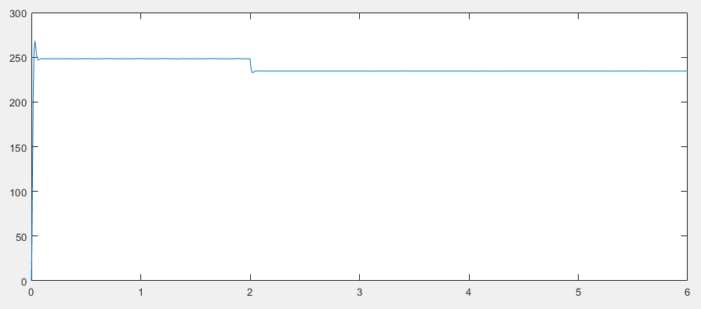
These results show that while the steady-state speed scales with input voltage, the disturbance effect remains approximately constant. This indicates that the disturbance response is independent of input magnitude in an open-loop system.
Additionally, once the disturbance is applied, the system settles to a new steady-state value without recovering. This demonstrates that open-loop systems lack the ability to compensate for disturbances, resulting in a permanent steady-state error.

LEAVE ROOM FOR PART B

Comparison and Interpretation
A direct comparison between open-loop and closed-loop performance highlights the advantages of feedback control. In the open-loop system, disturbances caused a permanent reduction in motor speed, regardless of input voltage. In contrast, the closed-loop system actively corrected for disturbances and maintained the desired speed.
The addition of feedback introduces a corrective mechanism that continuously adjusts the input to minimize error. As a result, the system becomes significantly more robust to disturbances.
Both MATLAB and Simulink results were consistent, validating the theoretical model and demonstrating the effectiveness of feedback control.

Conclusion
This project demonstrated the behavior of a DC motor under both open-loop and closed-loop control conditions. In the open-loop configuration, disturbances caused a permanent reduction in speed, and the system was unable to recover due to the absence of feedback. The disturbance effect was shown to be independent of input voltage, highlighting a key limitation of open-loop control.
In contrast, the closed-loop system significantly improved performance by reducing the effect of disturbances and minimizing steady-state error. Increasing the controller gain further enhanced disturbance rejection, allowing the system to maintain the desired speed even in the presence of external loads.
Overall, this project highlights the importance of feedback in control systems and demonstrates how closed-loop control can effectively regulate system behavior and improve robustness in practical applications.

Appendix A – MATLAB CODE:
%% Model Parameters

function p = params()
p = struct();

%% DC Motor Parameters
p.Kb = 0.0772;
p.Ki = 0.067;
p.Ra = 0.7454;
p.La = 4.8e-3;
p.Jm = 6.87e-5;
p.Bm = 0.0003;

%% Controller / Sensor
p.Ks = 1;
p.Ka = 5;

%% Disturbance
p.TL_step = 0.1;
p.Td = 2;

%% Inputs (default)
p.Ea = 10;
p.wm_ref = 140;

%% Simulation
p.tstop = 6;

p.den = [p.Jm * p.La, ...
p.Jm * p.Ra + p.Bm * p.La, ...
p.Bm * p.Ra + p.Ki * p.Kb];

p.num_v = [p.Ki];
p.num_d = [-p.La, -p.Ra];

%%%%%%%%%%%%%%%%%%%%%%%%%%%%%%%%%%%%%%%%%%%%%%%%%%%%%%%%%%%%%%%%%

clc
clear;
close all;

%% Load Parameters
p = params();

%% Modify
p.Ea = 20;

%% Simulink
model = 'sim_open';

simIn = Simulink.SimulationInput(model);
simIn = simIn.setVariable('params', p);
simIn = simIn.setModelParameter('StopTime', num2str(p.tstop));
simOut = sim(simIn);

t = simOut.wm.Time;
wm = simOut.wm.Data;

info = stepinfo(t, wm);
disp(info);

plot(t, wm);

Appendix B – Hand Calculations:

