Installation Instructions  
  
Prerequisite to building project:  
Download java jdk 1.8 from oracle.com [jdk-8u281-windows-x64.exe](https://www.oracle.com/java/technologies/javase/javase-jdk8-downloads.html#license-lightbox)

1. Download and install Github Desktop   
   https://desktop.github.com/
2. Clone the repository  
   Once you have installed github desktop, you want to permit github desktop to access your repository. Just follow the instructions after you install github desktop.  
   Clone the last option on right.  
   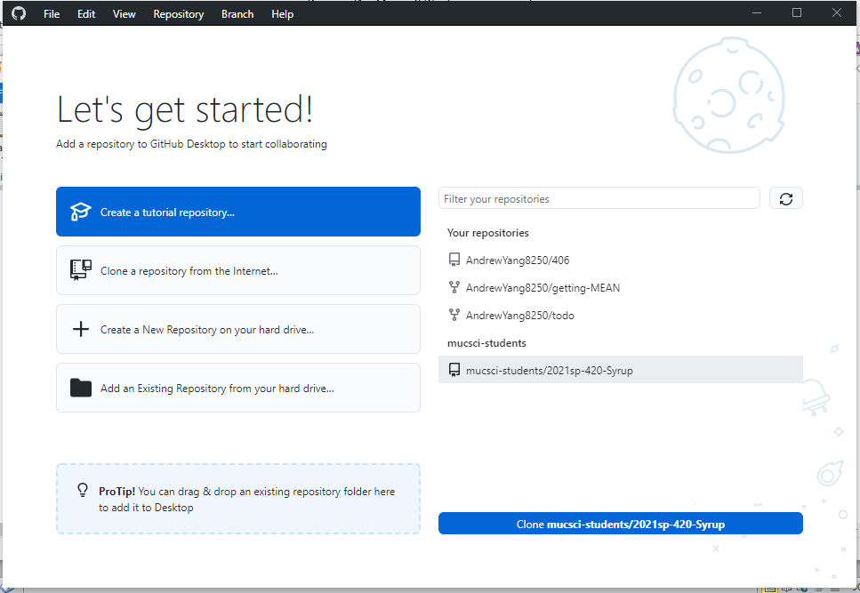  
   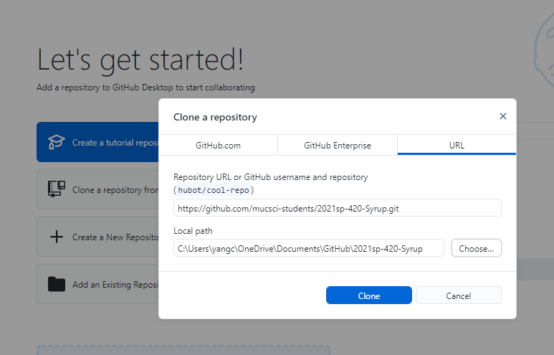  
   Choose the folder where you want to install your project. Then click ‘Clone.’
3. After you clone the repository, you want to create your branch.  
     
   Go to github webpage and create a branch (ex: uml-andrew)  
   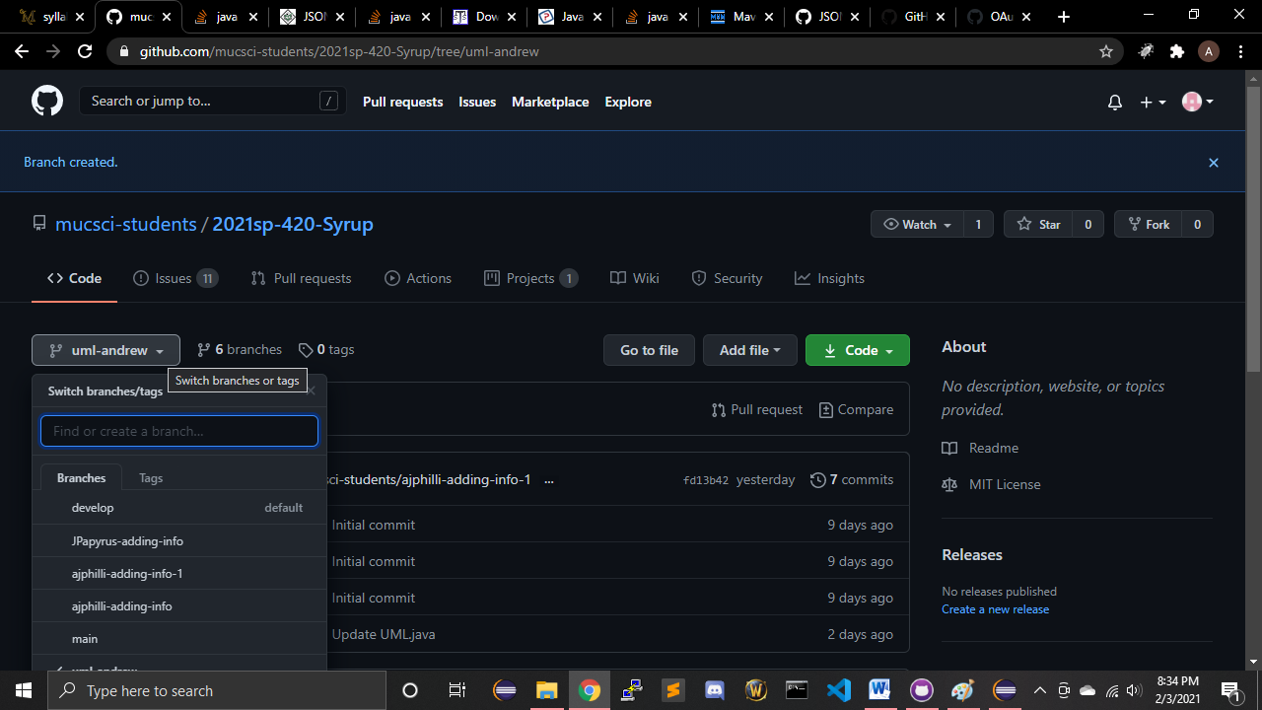  
   Once you create your branch, using github desktop, *Fetch Origin,* then select your branch. DO NOT WORK ON *develop* BRANCH!!!   
   Now you have your own branch on which to work!
4. In eclipse, you want to click on *white space* in project manager and do Import  
   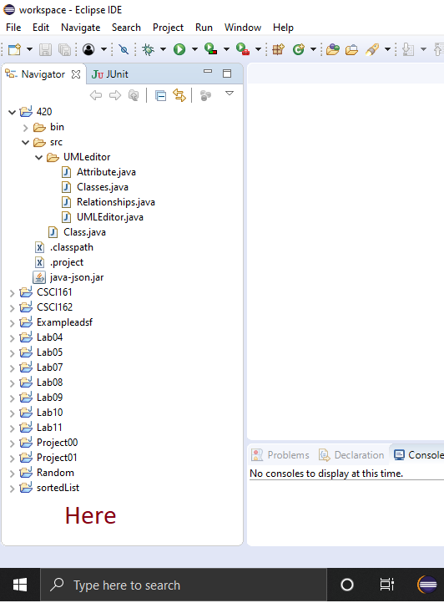  
   Select Maven -> Existing Maven Projects -> Next  
   Browse to folder you saved the cloned repository  
   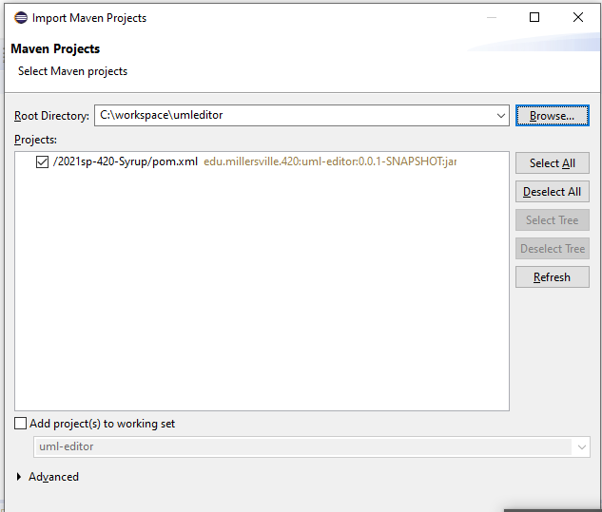  
   Your project should be imported into eclipse.
5. How to build your project  
   Right click your project from the Project Manager in eclipse  
   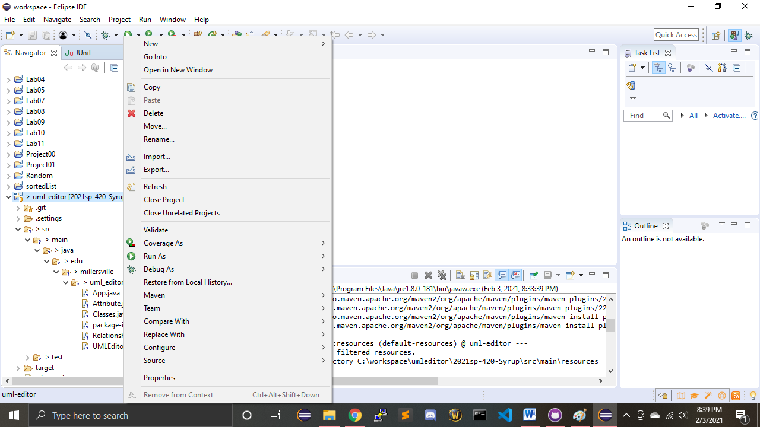  
   Select *Run As* or *Debug As* -> Maven build  
     
   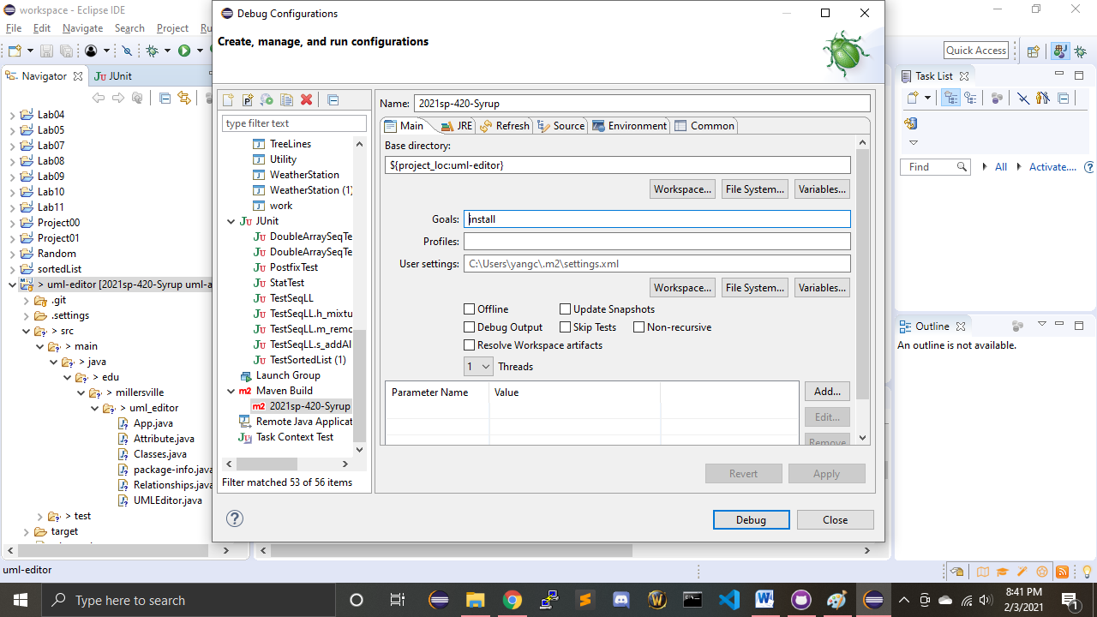  
   Under goals type *Install* and click Debug/Build (depending on whether you chose Run As or Debug As).
6. Learn how to use basic Git commands  
   Committing your code changes to your branch: Add Summary and Descrip, then click Commit To *branch*.   
   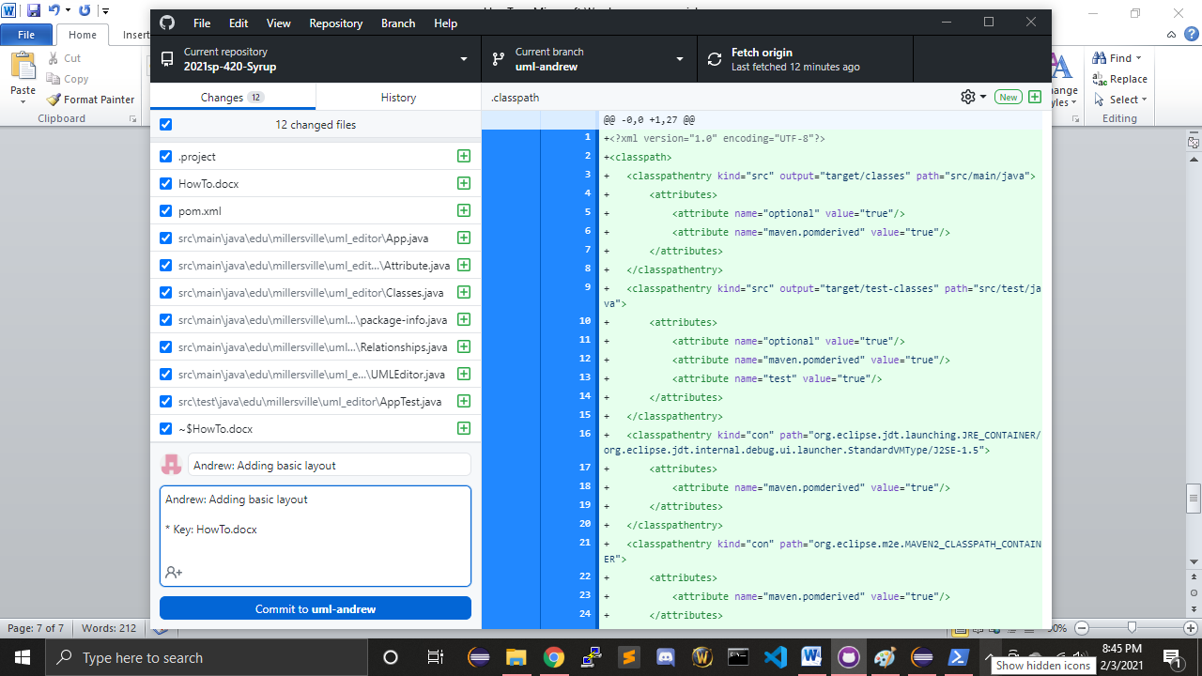  
   Then click Push Origin (far right) to push the changes to your branch in github.com.  
   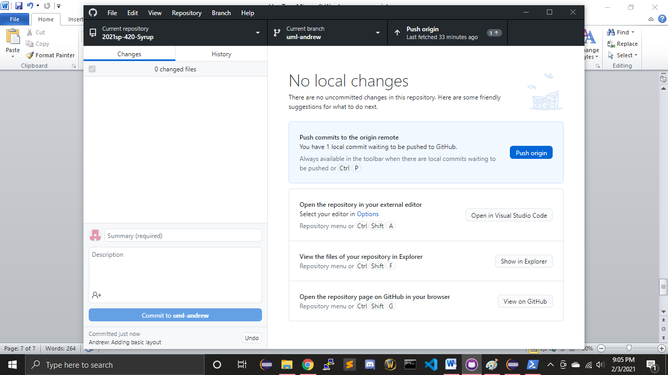
7. Then you create a Pull Request (PR). And the team reviews the code. Once is has passed review, then the code can be merged(Squash/Merge) into the *develop* branch.
8. You’re done with installation. Get to work!