Question 1)

a) A CPU instruction set is a set of commands and operations the computer processor can perform. It is important in programming as it allows for the use of programming languages, which are instructions written in a more user-friendly language, to instruct the machine to perform complex operations.

b) The principal properties distinguishing higher and lower level languages are as follows:

Higher level languages are primarily more user-friendly and is very different to the instruction set. Since the instructions written must be compiled to CPU instructions, it has a slower execution. By contrast, there is less ‘compilation’ in lower level languages as they resemble the instruction set, this allows for much faster execution but at the cost of writing in a language that is less semantic to its linguistic counterpart.

c) C++ fits in the category of an intermediate level language as it has high level components as it is relatively readable by the user, with other high level features such as cross-platform support with other languages and a vast library base but equally it also borrows low level components, namely in fast execution speed.

**END OF QUESTION 1**

Question 2)

ai) The largest numeric value that **float length** can store is +/- 3.4 x 10+/-38

aii) The largest numeric value that **double hyperfine_frequency** can store is +/- 1.7 x 10+/-308

aiii) The largest numeric value that **unsigned int size** can store is 4294967295

aiv) The largest numeric value that **long long bigInt** can store is between 9223372036854775808

av) The largest numeric value that **unsigned long counter** can store is 4294967295

bi) *Whether a switch is open*:

The variable type suitable for this is a **bool** as a boolean takes either of the two values: True (switch is open) or False (switch is not open).

bii) *The mass of an electron*:

The variable type suitable for this is a **float** since the mass of an electron has a magnitude of 10-31 and the maximum range for a float variable is 10+/-38.

biii) *The height of the highest point of Founder’s*:

The variable type suitable for this is a **float** as a measurement using measuring tape/calculating the height by timing the fall of a heavy mass would give a numerical value of up to two decimal points.

biv) *12!*

The variable type suitable for this is an **int** as a factorial outputs an integer (12! = 479001600) and this is well within range of both signed and unsigned int.

bv) *The title of a book*

The variable type suitable for this is a **string** because a title of a book is most likely composed of multiple characters strung together.

**END OF QUESTION 2**

Question 3)

Below is a copy of the code from the problem sheet, with comments provided by myself:

double badCode()

{

int numberA=1; // << no indentation after curly brackets

double numberB=5.3;

int numberA+=numberB // << missing a semi-colon (;) AND redefinition of variable 'numberA' not possible

return numberA;

}

Below is EDITED code, with new comments, now possible for compiling:

double badCode() // not so bad anymore, perhaps?

{

int numberA=1; // now with indentation

double numberB=5.3;

numberA+=numberB; // here the 'int' declaration is omitted and the semi-colon included

return numberA;

}

**END OF QUESTION 3**

Question 4

a) Below is a screenshot of Question 4a.

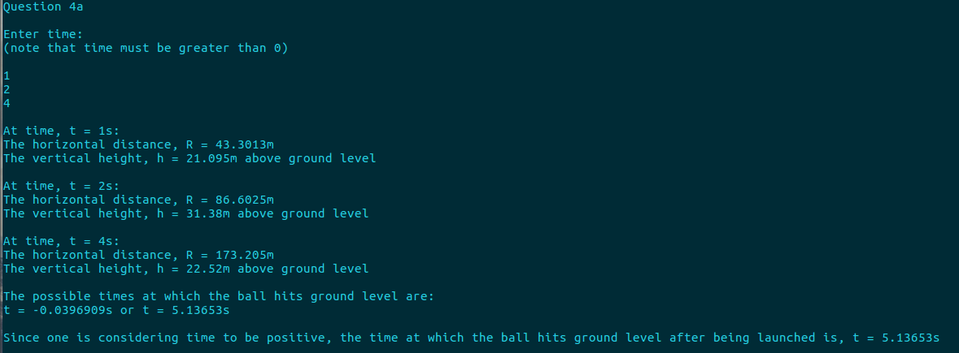

c) Below is a screenshot of Question 4c.

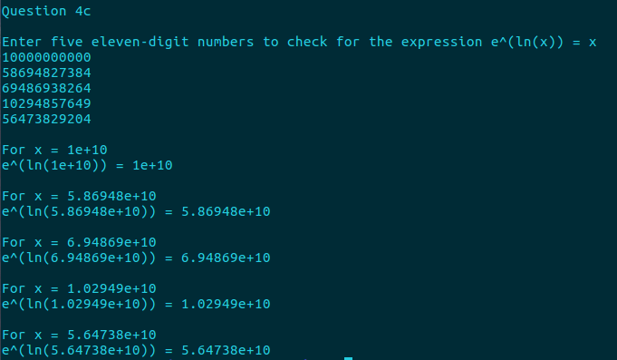

**END OF QUESTION 4**