CS 143 HW#1

Zhouyang Xue

104629708

PART I

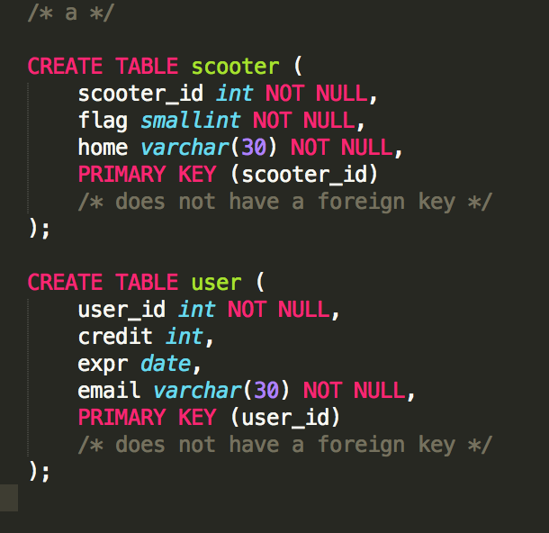

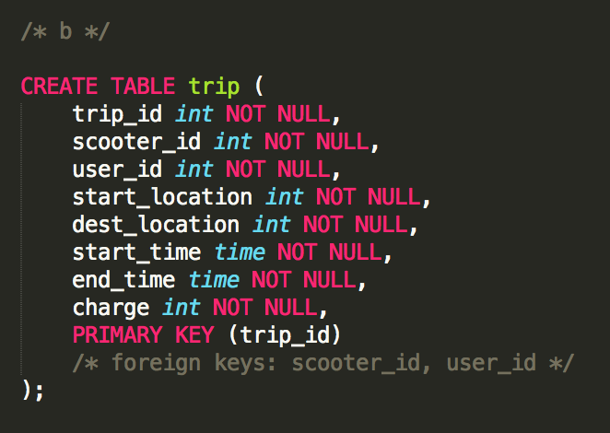

1. Insert & Edit

* Pros: Beneficial for real-time data analysis. Once a USER picks up a SCOOTER, the data is updated. If the TRIP last for a long time, the table would not be updated until the end of the TRIP, which compromises the accuracy of real-time analysis (such as hourly trends, etc.).
* Cons: This approach is not efficient. Editing existent tuple causes overhead of searching and inserting.

Caching

* Pros: Efficient. Each tuple is only inserted once, after all data is finalized.
* Cons: It doesn’t help real-time data analysis, because a TRIP is only added to the table after the TRIP is over. This approach is also less reliable, because the data of the TRIP is temporarily cached on the user’s phone. If something happened that caused data loss, it takes extra effort to restore the data of the trip. Moreover, since the data is cached on the server side, there are security issues to consider.

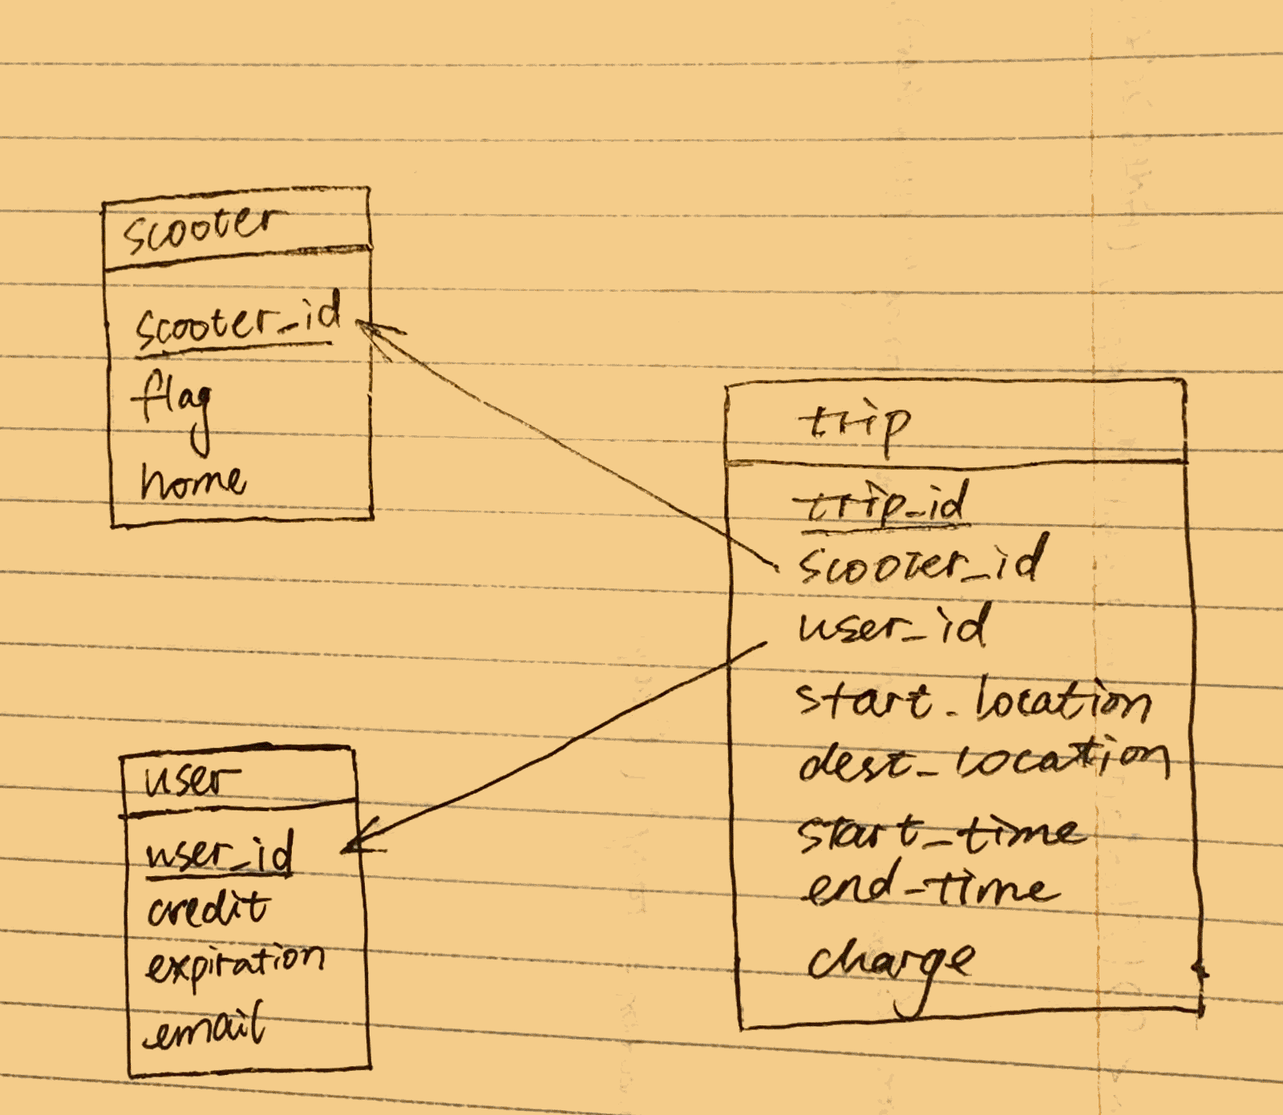

EXTRA:

1. I would not, because I already stored the starting time and ending time of the TRIP. The duration can be simply calculated. It would be a waste of space to include this information again.
2. If the price doesn’t follow a constant formula, keeping the charge would be necessary, because it cannot be easily calculated with other information. Also, it is always safer to keep a merchant copy of charges of each trip just in case.

PART II

