Zhouyang Xue

104629708

HW#4 CS143

**PART I**

1. The decomposition is not lossless because the dependencies CD -> E and B -> D are lost.

C and D are not in the same relation. Neither are B and D.

1. C -> A

C -> B

1. A) Yes

E -> A & A -> BC => E -> ABCE

E -> ABC & B ->D => E -> ABCDE

B) Yes

B -> D => BC -> BCD

BC -> BCD & CD -> E => BC -> E

Since E is a key, BC is also a key.

1. R is not BCNF.

A -> BCDE, F -> F => superkey: AF

None of A, C, or B is a candidate key, therefore R is not BCNF.

Decomposition:

A -> BCDE:

R1 (A, B, C, D, E); R2 (A, F)

C -> E:

R1 (A, B, C, D); R2(C, E); R3(A, F)

B -> D:

R1 (A, B, C); R2(B, D); R3(C, E); R4(A, F) – FINAL

1. (a, b1, c1, d2); (a, b1, c1, d3); (a, b2, c2, d1); (a, b2, c2, d3); (a, b3, c3, d1); (a, b3, c3, d2)
2. R is not 4NF, because neither of the left side of the multivalued dependencies are candidate keys.

To normalize R, we first decompose R into BCNF:

AB -> E:  
R1(A, B, E); R2(A, B, C, D, F)

R1(A, B, E) is BCNF but not 4NF:

A ->> B:

R3(A, B); R4(A, E)

R2(A, B, C, D, F) is BCNF but not 4NF:

AB ->> C:

R5(A, B, C); R6(A, B, D, F)

Therefore, the normalized 4NFs are:

R3(A, B); R4(A, E); R5(A, B, C); R6(A, B, D, F)

**PART II**

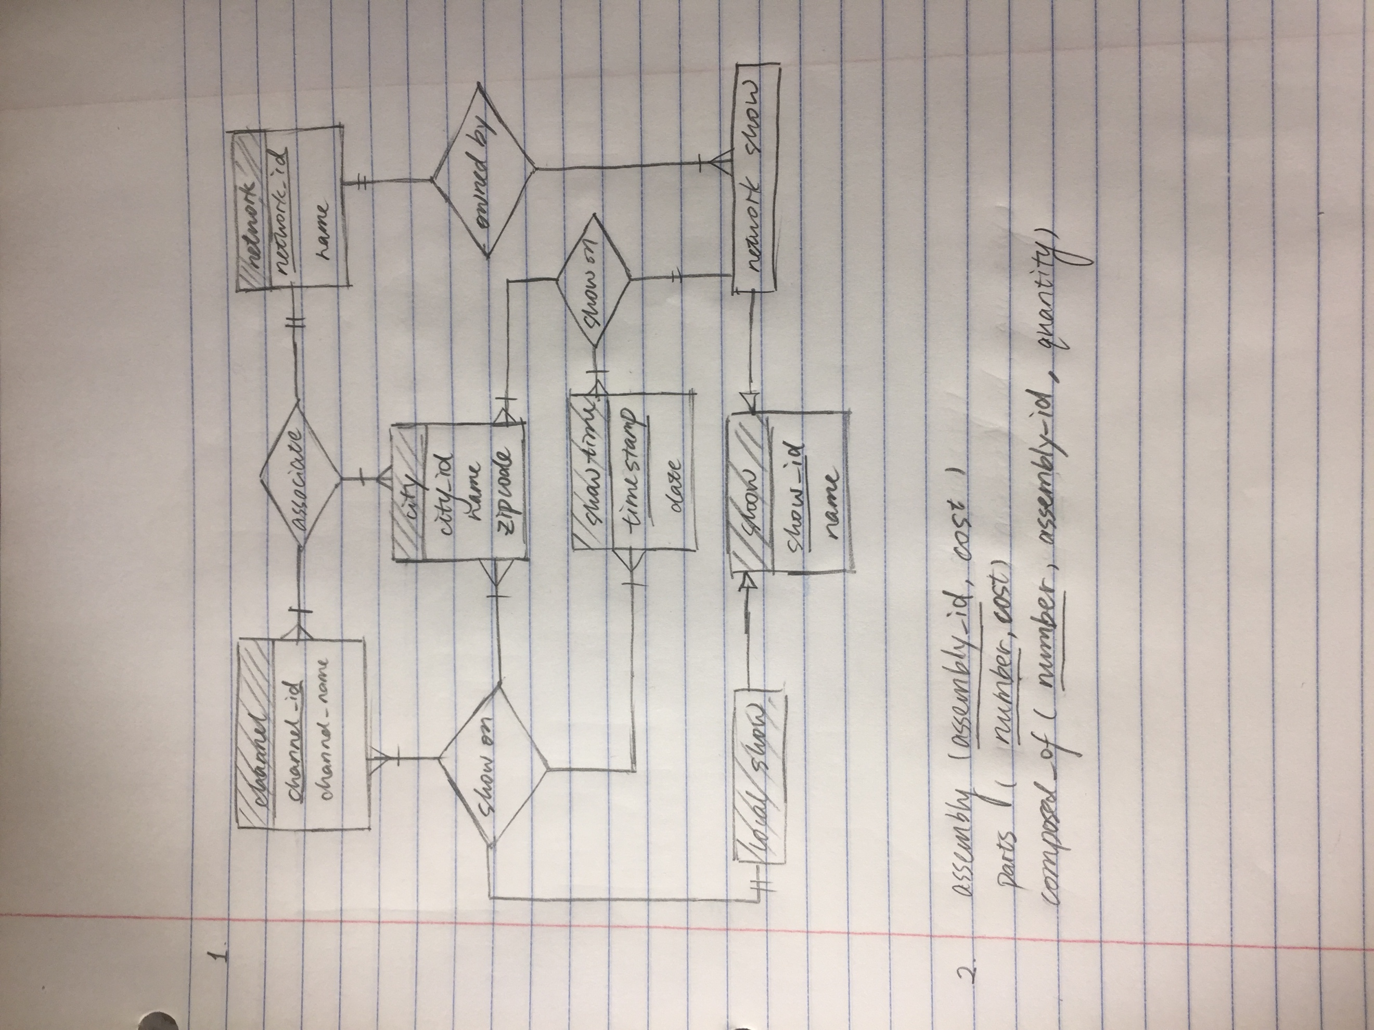

**PART III**



