- Creating debug configuration in NuEclipse.
- Go to Eclipse menu->Run->”Debug Configuration”
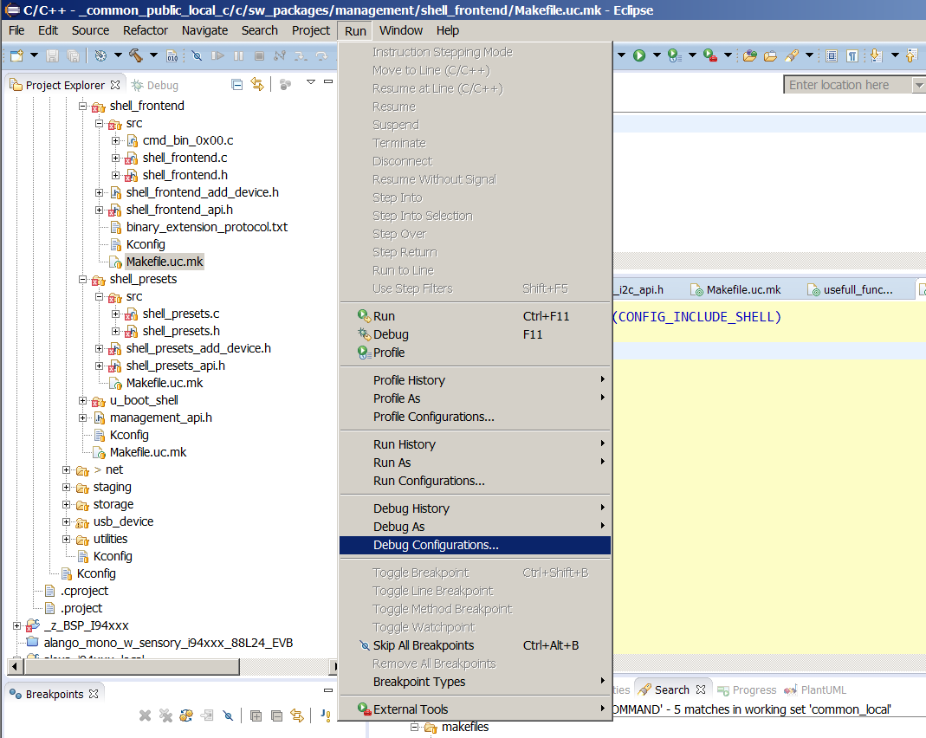

- Right click on “GDB Nuvoton Nu-Link Debugging” and select ‘New’.

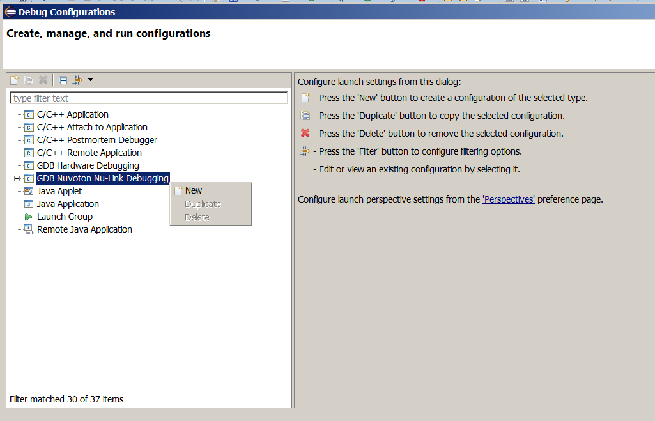

- Main tab:
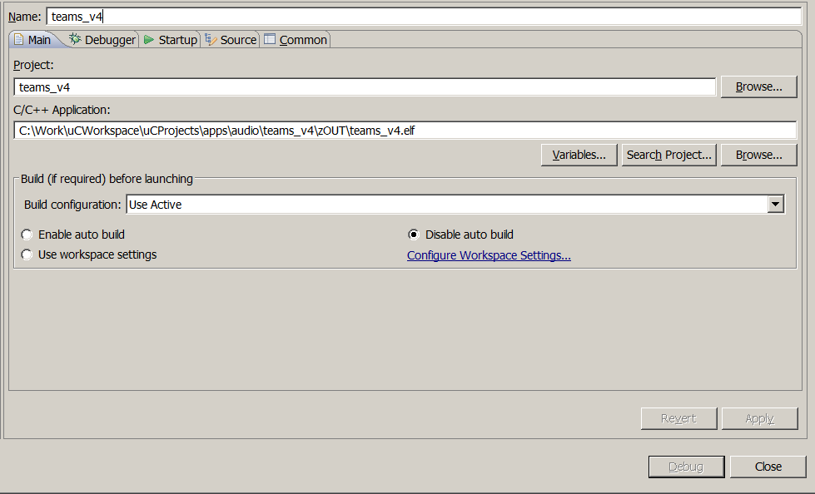
- Select some name for configuration.
- In ‘Project field press ‘Browse...’ and select the project you want to debug.
- In “C/C++ Application” put path to the output .elf file of you compilation. Usually the output located in $(YOUR_APP)/zOUT/ folder.

- Debugger tab:
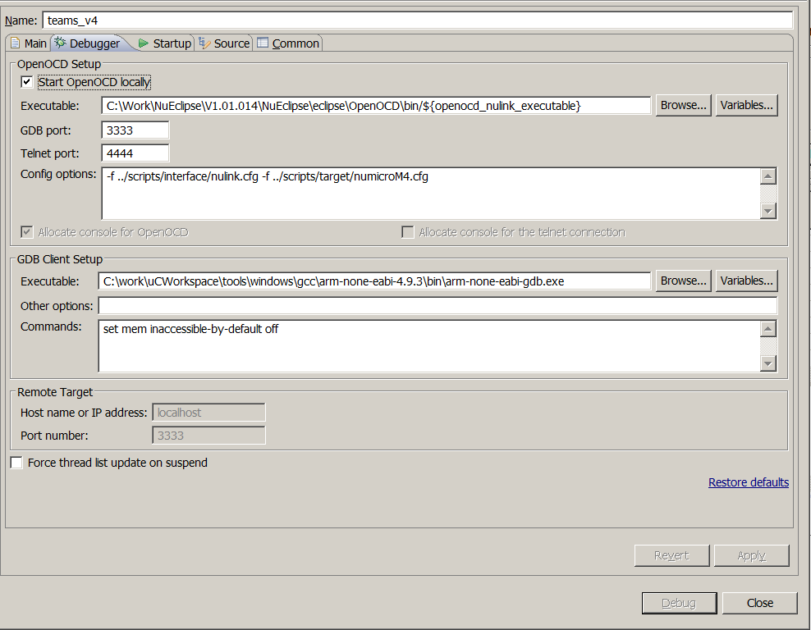
- Select ‘Start OpenOCD Localy’
- In OpenOCD ‘Executable:’ make sure that path points to openocd.exe executable.
- GDB port : 3333
- Telent por: 4444
- Config options:
select proper configuration based on your target SOC:
M4 : -f ../scripts/interface/nulink.cfg -f ../scripts/target/numicroM4.cfg
M0 : -f ../scripts/interface/nulink.cfg -f ../scripts/target/numicroM0.cfg

- In GDB Client Setup
a. Executable: IMPORTANT! You have to select gdb from compiler package that you used to compile the project.
b. Commands: set mem inaccessible-by-default off

- Startup tab
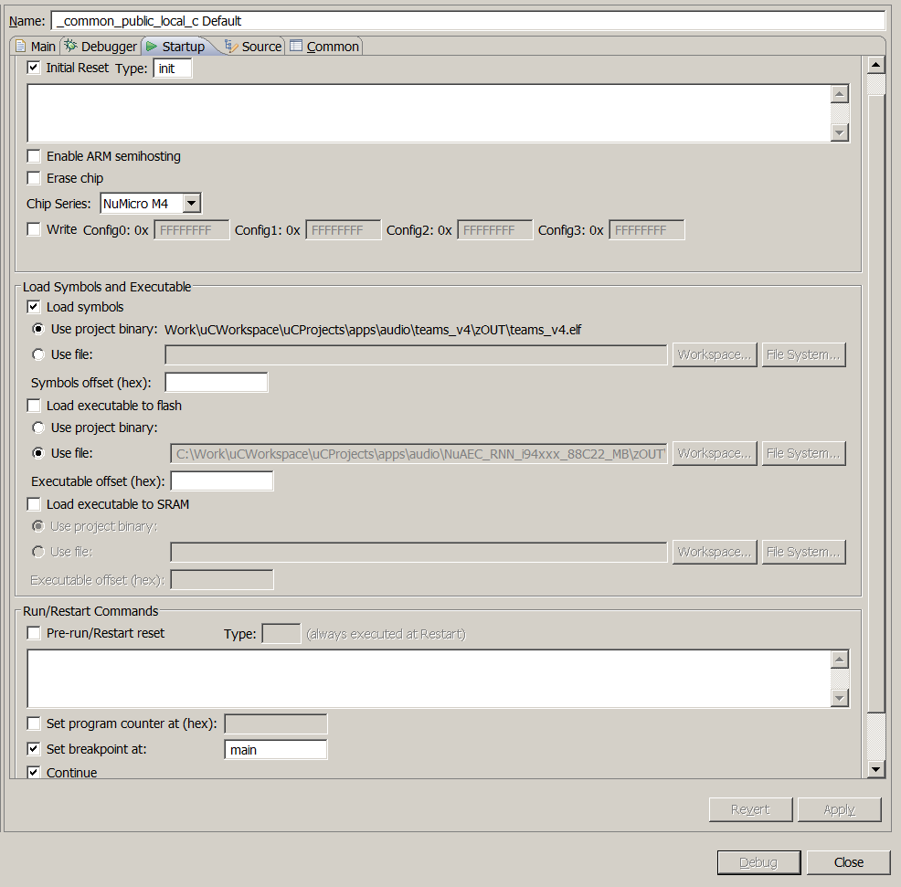

- in Chip series:
For M4 – select NuMicro M4
For M0 – select NuMicro M0
- Check ‘Load Symbols and Executable’ and select ‘Use project binary. ...’
- Un-check ‘Load executable to flash’
- Un-check ‘Load executable to SRAM’

