CSCI 162 - Problem-Solving, Programming and Data Representation

Lab 2 - Implementing a Simple ADT in Java and testing it with JUnit
This lab is a review of creating programs in Java and an introduction to JUnit testing. You will complete the documentation of an interface file and create a fully documented class file which together will implement a simple abstract data type (ADT), the Tank. You will then complete a JUnit test file and use it to test your class implementation.

Objectives:

--to become re-acquainted with DrJava
--to construct a simple but complete ADT
--to begin using JUnit to test Java classes

---If you do not already have a "JavaPackages" folder in your home directory, create one now. Be sure to spell the folder name exactly as specified here (without the double quotes, of course). We will use this folder throughout the course to store classes/packages we have developed that can be reused in
multiple applications.

---Launch DrJava to configure it properly:
*Choose the "Preferences" option from the "Edit" pull-down menu.
*Click on the "Resource Locations" category on the left. This allows us to identify resources
that DrJava needs to compile and run our programs.

*If it is not already there, enter (or select) the tools.jar location to let DrJava know where to
find it. (You can browse to this location if you like by clicking on the ... .)

/opt/jdk-1.6-i586/lib/tools.jar

*If not already there, add each of the following paths to your "Extra ClassPath" but clicking the
"Add" button just below the area next to "Extra Classpath":
1- /usr/people/classes/Java/
2- ~/JavaPackages (PS: ~ represents your home folder)
3- /usr/people/classes/Java/objectdraw/objectdraw.jar

*Click the "Javadoc" category and set "Access Level" to "private"
*Click the Display Options category and make sure “Show all Line Numbers” is clicked.
*Dismiss the "Preferences" window by pressing OK.

---Henceforth, work in pairs on this lab (BUT PLEASE NOTE that the assigned HW IS INDIVIDUAL WORK.) EMAIL FINISHED LAB MATERIAL TO EACH OTHER WHEN DONE.

Part 1. Completing the javadoc documentation for an interface

You have basically done this in Lab01. However, you may discover some things you wish to change in the more complete description here.

You can think of the Tank as simulating a large container that holds some unspecified contents, such as
water, oil, gasoline or salt pellets. The Tank has a capacity that specifies the maximum amount it may contain, and, of course, the minimum amount it may contain is 0.0.

Using a UML diagram format for an interface, the Tank looks like:

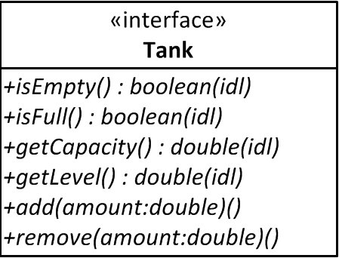
The operating specifications for the Tank interface are:

-- isEmpty() and isFull() test and return the boolean value appropriate to the condition being tested;
your javadoc should specify under what condition they return true.
-- getCapacity() returns the maximum level the contents of the Tank can reach.
-- getLevel() returns the current level of the contents of the Tank.
-- add() increases the level of the tank by amount, unless the resulting amount would exceed the
capacity. Use the precondition part of the comment to specify the corresponding restriction
on the value of amount. Use the @throws tag to specify that the method throws an
IllegalArgumentException if the precondition is not met.

-- remove() reduces the level in an analogous way and has similar preconditions and @throws clause.

Modify the interface comments you made last lab (if necessary).

Have the instructor or a TA review your javadoc comments before you proceed to writing any Java code.

Note that the Tank.java and DoubleTank.java files both include the statement "package tank;" at the beginning. We use pacakges to put together groups of related classes in Java. Java files that belong to a package must begin with a package statement that gives the name of the package and must be located
in a folder with the package name. In Java, package names begin with a lower-case letter.

Other programs can use the tank package by including the statement "import tank.*;" with the other import statements at the top.

Part 2. Implementing the DoubleTank class
The DoubleTank class must implement the Tank interface given to you in the Tank.java file. You can use the interface file as the starting point in writing the DoubleTank class. Copy the body of the interface file, Tank.java, and paste it inside DoubleTank.java to get started. The interface file contains method headers for most methods, but does not include instance variables or constructors. Discuss the design of the DoubleTank class with your pair partner then complete the class design and put in the appropriate javadoc comments using the UML diagram of the DoubleTank class and the specifications above and below to assist you. The class is called DoubleTank because it uses two instance variables of type double to store the level and capacity.

The UML diagram for the DoubleTank class is:

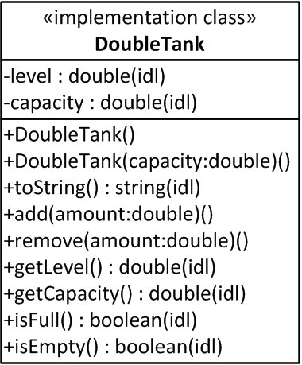

Additional specifications for the DoubleTank are:

-- the default constructor sets the level to 0.0 and the capacity to a reasonable default value which is
specified in the class as a constant ( i.e. static final) double value, and following Java
conventions is named using all caps and underscores.

-- the other constructor sets the internal capacity to the parameter value capacity and the level to 0.0.

-- the overridden toString method should return a string containing both the level and the capacity
along with some appropriate labelling text, beginning with the class name. For example, for a tank
with level 20 and capacity 100, it might return
"DoubleTank--level: 20.000, capacity: 100.000".
(You may come up with a better way to display the information in the Tank.)

-- the second constructor as well as methods remove and add should throw
new IllegalArgumentException("INCLUDE A DESCRIPTIVE MESSAGE FOR THE USER")
if their preconditions aren't met

Be sure to modify the header javadoc comments appropriately and add similar comments to the two constructors and the toString method.

When you have finished implementing the DoubleTank class, be sure that it compiles without errors or warnings. Run the javadoc utility from the command line for the DoubleTank.java file. Verify in a web browser that you have generated a valid javadoc page.

Show your DoubleTank to the TA or lab instructor BEFORE you leave the lab.

Testing the DoubleTank class with a JUnit test class

One of the best ways to test a class is to write a simple program that runs a fixed standard set of tests on class objects and then verifies whether those test results match the expected results. One tool for doing this that has become very popular is the JUnit testing suite. With JUnit, you just write a simple testing class consisting of test methods. Each method performs a few simple tests and after each test, asserts what the result should be. DrJava already has JUnit built in, so once you have the test class written, all you have to do is click the test button.

We have included the start for a JUnit test program called TankTest for you to use. Keep this class outside package tank. This class must access the tested class, i.e., DoubleTank.java, which is accomplished via the ”import tank.*" statement at the very top.
You will add appropriate methods to test the DoubleTank. One method is given for you, and a second one is sketched. The setUp() method is called at the beginning of each test, so each test starts with two NEW tanks in the initialized states.

Before you writing a JUnit test class, consider your testing strategy. The accessor methods (isEmpty(), isFull, getCapacity(), getLevel()and toString()) are simple enough, that they don't need separate testing. We can test them by using them in the tests of other methods. For the constructors and add() and
remove() methods use the following strategy:

Test the initial state of newly constructed tanks (method supplied):
--test both constructors (setUp() uses both constructors)
--test whether new tanks are empty (this implicitly tests a 0 level)
--test whether new tanks have the expected capacity
--(these tests seem to be sufficient for testing the constructors)

Test the add() method under ordinary conditions:
--test that adding to an empty tank gives the expected level
--test that adding to a non-empty tank gives the expected level
--test that tank is not empty after adding a non-zero amount
--test that adding to capacity produces a full tank

Test the remove() method under ordinary conditions:
--test that removing from a full tank gives the expected level
--test that removing from a partially filled tank gives the expected level
--test that the tank is not full after removing a non-zero amount
--test that removing all contents produces an empty tank

Test failure conditions (see note below on how these are done):
--test that adding more than remaining capacity throws an exception
--test that removing more than current level throws an exception

Test unanticipated conditions:
These are the tricky ones. What have we failed to consider in the above tests? Are there any situations that will fail that we haven't tested. Are there any situations that should fail, but don't? In this case, there are at least three problems which are due to specification deficiencies (errors) for the interface and class. (See note below on how these are done):
As noted above, the initial test of the constructors is already taken care of in the testInitialState() method. For the remaining tests, you will need to supply test methods that accomplish the given strategy. The testIsFullAtCapacity() method will test the condition that adding to capacity produces a full tank; the other conditions for testing the add() method under ordinary conditions need another test method. You can use similar test methods or the remove() method, but note that these methods will require you to add content before you do the tests.

To test the failure conditions, put the operation that should fail in a try block followed immediatly by a fail("message") call. Catch the exception type you expect to be thrown, but do nothing in the catch block. If the operation throws the exception you expect, the test succeeds (because it does what you
expect); if it doesn't throw an exception, the test fails (because it did something different than you expect).

There are three specification deficiencies (errors) somewhere in the Tank interface and the DoubleTank class (unless you had already discovered and corrected them). You won't find these problems with the JUnit tests described above; you need to figure out what the unanticipated conditions are. Consider what kind of values you haven't tested and add tests for what happens if you use those values. (There's a hint at the end of this writeup, but don't cheat and look at the hint before you try to figure it out for yourselves.) When you find the problems, go back and correct the interface and class specifications and add code to handle these situations. After you've made your corrections, revise the test class so that it adds tests for these conditions as well.

(Hint for the testing: the problems are in the add and remove

methods and in the second constructor when used with negative values.)

