Lab 15 Part 1: A mail client
Our eventual goal (in a 2-lab lab) is to create a client for a mail server that I have created.

The mail server recognizes a series of commands. These commands are:

- A send command when a user wishes to send a message to another user. This command is of the form:
sUSERID#PASSWORD#OTHERUSERID#MESSAGE
where the s tells the server the user is trying to send a message, USERID is the sender's user id, PASSWORD is the sender's password, OTHERUSERID is the user id of the recipient, and MESSAGE is the actual message. MESSAGE is the string which is the message and it should have @ symbols wherever a line-feed is meant to be. (The PrintWriter/BufferedReader used to send and read stuff over a socket have troubles with line-feeds.) This program will send a response back stating whether the message succeeded in being sent.
- A list command when a user wishes to receive a complete list of all of the messages sent to him/her. The form of this command is:
lUSERID#PASSWORD
where l says this is a list command and USERID and PASSWORD are the user id and password for the user. The user will be sent a list of his messages. (Each message will be sent in the form:
messagenumber#userid#truncatedMessage
where messagenumber is the number of the message, userid is the user who sent the message, and truncatedMessage is however many characters are left to make the message 50 characters long. The individual messages will be separated by @ symbols indicating a line feed so that all messages will be sent as one long string.)
- A get command when a user wants to read the full text of a specific message. The form of the get command is:
gUSERID#PASSWORD#messageNumber
where g says this is a get command, USERID and PASSWORD are the userid and password for the user, and messageNumber is the number of the message which will be sent to the user. This server will send that entire message to the user. (Remember that line feeds will be replaced by @ symbols.)
- A delete command when a user wants to delete a specific message. The form of the delete command is:
dUSERID#PASSWORD#messageNumber
where d says this is a delete command, USERID and PASSWORD are the userid and password of the user, and messageNumber is the number of the message to be deleted. This server will send a response stating whether the delete was successful. (Note that after a delete, the numbers of later messages will be changed.)
- A create new account command. This command has the form:
cUSERID#PASSWORD
where c means that this is a create command, USERID and PASSWORD are the USERID and PASSWORD for the user. This server will send a message to the user stating whether the account was created.
- A change password command. This command has the form:
pUSERID#PASSWORD#NEWPASSWORD
where USERID and PASSWORD are the current userid and password and NEWPASSWORD is the desired new password.

In this lab your job is to create a GUI that will be able to carry out the necessary functions of the client. I have included an example of what it might look like – and a very ugly example at that. Here it is:
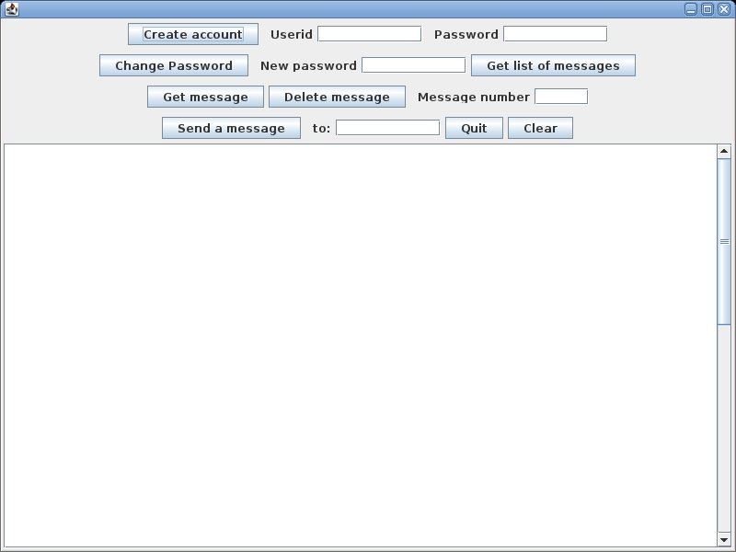
Note that it has buttons for each of the functions – Create account, Change Password, Get list of messages, Get message, Delete message, and Send a message. It also has fields for the userid, the passwords, the message number, and the recipient’s userid. It also has a quit button and a Clear button which can clear the large JtextArea inside the JScrollPane. You will not have access to the server this time so what you should do is test your GUI by having the action listeners append the appropriate commands to the JTextArea. When you do the send message, you should first clear the text area with the clear command, type the message into the text area, and produce the command by appending the text in the text area to the rest of the send message command. BE SURE TO CHANGE ALL LINE FEEDS TO @ BEFORE YOU DO THIS TO MAKE SURE THIS IS WORKING. (getText() on a text area returns everything there – including line feeds.)
Note also that I used the special JPasswordField components for the two places where I wanted passwords. This automatically types the little asterisks you are used to in a password field. However, to get the text from the password field, you should use the getPassword() command. The problem is that you want a String and getPassword returns an array of characters. You can overcome this by creating a String from the array of characters something like:
String pwd=new String(password.getPassword());
and that will do the trick.

