CSCI 162 Lab Exam 2 Spring 2011 Lynn Ziegler, Instructor

Problem 2 and 3 – 2 is getting the GUI right, 3 is getting the rest working.
This time you are to write a GUI program that will allow you to manipulate data from a file named ages.txt which contains the ages of the company’s employees. No two employees have the same age. The file contains the ages as a floating point number in the form yy.ddd where yy is the age in years and ddd is the additional days beyond whole years (Thus, 62.145 would mean 62 years and 145 days old.) Your GUI will have three buttons and three text fields and one text area. The first button will be a “Read file” button which will read in the ages from a file you choose and store them in a data structure that will keep them in order. The second button will be a “Find” button with an associated text field that will put true in the text area if the text field contains an age in the data structure. The third button will be a “Display range” button that will list (in the text area) all ages in the data structure between the ages stored in the two associated text fields. The file will look like:
62.134
34.157
42.008 ...
This counts as two questions. One for the proper GUI setup and one for the reading and actions in the GUI.

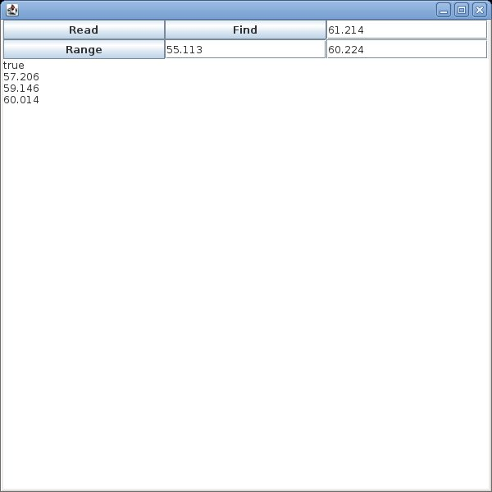
Here is an example of what your GUI might look like:

