To Solve: f_{n}=3f_{n-1}+2f_{n-2}-6f_{n-3} with f₀=1, f₁=4, f₂=9 we do the following:

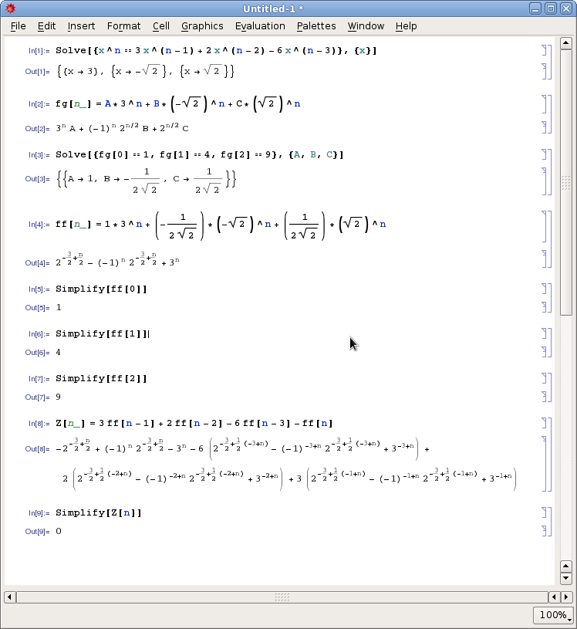
So the solution is:

