Lab 22 – Introduction to Minimum Spanning tree – paper lab
A minimum spanning tree for a connected graph is a selection of edges that:
- Connects all vertices.
- Has the property that the sum of the edges in the graph have minimum total weight.
It turns out that most graphs have many minimum spanning trees. There are also two very fast algorithms for finding a minimum spanning tree. You should apply each of the algorithms to the supplied graph in order to find two minimum spanning trees. (They actually may turn out the same.)

Algorithm 1: (Prim's algorithm) Add edges in increasing order by weight EXCEPT if the edge would make a closed loop in the graph (a cycle). In that case, skip that edge and go to the next smallest edge.

Algorithm 2: (Kruskal's algorithm) Pick an edge of smallest weight. Then add edges of smallest weight which connect a vertex already connected by an edge to a vertex not already connected to an edge.

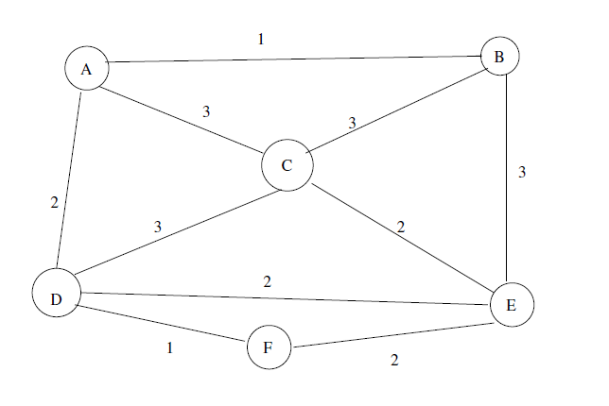
Apply each of the algorithms to the following graph. You should find places where there is more than one choice. Construct at least two different minimum spanning trees for each algorithm – hence a total of at least 4 spanning trees.

