Example Graph 2 for All-Pairs Shortest Path

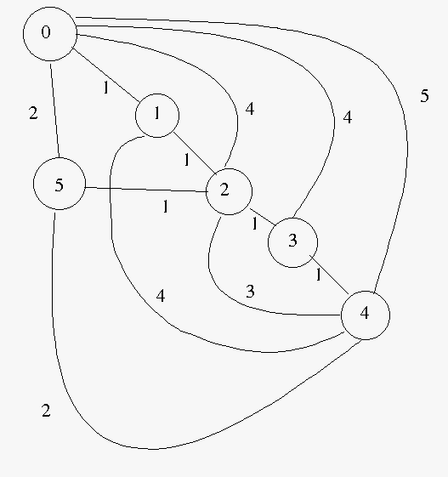

0 1 2 3 4 5
0 9999 1 4 4 5 2
1 1 9999 1 9999 4 9999
2 4 1 9999 1 3 1
3 4 9999 1 9999 1 9999
4 5 4 3 1 9999 2
5 2 9999 1 9999 2 9999

0 1 2 3 4 5
0 infinity[ 1, 0][ 2, 1][ 3, 2][ 4, 3][ 2, 0]
1 [ 1, 1] infinity[ 1, 1][ 2, 2][ 3, 3][ 2, 2]
2 [ 2, 1][ 1, 2] infinity[ 1, 2][ 2, 3][ 1, 2]
3 [ 3, 2][ 2, 2][ 1, 3] infinity[ 1, 3][ 2, 2]
4 [ 4, 3][ 3, 3][ 2, 3][ 1, 4] infinity[ 2, 4]
5 [ 2, 5][ 2, 2][ 1, 5][ 2, 2][ 2, 5] infinity

Example Graph 1 for All Pairs Shortest path

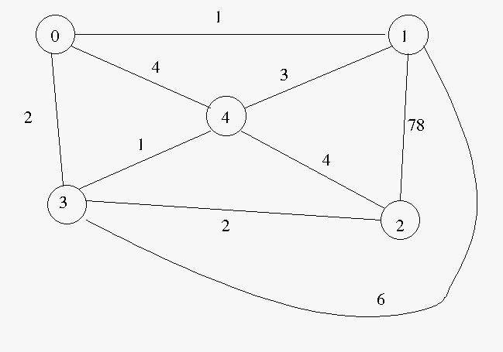

0 1 2 3 4
0 99999 1 99999 2 4
1 1 99999 78 6 3
2 99999 78 99999 2 4
3 2 6 2 99999 1
4 4 3 4 1 99999

0 1 2 3 4
0 infinity[ 1, 0][ 4, 3][ 2, 0][ 3, 3]
1 [ 1, 1] infinity[ 5, 3][ 3, 0][ 3, 1]
2 [ 4, 3][ 5, 3] infinity[ 2, 2][ 3, 3]
3 [ 2, 3][ 3, 0][ 2, 3] infinity[ 1, 3]
4 [ 3, 3][ 3, 4][ 3, 3][ 1, 4] infinity

