Andrew Zurn
HW1 – Imad Rahal
Video Company and Luxary Car Company Diagrams
Due: 09/10/13
Problem 1 – Video Company

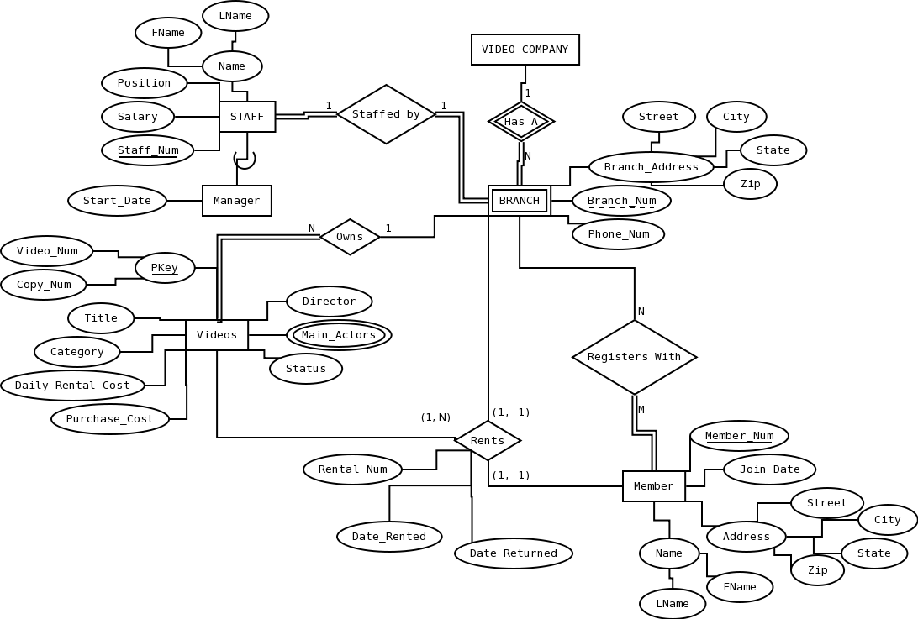
Problem 2 – Luxary Car Company

