Page: Leave Feedback
Description: This page will have three options that a user can take. They can either rate the buyer's of the items they sold, rate the seller's of the items they bought, or return to the previous menu.

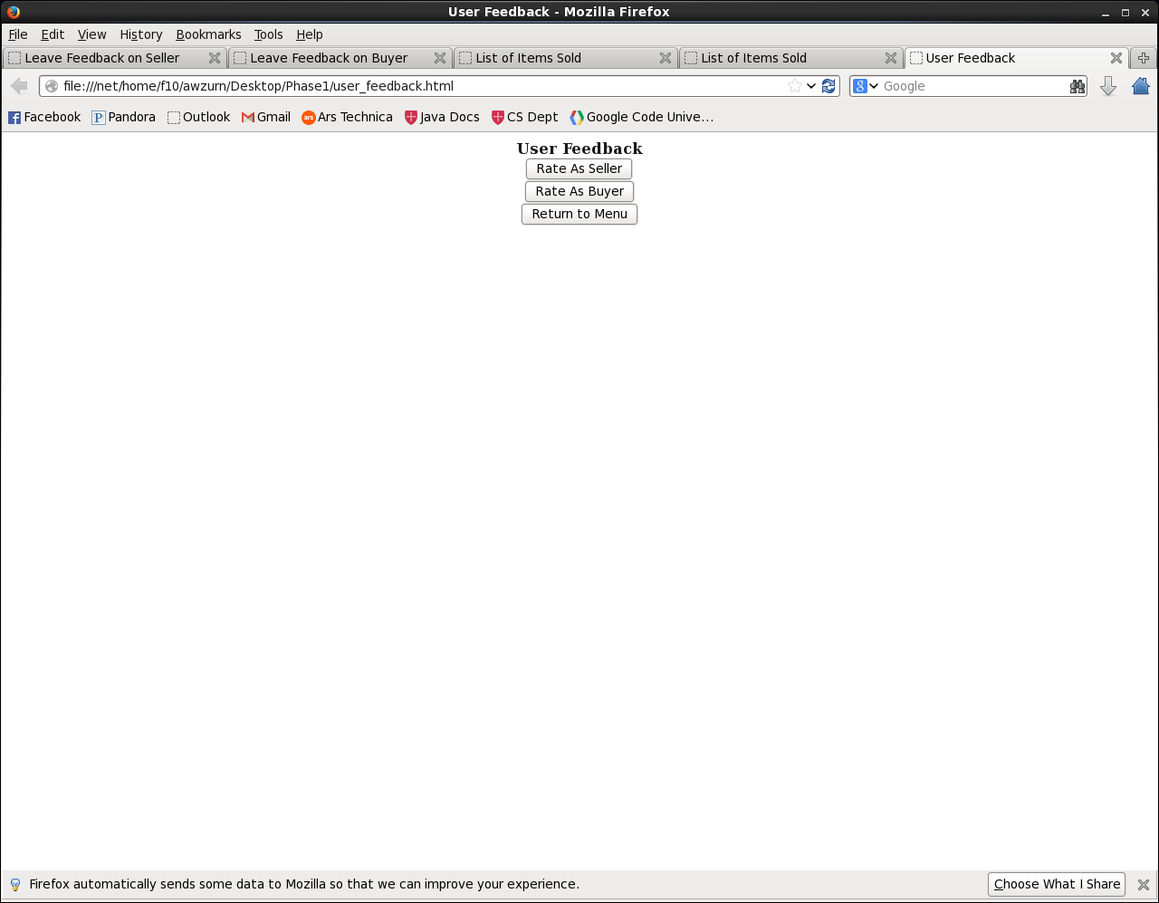
Page: Leave Feedback on Seller
Description: On this page, a user will be able to leave feedback on a seller. There are various options the user can fill out, which can then be submitted to 'Rate' the seller. The user can also cancel and return to the previous page.

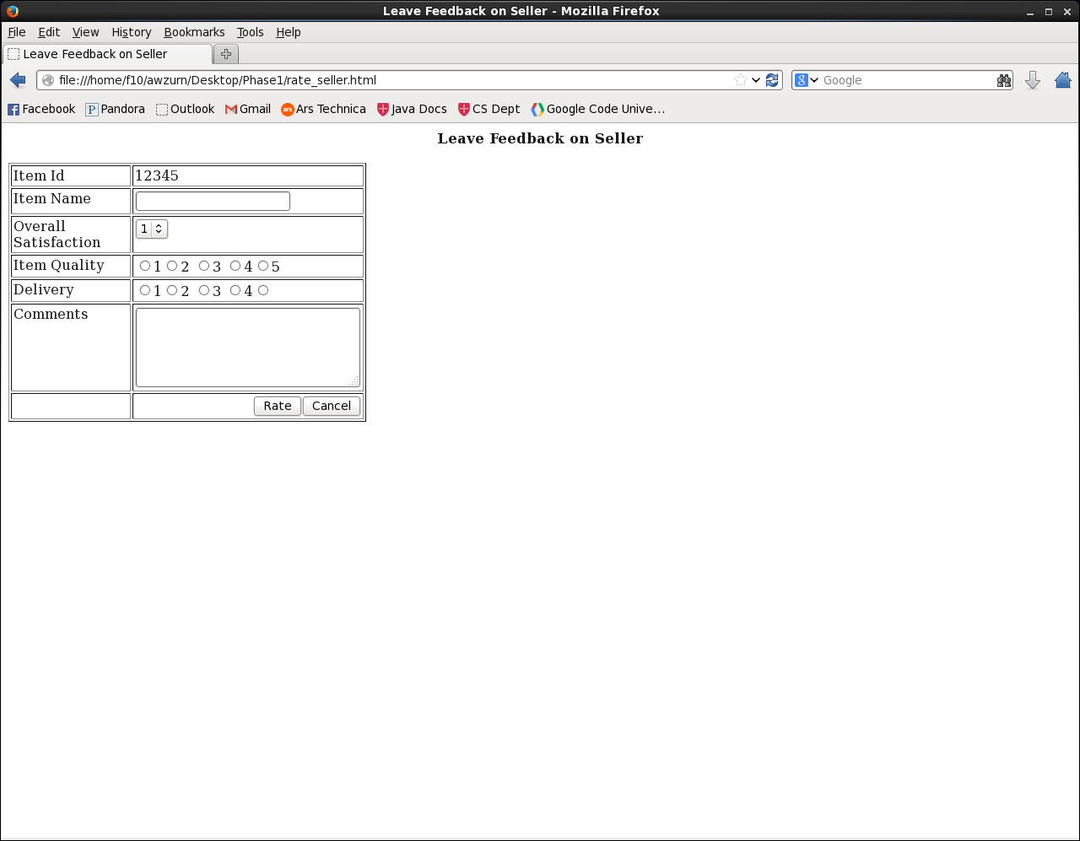
Page: Leave Feedback on Buyer
Description: On this page, a user will be able to leave feedback on a buyer. There are various options the user can fill out, which can then be submitted to 'Rate' the buyer. The user can also cancel and return to the previous page.

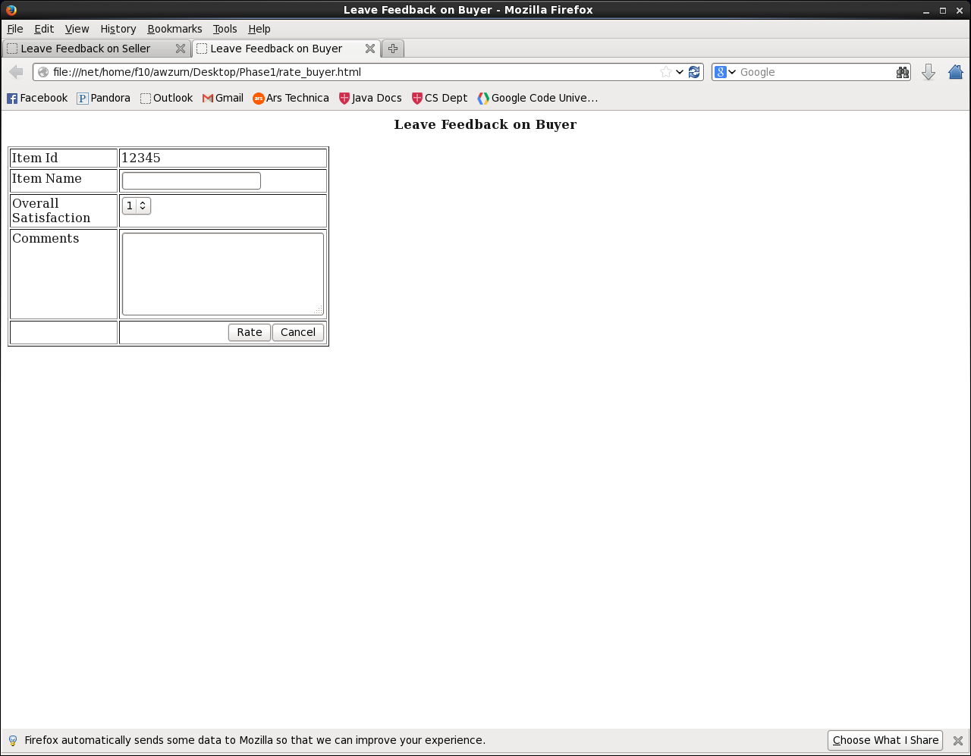
Page: Rate As Seller
Description: This page will contain a table of items that a user sold. Each row will have information describing what the item is, start and end times, who won it, and also have a link that will allow the seller to rate the buyer. It will also contain a link that will bring up a dedicated item info webpage.

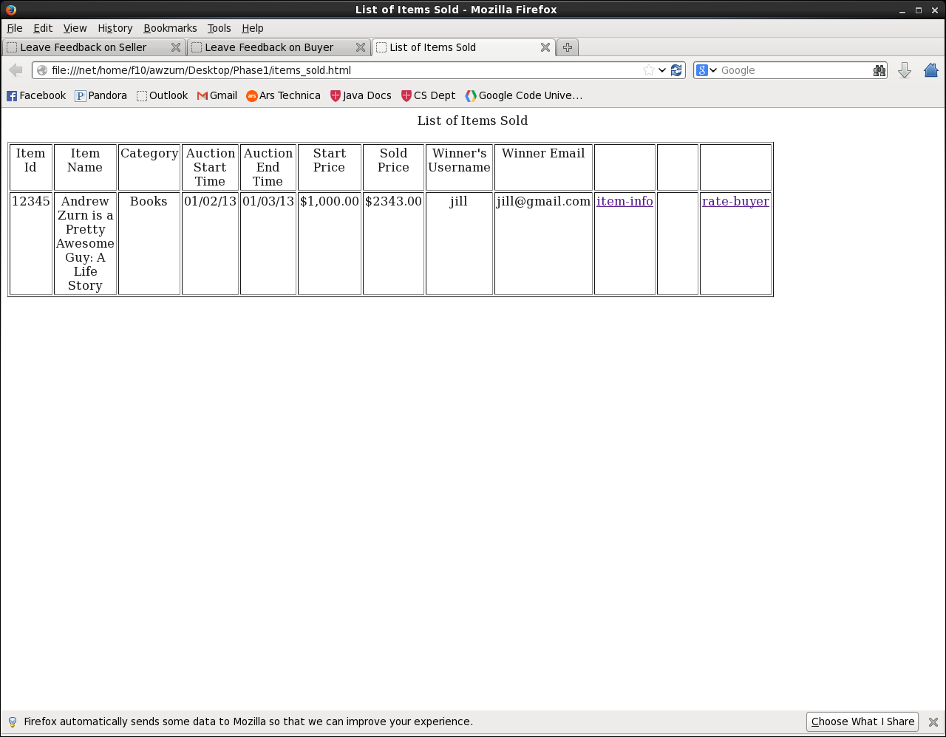

Page: Rate As Buyer
Description: This page will contain a table of items that a user bought. Each row will have information describing what the item is, start and end times, the user's contact information, and also have a link that will allow the buyer to rate the seller. It will also contain a link that will bring up a dedicated item info webpage.

