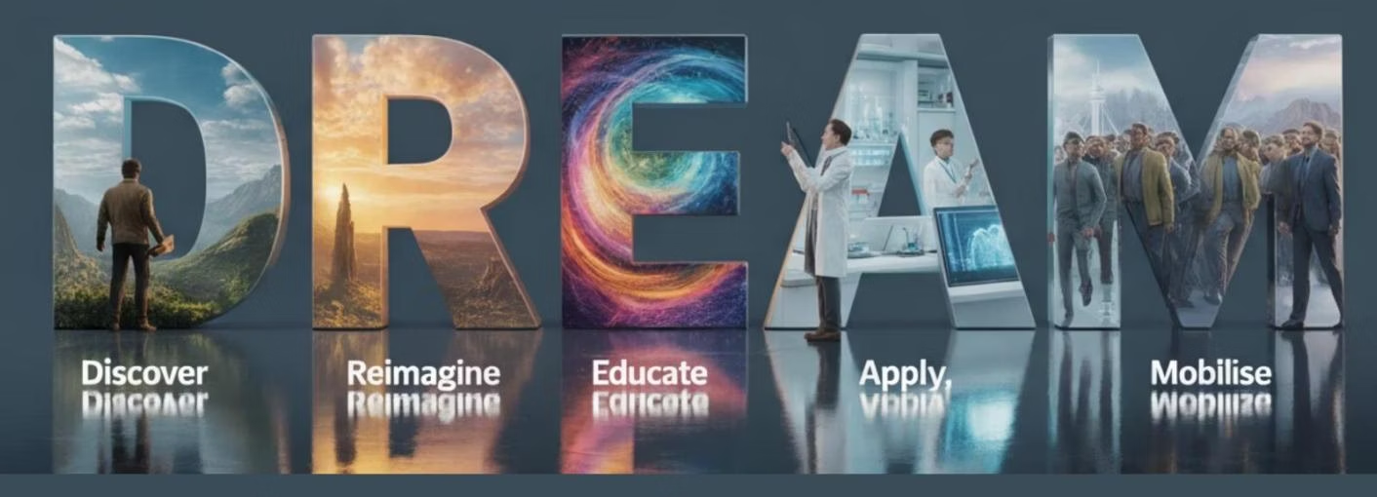 | 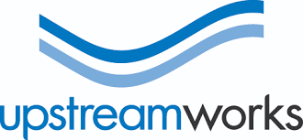
THE WORLD'S FIRST AGENTIC DECISION INTELLIGENCE PLATFORM
Stop Guessing. Start Deciding With Confidence.
DREAM transforms how leadership teams align strategy, cut through conflicting priorities, and produce decisions executives can defend — in hours, not months.

1,000+  Insights per session | 10×  Faster than surveys | 7  Analytical views | 5  Lenses covered per session

Why Organisations Choose DREAM
🤖  Agentic AI Engine  Multiple specialist agents — Discovery, Facilitation, Synthesis — working in concert. Not a chatbot wrapper. | 🔮  7 Analytical Views  Hemisphere, Sentiment, Bias, Balance, Multi-Lens, Psyche Diagnostic, Executive Scratchpad. Surfaces what surveys miss. | ⚡  Before · During · After  AI discovery prep, live cognitive guidance, and instant intelligence — all in one continuous workflow.
🗺️  DREAM Methodology  Discover → Reimagine → Educate → Apply → Mobilise. Five structured phases from raw insight to board-ready strategy. | 🎯  Field + Remote Discovery  Stream A (remote AI interviews) and Stream B (on-site field capture) synthesised together for a complete picture. | 🔒  Enterprise Ready  GDPR compliant, consent-first, encrypted transcripts. Built for regulated industries from day one.
One Platform. Three Moments That Matter.

PRE-WORKSHOP  Before  Participants complete a 15-minute AI-guided conversation. Themes, insights and a facilitator brief are ready before anyone enters the room. | LIVE SESSION  During  Specialist agents generate questions in real time. The 360° Hemisphere builds live on screen. Contradictions and consensus surface as they happen. | INSTANT INTELLIGENCE  After  The full 7-view analytical dashboard is available immediately — no waiting for consultants to write reports.

Ready to see DREAM in action?
Book a live demonstration with Upstream Works
www.upstreamworks.co.uk · hello@upstreamworks.co.uk

