PROBLEM #1

Normal display, without invalid input.

PROBLEM1.cpp

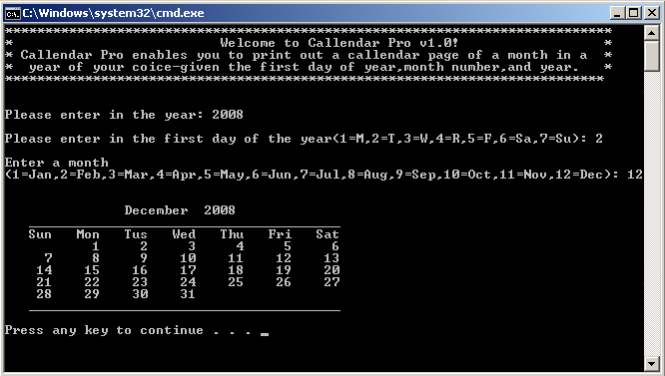

PROBLEM #1

Invalid input, more than the limited three times.

PROBLEM1.cpp

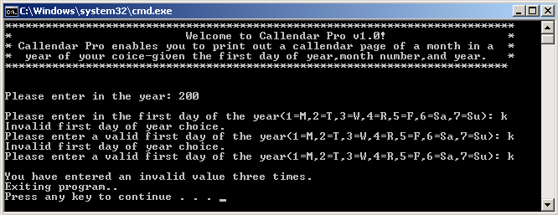

PROBLEM #2

Normal display, without invalid input.

PROBLEM2.cpp

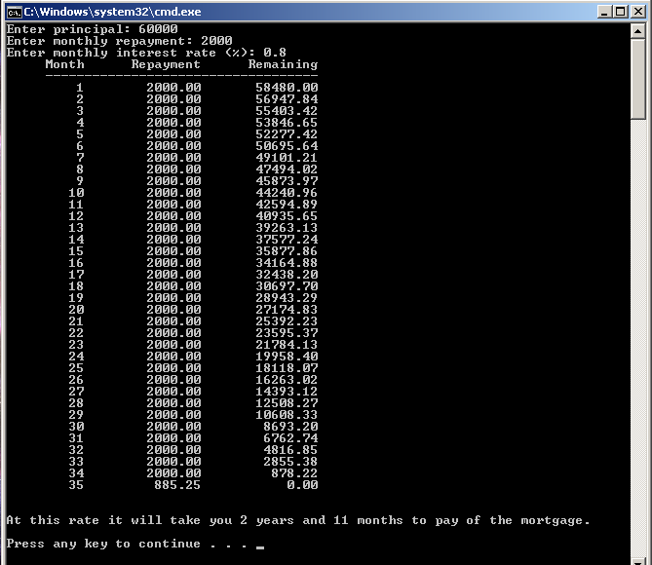

PROBLEM #2

Input validation example.

PROBLEM3.cpp

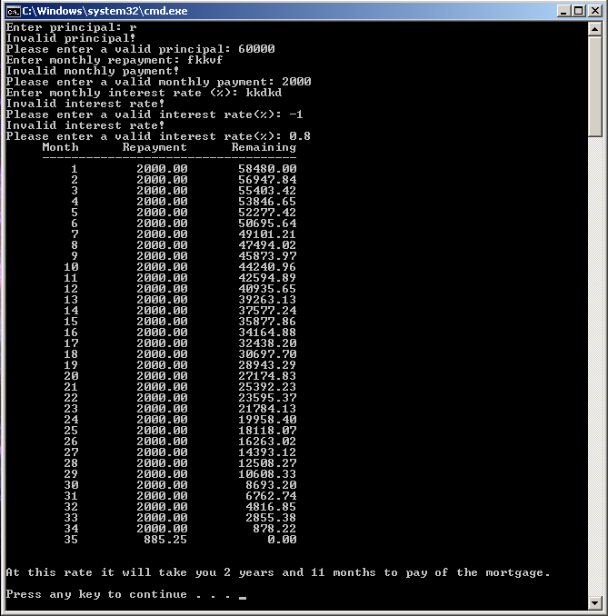

\

PROBLEM #3

Standard display.

PROBLEM3.cpp

