PROBLEM #1

Normal Display

PROBLEM1.cpp

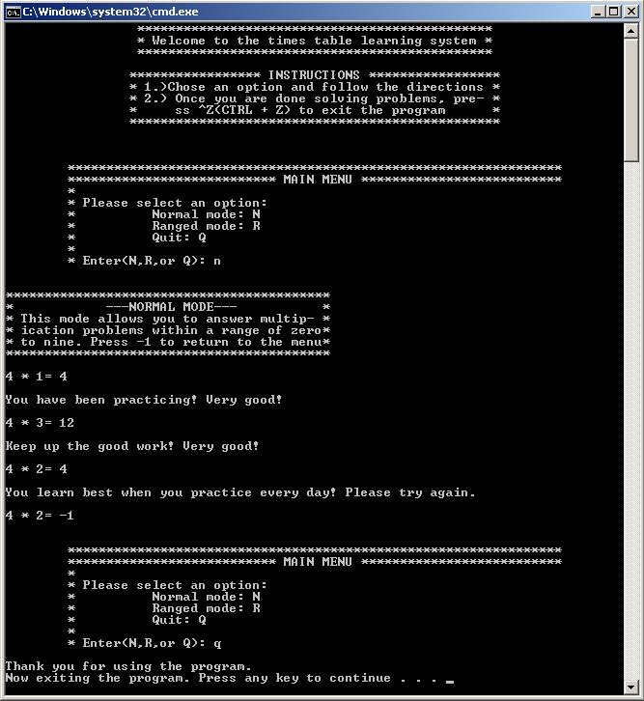

PROBLEM #1

Input Validation

PROBLEM1.cpp

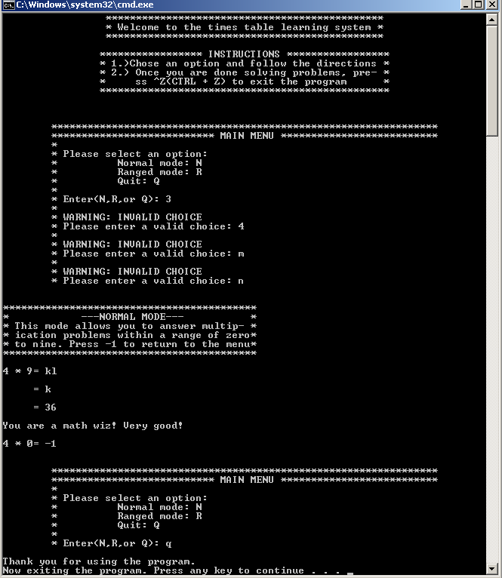

PROBLEM #2

Normal display

PROBLEM2.cpp

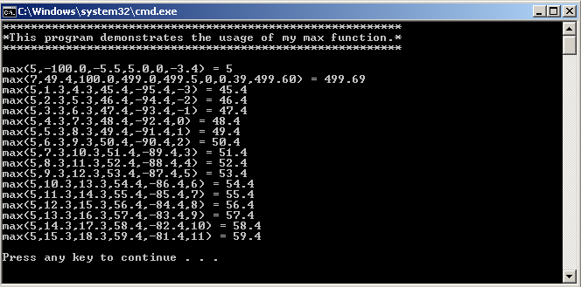

PROBLEM #3

Standard Input

PROBLEM3.cpp

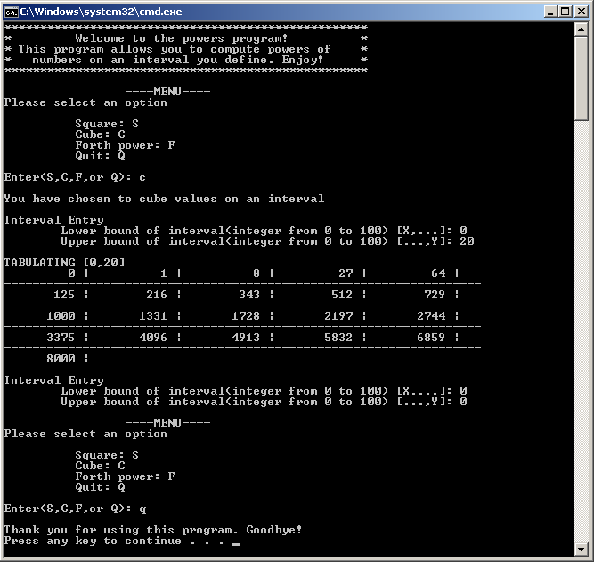

\

PROBLEM #3

Input Validation

PROBLEM3.cpp

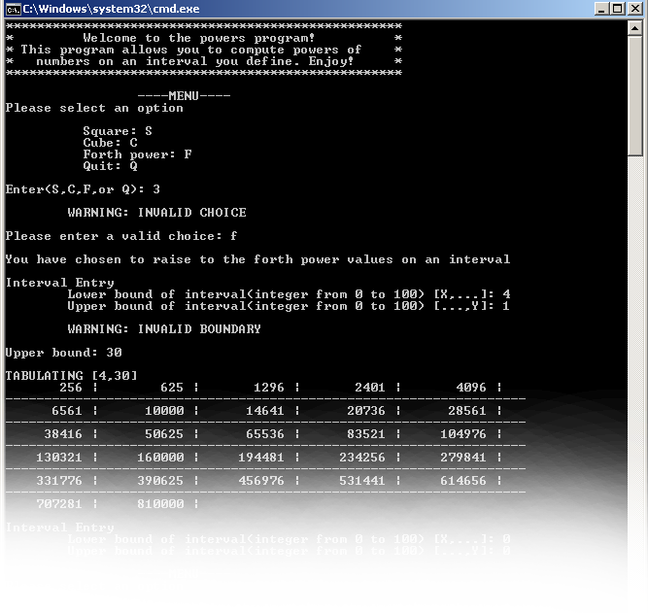

PROBLEM #4

Standard display.

PROBLEM4.cpp

