Student  Name: Andrew Ribeiro |  | Instructor: | G. Ganchev
Student  email  address: andrewnetwork@gmail.com |  | Due Date: December 08, 2009
Course: | CS 205  Fall 2009 | Directories: X:\Dropoff\CS\ganchevg\CS205\Assignment\AndrewRibeiro_Project
Subject: | Data Modeling and DB Design | File Names:  setup.sql  drop.sql  spoolCreate.txt  spoolDrop.txt  implementationQueries.sql  spoolImplementation.txt  testQueries.sql  spoolTesting.txt
Assessment: | Assignment 2009

Contents
Problem statement | 2
Planning | 3
Entity relationship model | 4
Logical design | 5
Physical Design | 6 - 7
Appended files | 8

Problem Statement
Topic 01: Room House

Mrs. Grey owns a rooming house in College Town, Missouri. Students' visitors often stay at Mrs. Grey's because it is cheap, clean, and almost always available. Students attending the university often spend a few weeks at Mrs. Grey's before finding permanent accommodations.

The rooming house has seven rooms, some of which are double rooms, i.e., have two twin beds, and some are single rooms. In addition, some rooms have a bathroom.

The database management system will be used to do the following:

- Keep track of customers and their permanent address.
- Keep track of the rooms in the house and their room type.
- List the price of each room type.
- Record the length of a stay in a specific room by a customer.
- Rank the popularity of each room.
- Generate monthly bills for customers.

In addition, Mrs. Grey requested two reports: the first report should show her how often each type of room is rented, with the most popular room being noted first, sorted to the least popular Next, she would like a report from which she can generate her occupants' end-of-month bills. This report should include the occupant's name, address, and date first rented and total amount due.

Mrs. Gray does not require reservations for room rentals, but usually visitors reserve their rooms in advance. However, some reservations are changed before arrival, or even cancelled. Also, some renters leave earlier or later than they indicated on their reservations. Mrs. Gray wants to keep record of all reservations made, so that she can generate additional statistics about room reservations and actual rentals.

I hope some of your students can help me with this project. Thank you.

Yours truly,
Amy Patterson

Planning

Goals
- Better serve room house customers in terms of data availability and reliability.
- Gather information for statistical analysis
- Improve the room house workflow

Critical Success Factors
- Must be efficent and cost sensitive
- Reliable customer information
- Transaction completeness: if a customer changes the length of stay, it must be reflected in the records.

Problem Areas
- Invalid or false data
- Loss of customer data
- Data incompleteness: if a customer has a visit, the visit must be logged in the database or it makes other reports like room rental frequency invalid.

Entity Types
- Room
- Customer
- Room type
- Visit
- Reservation

Entity Relationship Model

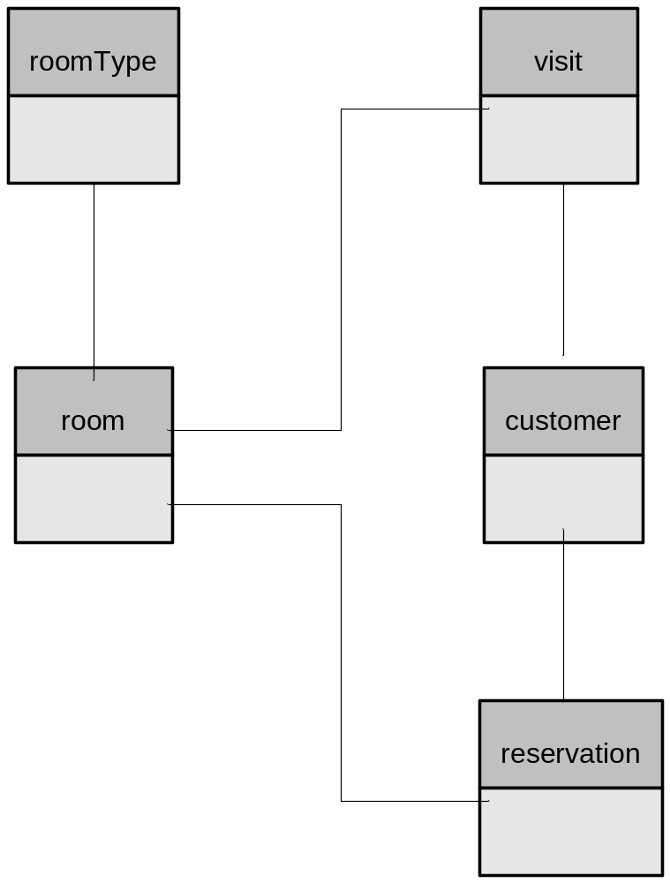

Logical Design

customer(customerID, name, streetAddress, city, state, zip)

reservation(reservationID, customerID, room, startDate, endDate)

roomType(type , nightlyRate)

room(roomNumber, roomType)

visit(visitID, startDate, endDate, customerID, roomNumber)

Referential Constraints

- visit(customerID) -> customer(uid)
- visit(roomNumber) -> room(roomNumber)
- room(roomType) -> roomType(type)
- reservation(room)->room(roomNumber)

Physical Design
Here is the physical design of the database management system:

Customer
(
customerID NUMBER(4) NOT NULL,
name VARCHAR2(25) NOT NULL,
streetAddress VARCHAR2(100) NOT NULL,
city VARCHAR2(15) NOT NULL,
state CHAR(2) NOT NULL,
zip CHAR(5) NOT NULL,
PRIMARY KEY(customerID)
)

Reservation
(
reservationID NUMBER(4) NOT NULL,
customerID NUMBER(4) NOT NULL,
room NUMBER(1) NOT NULL,
startDate DATE NOT NULL,
endDate DATE,
PRIMARY KEY(reservationID)
);

Room Type
(
type NUMBER(1) NOT NULL,
nightlyRate NUMBER(10,2) NOT NULL,
PRIMARY KEY(type)
);

Visit
(
visitID NUMBER(4) NOT NULL,
startDate DATE NOT NULL,
endDate DATE NOT NULL,
customerID NUMBER(4) NOT NULL,
roomNumber NUMBER(1) NOT NULL,
PRIMARY KEY(visitID)
);

Room
(
roomNumber NUMBER(1) NOT NULL,
roomType NUMBER(1) NOT NULL,
PRIMARY KEY(roomNumber)
);
Physical Design Documentation
Here is the rationale behind the physical design of the database management system:
Customer

For the customer table, there were no special considerations other than to make the address of the customer multiple fields in order to better facilitate sorting and searching of the customers.

Reservation
The reservation table is pretty standard as well. It has a link to the room and customer because one must know the room and the customer when making a reservation. In addition, the field endDate is allowed to be null because the user may not have a set date to leave.

Room Type
For the room type, I decided to make the primary key the length of one number because there is only four different room types in the house. In addition, the nightly rate has floating point precision so it can hold change information—good for the 19.99 type deals.

Visit

The visit table links a customer to a room for a certain period of time. Also, I have a start date and end date of stay which allows for the derivation of the length of stay.

Room

The room table is simple with two one digit numbers, because there are seven rooms and four room variations in the house.

NOTES
- The id’s of each table are four digits long because the traffic seen by this room house is minimal – since it only has seven rooms.
- Most of the data is required, hence the many not null columns.

