Andrew Ribeiro

Professor Antokoletz

WRT 245

April 12 2011

Pg. 253, #2

**How to Eat Cereal**

1. Get a bowl or container.
2. Open the cereal box, if not already opened, and pour the cereal into the bowl.
3. Pour enough milk in the bowl to fill it.
4. Get a spoon or use your hand if you do not have a spoon.
5. Fill your spoon, or hand, with cereal and insert into your mouth.
6. Chew and swallow.

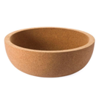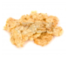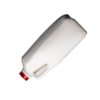

**4**

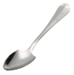

**1**

**2**

**3**

Get Bowl Pour Cereal Pour Milk Eat with Spoon

Figure 1.0

Crude drawing of cereal preparation and consumption instructions