Andrew Ribeiro

March 1, 2010

WRT 245: Professor Antokoletz

Page 82, #2

**GrillWizard**

GrillWizardprovides **fast and efficient** outdoor frying and cooking platform with propane gas. Light the burner and instantly you have **a hot 100,000 BTU** **continuous flame**!

**Features**

* 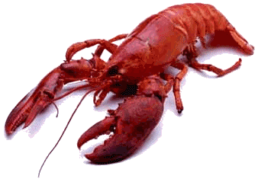The GrillWizard will help you **eliminate fish and other lingering cooking odors** from your home.
* The GrillWizard is used for fast frying of:
  + fish potatoes
  + onion rings
  + chicken
  + 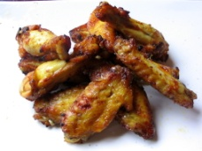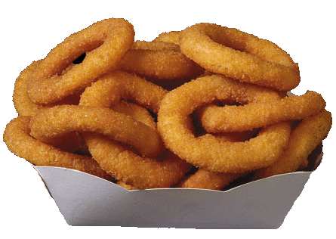vegetables
  + donuts
  + shrimp
  + crab
  + lobster boils
  + steaming clams
* ***This cooker is completely portable*** with all parts easily assembled and disassembled for compact transportation and storage, yet it weighs only 40 lbs.
* When the control valve is open, a **full 100,000 BTUs of powerful heat** prepares cooking oil in **3 minutes for frying**. Adjust the heat with a touch of the control valve
* The GrillWizardworks with **any size of propane tank** cylinder and all will give off the same amount of heat. A 20 pound. cylinder will provide approximately 6 hours of cooking time if valves are completely opened.
* The **intense heat** produced by the GrillWizardallows you to **fast fry all foods**. The cooking oils of conventional fryers drop in temperature as food is added, but the GrillWizardmaintains its temperature with just a quick touch of the control valve.
* The GrillWizardhas been designed for **easy care**.

**Operating Instructions**

1. Place grill on level ground. Insert tapered end of tubing into the hole in the base of the grill. Make sure the hole in the base is clear of all dirt and foreign objects, that the cooker is level, and the burner is facing up.
2. Attach grill connector to propane cylinder.
3. Completely open propane valve.
4. Slightly open control valve at grill connector and light cooker at top of tube immediately *(CAUTION: DO NOT stand directly over cooker when lighting burner. Also if you suspect leaks DO NOT light unit before checking.)*
5. Adjust control valve for desired flame height.
6. When finished cooking, always close both grill connector valve and propane cylinder valve completely.
7. After cooking, washing pan with soap and water, dry thoroughly and coat the entire pan with cooking oil on paper towel to prevent rusting.