Practicum Assignment

**Practicum log**

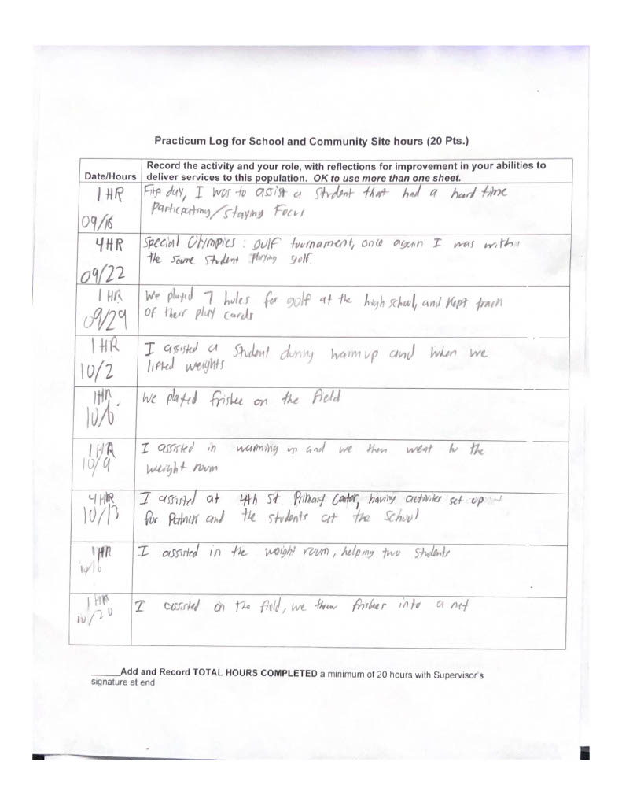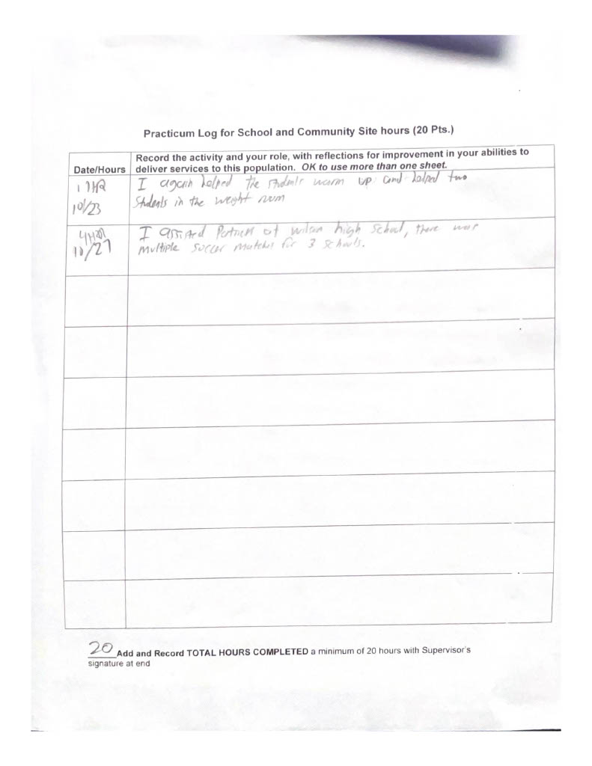

**Observation Report**

1. The place of observation was Mendez high school located at 1200 Plaza Del Sol E, Los Angeles. The supervisor’s name is Edwin Zepeda, and his contact information is (626) 542-5314 with his email being [eez5776@lausd.net](mailto:eez5776@lausd.net).
2. The total number of participants varied each week as some were sick or did not show up to class at all that day. On average there were a total of 10-15 students in PE class. Their approximate grade levels are anywhere from 9th-12th grade and approximate age I would not know since some of them could have gotten held back a year or two. I personally did not ask Mr. Zepeda or the other students/staff what disabilities the students had. From what I was told some students had multiple disabilities, Intellectual disability, Autism, emotional disturbance and orthopedic disability.
3. While I was at the site, I participated in multiple activities ranging from weightlifting, playing frisbee, and golf. When I went to go help Patrick at other sites, we did other activities such as a golf tournament, soccer tournament and multiple activities for a primary center.
4. My role at the school was to help out a student in every activity they had planned for the class. The student would easily get distracted or not pay attention so they would fall behind. An example of me helping them on the first day I was able to assist them in doing weights, which the student found fun. I also helped the student in warming up by joining him/her as well as cooling down before and after class. My task would be given by Mr. Zepeda himself and he would let me know if I could help the student in every activity in which I was successful in getting the student to participate in every class.
5. A student had an intellectual disability so in order for them to participate, they would always have a chaperone with them. When it came to warming up at the start of class, the chaperone would guide them by hand to help them stretch and get their blood flowing. When it came to the weight room, the chaperone would hold their hand and they would just walk back and forth because the student had no interest in weightlifting so to keep him/her active, they just walked. Moving on, when it came to playing golf or Frisbee, his/her chaperone would talk to the student one on one to give him/her specific instructions and break down the steps in how to play so the student could understand. Also, during gold and Frisbee the students were given no time and were just allowed to move on to the next course when scoring.
6. One feedback that I noticed right away was during the warmup, Mr. Zepeda would give positive feedback like “great work J” or “good run M”, “keep it up A” and this would give the students the enjoyment that they are doing well. During the cool down, Mr. Zepeda would have a particular student lead it, and once again he would motivate his student by giving him an appraisal and ending the class with a round of applause. Another feedback that I noticed is that to keep the class fun, Mr. Zepeda would have the class be inside to work out or have the class go outside on the field to play an activity such as golf or Frisbee. He would have the class entertained by changing the activity every other day to keep it fun. Lastly final feedback that I observed is during weightlifting, Mr. Zepeda would go around and ask each student how they are doing and if they are struggling and if they were he would show them the task or give them clear instructions on how to perform the movement by breaking it down or modifying the task to their needs.

**Supervisor Evaluation**

