**DOCUMENTATION**

**Background/Inspiration**

* Living in a society where graphics, tv and radio seemed the main media for communicating news to the student population, it was the fact that not everyone had access to these. We were therefore inspired to create this blog so as to meet this need. A platform where people may gain access to information reported in newspaper or magazine about recent and important events from all over the world.
* THE BLOG, which is the name of the blog, was created by Team Ganoh, influenced by Ameyaw Debrah, a popularly known Blogger in Ghana.

**Goals**

* To be the voice of the people.
* To connect personally with the people.
* To give a behind-the-scenes look into events.
* A platform to express our brand identity and distinguish ourselves from the competition.

**Scope of the blog site**

* The blog is user-friendly to the right audience to find and provides the information the targeted audience wants and needs.
* All information is documented for easy reference to keep everyone headed in the same direction.
* THE BLOG site contains twelve (12) webpages. Thus, the Content and Admin page
* The Content Page contains several pages, thus:
  1. Entertainment
  2. Sports
  3. Education
  4. Science/Technology
  5. Health/Fitness
  6. Lifestyle
* The Admin Page contains several tabs, such as:
  1. Posts (View all posts, Add post)
  2. Categories
  3. Comments
  4. Users (View all users, Add users)

**Description of the blog site**

* The Project is actually a blogging site with the following main features
  1. The Content Page
  2. The Admin Page

**The Content Page**

* + - The content page is made up of the interface that consists of the published posts, a navbar with six (6) different **Categories** as the navs. The page also consists of a sidebar that have a Search Tag for easily accessing a specific post as well as a **Login** page for Admins only, with which eligible users only can log in to the Admin page and control or manipulate the various features.
    - Categories: Each category in the homepage contains related posts with a comment block for the users to comment on specific posts but with a truncated information. To access the full post, the user needs to click on the displayed title of the post and he or she will be directed to the specific post with full information.

**The Admin Page**

* + - The Admin page consists of a dashboard with tabs like Posts, Categories, Comments, Users etc. The Posts tab in the Admin page is a dropdown with two tabs (View All Posts and Add Posts). These tabs enable the Admin to Edit and Delete the Posts. Furthermore, the Admin can Add new Posts to be published.
    - The categories tab provides opportunity for the Admin to Add, Edit and Delete the categories
    - The Comments tab consist of a table displaying Comments made by users, the email of the users, the author etc and also provides an opportunity for the Admin to either approve a comment to be published or otherwise
    - The Users tab is a dropdown with two tabs (View All Users and Add Users) which is used by the Admin to manipulate and validate Users as to making them Admins or normal Subscribers. Furthermore, the Add Users tab allows the Admin to Add new Users to the site.

**THE BLOG MOCKUP**

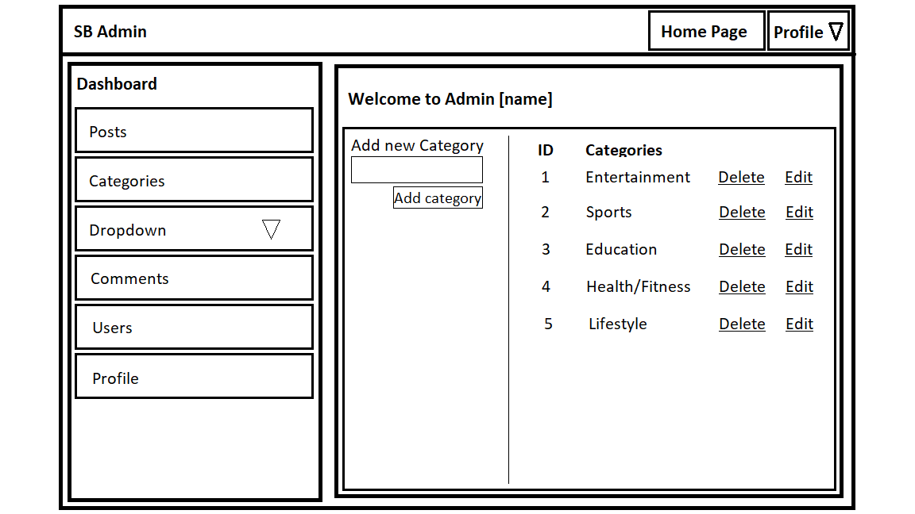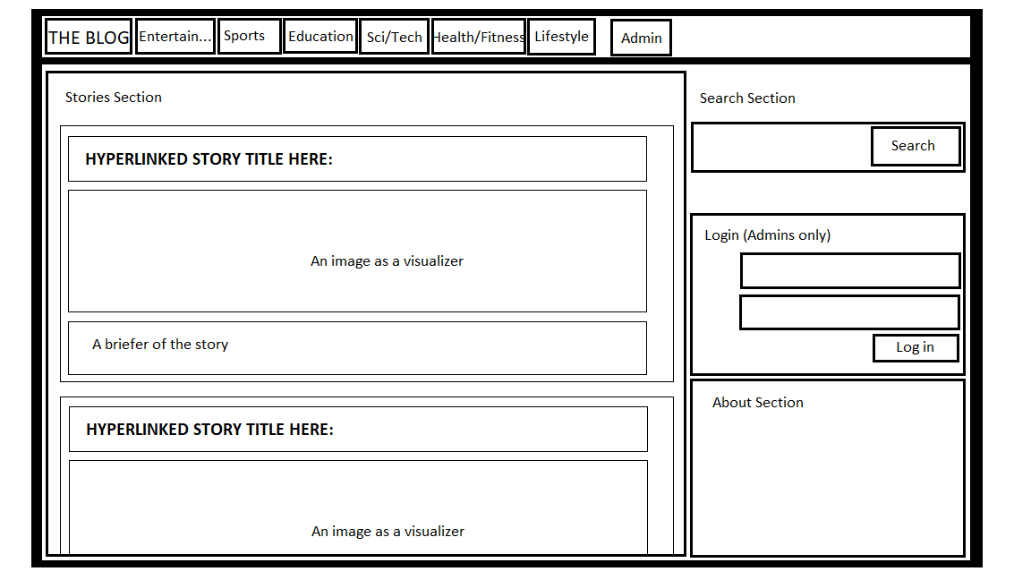

**User Constraints**

* Users of the Blog sites have privileges with respect to accessing the blog. Also, they have limitations’ that is, they only have the privilege to view the contents of the page, search for specific posts they prefer and also comment on those posts as well.

**Terms of Use and Privacy Policy**

**Welcome to THE BLOG.**

**These Terms of Use and Policy govern your use of the blog and provide information about the blog Service, outlined below.**

**Service and User Guide**

**We agree to provide you with *THE BLOG* Service and User Guide. The Service includes all of *THE BLOG* features, applications, services, technologies, and software that we provide to advance our mission: To bring you closer to the people, lecturers and things you love with its user guide for new users that are willing to be part of our community. These are as follows:**

* A blog is an online diary or journal located on a website. The content of a blog typically includes text, pictures, videos, animated GIFs and even scans from old physical offline diaries or journals and other hard copy documents. Since a blog can exist merely for personal use, sharing information with an exclusive group or to engage the public, a blog owner can set their blog for private or public access.
* Additionally, social and anti-social people use blogs to build new friendships and other types of relationships and gain a better understanding of the lives of people who they might not likely interact with on a daily basis. For example, THE BLOG offers opportunities to interact with people who are from others cultures and/or live in other geographic regions, people who work in different career fields and people who have taken up previously geographically-limited and rare types of hobbies. In these cases, blog offer contents that people could only find in the past through offline newspapers, magazines, television programs, films, documentaries and special festivities sponsored by communities, businesses art organizations, local, state and federal government administrations and academic institutions.
* **Offering personalized opportunities to create, connect, communicate, discover, and share.**  
  People are different. We want to strengthen your relationships through shared experiences you actually care about. So, we build systems that try to understand who and what you and others care about, and use that information to help you create, find, join, and share in experiences that matter to you. Part of that is highlighting content, features, offers, issues, and topics you might be interested in, and offering ways for you to experience THE BLOG, based on things you and others do on and off the blog.

**Privacy Policy**

* This blog is written and edited by Team Ganoh. For questions about this blog, please email Contact at kofiganoh@gmail.com. This blog accepts forms of cash advertising, sponsorship, paid insertions or other forms of compensation. This blog abides by word of mouth marketing standards. We believe in honesty of relationship, opinion and identity. The compensation received may influence the advertising content, topics or posts made in this blog. That content, advertising space or post will be clearly identified as paid or sponsored content. The owner(s) of this blog may be compensated to provide opinion on products, services, websites and various other topics. Even though the owner(s) of this blog receive compensation for our posts or advertisements, we always give our honest opinions, findings, beliefs, or experiences on those topics or products. The views and opinions expressed on this blog are purely the bloggers’ own. Any product claim, statistic, quote or other representation about a product or service should be verified with the manufacturer, provider or party in question. This blog does not contain any content which might present a conflict of interest.

**Technology Used**

* + Bootstrap
  + Database (MySQL)
  + HTML (Hyper Text Markup Language)
  + CSS (Cascading Style Sheet)
  + PHP
  + XAMPP (localhost server)
  + GITHUB
  + Trello

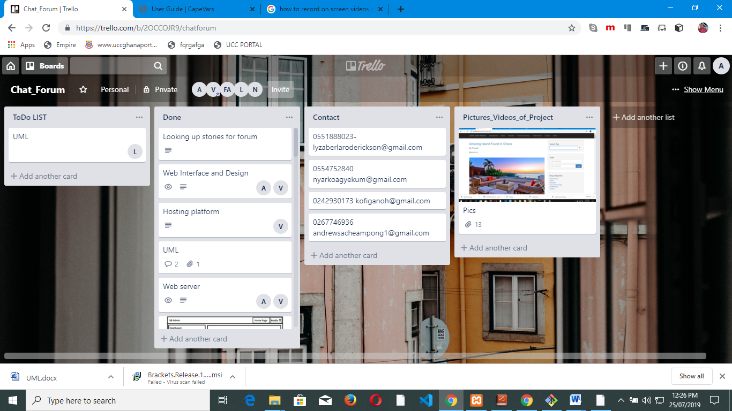**Project Process Record**Trello was used for the project process record to read and record our four day project process to know how far we have got to.