SMART CARE SYSTEM
Technical Documentation

Team Project Module
National College of Ireland

Team Members
Timothy Semafumu — 23361131
Kamlesh Choudhary — 23381817
Le Hoang Huynh — 23385511
Enrico Frossard -23415924

Submission Date: [Date]
GitHub Repository: [URL]

Table of Contents
1. Executive Summary | 3
2. Problem & Solution | 4
3. System Architecture | 5
4. Features & Screenshots | 6
5. Requirements Traceability | 7
6. Installation & Usage | 8
7. Project Reflection | 9
8. Individual Contributions | 10

Update page numbers after completing the document.

1. Executive Summary
The smart Care System is an application built for medical clinics that are struggling with synchronising patient records and scheduling appointments while ensuring efficiency. The smart care System is designed to specifically replace faulty unreliable systems while ensuring quality patient care. This is important because it will empower the health sector to operate smoothly by relieving it of its administrative burdens allowing medical workers to focus on what matters the most which is the patients

2. Problem & Solution

2.1 Problem Statement
The smart care system addresses the problem of medical clinics that struggle with synchronising patient records and scheduling appointments in terms of cutting off double bookings and ensure systems are reliable, hence reducing inefficiency.

2.2 Solution Overview
Prisma transaction feature was used to ensure that when a patient books an appointment. The system will perform a check if the slot is available before confirming the booking this is a single, unbreakable database operation

Therefore when a receptionist or patient books the slot and confirms the Prisma transaction is initiated and the selected time slot is locked so no modification can happen at that particular time with the slot locked the system checks if its still available does the patient already have an appointment If the slot is available a booking will be confirmed if not a new slot will be requested for the user to book

2.3 Target Users

User Type | Description
Receptionist | As a receptionist, I want to register new patients, so that their records can be stored before their first visit.
Doctor | As a doctor I want to access my patient's history records so that I can make accurate diagnosis based on the patient history records
Patient | As a patient, I want to log in using Gmail or my phone number, so that I can securely access my medical records and appointments.

3. System Architecture

3.1 Architecture Diagram

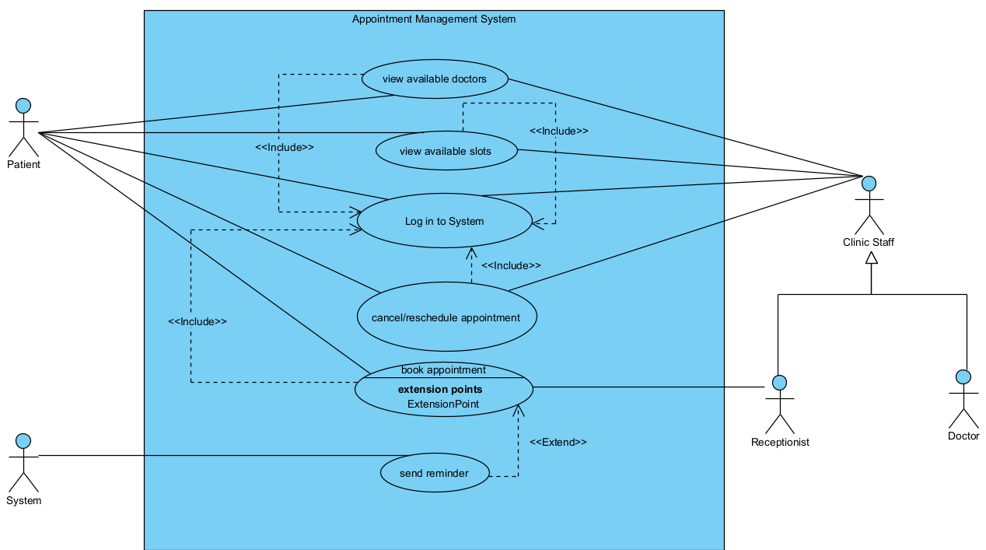

3.2 Technology Stack
List the technologies used in your project. Explain briefly

Layer | Technology | Justification
Frontend | React.js | React was used because we had prior knowledge of it from our web application module last semester and because it’s easy to build a responsive user interface with it
Styling | CSS | We used CSS because we all have knowledge on it and its just basic for development and was compatible in all our coding environments
Backend | Node.js | We used Node.js because it can handle multiple requests in terms of restarting due to changes and updating immediately hence efficient for a booking system
Database | SQL with Prisma ORM | SQL was used because there’s clear relationships hence creating relational database with Prisma ORM there’s easy schema management in terms of migrations
Authentication | Role based Access Control | This is an important part for our project because we have different users and each person has features; they can access hence using JSON WEB Tokens
Hosting | Localhost (Development) | Currently running on localhost to allow easy debugging and rapid testing

3.3 Component Overview
The Smart care system has 4 main components which include the user system which allows you to log in, log out or register an account basing on your role different features will be displayed
The smart care system has a component for viewing available doctors on that date or time these are doctors with different specialities
The smart Care system has a booking feature which allows a user to confirm a booking for an appoint after selection of an available slot
The smart care system has a feature for cancelation or rescheduling appointments in case there’s a change in one’s schedule

4. Features & Screenshots
Document your key features with screenshots. Include 4-6 features. For each feature, provide a brief description and a screenshot.

4.1 user Log in and register
The user will have to log in or create an account there’s validation required for different passwords or usernames and the system will reference with the database to make sure all details match

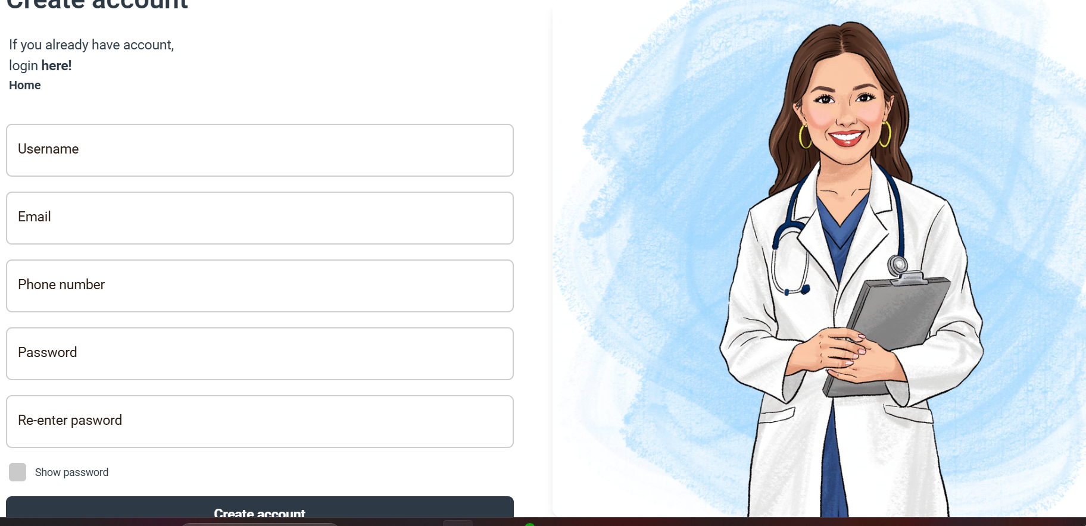
Figure 1: user registration

4.2 Booking
The user feels in the required details to make a booking this is the view of a receptionist that’s why previous bookings can be seen

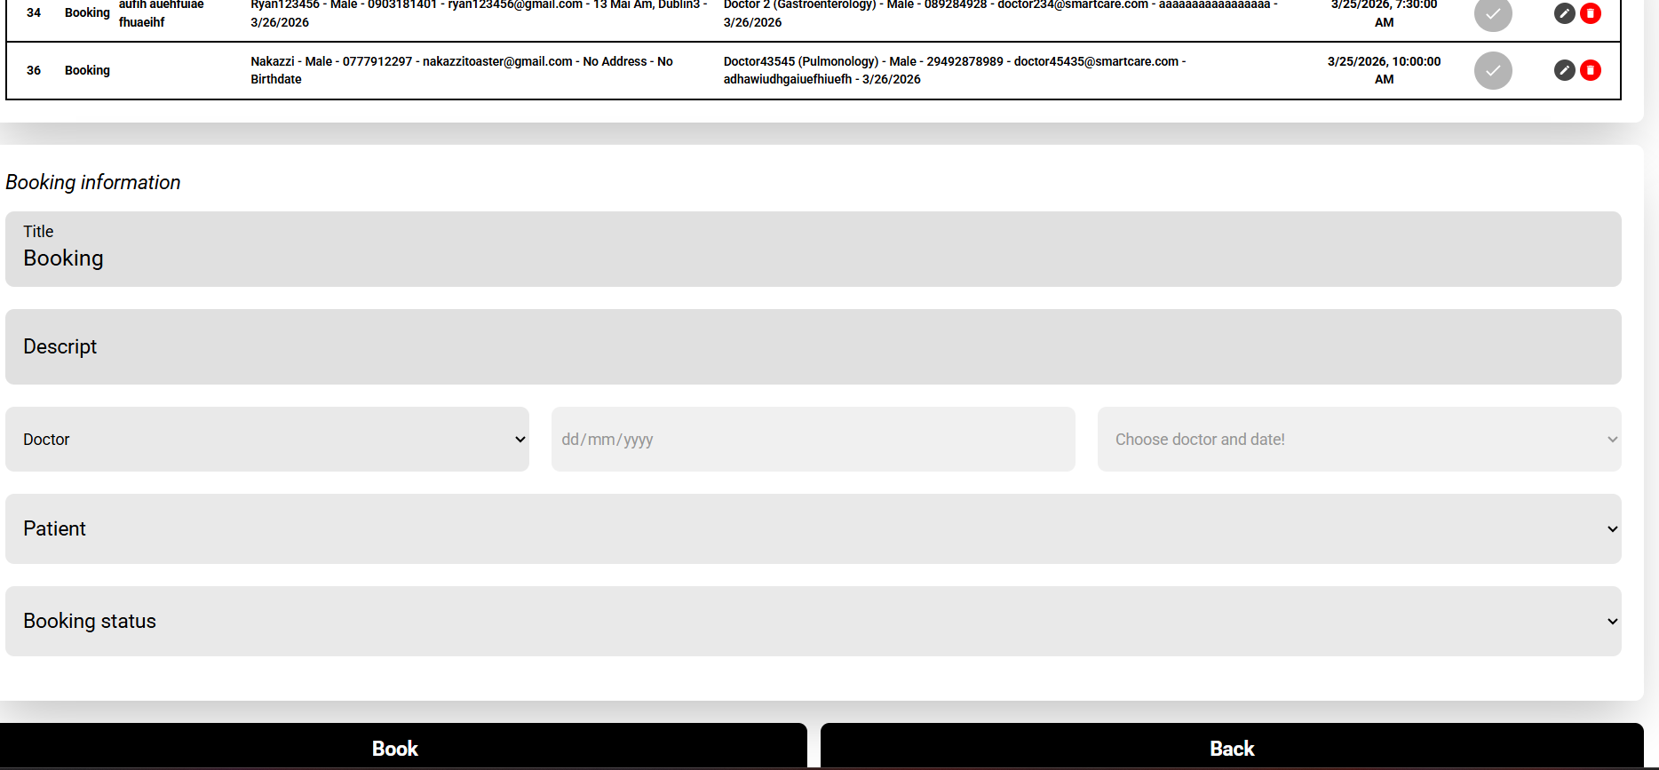
Figure 2: Booking window

4.3 Change password
The user can change password to a new password if they feel they have been compromised without creating a new account

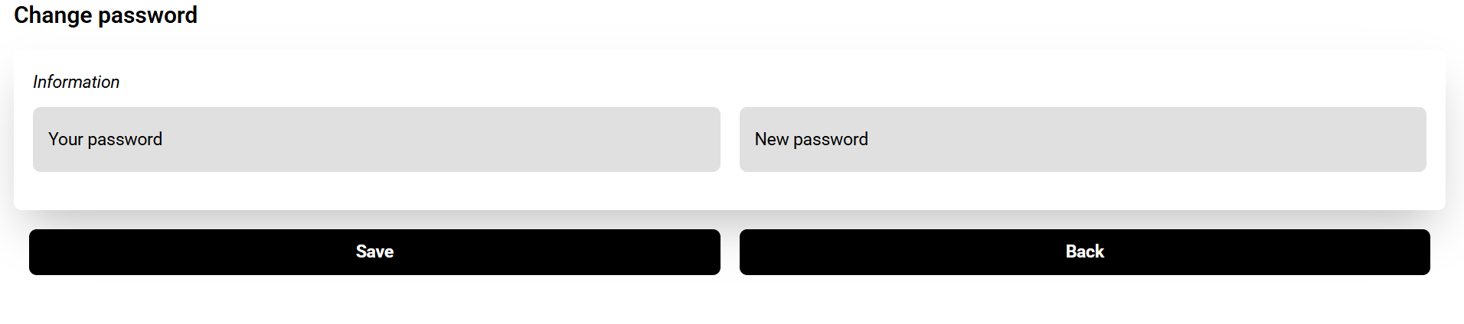
Figure 3: saving the new password please click save

4.4 Statistics
This is a dashboard for receptionists and administrators to give a summary of the required statistics just showing different number of bookings a day

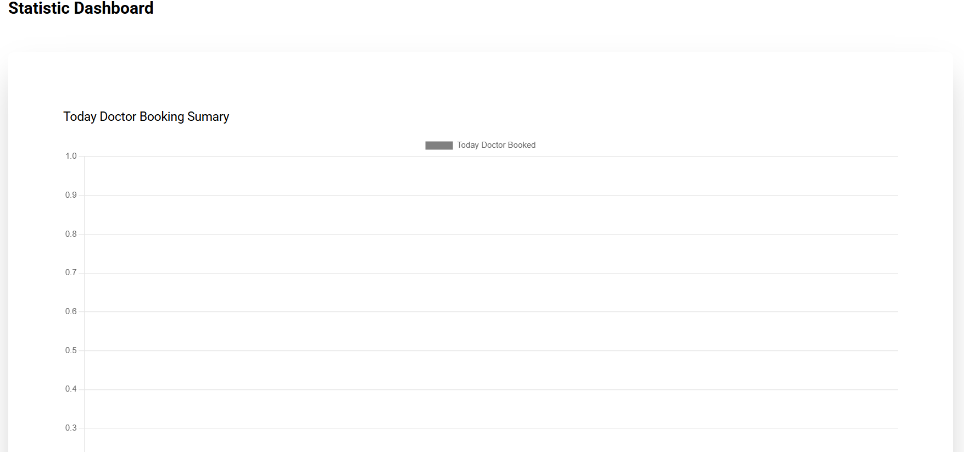

4.5 User manager
A receptionist can create a new user for the system
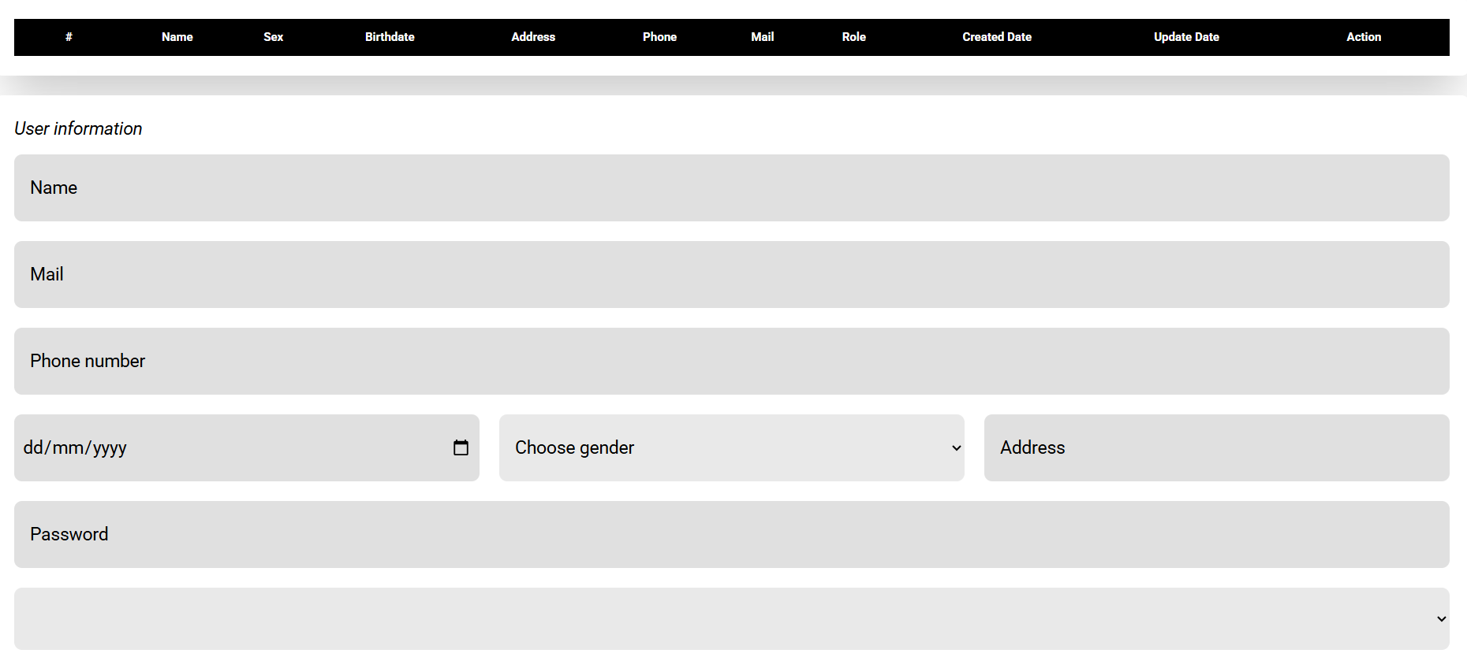

4.6 Daily report
A daily report is created at the end of the day for the receptionist
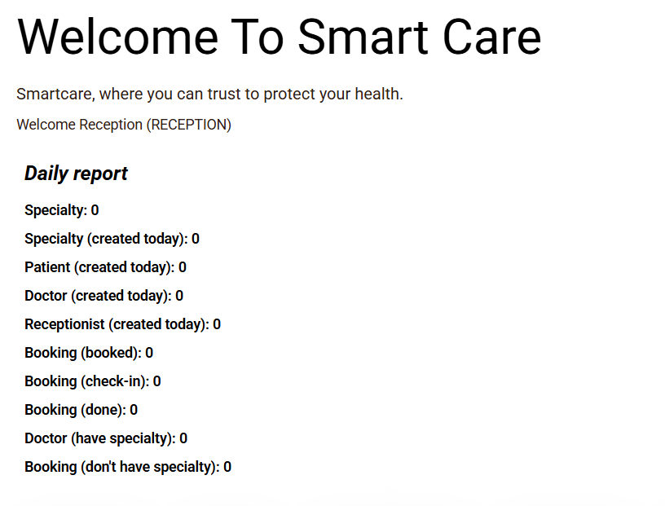

5. Requirements Traceability
Map your original requirements to their final implementation status. Reference your Requirements List submission. Be honest about what was not completed.

5.1 Functional Requirements
ID | User Story | Priority | Status
FR-001 | As a doctor I want to access my patient's history records so that I can make accurate diagnosis based on the patient history records | Must | Complete
FR-002 | As a receptionist, I want to be able to generate daily reports showing how many appointments have been scheduled so that I can track the performance of our clinic | Should | Complete
FR-003 | As a patient, I want to book an appointment online, so that I can schedule a clinic visit without calling the reception | Must | Complete
FR-004 | As a patient, I want to see available time slots only, so that I do not double book an appointment | Must | Complete
FR-005 | As a patient, I want to be reminded via email 24 hours prior to my appointment, so that I don't forget to come in. | Should | Failed
FR-006 | As a receptionist, I want to update appointment status, so that patient visits are precisely recorded. | Should | Complete
FR-007 | As a clinic manager, I want to see booking statistics so I can assess clinic performance. | Must | Complete
FR-008 | As a system administrator, I want role-based access control, so that the users can only access features that they are permitted to use. | Must | Complete
FR-009 | As a receptionist, I want to manage doctors’ availability, so that appointments are only booked when doctors are available. | Should | Complete
FR-010 | As a patient, I want to reschedule my appointment, so that I can change my booking if I am unavailable. | Must | Complete
FR-011 | As a receptionist, I want to register new patients, so that their records can be stored before their first visit. | Must | Complete
FR-012 | As a doctor, I want to add new diagnosis notes after each consultation, so that patient history can kept updated. | Must | Complete
FR-013 | As a developer, I want to give users an interface with animations, so that they have an excellent experience. | Could | Failed
FR-014 | As a business owner, I want to implement a part of the interface only for feedback on functionality and performance of our application, so that we have a closer engagement and understanding of how it’s performing. | Won’t | Didn’t do it

5.2 Non-Functional Requirements
ID | Requirement | Status
NFR1 | The application must load quickly to ensure efficiency | Not met
NFR2 | The system must protect patient records in compliance with international regulations | Met
NFR3 | The system must work with multiple desktop browsers. | Met

5.3 Scope Changes
Initially we had an idea of sending reminders to our clients but this was removed because of its complexity and time to develop it

6. Installation & Usage

6.1 Prerequisites
List what needs to be installed to run your project.

- npm run dev
- npx prisma

6.2 Installation Steps
Provide step-by-step instructions to get the project running locally.
Open Backend first by navigating to the directory no installing needed as required installation have been zipped in the folder therefore just navigate to backend write npm run dev do the same for front end and then to access the database navigate to the directory where the backend is type npx prisma generate then npx prisma migrate dev and finally npx Prisma studio to open the database on the localhost

7. Project Reflection
This section captures the team's collective learning. Write as a team, not individually.
- Timothy Semafumu – I learnt that in a team everyone has their strengths and working together can lead to a successful project since everyone contributes something to the team

7.1 Challenges Faced
Describe 2-3 significant challenges your team encountered and how you addressed them.

Challenge 1: [Title]
[Describe the challenge and how your team overcame it.]

Challenge 2: [Title]
[Describe the challenge and how your team overcame it.]

7.2 Key Learnings
What did your team learn from this project? Consider technical skills, teamwork, and project management.

[Describe your key learnings here.]

7.3 What We Would Do Differently
With hindsight, what would you change if you started this project again?

[Describe what you would do differently.]

7.4 Future Enhancements
If you had more time, what features or improvements would you add?

- [Future enhancement 1]
- [Future enhancement 2]
- [Future enhancement 3]

8. Individual Contributions
Each team member should list their main contributions. Keep it brief — 3-5 bullet points each.

[Team Member 1 Name]
- [Main contribution 1]
- [Main contribution 2]
- [Main contribution 3]
GitHub commits: [link or commit count]

[Team Member 2 Name]
- [Main contribution 1]
- [Main contribution 2]
- [Main contribution 3]
GitHub commits: [link or commit count]

[Team Member 3 Name]
- [Main contribution 1]
- [Main contribution 2]
- [Main contribution 3]
GitHub commits: [link or commit count]

[Team Member 4 Name]
- [Main contribution 1]
- [Main contribution 2]
- [Main contribution 3]
GitHub commits: [link or commit count]

End of Document

