Word 参考文档

WSJ

2018-09-15

# 标题一

引用一 (Xie 2018)，引用二， Allaire et al. (2018)。

## 标题二

数学公式以及引用，见公式(1)：

$$f\left(k\right)=\left({n \atop k}\right)p^{k}{\left(1-p\right)}^{n-k} (1)$$

### 标题三

The **Knit** button a document will be generated that includes both content as well as the output of any embedded R code chunks within the document.

# 标题一：图表

## 图形

You can also embed plots, for example:

par(mar = c(4, 4, .1, .1))  
plot(pressure)

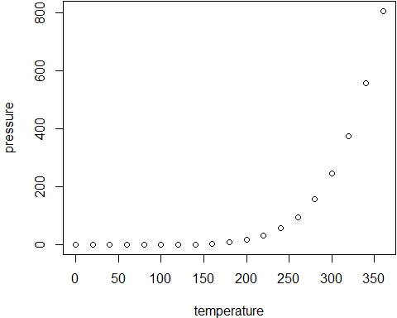

Figure 1 A figure example

Note that the echo = FALSE parameter was added to the code chunk to prevent printing of the R code that generated the plot.

## 表格

一个简单表格：

knitr::kable(  
 head(mtcars[, 1:5], 5), booktabs = TRUE,  
 caption = '表格-mtcars数据'  
)

Table 1 表格-mtcars数据

|  |  |  |  |  |  |
| --- | --- | --- | --- | --- | --- |
|  | mpg | cyl | disp | hp | drat |
| Mazda RX4 | 21.0 | 6 | 160 | 110 | 3.90 |
| Mazda RX4 Wag | 21.0 | 6 | 160 | 110 | 3.90 |
| Datsun 710 | 22.8 | 4 | 108 | 93 | 3.85 |
| Hornet 4 Drive | 21.4 | 6 | 258 | 110 | 3.08 |
| Hornet Sportabout | 18.7 | 8 | 360 | 175 | 3.15 |

# 参考文献

Allaire, JJ, Yihui Xie, Jonathan McPherson, Javier Luraschi, Kevin Ushey, Aron Atkins, Hadley Wickham, Joe Cheng, and Winston Chang. 2018. *Rmarkdown: Dynamic Documents for R*. <https://CRAN.R-project.org/package=rmarkdown>.

Xie, Yihui. 2018. *Bookdown: Authoring Books and Technical Documents with R Markdown*. <https://CRAN.R-project.org/package=bookdown>.