1.

a. 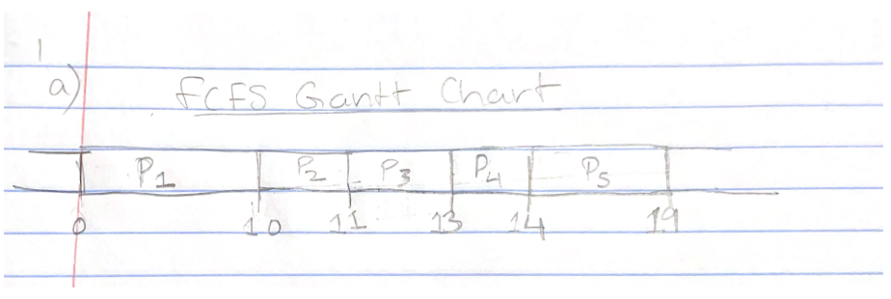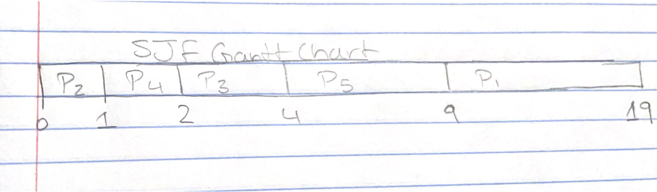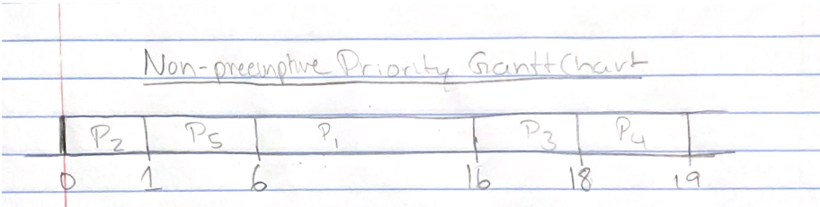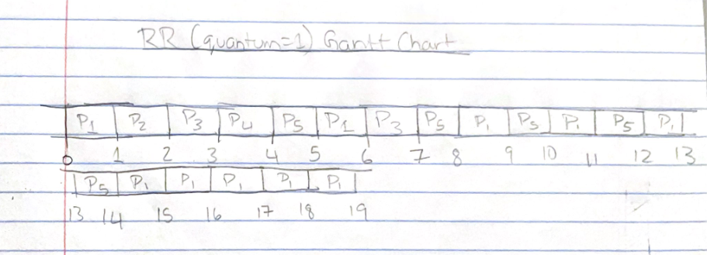

b.

FCFS Average Turnaround Time(ATT) = (p1+p2+p3+p4+p5)/5 = (10+11+13+14+19)/5 = 13.4msecs

SJF ATT = (p1+p2+p3+p4+p5)/5 = (19+1+4+2+9)/5 = 7msecs

Non-preemptive priority ATT = (p1+p2+p3+p4+p5)/5 = (16+1+18+19+6)/5 = 12 msecs

RR(quantum is 1) ATT = (p1+p2+p3+p4+p5)/5 = (19+2+7+4+14)/5 = 9.2 msecs

c.

FCFS Average Waiting Time(AWT) = (p1+p2+p3+p4+p5)/5 = (0+10+11+13+14)/5 = 9.6 msecs

SJF AWT = (p1+p2+p3+p4+p5)/5 = (9+0+2+1+4)/5 = 3.2 msecs

Non-preemptive priority AWT = (p1+p2+p3+p4+p5)/5 = (6+0+16+18+1)/5 = 8.2 msecs

RR(quantum is 1) AWT = (p1+p2+p3+p4+p5)/5 = ((14-1-1-1-1-1) + 1 + (6-1) + 3 + (13 – 4))/5 = 5.4 msecs

d.

The SJF scheduling algorithm had the minimal average waiting time at 3.2 msecs out of all of the other scheduling algorithms.

2.

a. 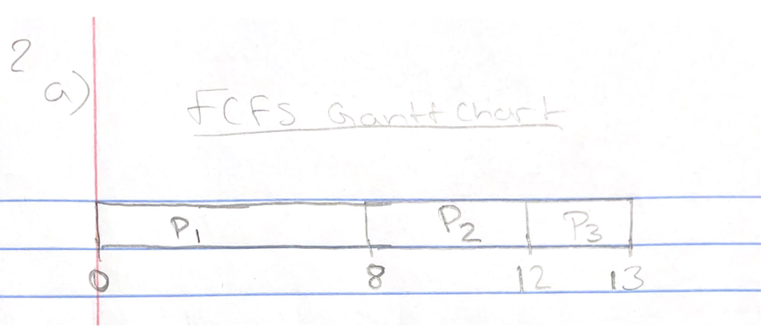

FCFS ATT = (p1 + p2 + p3)/3 = (8+(12-0.4)+(13-1))/3 = 10.53 msecs

b. 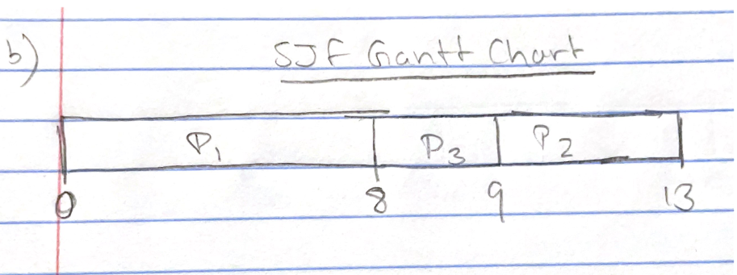

SJS ATT = (p1 + p2 + p3)/3 = (8+(13-0.4)+(9-1))/3 = 9.53 msecs

c.

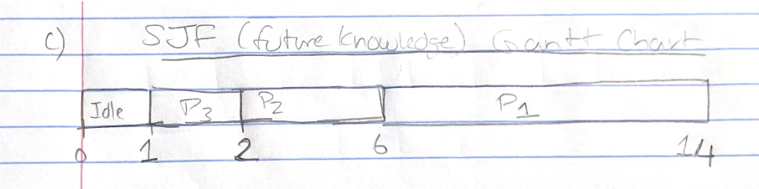

SJF (future knowledge) ATT = (p1 + p2 + p3)/3 = (14+(6-0.4)+(2-1))/3 = 6.87 msecs

3.

The algorithm will favor I/O bound processes because they have relatively low CPU processing requirements. However, this will not permanently starve CPU bound processes because CPU bursts and I/O bursts are part of a bigger program and the I/O bound processes will relinquish control back to the CPU when its done.