893014019

Andrew De La Fuente

Get Victim Improved Assignment

This assignment is for **EXTRA CREDIT**.

Default run of get_Victim_V1 – assumes 32 students

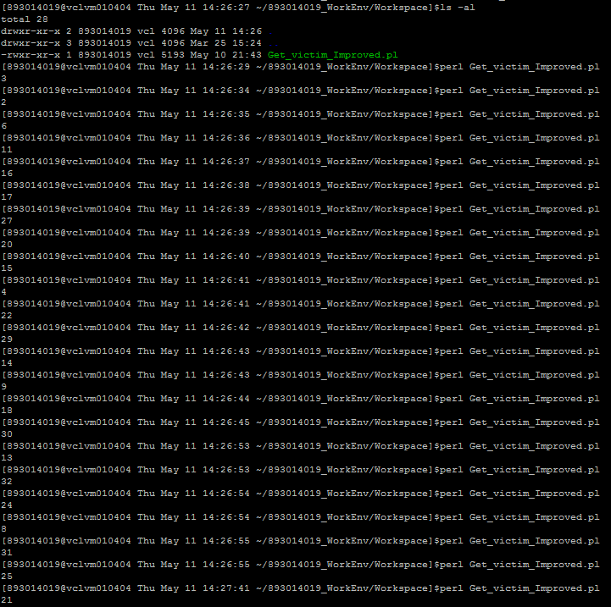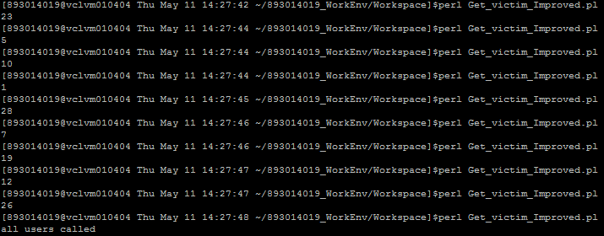

Print out number_called.txt

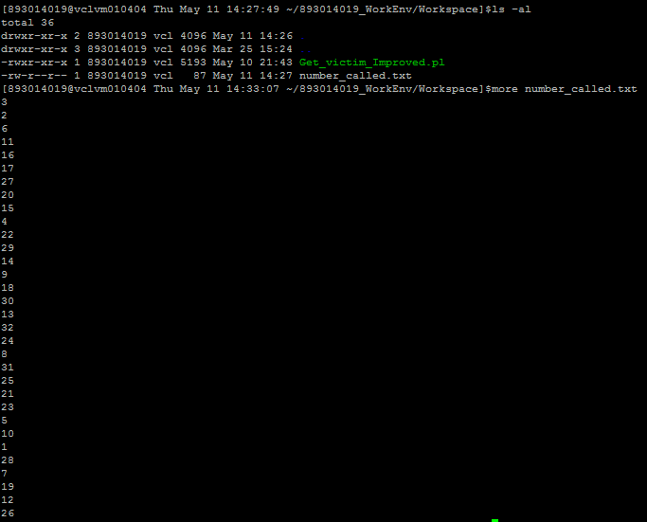

Running getVictim_V1 functionality with 5 numbers and removed number_called.txt

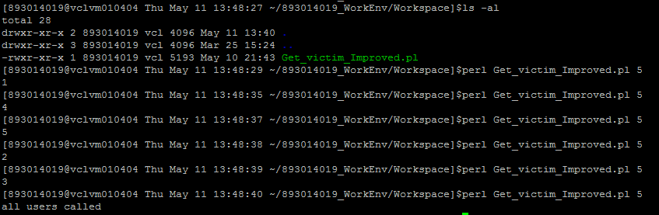

Print all numbers called and add 3 more students to the list

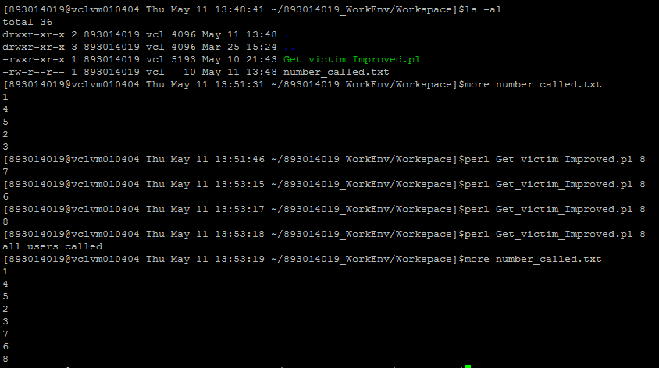

Running getVictim_V2 with student sign in

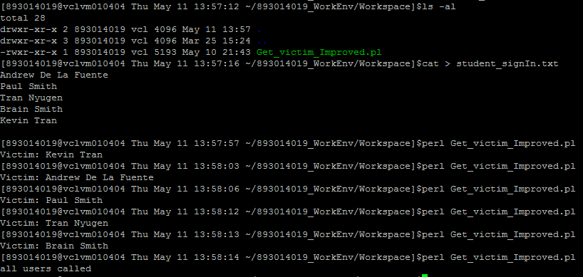

Print out of student called archive file and the actual student signIn with pre-assigned random numbers

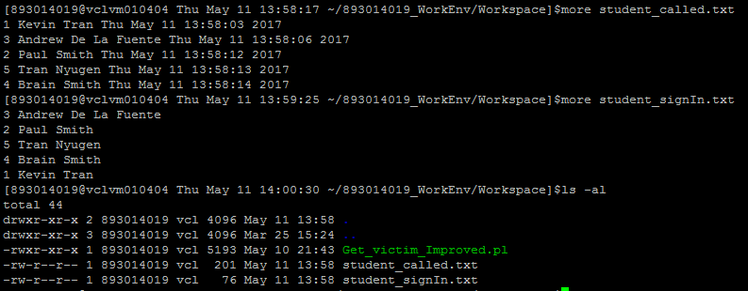

Code of Get_victim.pl

#! /usr/bin/perl

use strict;

use warnings;

use Data::Dumper;

use Scalar::Util qw(looks_like_number);

my @number_called;

my @student_assign;

my @student_called;

my @student_List;

my $random_number;

my $date = localtime();

if (-f "student_signIn.txt") # use Get_victim version 2.0

{

    open(my $read, '<', "student_signIn.txt") or die "student_signIn.txt NOT OPENED!!!!\n";

    while(my $row = <$read>)

    {

        chomp($row);

        push @student_List, $row;

    }

    close($read);

    if (! -f "student_called.txt" && !looks_like_number($student_List[0])) # pre-assign values for all students and create "student_called.txt"

    {

        my $count = 0;

        open(my $overwrite, '>', "student_signIn.txt") or die "student_signIn.txt NOT Wriiten Too!!!!\n";

        while (scalar(@student_assign) < scalar(@student_List))

        {

            my $bValid = 1;

            # if no matches found within the array

            while($bValid eq 1)

            {

                $bValid = 0;

                # Create a new random number if found on the list

                $random_number = int(rand(scalar(@student_List))) + 1;

                # search within the list

                for (my $i=0; $i < scalar(@student_assign); $i++)

                {

                    my @number = split(" ",$student_assign[$i]);

                    if (looks_like_number($number[0]))

                    {

                        if ($number[0] eq $random_number)

                        {

                        $bValid = 1;

                        }

                    }

                }

            }

            $student_assign[$count] = "$random_number $student_List[$count]";

            print $overwrite "$student_assign[$count]\n";

            $count++;

        }

        close($overwrite);

        open(my $create, '>>', "student_called.txt") or die "student_called.txt NOT CREATED!!!!\n";

            open(my $read, '<', "student_signIn.txt") or die "student_signIn.txt NOT OPENED!!!!\n";

            while(my $row = <$read>)

            {

                chomp($row);

                my @line = split(" ",$row);

                if ( $line[0] eq $random_number){

                    print $create "$row $date\n";

                    my @name = split(" ",$row);

                    print "Victim: ";

                    for (my $i=1; $i < scalar(@name); $i++)

                    {

                        print "$name[$i] ";

                    }

                    print "\n";

                }

            }

                close($read);

        close($create);

    }

    else # use pre-existing assigned values

    {

    open($read, '<', "student_called.txt") or die "student_called.txt NOT OPENED!!!!\n";

    while(my $row = <$read>)

    {

        chomp($row);

        push @student_called, $row;

    }

    close($read);

    my $bValid = 1;

        if (scalar(@student_called) < scalar(@student_List))

        {

            my $student;

            # if no matches found within the array

            while($bValid eq 1)

            {

                $bValid = 0;

                # Create a new random number if found on the list

                $random_number = int(rand(scalar(@student_List))) + 1;

                # search within the list

                for (my $i=0; $i < scalar(@student_called); $i++)

                {

                    my @number = split(" ",$student_called[$i]);

                    if ($number[0] eq $random_number)

                    {

                        $bValid = 1;

                    }

                    else

                    {

                        $student = $student_List[$i];

                    }

                }

            }

            open(my $write, '>>', "student_called.txt") or die "student_called.txt NOT Wriiten Too!!!!\n";

            print $write "$student $date\n";

            my @name = split(" ",$student);

            print "Victim: ";

            for (my $i=1; $i < scalar(@name); $i++)

            {

                print "$name[$i] ";

            }

            print "\n";

            close($write);

        }

        else

        {

            print "all users called\n";

        }

    }

}

else # use Get_victim version 1.0

{

    #gather all values that have been called

    if (-f "number_called.txt"){

        open(my $fh, '<', "number_called.txt") or die "number_called.txt NOT OPENED!!!!\n";

        while(my $row = <$fh>)

        {

            chomp($row);

            push @number_called, $row;

        }

        close($fh);

    }

    # Get random number

    if (@ARGV) #custom class size

    {

        my $bValid = 1;

        if (scalar(@number_called) < $ARGV[0])

        {

            # if no matches found within the array

            while($bValid eq 1)

            {

                $bValid = 0;

                # Create a new random number if found on the list

                $random_number = int(rand($ARGV[0])) + 1;

                # search within the list

                for (my $i=0; $i < scalar(@number_called); $i++)

                {

                    if ($number_called[$i] eq $random_number)

                    {

                        $bValid = 1;

                    }

                }

            }

            open(my $fh, '>>', "number_called.txt") or die "number_called.txt NOT Wriiten Too!!!!\n";

            print $fh "$random_number\n";

            print "$random_number\n";

            close($fh);

        }

        else

        {

            print "all users called\n";

        }

    }

    else

    { #Default class size of 32

        my $bValid = 1;

        if (scalar(@number_called) < 32)

        {

            # if no matches found within the array

            while($bValid eq 1)

            {

                $bValid = 0;

                # Create a new random number if found on the list

                $random_number = int(rand(32)) + 1;

                # search within the list

                for (my $i=0; $i < scalar(@number_called); $i++)

                {

                    if ($number_called[$i] eq $random_number)

                    {

                        $bValid = 1;

                    }

                }

            }

            open(my $fh, '>>', "number_called.txt") or die "number_called.txt NOT Wriiten Too!!!!\n";

            print $fh "$random_number\n";

            print "$random_number\n";

            close($fh);

        }

        else

        {

            print "all users called\n";

        }

    }

}