Images Priming

Before we begin using the program, we first need to prepare a folder of images for the script to be able to access. The program uses pyautogui’s locate by image feature to search the computer screen for elements matching those of the images stored in the ‘images’ folder. However, it is not very robust – different screen resolutions/dpi may not be identifiable with the same images. Therefore, the images stored in the current images file may work for display resolution 1920 x 1200, but not for 1280 x 800. To solve this we need to manually go through the CrowdTangle extension process on your computer and screenshot and store the needed checkpoints into the images file. Think of it like walking the program through the process one time, to get it familiar with its new environment. This should only need to be done once.

To begin, make sure the environment setup is finished and your virtual environment is activated (if used). Then, start the image_setup.py script by running in your CLI:

python image_setup.py

This should open the Selenium WebDriver with the Google webpage. Your screen should look something like this:

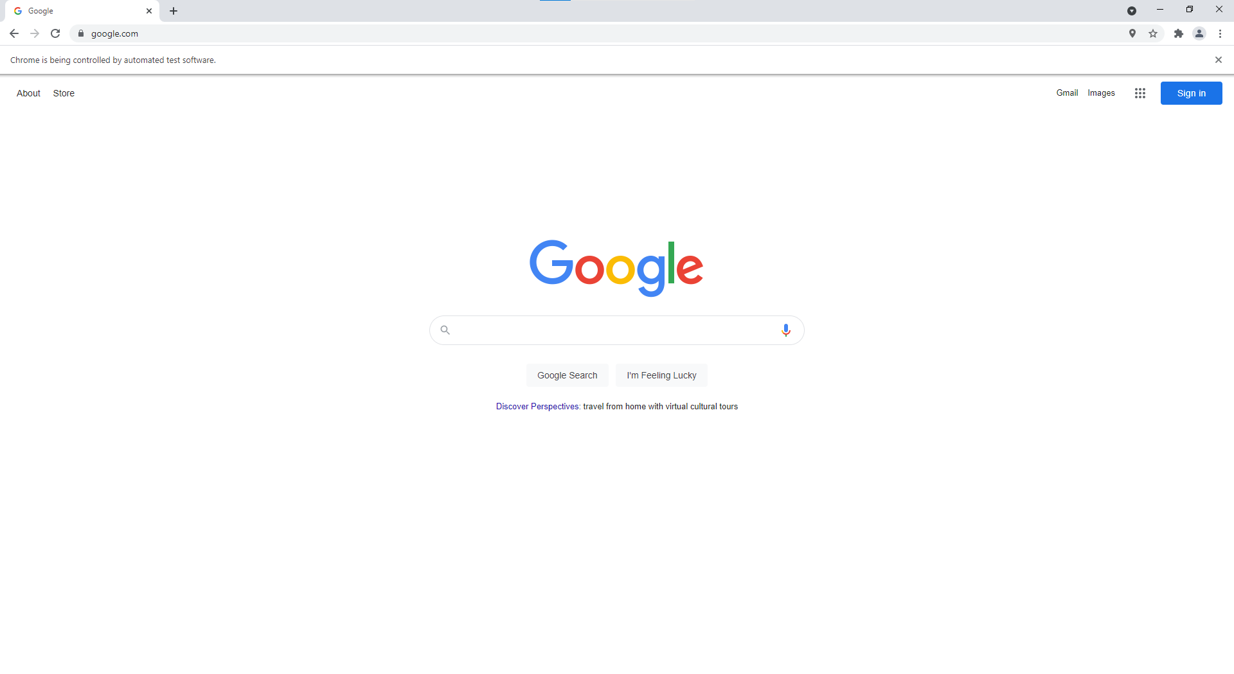

Follow these next steps to set up the images file:

1. Screenshot the extensions icon so that the screenshotted file looks something like this: 

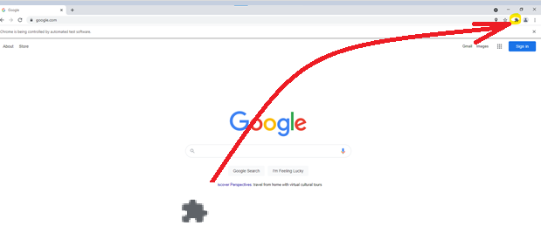

* 1. Replace the screenshotted file in the images folder called ‘extensions_icon.png’ by saving the screenshot as ‘extension_icon.png’ in that folder like so (shown for Windows snip and sketch):

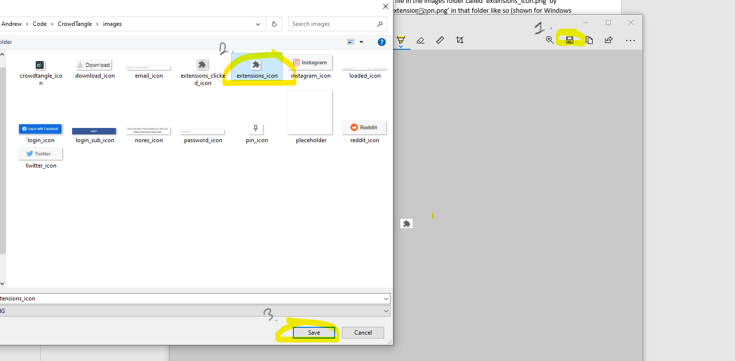

* 1. Click on the extension icon in the actual WebDriver window so that the extensions dialog box is opened.

1. Screenshot the pin icon so the file looks something like this: 

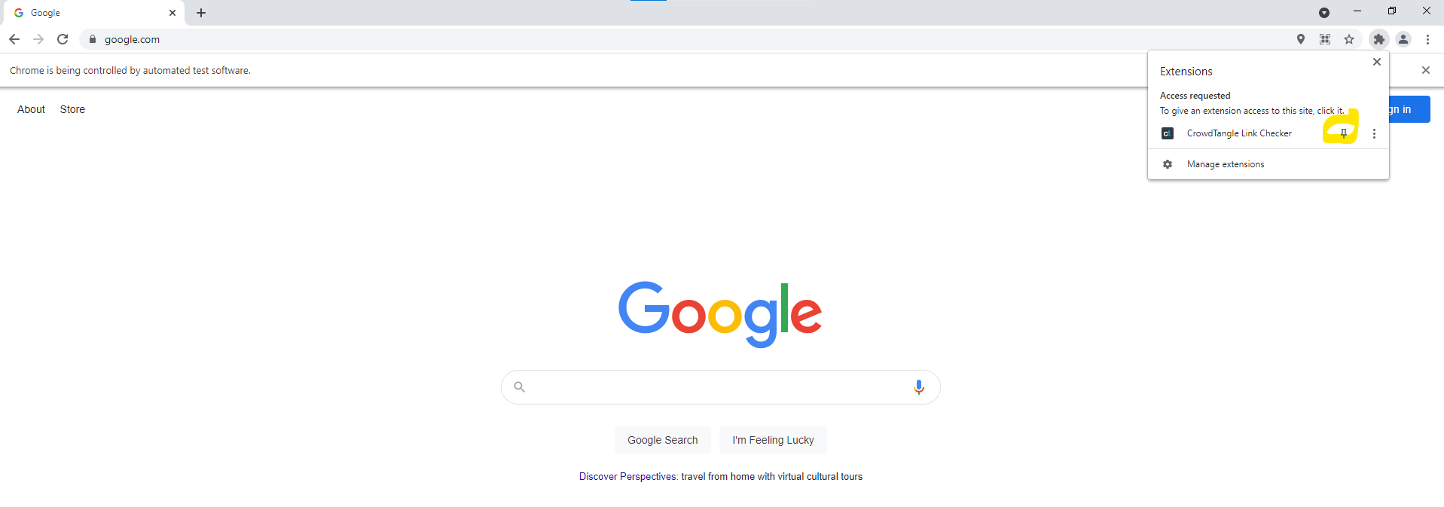

* 1. Replace the file in the images folder called ‘pin_icon.png’ by saving the screenshot as ‘pin_icon.png’ in the same way as described before
  2. Click on the pin icon in the actual WebDriver window

1. Screenshot the extensions icon so the file looks something like this:  (Note: make sure the extensions button is still selected so the area around the image is shaded gray)

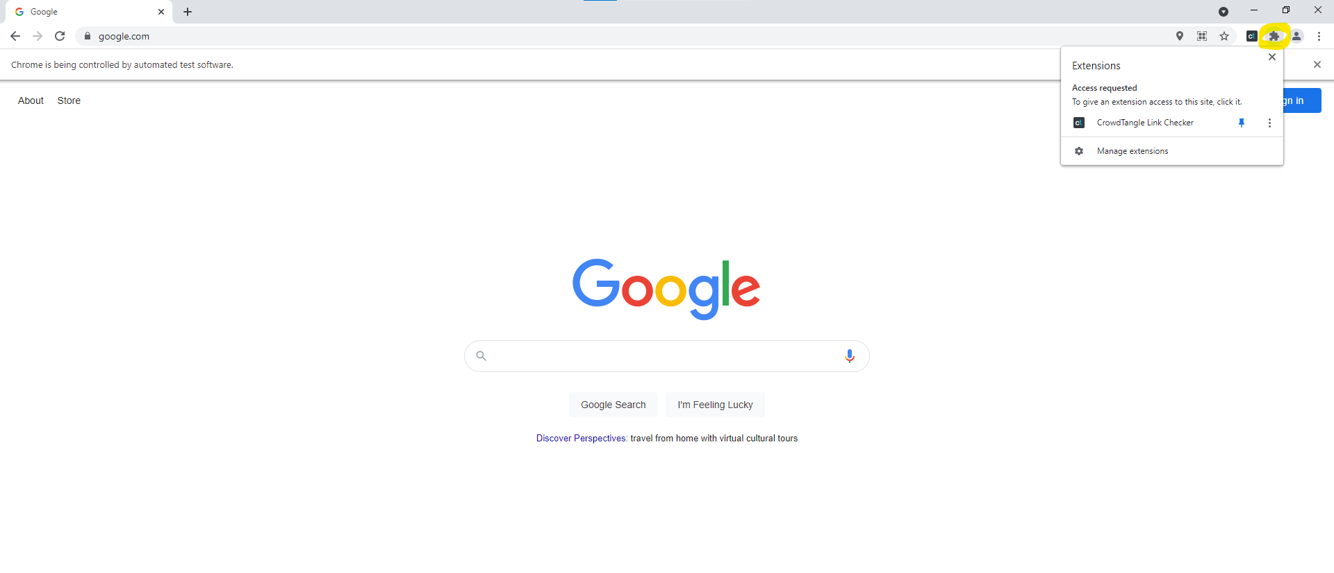

* 1. Replace the file in the images folder called ‘extensions_clicked_icon.png’ by saving the screenshot as ‘extensions_clicked_icon.png’ in the same way as described before
  2. Click on any blank space on the screen in the actual WebDriver window (to close the dialog box)

1. Screenshot the CrowdTangle icon so the file looks something like this: 

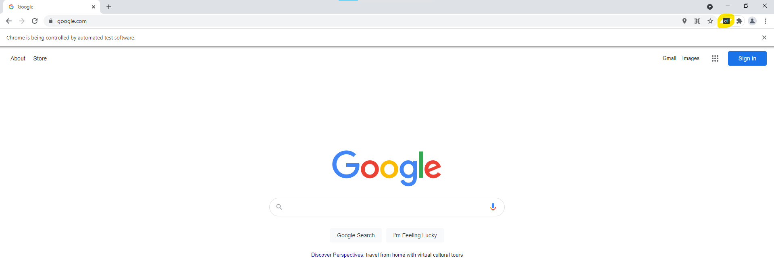

* 1. Replace the file in the images folder called ‘crowdtangle_icon.png’ by saving the screenshot as ‘crowdtangle_icon.png’ in the same way as described before
  2. Click on the crowdtangle icon in the actual WebDriver window

1. After waiting for a tiny bit, a new login tab should’ve opened. Screenshot the login icon so the file looks something like this: 

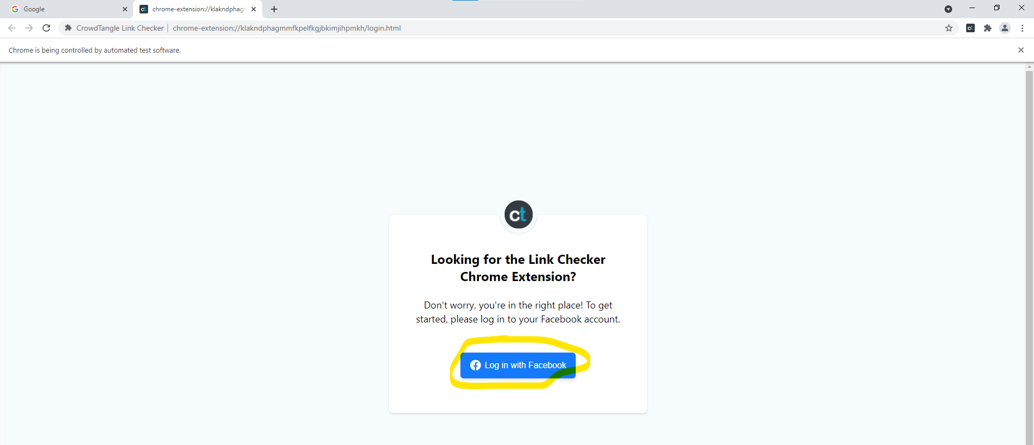

* 1. Replace the file in the images folder called ‘login_icon.png’ by saving the screenshot as ‘login_icon.png’ in the same way as described before
  2. Click on the login icon in the actual WebDriver window

1. A popup should’ve opened asking for Facebook login. Screenshot the email/phone number enter icon so the file looks something like this: 

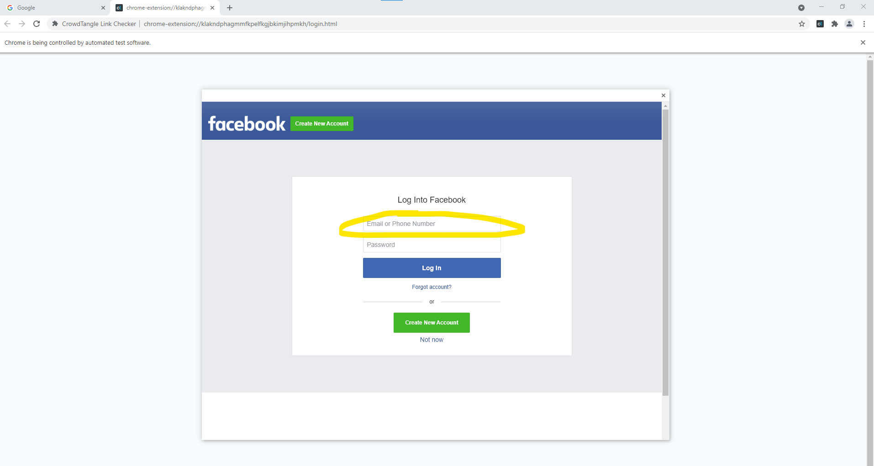

* 1. Replace the file in the images folder called ‘email_icon.png’ by saving the screenshot as ‘email_icon.png’ in the same way as described before
  2. Click on the email/phone number icon in the actual WebDriver window and enter the email associated with your Facebook account

1. Screenshot the (unfilled in) password number enter icon so the file looks something like this: 

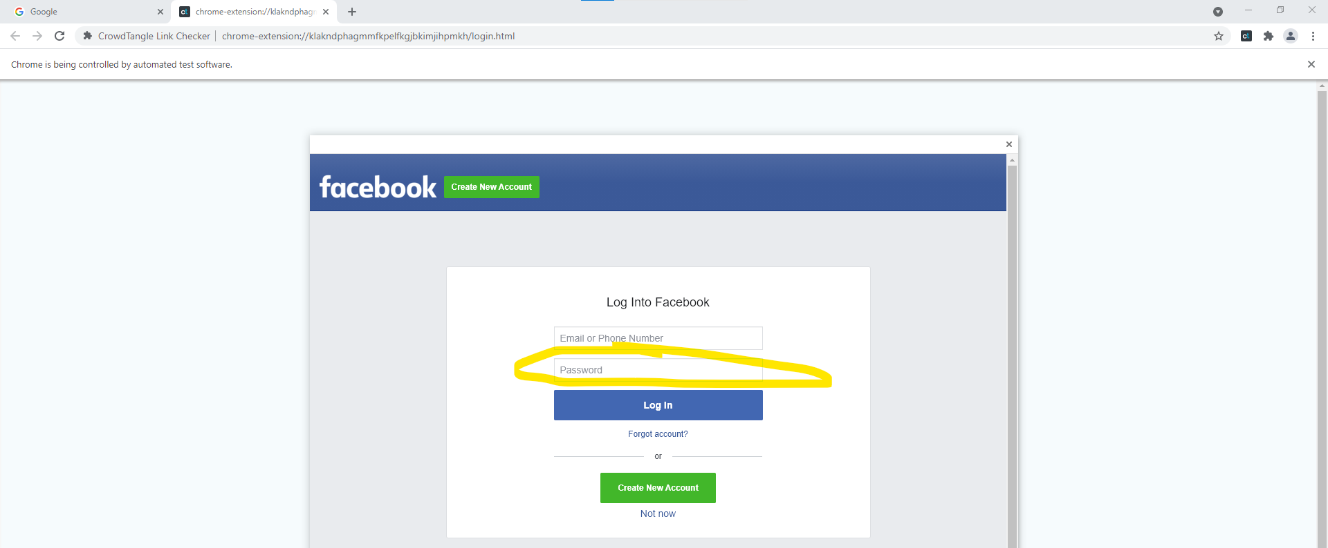

* 1. Replace the file in the images folder called ‘password_icon.png’ by saving the screenshot as ‘password_icon.png’ in the same way as described before
  2. Click on the password icon in the actual WebDriver window and enter the password associated with your Facebook account

1. Screenshot the login submission icon so the file looks something like this: 

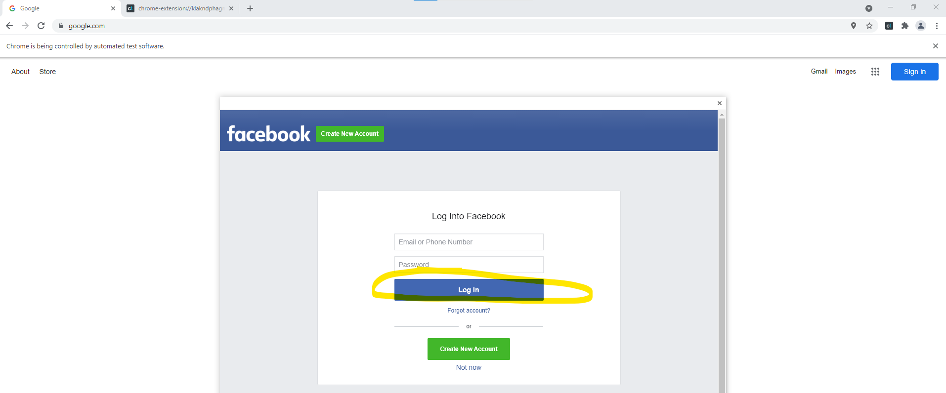

* 1. Replace the file in the images folder called ‘login_sub_icon.png’ by saving the screenshot as ‘login_sub_icon.png’ in the same way as described before
  2. Click on the login submission icon in the actual WebDriver window to submit login

1. The popup window should’ve closed, and we should be back on the Google search page. Now we can access CrowdTangle. Click on the CrowdTangle icon to open the extension. Screenshot the download icon so the file looks like: 

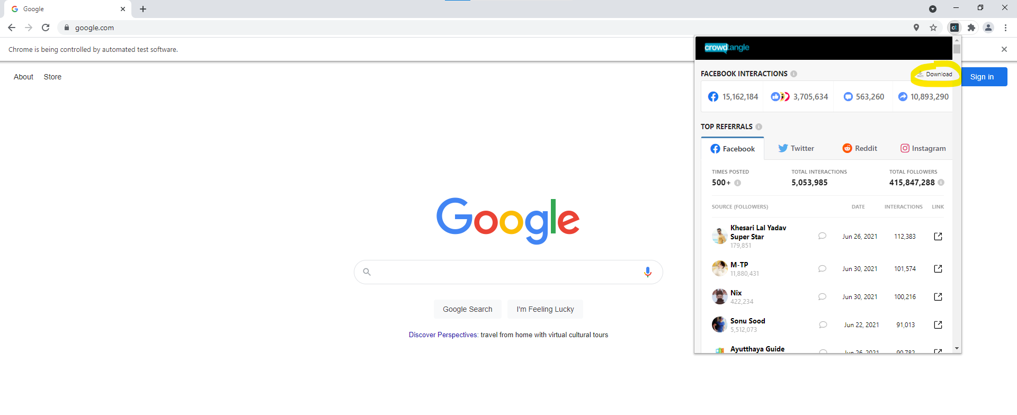

* 1. Replace the file in the images folder called ‘download_icon.png’ by saving the screenshot as ‘download_icon.png’ in the same way as described before
  2. DO NOT click on the download icon. It’s not a big deal if you do, it’s just not necessary at this point

1. With the CrowdTangle extension open, screenshot the Twitter, Reddit, and Instagram logos (Facebook is not required) so the files look like: ,  . Note that the backgrounds should be unclicked (gray as opposed to white)
   1. Replace the files in the images folder called ‘twitter_icon.png’, ‘reddit_icon.png’, ‘instagram_icon.png’ by saving the screenshots as ‘twitter_icon.png’, ‘reddit_icon.png’, ‘instagram_icon.png’ in the same way as described before (twitter image to twitter file, reddit image to reddit file, etc.)
   2. You DO NOT need to click on these icons. Again, no big deal if you do, it’s just not necessary

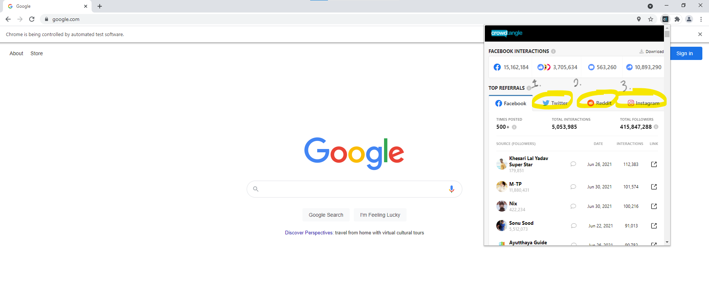

1. Still with the CrowdTangle extension open, screenshot the row headers so the files look like: 
   1. Replace the file in the images folder called ‘loaded_icon.png’ by saving the screenshot as ‘loaded_icon.png’ in the same way as described before
   2. DO NOT click on it. This one doesn’t really do anything.

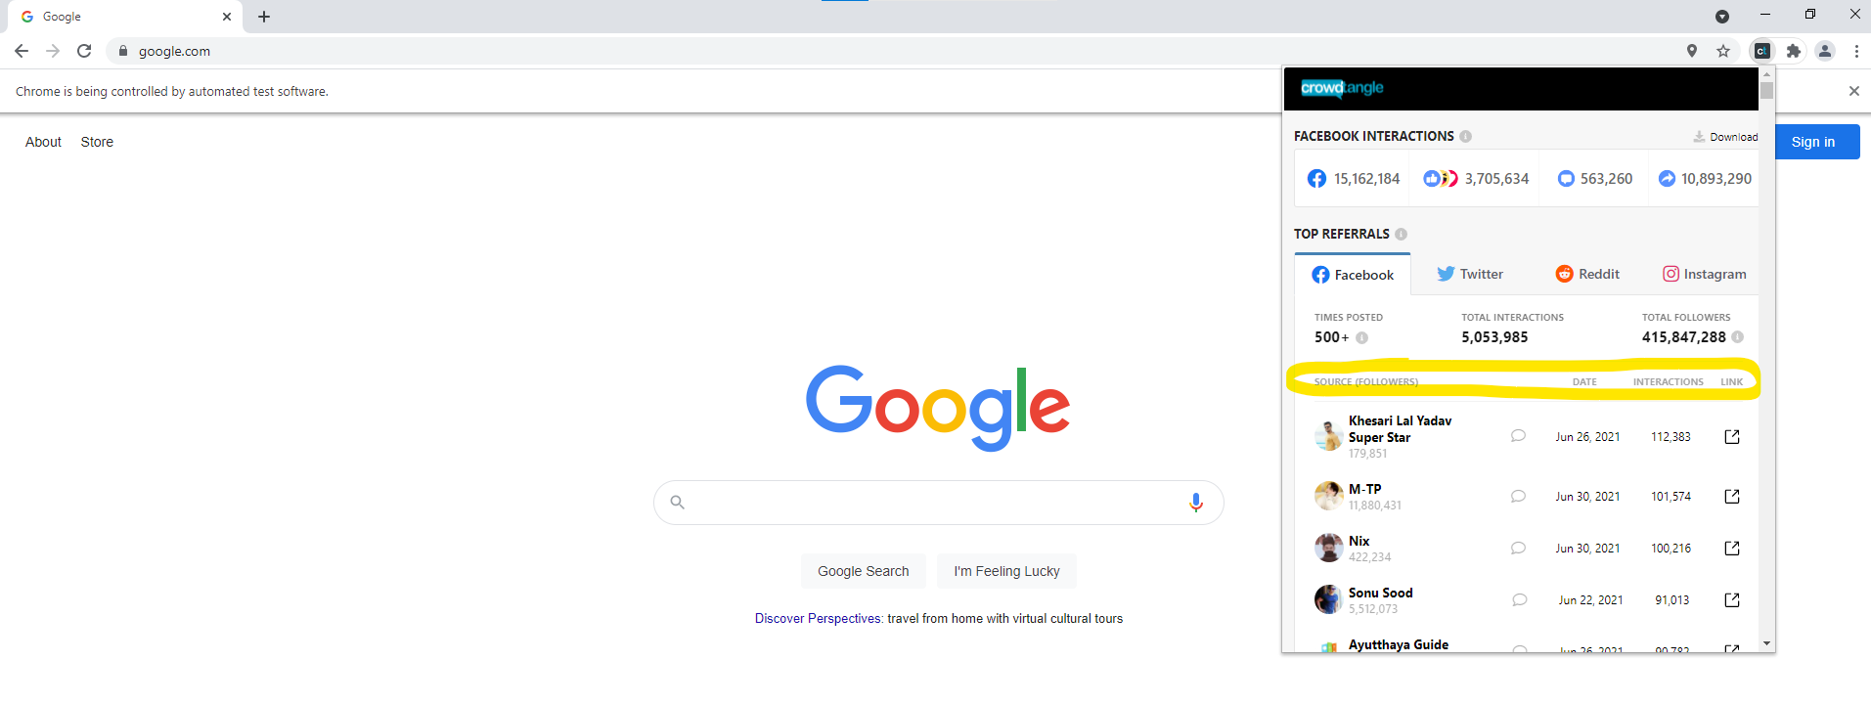

1. Last image! Copy and paste a new link that isn’t commonly cited in a new tab (still in the WebDriver). You can use this link if you’d like:
   1. <https://www.pokemon.com/us/pokedex/squirtle>
   2. Open CrowdTangle and ensure your screen has the circled region (if it doesn’t, try clicking on the Twitter or Instagram tabs):

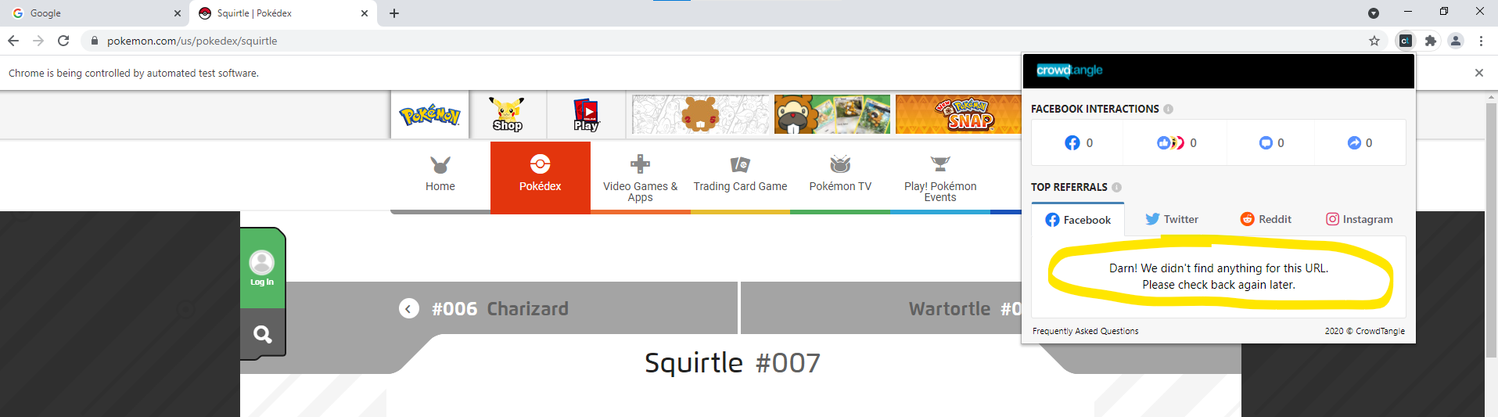

* 1. Screenshot the highlighted section so that the file looks like: 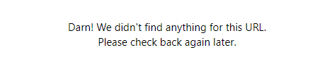
  2. Replace the file in the images folder called ‘nores_icon.png’ by saving the screenshot as ‘nores_icon.png’ in the same way as described before
  3. NO need to click on it. Again, it doesn’t do anything.

1. You can leave the ‘placeholder.png’ file be
2. All Done! The image folder setup should be all set