LESSON 5 - PRACTICES
—-------

CHAPTER 8: USE CASE APPROACH

Use case Diagram:
- Draw a Use case diagram representing the User Requirement of a Xanh SM Mobile Application.
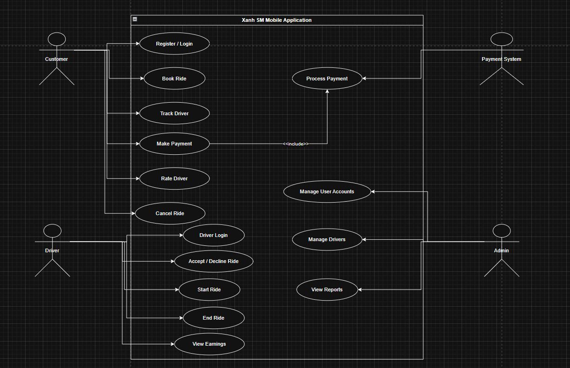

Use case Specification:
- Analyse and write a use case specification for use case “booking car” in the Xanh SM Mobile Application.
ID and Name | UC-1 Book a Car
Created By | Nguyen Duy Nam
Date Created | 30/09/2025
Primary Actor | Customer
Secondary Actors | Driver, Payment System, Notification Service, GPS/Map Service
Description | The customer opens the Xanh SM mobile app, chooses pickup and destination, sees available car types and estimated price. The customer confirms the booking, the system finds a driver, and shows trip and driver information in real time.
Trigger | Customer selects the “Book a Car” function in the app.
Preconditions | PRE-1: The user is logged in.  PRE-2: The system can get the user's current location.  PRE-3: Internet connection is available.  PRE-4: GPS/location service is working.
Postconditions | POST-1: The booking request is stored in the system.  POST-2: A driver is assigned (if available).  POST-3: The customer gets driver and trip information.
Normal Flow | 1.0 Book a Car  - The customer opens the app and selects "Book a Car."  - The system shows the current location or lets the user enter a pickup point.  - The customer enters the destination.  - The system shows estimated price and available car types.  - The customer chooses a car type.  - The customer confirms the booking.  - The system searches for a nearby driver.  - A driver accepts the trip.  - The system shows driver information (name, license plate, phone, location).  - The system updates the trip status in real time.
Alternative Flows | 2.1 No Driver Available  - The system shows a message: "No drivers available right now."  - The customer can try again or exit.  3a. If retry → go back to step 7 (Normal Flow).  3b. If exit → the use case ends.  2.2 Customer Changes Destination Before Driver Is Found  - The customer changes destination.  - The system updates the price.  - Go back to step 4 (Normal Flow).
Exceptions | E1: No Internet Connection  - The system shows "Connection lost. Please try again."  - The use case pauses until the customer tries again.  E2: GPS Cannot Detect Location  - The system asks the user to enter the pickup point manually.  - Go back to step 3 (Normal Flow).
Priority | High
Frequency of Use | Used many times per day by many users.
Business Rules | BR-01: The price must be shown before confirmation.  BR-02: Only nearby drivers receive the request.  BR-03: Only one driver is assigned per booking.
Other Information | - Works with maps, notifications, and payment services.  - Trip history may be saved.
Assumptions | - The customer knows how to enter locations.  - There are online drivers in the service area.

