1. Draw at least three state transition diagrams to represent the states and transitions of three objects that require state management in the system.
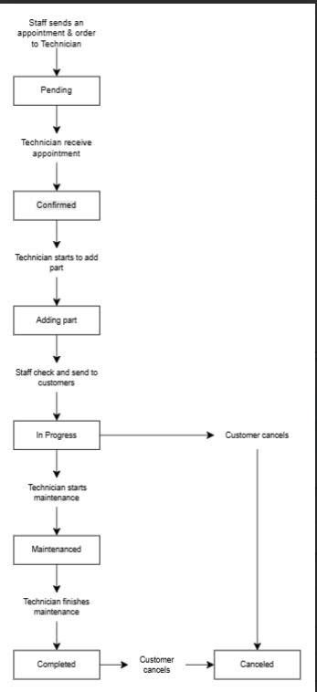
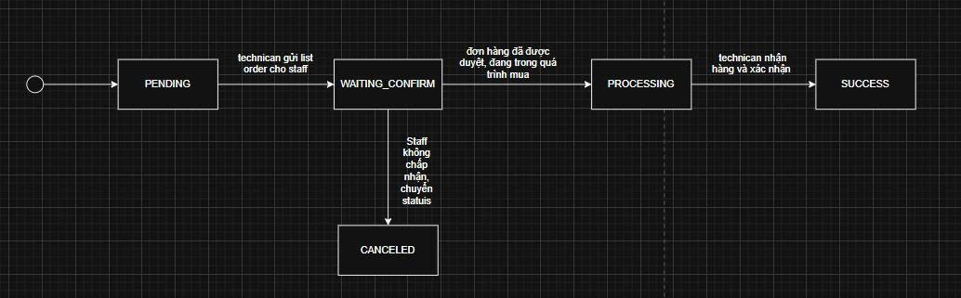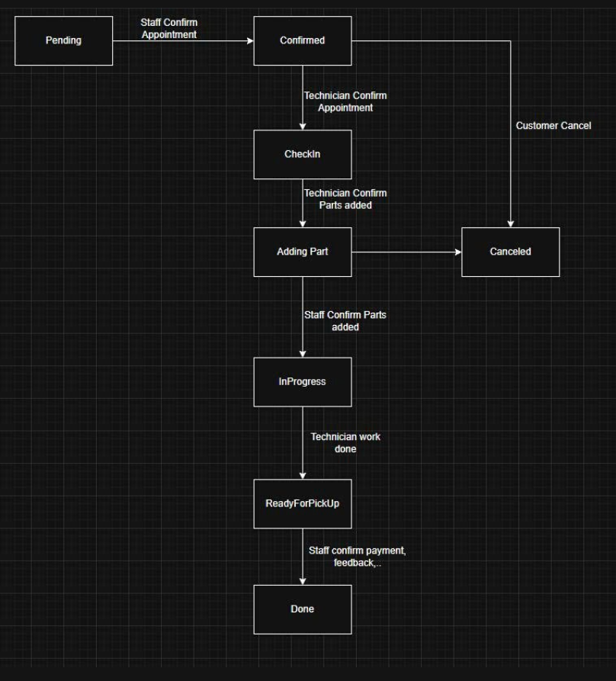
2. Draw at least one DFD (Data Flow Diagram) representing one core flow of the system.
