**Ex 3.12: Steerable filters (Freeman and Adelson’s)**

1. Get the initial Gaussian
$$G\left(x,y,σ\right)= \frac{1}{2πσ^{2}}e^{-\frac{x^{2}+y^{2}}{2σ^{2}}}$$

2. Get the gradient components $G_{x}$ and $G_{y}$
3. Get the smoothed directional derivative filter,

$$G_{\hat{u}}=uG_{x}+vG_{y}$$

where $\hat{u}=\left(u,v\right)=\left(\cos{θ, \sin{θ}}\right)$

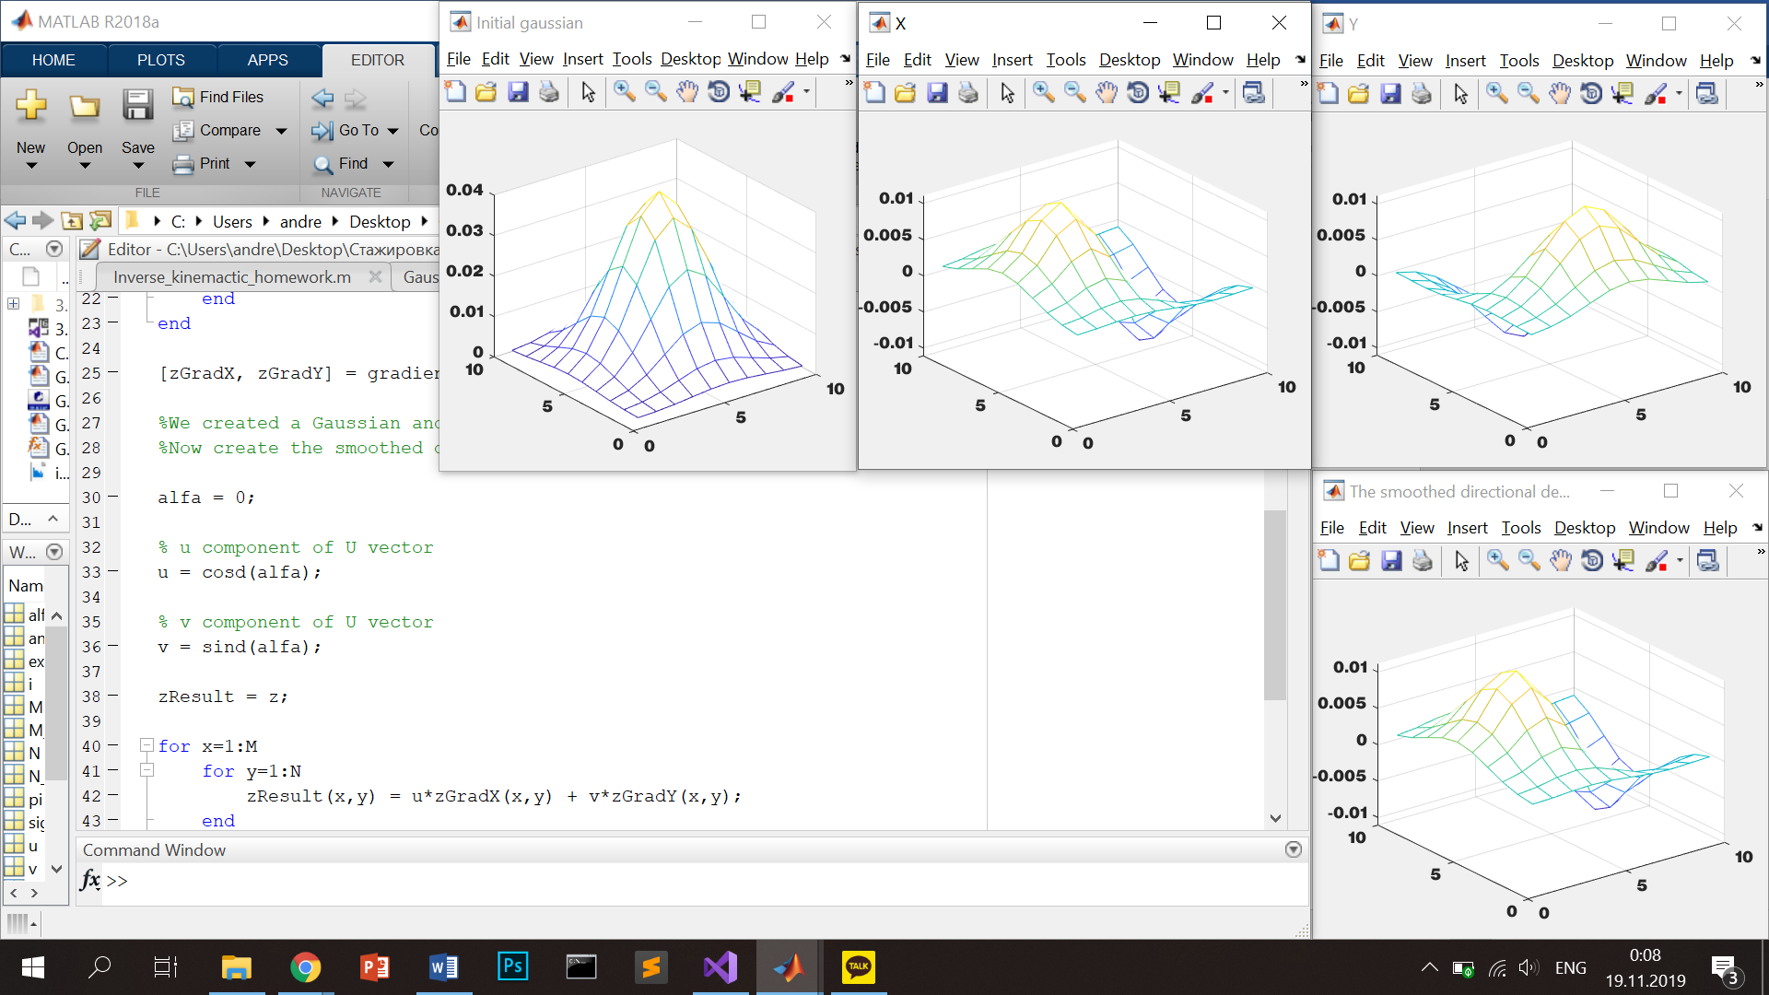

Then by changing the angle of rotation we can obtain different filters:

0 degrees 30 degrees

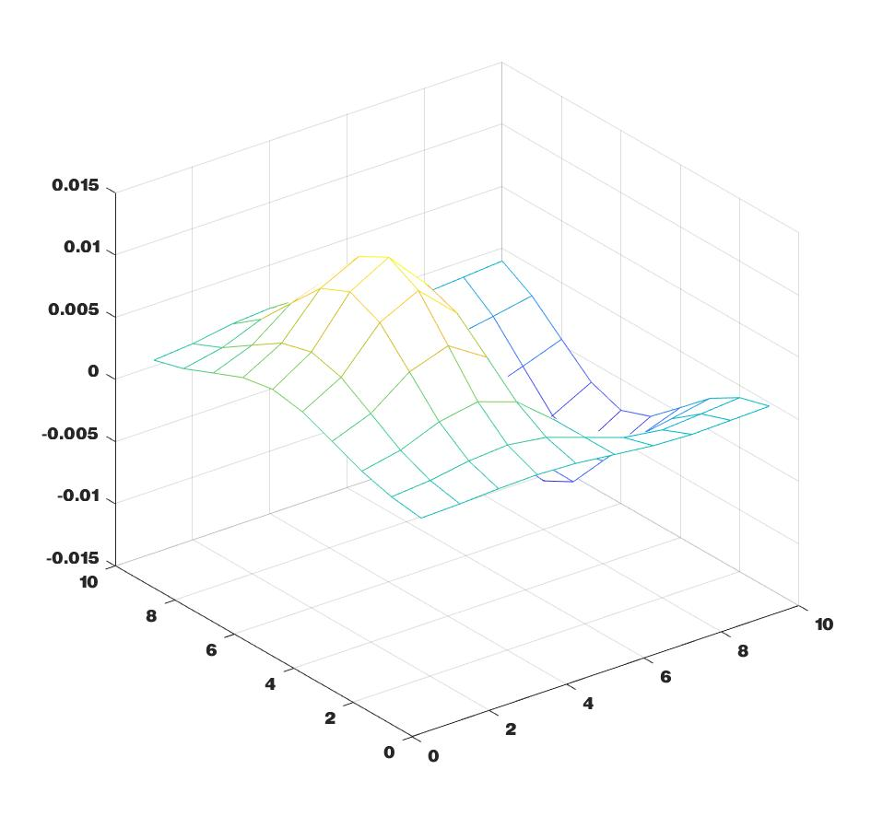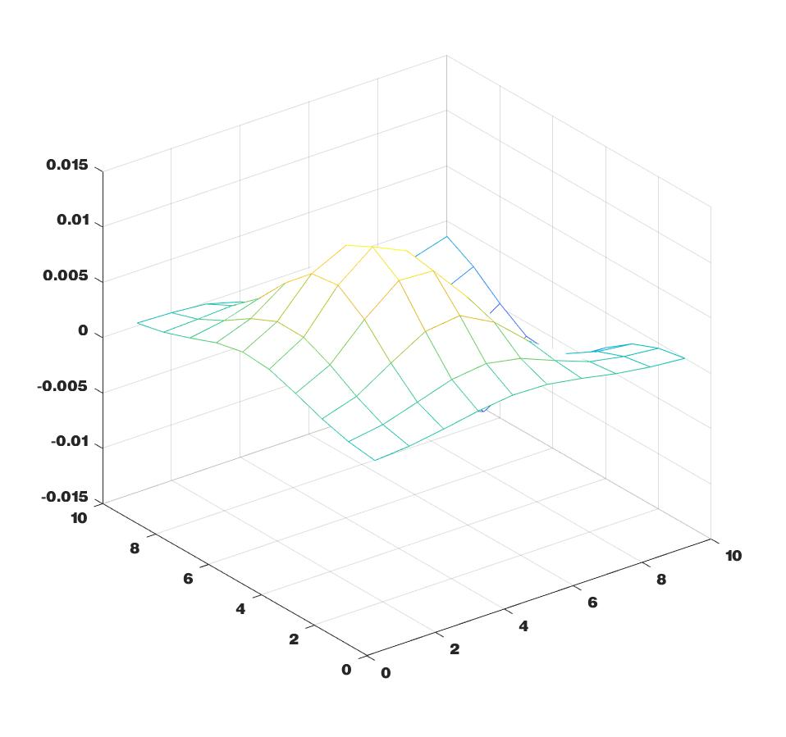

180 degrees 270 degrees

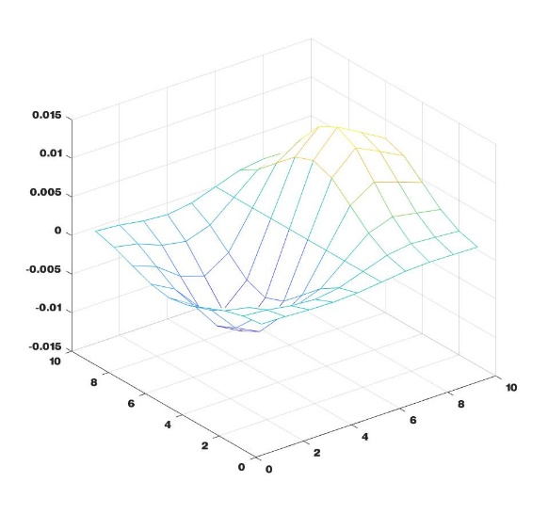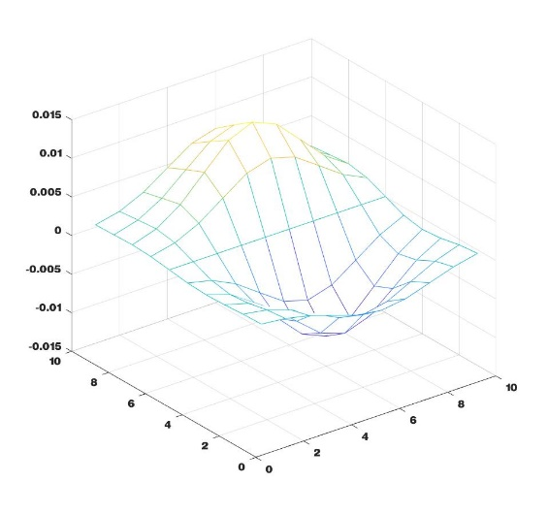

It can be used for detection of the boundaries of objects, analysis of oriented textures, determination of the volumetric shape of an object from the maps of its shading.