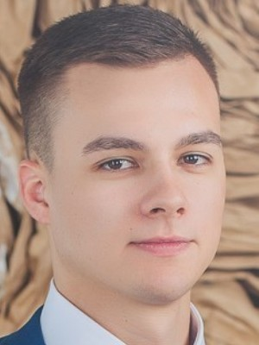  
**Rudnik Andrey Aleksandrovich**

## Front-end Developer

Full-time employment.

Age: 29 years

City: Kiev

**Contact information**

Phone: (063)324-87-52

Mail: [andr.rudnik@gmail.com](mailto:andr.rudnik@gmail.com)

Social networks: LinkedIn (<https://www.linkedin.com/in/andrey-rudnik-smile/>)

Github <https://github.com/Andrey-rudnik>,

Portfolio <https://andrey-rudnik.github.io/>

## Additional information I'm a Front-end Developer with commercial experience of about 2 years. During the time of work I gained skills to work under the CEO, optimization, and acceleration of sites, also purchase domains, work with FTP.

Knowledge, skills**:**  
HTML/HTML5 (2 years of experience) Advanced, use now.

CSS / SCSS (2 years of experience) Advanced, use now.

JS IE6 +, jQuery (2 years of experience) Mid-level, use now.

Bootstrap 3, 4 (2 years of experience) Advanced, use now.

BEM methodology (2 years of experience) Mid-level, use now.

WordPress (1.5 years of experience) Mid-level, use now.

PHP (1.5 years of experience) Low-level, use now.

React.js (6 months of experience) Beginner, use now.

Vue.js (Components layout) Beginner

GIT (1 year of experience) Mid-level, use now.

Gulp (1 year of experience) Mid-level, use now.

Adobe Photoshop, Figma (2 years of experience) Mid-level, use now.

Responsive, adaptive HTML-coding

**Experience**

Front-end developer

November 2019 - till now at NDA

* development of a couple of blogs on React.js, also layout of React.js components on other sites
* development sites on the WordPress
* development sites on HTML, CSS, JS
* working with SEO Specialist

Junior front-end developer

### Jun 2019 - October 2019 at GS4B (Global Solutions for your Business)

* development sites on the WordPress

### Military at Ministry of Defence (Engineer)

Jun 2014 - May 2019

### **Education**

### Military Institute at National Technical University of Ukraine

### “Kyiv Polytechnic institute”

Specialization: Telecommunication  
Вища, July 2009 – June 2014 (4 years 11 months)

## Additional education

* GoIt, Front-end Core (2017, 3 months)
* GоIt, JavaScript (2018, 3,5 months)

## Languages

* English ─ Intermediate
* Ukrainian ─ Native
* Russian ─ Fluency

**Personal qualities:**

Attentiveness to detail, sociability, desire for constant development and training.