|  |
| --- |
| МИНОБРНАУКИ РОССИИ |
|  |
| Федеральное государственное бюджетное образовательное учреждение  высшего образования  **«МИРЭА – Российский технологический университет»**  **РТУ МИРЭА** |
| Институт кибербезопасности и цифровых технологий |
|  |

**Практическая работа № 5,**

по дисциплине: **«Технологии и методы программирования»**.

Выполнил студент 3 курса группы БИСО-01-21 Нагибин А. А.

Проверил преподаватель Лесько С.А.

Москва 2024

# Абстрактная фабрика

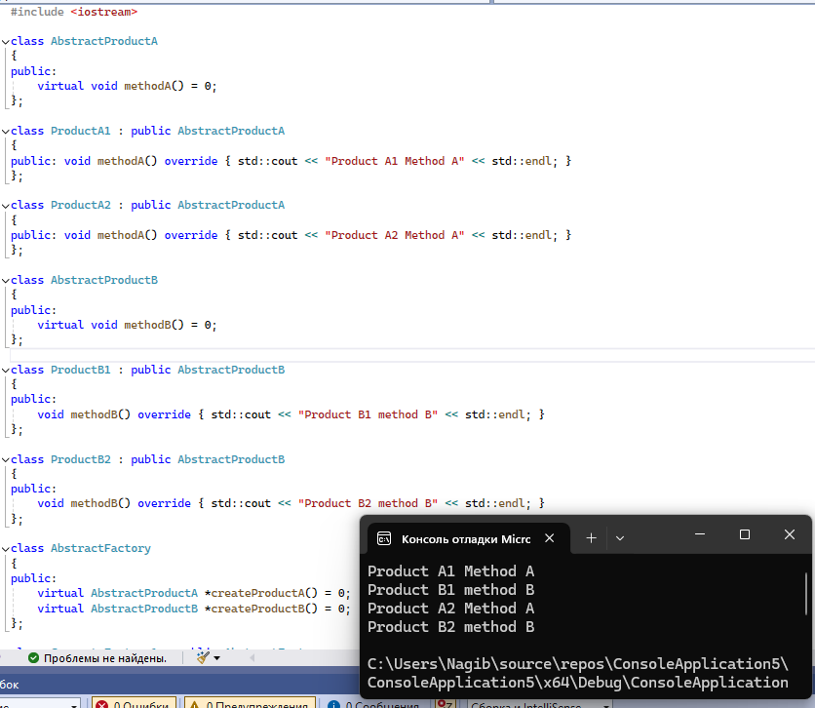

Рисунок 1 – листинг программы и результат работы

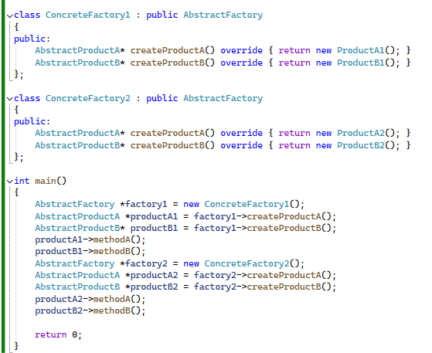

Рисунок 2 – листинг программы

Листинг программы:

#include <iostream>

class AbstractProductA

{

public:

virtual void methodA() = 0;

};

class ProductA1 : public AbstractProductA

{

public: void methodA() override { std::cout << "Product A1 Method A" << std::endl; }

};

class ProductA2 : public AbstractProductA

{

public: void methodA() override { std::cout << "Product A2 Method A" << std::endl; }

};

class AbstractProductB

{

public:

virtual void methodB() = 0;

};

class ProductB1 : public AbstractProductB

{

public:

void methodB() override { std::cout << "Product B1 method B" << std::endl; }

};

class ProductB2 : public AbstractProductB

{

public:

void methodB() override { std::cout << "Product B2 method B" << std::endl; }

};

class AbstractFactory

{

public:

virtual AbstractProductA *createProductA() = 0;

virtual AbstractProductB *createProductB() = 0;

};

class ConcreteFactory1 : public AbstractFactory

{

public:

AbstractProductA* createProductA() override { return new ProductA1(); }

AbstractProductB* createProductB() override { return new ProductB1(); }

};

class ConcreteFactory2 : public AbstractFactory

{

public:

AbstractProductA* createProductA() override { return new ProductA2(); }

AbstractProductB* createProductB() override { return new ProductB2(); }

};

int main()

{

AbstractFactory *factory1 = new ConcreteFactory1();

AbstractProductA *productA1 = factory1->createProductA();

AbstractProductB* productB1 = factory1->createProductB();

productA1->methodA();

productB1->methodB();

AbstractFactory *factory2 = new ConcreteFactory2();

AbstractProductA *productA2 = factory2->createProductA();

AbstractProductB *productB2 = factory2->createProductB();

productA2->methodA();

productB2->methodB();

return 0;

}

# Строитель

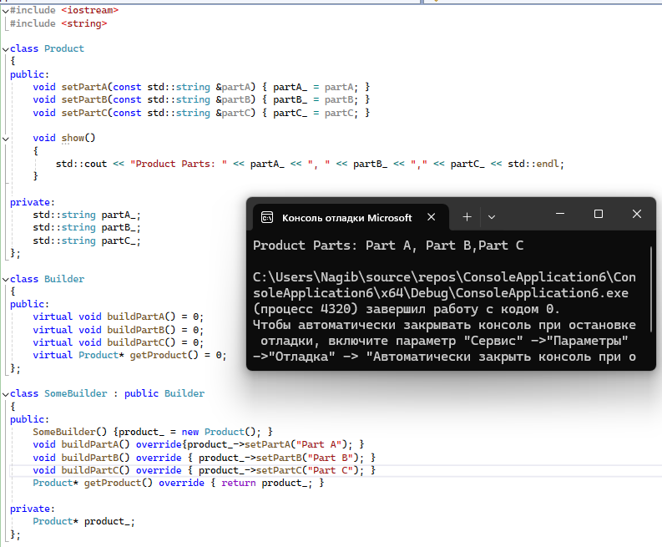

Рисунок 3 – листинг программы и результат работы

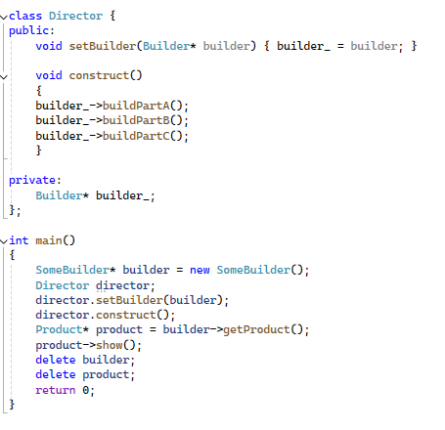

Рисунок 4 – листинг программы

Листинг программы:

#include <iostream>

#include <string>

class Product

{

public:

void setPartA(const std::string &partA) { partA_ = partA; }

void setPartB(const std::string &partB) { partB_ = partB; }

void setPartC(const std::string &partC) { partC_ = partC; }

void show()

{

std::cout << "Product Parts: " << partA_ << ", " << partB_ << "," << partC_ << std::endl;

}

private:

std::string partA_;

std::string partB_;

std::string partC_;

};

class Builder

{

public:

virtual void buildPartA() = 0;

virtual void buildPartB() = 0;

virtual void buildPartC() = 0;

virtual Product* getProduct() = 0;

};

class SomeBuilder : public Builder

{

public:

SomeBuilder() {product_ = new Product(); }

void buildPartA() override{product_->setPartA("Часть A"); }

void buildPartB() override { product_->setPartB("Часть B"); }

void buildPartC() override { product_->setPartC("Часть C"); }

Product* getProduct() override { return product_; }

private:

Product* product_;

};

class Director {

public:

void setBuilder(Builder* builder) { builder_ = builder; }

void construct()

{

builder_->buildPartA();

builder_->buildPartB();

builder_->buildPartC();

}

private:

Builder* builder_;

};

int main()

{

SomeBuilder* builder = new SomeBuilder();

Director director;

director.setBuilder(builder);

director.construct();

Product* product = builder->getProduct();

product->show();

delete builder;

delete product;

return 0;

}

# Адаптер

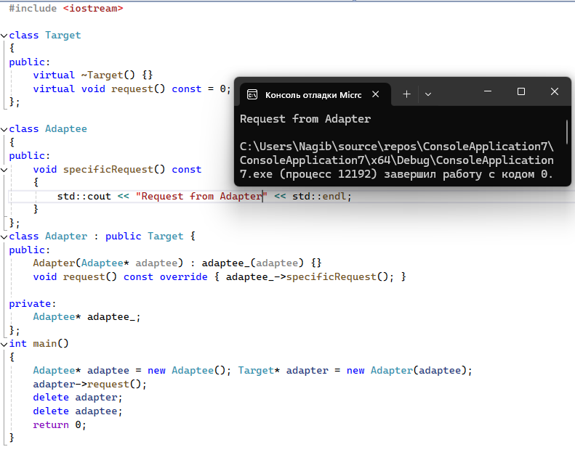

Рисунок 3 – листинг программы и результат работы

Листинг программы:

#include <iostream>

class Target

{

public:

virtual ~Target() {}

virtual void request() const = 0;

};

class Adaptee

{

public:

void specificRequest() const

{

std::cout << "Request from Adapter" << std::endl;

}

};

class Adapter : public Target {

public:

Adapter(Adaptee* adaptee) : adaptee_(adaptee) {}

void request() const override { adaptee_->specificRequest(); }

private:

Adaptee* adaptee_;

};

int main()

{

Adaptee* adaptee = new Adaptee(); Target* adapter = new Adapter(adaptee);

adapter->request();

delete adapter;

delete adaptee;

return 0;

}

# Посредник

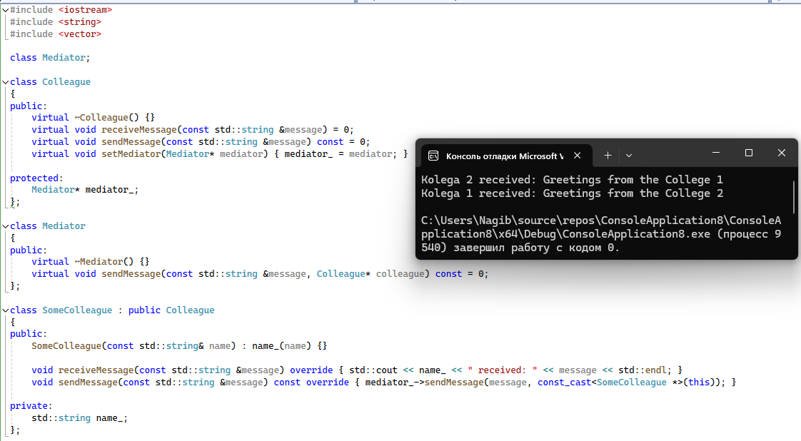

Рисунок 4 – листинг программы и результат работы

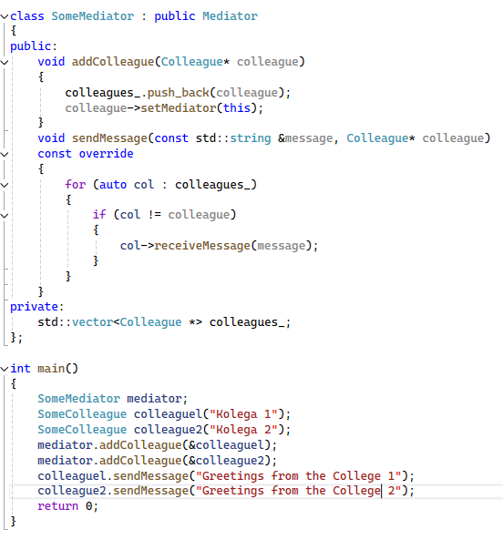

Рисунок 5 – листинг программы

Листинг программы:

#include <iostream>

#include <string>

#include <vector>

class Mediator;

class Colleague

{

public:

virtual ~Colleague() {}

virtual void receiveMessage(const std::string &message) = 0;

virtual void sendMessage(const std::string &message) const = 0;

virtual void setMediator(Mediator* mediator) { mediator_ = mediator; }

protected:

Mediator* mediator_;

};

class Mediator

{

public:

virtual ~Mediator() {}

virtual void sendMessage(const std::string &message, Colleague* colleague) const = 0;

};

class SomeColleague : public Colleague

{

public:

SomeColleague(const std::string& name) : name_(name) {}

void receiveMessage(const std::string &message) override { std::cout << name_ << " received: " << message << std::endl; }

void sendMessage(const std::string &message) const override { mediator_->sendMessage(message, const_cast<SomeColleague *>(this)); }

private:

std::string name_;

};

class SomeMediator : public Mediator

{

public:

void addColleague(Colleague* colleague)

{

colleagues_.push_back(colleague);

colleague->setMediator(this);

}

void sendMessage(const std::string &message, Colleague* colleague)

const override

{

for (auto col : colleagues_)

{

if (col != colleague)

{

col->receiveMessage(message);

}

}

}

private:

std::vector<Colleague *> colleagues_;

};

int main()

{

SomeMediator mediator;

SomeColleague colleaguel("Kolega 1");

SomeColleague colleague2("Kolega 2");

mediator.addColleague(&colleaguel);

mediator.addColleague(&colleague2);

colleaguel.sendMessage("Greetings from the College 1");

colleague2.sendMessage("Greetings from the College 2");

return 0;

}