HW6_Reloaded_R_code.R

AM

2020-11-12

#source("http://math.ucdenver.edu/~jfrench/data/bayesdists.R")  
#devtools::install_github("jfrench/bayesutils")  
library(mvtnorm)  
library(bayesplot)

## This is bayesplot version 1.7.2

## - Online documentation and vignettes at mc-stan.org/bayesplot

## - bayesplot theme set to bayesplot::theme_default()

## * Does _not_ affect other ggplot2 plots

## * See ?bayesplot_theme_set for details on theme setting

library(invgamma)  
library(coda)  
library(rstan)

## Loading required package: StanHeaders

## Loading required package: ggplot2

## rstan (Version 2.21.2, GitRev: 2e1f913d3ca3)

## For execution on a local, multicore CPU with excess RAM we recommend calling  
## options(mc.cores = parallel::detectCores()).  
## To avoid recompilation of unchanged Stan programs, we recommend calling  
## rstan_options(auto_write = TRUE)

##   
## Attaching package: 'rstan'

## The following object is masked from 'package:coda':  
##   
## traceplot

set.seed(77)  
y = bayesutils::rinvgamma(100, 2, 3)  
range(y)

## [1] 0.4647718 12.0184742

mean(y)

## [1] 2.520916

sd(y)

## [1] 2.244544

sum_inv = sum(1/y)  
sigma = 0.3  
beta_a = 1.01  
beta_b = 1.01  
### 1b  
log_q_alpha = function (a, b) {  
 100*a*log(b) +   
 (a+1)*sum(log(1/y)) -  
 100 * log(factorial(a-1))  
}  
alpha_seq = seq(1,5, length=500)  
beta_point = 6  
plot(alpha_seq, log_q_alpha(a = alpha_seq, b=beta_point), ylab = "log_q_alpha",   
 type = "l", col = "blue")  
title("beta_point = 6")

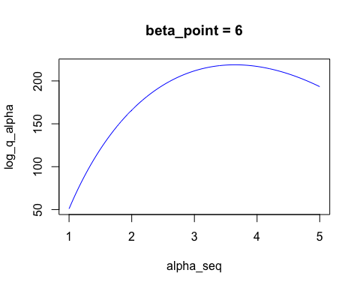

plot(alpha_seq, dbeta((alpha_seq-1)/4, 1.01,1.01), ylab = "density",   
 type = "l", col = "blue")  
title("Beta(1.01, 1.01)*4 + 1")

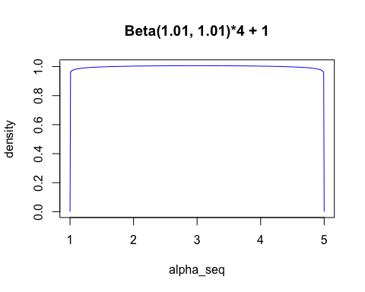

### 1b  
alpha_point = 2  
beta_seq = seq(1, 7, length = 1000)  
  
d_beta = function(a, b) {  
 dgamma(b, shape = (100*a + 4), rate = (4 + sum_inv))  
}  
plot(beta_seq, d_beta(a = alpha_point, b=beta_seq), ylab = "d_beta",   
 type = "l", col = "orange")  
legend("topright",   
 legend = c("d_beta"),   
 col = c("orange"), lty = 1, bty = "n")  
title("alpha_point = 4")

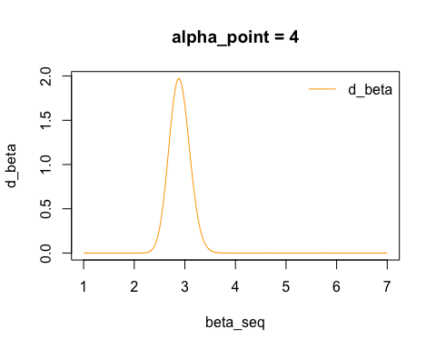

### 2c  
mh_gibbs = function(B, theta_start) {  
 theta = array(0, c((B+1), 2))  
 theta[1,1] = theta_start[1]  
 theta[1,2] = theta_start[2]  
  
 for (i in 2:dim(theta)[1]) {  
 alpha_star = theta[(i-1),1]  
 beta_star = rgamma(1, shape = (100*alpha_star+4), rate = (4 + sum_inv))  
 theta[i,2] = beta_star  
 alpha_star = rbeta(1, beta_a, beta_b)*4+1  
 #alpha_star = runif(1, 1, 5)  
 #alpha_star = rnorm(1, theta[(i-1),1], sigma)   
 #while ((alpha_star < 1)|(alpha_star > 5)) {  
 # alpha_star = rnorm(1, theta[(i-1),1], sigma)   
 #}  
 ### why does rnorm work better than runif??  
  
 num_logr = log_q_alpha(a=alpha_star, b=beta_star) -  
 dbeta((alpha_star-1)/4,beta_a,beta_b)  
 #dnorm(alpha_star, theta[i-1, 1], sigma, log = TRUE)   
 #-   
 #dunif(alpha_star, 1, 5, log = TRUE)   
 ### think it is possible not to correct for the proposal/ jumping (both for unif and norm) ###  
 ### as it is symmetric and thus cancels in den_logr ###  
 den_logr = log_q_alpha(a=theta[i-1, 1], b=beta_star) -  
 dbeta((theta[i-1, 1]-1)/4,beta_a,beta_b)  
   
 #dnorm(theta[i-1, 1], alpha_star, sigma, log = TRUE)   
 #-  
 #dunif(alpha_star, 1, 5, log = TRUE)  
 ### think it is possible not to correct for the proposal/ jumping (both for unif and norm) ###  
 ### as it is symmetric and thus cancels in den_logr ###  
 logr = num_logr - den_logr  
 if (log(runif(1)) <= min(logr, 0)) {  
 theta[i,1] = alpha_star  
 } else {  
 theta[i,1] = theta[(i - 1), 1]  
 }  
 }  
 return(theta)  
}  
B = 10^5  
keep = (B/2 + 1):(B + 1)  
chain1 = mh_gibbs(B, theta_start = c(2.3,4))  
chain2 = mh_gibbs(B, theta_start = c(2.8,5))  
chain3 = mh_gibbs(B, theta_start = c(3.3,6))  
chain4 = mh_gibbs(B, theta_start = c(3.9,8))  
chain5 = mh_gibbs(B, theta_start = c(4.2,10))   
  
chain = rbind(chain1[keep,], chain2[keep,], chain3[keep,], chain4[keep,], chain5[keep,])  
mc_a = mcmc.list(mcmc(chain1[keep,1]), mcmc(chain2[keep,1]),  
 mcmc(chain3[keep,1]), mcmc(chain4[keep,1]),  
 mcmc(chain5[keep,1]))  
summary (mc_a)

##   
## Iterations = 1:50001  
## Thinning interval = 1   
## Number of chains = 5   
## Sample size per chain = 50001   
##   
## 1. Empirical mean and standard deviation for each variable,  
## plus standard error of the mean:  
##   
## Mean SD Naive SE Time-series SE   
## 2.0114898 0.2498864 0.0004998 0.0039133   
##   
## 2. Quantiles for each variable:  
##   
## 2.5% 25% 50% 75% 97.5%   
## 1.550 1.837 2.003 2.176 2.528

mc_b= mcmc.list(mcmc(chain1[keep,2]), mcmc(chain2[keep,2]),  
 mcmc(chain3[keep,2]), mcmc(chain4[keep,2]),  
 mcmc(chain5[keep,2]))  
summary (mc_b)

##   
## Iterations = 1:50001  
## Thinning interval = 1   
## Number of chains = 5   
## Sample size per chain = 50001   
##   
## 1. Empirical mean and standard deviation for each variable,  
## plus standard error of the mean:  
##   
## Mean SD Naive SE Time-series SE   
## 2.9121331 0.4080953 0.0008162 0.0056665   
##   
## 2. Quantiles for each variable:  
##   
## 2.5% 25% 50% 75% 97.5%   
## 2.161 2.626 2.896 3.180 3.757