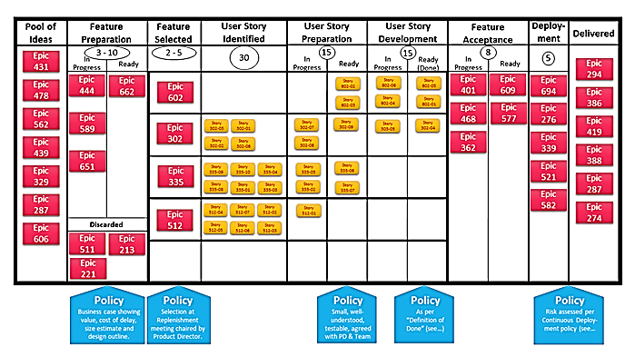

|  |  |  |  |  |  |  |  |  |  |  |  |  |  |
| --- | --- | --- | --- | --- | --- | --- | --- | --- | --- | --- | --- | --- | --- |
| **Pool of Ideas** | **Feature**  **Preparation** | | **Feature**  **Selected** | **User Story**  **Identified** | | **User Story**  **Preparation** | | **User Story**  **Development** | | **Feature**  **Acceptance** | | **Deploy-**  **ment** | **Delivered** |
| **Epic**  **431**  **Epic**  **478**  **Epic**  **562**  **Epic**  **439**  **Epic**  **329**  **Epic**  **287**  **Epic**  **606** | **3-10** | | **2-5** | **30** | | **15** | | **15** | | **8** | | **5** | **Epic**  **294**  **Epic**  **386**  **Epic**  **419**  **Epic**  **388**  **Epic**  **287**  **Epic**  **274** |
| **In Progress** | **Ready** | **In Progress** | **Ready** | **In Progress** | **Ready** | **In Progress** | **Ready** |
| **Epic**  **444**  **Epic**  **589**  **Epic**  **651** | **Epic**  **662** | **Epic**  **602** |  | |  | **Story**  **602-01**  **Story**  **602-04** | **Story**  **602-02**  **Story**  **602-03** | **Story**  **602-06**  **Story**  **602-05** | **Epic**  **401**  **Epic**  **468**  **Epic**  **362** | **Epic**  **609**  **Epic**  **577** | **Epic**  **694**  **Epic**  **276**  **Epic**  **339**  **Epic**  **521**  **Epic**  **582** |
| **Epic**  **302** | **Story**  **302-06**  **Story**  **302-01**    **Story**  **302-02**  **Story**  **302-08** | | **Story**  **302-07**  **Story**  **302-05** | **Story**  **302-09** | **Story**  **302-03** | **Story**  **302-04** |
| **Epic**  **335** | **Story**  **335-03**  **Story**  **335-10**  **Story**  **335-04**    **Story**  **335-05**  **Story**  **335-09**  **Story**  **335-01** | | **Story**  **335-06**  **Story**  **335-02** | **Story**  **335-08**  **Story**  **335-07** |  |  |
| **Epic**  **512** | **Story**  **512-04**  **Story**  **512-06**  **Story**  **512-02**    **Story**  **512-05**  **Story**  **512-07**  **Story**  **512-03** | | **Story**  **512-01** |  |  |  |
| **Discarded** | |
| **Epic**  **662**  **Epic**  **662**  **Epic**  **662** | |
|  |  | |  |  |  |  |
|  | **Policy**  **Business case showing value, cost of delay, size estimate and design outline** | | **Policy**  **Selection at Replenishment meeting chaired by Product Director** | |  | **Policy**  **Small, well- understood, testable, agreed with PD & Team**  **Policy**  **As per “Definition of Done” (see _)** | | | |  |  | **Policy**  **Risk assessed per Continuous Deploy- ment policy (see _)** | |