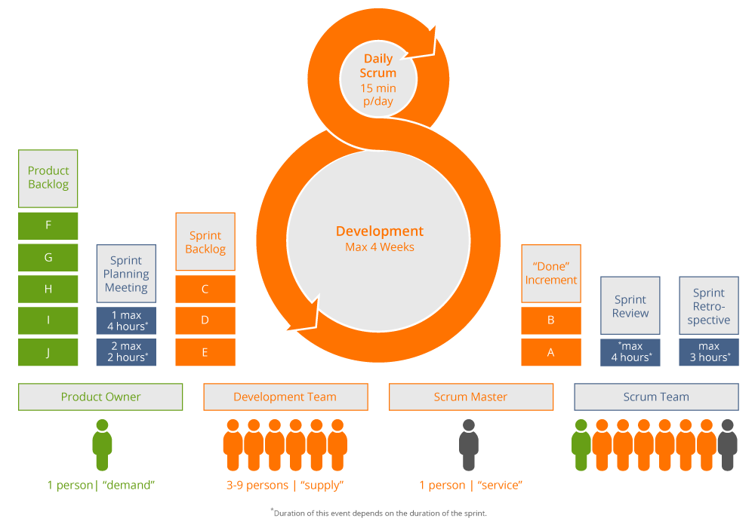

*\* Duration of this event depends on the duration of the sprint.*

1 person | “service”

3-9 persons | “supply”

1 person | “demand”

**Scrum Team**

**Scrum Master**

**Product Owner**

**Development Team**

**Daily**

**Scrum**

**15 min/day**

**Development Team**

**Product Owner**

**Scrum Master**

**Scrum Team**

**Product**

**Backlog**



**Sprint**

**Planning**

**Meeting**

**Sprint**

**Backlog**

**F**

**G**

**H**

**I**

**J**

**1 max**

**4 hours\***

**2 max**

**2 hours\***

**C**

**D**

**E**

**“Done”**

**Increment**

**B**

**A**

**Sprint**

**Review**

**Sprint**

**Retro-**

**spective**

**max**

**4 hours\***

**max**

**3 hours\***

**1 person | “demand”**

**3-9 persons | “supply”**

**1 person | “service”**

*\* Duration of this event depends on the duration of the sprint.*



**Development**

**Max 4 Week**

**Daily**

**Scrum**

**15 min/day**