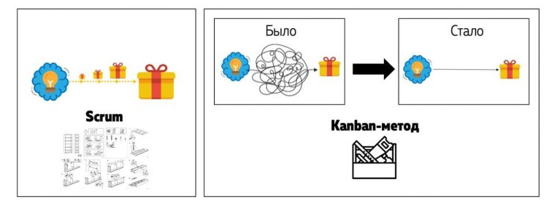

1

2

3

4

5

**SCRUM**



**BEFORE**

**AFTER**

**KANBAN**