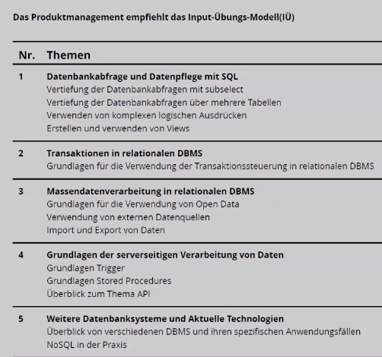
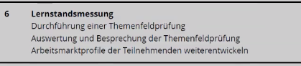
https://annas-archive.gl/
https://welib.org/

