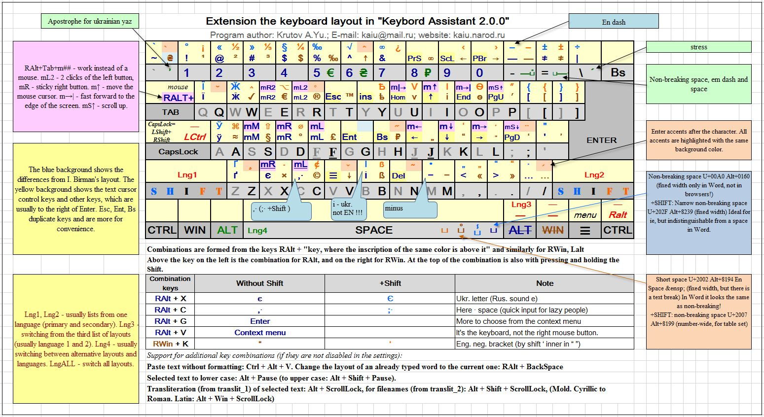

What is Keybord_Assistant?

==========================

The program helps in switching keyboard layouts, adds the Birman layout and allows you to control the cursor from the main keyboard.

Allows you to switch a very large number of layouts with sound and with a hint.

You can define eight different layout lists.

You can switch all layouts (or a separate list) using the keys:

CapsLock, LShift, LCtrl, LAlt+Space, RAlt, RShift, RCtrl

Keybord_Assistant is free software. Running in the MS Windows environment, its use is governed by GPL (GNU General Public License).

How to install:

===============

Admin rights required!

1. From the "installation" folder, run the file "Reassign_RAlt_RWin.reg".

2. Reboot your computer.

3. Run "Keybord_Assistant.exe" file.

4. Select the "Startup with operating system" item in the program menu and activate it.

How to setup:

=============

After starting the program, find the "KA" icon in the tray and right-click on it.

Select the menu item "Settings:" by clicking on it.

The settings file (settings.ini) will open.

In the settings file, in the [KEYBOARDS] section, lists of your keyboard layouts will be created.

If necessary, change NAME and SOUND to suit your preferences.

From the [KEYBOARDS] section, copy the required layout numbers in the [LAYOUT_LIST_1...8] section.

Set the required layout switching in sections:

[CAPSLOCK_OPTIONS], [LSHIFT_OPTIONS], [RSHIFT_OPTIONS],

[RCTRL_OPTIONS], [LCTRL_OPTIONS], [LALT_SPACE_OPTIONS], [RALT_OPTIONS]

Customize other options to suit your preferences.

How to uninstall:

=================

1. Run "Keybord_Assistant.exe" file.

2. Select the "Startup with operating system" item in the program menu and and deactivate it.

3. From the "uninstall" folder, run the file "Cancel_reassign_RAlt_RWin.reg".

4. Reboot your computer.

Web site:

=========

https://kaiu.narod.ru/KeybAs/KeybAs.html

Author:

=======

Krutov A.Yu. <kaiu@mail.ru>