|  | **Министерство науки и высшего образования Российской Федерации**  **Федеральное государственное бюджетное образовательное учреждение**  **высшего образования**  **«Московский государственный технический университет**  **имени Н.Э. Баумана**  **(национальный исследовательский университет)»**  **(МГТУ им. Н.Э. Баумана)** |
| --- | --- |

ФАКУЛЬТЕТ Информатики и систем управления

КАФЕДРА Теоретической информатики и компьютерных технологий

**Домашнее задание № 6**

**Рекуррентные нейронные сети (RNN, GRU, LSTM).**

**Классификация текстов**

**ПО КУРСУ:**

***«Теория искусственных нейронных сетей»***

Студент *Караник А. А.*

Преподаватель *Каганов Ю. Т.*

*Москва, 2024 г.*

**ОГЛАВЛЕНИЕ**

Цель работы 3

Постановка задачи 3

Практическая реализация 3

Результаты 9

Вывод 11

# Цель работы

1. Изучение архитектур рекуррентных нейронных сетей: RNN, GRU, LSTM.

2. Реализовать нейронные сети на основе данных архитектур с использованием фреймворка PyTorch и обучить модели для задачи классификации отзывов на основе базы данных IMDB.

# Постановка задачи

1. Требуется обучить рекуррентные нейронные сети RNN, GRU, LSTM на основе базы данных отзывов IMDB с использованием различных оптимизаторов(SGD, AdaDelta, NAG, Adam).

2. Необходимо также сравнить полученные результаты и выделить лучшие модели.

# Практическая реализация

Исходный текст программы на языке программирования Python:

import math

import torch

import torch.nn as nn

import torch.nn.functional as F

from torch.utils.data import DataLoader

from torchtext.datasets import IMDB

from torchtext.data.utils import get_tokenizer

from torchtext.vocab import build_vocab_from_iterator

import time

import matplotlib.pyplot as plt

embedding_size = 64

h_size = 8

max_length = 200

number_of_layers = 25

batch_size = 1000

epochs = 5

device = torch.device("cuda" if torch.cuda.is_available() else "cpu")

def prepare(text):

    tokens = tokenizer(text)

    token_ids = vocab(tokens)

    if len(token_ids) > max_length:

        token_ids = token_ids[:max_length]

    else:

        token_ids = token_ids + [0]*(max_length - len(token_ids))

    return torch.tensor(token_ids, dtype=torch.long)

def yield_tokens(data_iter):

    for _, line in data_iter:

        yield tokenizer(line)

def collate_fn(batch):

    texts, labels = [], []

    for label, text in batch:

        texts.append(prepare(text))

        labels.append(1 if label == 'pos' else 0)

    return torch.stack(texts), torch.tensor(labels, dtype=torch.float)

train_iter, test_iter = IMDB(split=('train', 'test'))

tokenizer = get_tokenizer('basic_english')

vocab = build_vocab_from_iterator(yield_tokens(train_iter), specials=["<unk>"])

vocab.set_default_index(vocab["<unk>"])

train_loader = DataLoader(list(train_iter), batch_size=batch_size, shuffle=True, collate_fn=collate_fn)

test_loader = DataLoader(list(test_iter), batch_size=batch_size, shuffle=False, collate_fn=collate_fn)

class RNNModel(nn.Module):

    def __init__(self, vocab_size, embedding_size, h_size, output_size=1, number_of_layers=25):

        super(RNNModel, self).__init__()

        self.h_size = h_size

        self.number_of_layers = number_of_layers

        self.embedding = nn.Embedding(vocab_size, embedding_size)

        W_xh_layers = [nn.Parameter(torch.Tensor(embedding_size, h_size))]

        W_hh_layers = [nn.Parameter(torch.Tensor(h_size, h_size))]

        b_h_layers = [nn.Parameter(torch.Tensor(h_size))]

        for _ in range(number_of_layers - 1):

            W_xh_layers.append(nn.Parameter(torch.Tensor(h_size, h_size)))

            W_hh_layers.append(nn.Parameter(torch.Tensor(h_size, h_size)))

            b_h_layers.append(nn.Parameter(torch.Tensor(h_size)))

        self.W_xh_layers = nn.ParameterList(W_xh_layers)

        self.W_hh_layers = nn.ParameterList(W_hh_layers)

        self.b_h_layers = nn.ParameterList(b_h_layers)

        self.W_hy = nn.Parameter(torch.Tensor(h_size, output_size))

        self.b_y = nn.Parameter(torch.Tensor(output_size))

        self.reset_parameters()

    def reset_parameters(self):

        for i in range(self.number_of_layers):

            nn.init.kaiming_uniform_(self.W_xh_layers[i], a=math.sqrt(5))

            nn.init.kaiming_uniform_(self.W_hh_layers[i], a=math.sqrt(5))

            nn.init.zeros_(self.b_h_layers[i])

        nn.init.kaiming_uniform_(self.W_hy, a=math.sqrt(5))

        nn.init.zeros_(self.b_y)

    def forward(self, x, h_0=None):

        batch_size, seq_len = x.size()

        if h_0 is None:

            h_0 = torch.zeros(self.number_of_layers, batch_size, self.h_size, device=x.device)

        embedded = self.embedding(x)

        h_t_layers = [h_0[i] for i in range(self.number_of_layers)]

        for t in range(seq_len):

            input_t = embedded[:, t, :]

            for i in range(self.number_of_layers):

                h_t_layers[i] = torch.tanh(input_t @ self.W_xh_layers[i] + h_t_layers[i] @ self.W_hh_layers[i] + self.b_h_layers[i])

                input_t = h_t_layers[i]

        logits = input_t @ self.W_hy + self.b_y

        h_last = torch.stack(h_t_layers, dim=0)

        return logits.squeeze(1), h_last

class LSTMModel(nn.Module):

    def __init__(self, vocab_size, embedding_size, h_size, output_size=1, number_of_layers=25):

        super(LSTMModel, self).__init__()

        self.h_size = h_size

        self.number_of_layers = number_of_layers

        self.embedding = nn.Embedding(vocab_size, embedding_size)

        W_xf_layers = [nn.Parameter(torch.Tensor(embedding_size, h_size))]

        W_hf_layers = [nn.Parameter(torch.Tensor(h_size, h_size))]

        b_f_layers = [nn.Parameter(torch.Tensor(h_size))]

        W_xi_layers = [nn.Parameter(torch.Tensor(embedding_size, h_size))]

        W_hi_layers = [nn.Parameter(torch.Tensor(h_size, h_size))]

        b_i_layers = [nn.Parameter(torch.Tensor(h_size))]

        W_xC_layers = [nn.Parameter(torch.Tensor(embedding_size, h_size))]

        W_hC_layers = [nn.Parameter(torch.Tensor(h_size, h_size))]

        b_C_layers = [nn.Parameter(torch.Tensor(h_size))]

        W_xo_layers = [nn.Parameter(torch.Tensor(embedding_size, h_size))]

        W_ho_layers = [nn.Parameter(torch.Tensor(h_size, h_size))]

        b_o_layers = [nn.Parameter(torch.Tensor(h_size))]

        for _ in range(number_of_layers - 1):

            W_xf_layers.append(nn.Parameter(torch.Tensor(h_size, h_size)))

            W_hf_layers.append(nn.Parameter(torch.Tensor(h_size, h_size)))

            b_f_layers.append(nn.Parameter(torch.Tensor(h_size)))

            W_xi_layers.append(nn.Parameter(torch.Tensor(h_size, h_size)))

            W_hi_layers.append(nn.Parameter(torch.Tensor(h_size, h_size)))

            b_i_layers.append(nn.Parameter(torch.Tensor(h_size)))

            W_xC_layers.append(nn.Parameter(torch.Tensor(h_size, h_size)))

            W_hC_layers.append(nn.Parameter(torch.Tensor(h_size, h_size)))

            b_C_layers.append(nn.Parameter(torch.Tensor(h_size)))

            W_xo_layers.append(nn.Parameter(torch.Tensor(h_size, h_size)))

            W_ho_layers.append(nn.Parameter(torch.Tensor(h_size, h_size)))

            b_o_layers.append(nn.Parameter(torch.Tensor(h_size)))

        self.W_xf_layers = nn.ParameterList(W_xf_layers)

        self.W_hf_layers = nn.ParameterList(W_hf_layers)

        self.b_f_layers = nn.ParameterList(b_f_layers)

        self.W_xi_layers = nn.ParameterList(W_xi_layers)

        self.W_hi_layers = nn.ParameterList(W_hi_layers)

        self.b_i_layers = nn.ParameterList(b_i_layers)

        self.W_xC_layers = nn.ParameterList(W_xC_layers)

        self.W_hC_layers = nn.ParameterList(W_hC_layers)

        self.b_C_layers = nn.ParameterList(b_C_layers)

        self.W_xo_layers = nn.ParameterList(W_xo_layers)

        self.W_ho_layers = nn.ParameterList(W_ho_layers)

        self.b_o_layers = nn.ParameterList(b_o_layers)

        self.W_hy = nn.Parameter(torch.Tensor(h_size, output_size))

        self.b_y = nn.Parameter(torch.Tensor(output_size))

        self.reset_parameters()

    def reset_parameters(self):

        for i in range(self.number_of_layers):

            nn.init.kaiming_uniform_(self.W_xf_layers[i], a=math.sqrt(5))

            nn.init.kaiming_uniform_(self.W_hf_layers[i], a=math.sqrt(5))

            nn.init.zeros_(self.b_f_layers[i])

            nn.init.kaiming_uniform_(self.W_xi_layers[i], a=math.sqrt(5))

            nn.init.kaiming_uniform_(self.W_hi_layers[i], a=math.sqrt(5))

            nn.init.zeros_(self.b_i_layers[i])

            nn.init.kaiming_uniform_(self.W_xC_layers[i], a=math.sqrt(5))

            nn.init.kaiming_uniform_(self.W_hC_layers[i], a=math.sqrt(5))

            nn.init.zeros_(self.b_C_layers[i])

            nn.init.kaiming_uniform_(self.W_xo_layers[i], a=math.sqrt(5))

            nn.init.kaiming_uniform_(self.W_ho_layers[i], a=math.sqrt(5))

            nn.init.zeros_(self.b_o_layers[i])

        nn.init.kaiming_uniform_(self.W_hy, a=math.sqrt(5))

        nn.init.zeros_(self.b_y)

    def forward(self, x, h_0=None, c_0=None):

        batch_size, seq_len = x.size()

        if h_0 is None:

            h_0 = torch.zeros(self.number_of_layers, batch_size, self.h_size, device=x.device)

        if c_0 is None:

            c_0 = torch.zeros(self.number_of_layers, batch_size, self.h_size, device=x.device)

        embedded = self.embedding(x)

        h_t_layers = [h_0[i] for i in range(self.number_of_layers)]

        c_t_layers = [c_0[i] for i in range(self.number_of_layers)]

        for t in range(seq_len):

            input_t = embedded[:, t, :]

            for i in range(self.number_of_layers):

                f_t_layer = torch.sigmoid(input_t @ self.W_xf_layers[i] + h_t_layers[i] @ self.W_hf_layers[i] + self.b_f_layers[i])

                i_t_layer = torch.sigmoid(input_t @ self.W_xi_layers[i] + h_t_layers[i] @ self.W_hi_layers[i] + self.b_i_layers[i])

                C_t_layer = torch.tanh(input_t @ self.W_xC_layers[i] + h_t_layers[i] @ self.W_hC_layers[i] + self.b_C_layers[i])

                o_t_layer = torch.sigmoid(input_t @ self.W_xo_layers[i] + h_t_layers[i] @ self.W_ho_layers[i] + self.b_o_layers[i])

                c_t_layers[i] = c_t_layers[i] * f_t_layer + i_t_layer * C_t_layer

                h_t_layers[i] = o_t_layer * torch.tanh(c_t_layers[i])

                input_t = h_t_layers[i]

        logits = input_t @ self.W_hy + self.b_y

        h_last = torch.stack(h_t_layers, dim=0)

        return logits.squeeze(1), h_last

class GRUModel(nn.Module):

    def __init__(self, vocab_size, embedding_size, h_size, output_size=1, number_of_layers=25):

        super(GRUModel, self).__init__()

        self.h_size = h_size

        self.number_of_layers = number_of_layers

        self.embedding = nn.Embedding(vocab_size, embedding_size)

        W_xz_layers = [nn.Parameter(torch.Tensor(embedding_size, h_size))]

        W_hz_layers = [nn.Parameter(torch.Tensor(h_size, h_size))]

        b_z_layers = [nn.Parameter(torch.Tensor(h_size))]

        W_xr_layers = [nn.Parameter(torch.Tensor(embedding_size, h_size))]

        W_hr_layers = [nn.Parameter(torch.Tensor(h_size, h_size))]

        b_r_layers = [nn.Parameter(torch.Tensor(h_size))]

        W_xH_layers = [nn.Parameter(torch.Tensor(embedding_size, h_size))]

        W_rH_layers = [nn.Parameter(torch.Tensor(h_size, h_size))]

        b_H_layers = [nn.Parameter(torch.Tensor(h_size))]

        for _ in range(number_of_layers - 1):

            W_xz_layers.append(nn.Parameter(torch.Tensor(h_size, h_size)))

            W_hz_layers.append(nn.Parameter(torch.Tensor(h_size, h_size)))

            b_z_layers.append(nn.Parameter(torch.Tensor(h_size)))

            W_xr_layers.append(nn.Parameter(torch.Tensor(h_size, h_size)))

            W_hr_layers.append(nn.Parameter(torch.Tensor(h_size, h_size)))

            b_r_layers.append(nn.Parameter(torch.Tensor(h_size)))

            W_xH_layers.append(nn.Parameter(torch.Tensor(h_size, h_size)))

            W_rH_layers.append(nn.Parameter(torch.Tensor(h_size, h_size)))

            b_H_layers.append(nn.Parameter(torch.Tensor(h_size)))

        self.W_xz_layers = nn.ParameterList(W_xz_layers)

        self.W_hz_layers = nn.ParameterList(W_hz_layers)

        self.b_z_layers = nn.ParameterList(b_z_layers)

        self.W_xr_layers = nn.ParameterList(W_xr_layers)

        self.W_hr_layers = nn.ParameterList(W_hr_layers)

        self.b_r_layers = nn.ParameterList(b_r_layers)

        self.W_xH_layers = nn.ParameterList(W_xH_layers)

        self.W_rH_layers = nn.ParameterList(W_rH_layers)

        self.b_H_layers = nn.ParameterList(b_H_layers)

        self.W_hy = nn.Parameter(torch.Tensor(h_size, output_size))

        self.b_y = nn.Parameter(torch.Tensor(output_size))

        self.reset_parameters()

    def reset_parameters(self):

        for i in range(self.number_of_layers):

            nn.init.kaiming_uniform_(self.W_xz_layers[i], a=math.sqrt(5))

            nn.init.kaiming_uniform_(self.W_hz_layers[i], a=math.sqrt(5))

            nn.init.zeros_(self.b_z_layers[i])

            nn.init.kaiming_uniform_(self.W_xr_layers[i], a=math.sqrt(5))

            nn.init.kaiming_uniform_(self.W_hr_layers[i], a=math.sqrt(5))

            nn.init.zeros_(self.b_r_layers[i])

            nn.init.kaiming_uniform_(self.W_xH_layers[i], a=math.sqrt(5))

            nn.init.kaiming_uniform_(self.W_rH_layers[i], a=math.sqrt(5))

            nn.init.zeros_(self.b_H_layers[i])

        nn.init.kaiming_uniform_(self.W_hy, a=math.sqrt(5))

        nn.init.zeros_(self.b_y)

    def forward(self, x, h_0=None):

        batch_size, seq_len = x.size()

        if h_0 is None:

            h_0 = torch.zeros(self.number_of_layers, batch_size, self.h_size, device=x.device)

        embedded = self.embedding(x)

        h_t_layers = [h_0[i] for i in range(self.number_of_layers)]

        for t in range(seq_len):

            input_t = embedded[:, t, :]

            for i in range(self.number_of_layers):

                z_t_layer = torch.sigmoid(input_t @ self.W_xz_layers[i] + h_t_layers[i] @ self.W_hz_layers[i] + self.b_z_layers[i])

                r_t_layer = torch.sigmoid(input_t @ self.W_xr_layers[i] + h_t_layers[i] @ self.W_hr_layers[i] + self.b_r_layers[i])

                H_t_layer = torch.tanh(input_t @ self.W_xH_layers[i] + (h_t_layers[i] * r_t_layer) @ self.W_rH_layers[i] + self.b_H_layers[i])

                h_t_layers[i] = h_t_layers[i] * (1 - z_t_layer) + z_t_layer * H_t_layer

                input_t = h_t_layers[i]

        logits = input_t @ self.W_hy + self.b_y

        h_last = torch.stack(h_t_layers, dim=0)

        return logits.squeeze(1), h_last

def train_model(model, train_loader, optimizer, criterion):

    model.train()

    total_loss = 0

    total_correct = 0

    total_count = 0

    for texts, labels in train_loader:

        texts, labels = texts.to(device), labels.to(device)

        optimizer.zero_grad()

        logits, _ = model(texts)

        loss = criterion(logits, labels)

        loss.backward()

        optimizer.step()

        total_loss += loss.item() * texts.size(0)

        preds = (torch.sigmoid(logits) > 0.5).long()

        correct = (preds == labels.long()).sum().item()

        total_correct += correct

        total_count += texts.size(0)

    average_loss = total_loss / total_count

    accuracy = total_correct / total_count

    return average_loss, accuracy

def evaluate_model(model, test_loader, criterion):

    model.eval()

    total_loss = 0

    total_correct = 0

    total_count = 0

    with torch.no_grad():

        for texts, labels in test_loader:

            texts, labels = texts.to(device), labels.to(device)

            logits, _ = model(texts)

            loss = criterion(logits, labels)

            total_loss += loss.item() * texts.size(0)

            preds = (torch.sigmoid(logits) > 0.5).long()

            correct = (preds == labels.long()).sum().item()

            total_correct += correct

            total_count += texts.size(0)

    average_loss = total_loss / total_count

    accuracy = total_correct / total_count

    return average_loss, accuracy

vocab_size = len(vocab)

model = RNNModel(vocab_size, embedding_size, h_size, number_of_layers=number_of_layers).to(device)

criterion = nn.BCEWithLogitsLoss()

optimizer = torch.optim.Adam(model.parameters(), lr=1e-7)

RNN_losses, RNN_accuracy = [], []

test_loss, test_accuracy = evaluate_model(model, test_loader, criterion)

RNN_losses.append(test_loss)

RNN_accuracy.append(test_accuracy)

print(f"First Test Loss: {test_loss:.4f}; First Test Accuracy: {test_accuracy:.4f}")

for epoch in range(1, epochs + 1):

    start_time = time.time()

    train_loss, train_accuracy = train_model(model, train_loader, optimizer, criterion)

    test_loss, test_accuracy = evaluate_model(model, test_loader, criterion)

    RNN_losses.append(test_loss)

    RNN_accuracy.append(test_accuracy)

    elapsed_time = time.time() - start_time

    print(f"Epoch: {epoch} \n"

          f"Elapsed Time: {elapsed_time:.2f}s \n"

          f"Train Loss: {train_loss:.4f}; Train Accuracy: {train_accuracy:.4f} \n"

          f"Test Loss: {test_loss:.4f}; Test Accuracy: {test_accuracy:.4f} \n")

vocab_size = len(vocab)

LSTMmodel = LSTMModel(vocab_size, embedding_size, h_size, number_of_layers=number_of_layers).to(device)

criterion = nn.BCEWithLogitsLoss()

optimizer = torch.optim.Adam(LSTMmodel.parameters(), lr=1e-10)

LSTM_losses, LSTM_accuracy = [], []

test_loss, test_accuracy = evaluate_model(LSTMmodel, test_loader, criterion)

LSTM_losses.append(test_loss)

LSTM_accuracy.append(test_accuracy)

print(f"First Test Loss: {test_loss:.4f}; First Test Accuracy: {test_accuracy:.4f}")

for epoch in range(1, epochs + 1):

    start_time = time.time()

    train_loss, train_accuracy = train_model(LSTMmodel, train_loader, optimizer, criterion)

    test_loss, test_accuracy = evaluate_model(LSTMmodel, test_loader, criterion)

    LSTM_losses.append(test_loss)

    LSTM_accuracy.append(test_accuracy)

    elapsed_time = time.time() - start_time

    print(f"Epoch: {epoch} \n"

          f"Elapsed Time: {elapsed_time:.2f}s \n"

          f"Train Loss: {train_loss:.4f}; Train Accuracy: {train_accuracy:.4f} \n"

          f"Test Loss: {test_loss:.4f}; Test Accuracy: {test_accuracy:.4f} \n")

vocab_size = len(vocab)

GRUmodel = GRUModel(vocab_size, embedding_size, h_size, number_of_layers=number_of_layers).to(device)

criterion = nn.BCEWithLogitsLoss()

optimizer = torch.optim.Adam(GRUmodel.parameters(), lr=1e-9)

GRU_losses, GRU_accuracy = [], []

test_loss, test_accuracy = evaluate_model(GRUmodel, test_loader, criterion)

GRU_losses.append(test_loss)

GRU_accuracy.append(test_accuracy)

print(f"First Test Loss: {test_loss:.4f}; First Test Accuracy: {test_accuracy:.4f}")

for epoch in range(1, epochs + 1):

    start_time = time.time()

    train_loss, train_accuracy = train_model(GRUmodel, train_loader, optimizer, criterion)

    test_loss, test_accuracy = evaluate_model(GRUmodel, test_loader, criterion)

    GRU_losses.append(test_loss)

    GRU_accuracy.append(test_accuracy)

    elapsed_time = time.time() - start_time

    print(f"Epoch: {epoch} \n"

          f"Elapsed Time: {elapsed_time:.2f}s \n"

          f"Train Loss: {train_loss:.4f}; Train Accuracy: {train_accuracy:.4f} \n"

          f"Test Loss: {test_loss:.4f}; Test Accuracy: {test_accuracy:.4f} \n")

horizontal_axis = range(epochs + 1)

plt.plot(horizontal_axis, RNN_losses, label="RNN")

plt.plot(horizontal_axis, LSTM_losses, label="LSTM")

plt.plot(horizontal_axis, GRU_losses, label="GRU")

plt.title("Графики зависимости значений функции потерь от выбранной архитектуры")

plt.xlabel("Epoch")

plt.ylabel("Loss")

plt.grid(True)

plt.legend()

plt.show()

plt.plot(horizontal_axis, RNN_accuracy, label="RNN")

plt.plot(horizontal_axis, LSTM_accuracy, label="LSTM")

plt.plot(horizontal_axis, GRU_accuracy, label="GRU")

plt.title("Графики зависимости точности от выбранной архитектуры")

plt.xlabel("Epoch")

plt.ylabel("Accuracy")

plt.grid(True)

plt.legend()

plt.show()

# Результаты

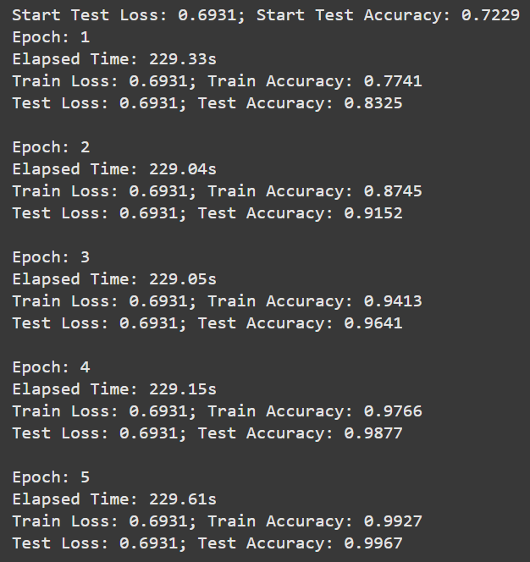

Рисунок – RNN

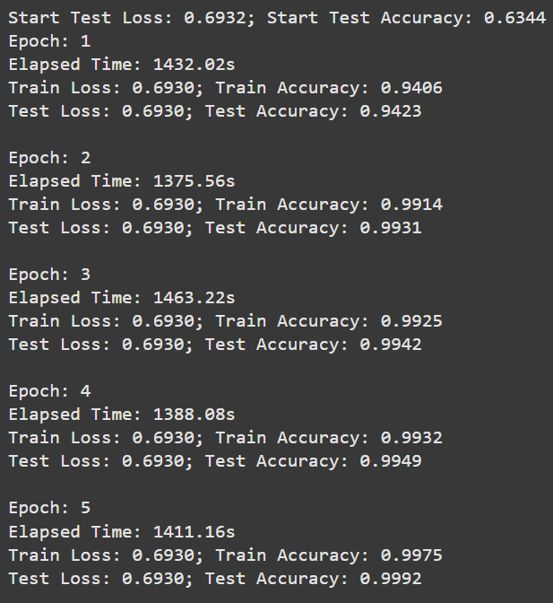

Рисунок – LSTM

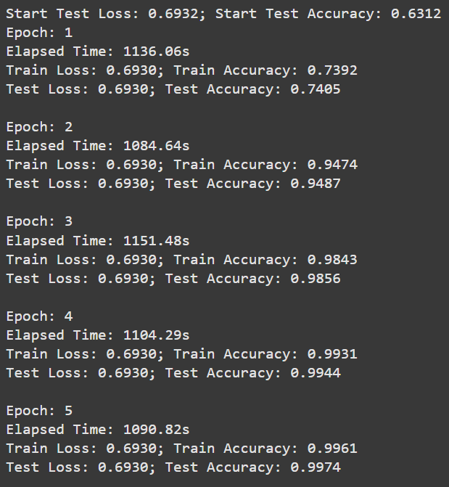

Рисунок – GRU

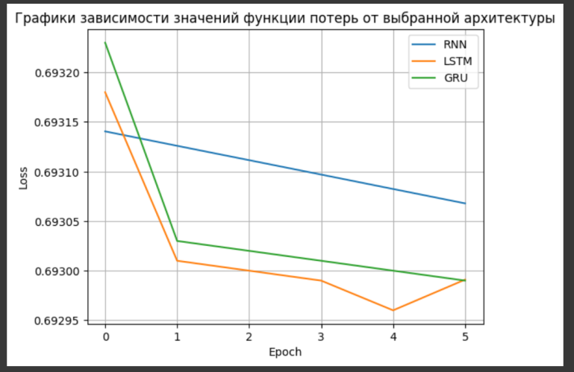

Рисунок - Графики зависимости значений функции потерь от выбранной архитектуры

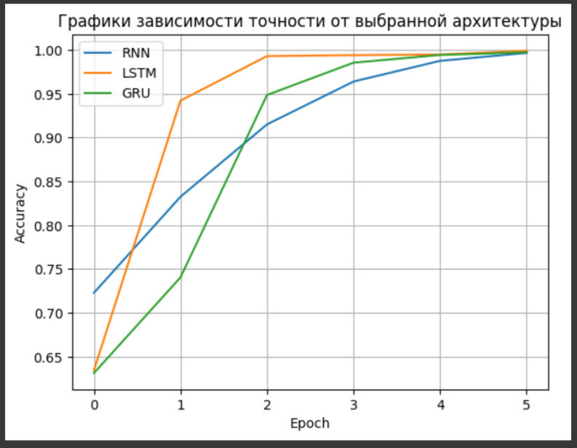

Рисунок - Графики зависимости точности от выбранной архитектуры

|  |  |  |  |  |
| --- | --- | --- | --- | --- |
|  | Архитектура | Кол-во эпох | Скорость обучения | Верность |
| 1 | RNN | 5 | 1e-7 | 0.9967 |
| 2 | LSTM | 2 | 1e-10 | 0.9992 |
| 3 | GRU | 3 | 1e-9 | 0.9974 |

# Вывод

В ходе выполнения данной работы было установлено, что наилучшие результаты для поставленной задачи продемонстрировала архитектура LSTM, тогда как простейшая рекуррентная нейронная сеть (RNN) оказалась наименее эффективной по сравнению с другими архитектурами.