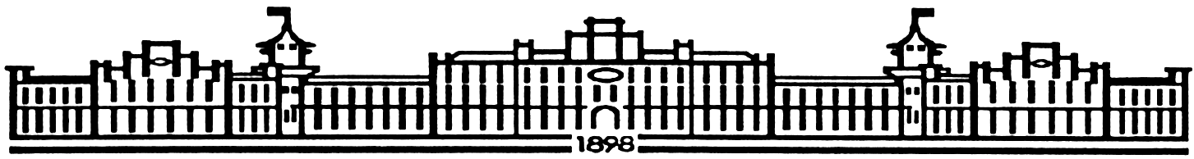

МIНIСТЕРСТВО ОСВIТИ І НАУКИ УКРАЇНИ

НАЦІОНАЛЬНИЙ ТЕХНІЧНИЙ УНІВЕРСИТЕТ УКРАЇНИ

“КИЇВСЬКИЙ ПОЛІТЕХНІЧНИЙ ІНСТИТУТ”

Факультет прикладної математики

Кафедра програмного забезпечення комп’ютерних систем

**Лабораторна робота №** 4

з дисципліни “ Основи програмування ”

тема “Клієнт-серверні програми”

|  |  |  |
| --- | --- | --- |
| Виконав  студент I курсу  групи КП-52  Крисюк Андрій Михайлович  (*прізвище, ім’я, по батькові*)  варіант №6 |  | Перевірив  “____” “____________” 2016 р.  викладач  Гадиняк Руслан Анатолійович  (*прізвище, ім’я, по батькові*) |

|  |  |  |  |  |  |  |  |  |  |  |  |  |  |
| --- | --- | --- | --- | --- | --- | --- | --- | --- | --- | --- | --- | --- | --- |
| Штрафні бали:   |  |  | | --- | --- | | **Термін здачі** | **Оформлення звіту** | |  |  | | Нараховані бали:   |  |  |  | | --- | --- | --- | | **Корект. програм (3 бала)** | **Відп. на теор. питання (2 бал)** | **Відп. на прогр. питання (3 бала)** | |  |  |  | | Сумарний бал:   |  | | --- | |  | |

Київ 2016

**Мета роботи**

Навчитись розділяти програми на серверні та клієнтські частини та організовувати доступ клієнтів до ресурсів та функцій серверів за допомогою протоколу взаємодії HTTP.

**Постановка завдання**

Реалізувати HTTP-сервер, що містить ресурс - список сутностей за варіантом.

При реалізації коду потрібно виділити такі обов’язкові модулі як Web (тип Сервер) та Resource (тип за варіантом).

Описати інтерфейс Ресурсу таким чином, щоби можна було замінити реалізацію списком сутностей на реалізацію взаємодії із базою даних у Лабораторній роботі №5 (аналогія: інтерфейс АТД Список та дві реалізації: на основі масиву та за допомогою зв’язаних елементів, для користувача не важлива реалізація, а тільки інтерфейс взаємодії).

Взаємодія із сервером можлива 2-ма способами:

* HTML сторінками через веб-браузер як клієнт (всі запити починаються на **/**)
* через API сутностей (всі запити починаються на **/api/**) де результат повертається у форматі XML або JSON (на вибір). Взаємодіяти з сервером через API можна за допомогою утиліти cURL.

**Тексти коду програми**

|  |
| --- |
| main.c |
| #include <stdio.h>  #include <stdlib.h>  #include "web.h"  #include "pupils.h"  #include "socket.h"  int main(){  char * fileName = "pupils.xml";  pupils_t pupils = pupils_new();  pupils_parseFromXML(pupils, fileName);  http_request_startServer(pupils);  pupils_remove(pupils);  } |

|  |
| --- |
| web.c |
| #include "web.h"  struct keyvalue_s{  char key[256];  char value[256];  };  struct http_request_s{  char method[8];  char uri[256];  keyvalue_t * form;  int formLength;  };  static char * readHTML(char * nameFile){  char page[2000];  FILE* finput = fopen(nameFile, "r");  int len = fread(page, sizeof(char), sizeof(page)/sizeof(char), finput);  page[len] = '\0';  fclose(finput);  return page;  }  static void sendErrorMessageHTML(char * code, socket_t * clientSocket){  char result_msg[MSG_LENGTH];  sprintf(result_msg,  "<!DOCTYPE html>"  "<html>"  "<head>"  "<meta charset=\"UTF-8\">"  "<title>Error</title>"  "</head>"  "<body>"  "<h1> %s </h1>"  "<p> <a href=\"http://127.0.0.1:5000/pupils\"> Back to menu</a></p>"  "</body>"  "</html>",  code);  socket_write_string(clientSocket, result_msg);  }  static void sendErrorMessageXML(char * code, socket_t * clientSocket){  char result_msg[MSG_LENGTH];  sprintf(result_msg,  "<message>\n"  "\t<status>Error</status>\n"  "\t<text>%s</text>\n"  "</message>\n",  code);  socket_write_string(clientSocket, result_msg);  }  static int checkInputData_HTMLresponse(socket_t * clientSocket, char * result, char * stName, char * stSurname, char* stBirthdate, char * stNameForm, int stNumberInList, double stScore){  if(strlen(stName) == 0 || strlen(stName) > WORD_LENGTH)  sendErrorMessageHTML("Incorrect name", clientSocket);  else if(strlen(stSurname) == 0 || strlen(stSurname) > WORD_LENGTH)  sendErrorMessageHTML("Incorrect Surname", clientSocket);  else if(strlen(stBirthdate) == 0 || strlen(stBirthdate) > WORD_LENGTH)  sendErrorMessageHTML("Incorrect Date", clientSocket);  else if(strlen(stNameForm) == 0 || strlen(stNameForm) > WORD_LENGTH)  sendErrorMessageHTML("Incorrect Form", clientSocket);  else if(stScore < 0 || stScore > 12.0)  sendErrorMessageHTML("Incorrect Score", clientSocket);  else if(stNumberInList < 0 || stNumberInList > 50)  sendErrorMessageHTML("Incorrect Number", clientSocket);  else return 0;  return 1;  }  static int checkInputData_XMLresponse(socket_t * clientSocket, char * result, char * stName, char * stSurname, char* stBirthdate, char * stNameForm, int stNumberInList, double stScore){  if(strlen(stName) == 0 || strlen(stName) > WORD_LENGTH)  sendErrorMessageHTML("Incorrect name", clientSocket);  else if(strlen(stSurname) == 0 || strlen(stSurname) > WORD_LENGTH)  sendErrorMessageHTML("Incorrect Surname", clientSocket);  else if(strlen(stBirthdate) == 0 || strlen(stBirthdate) > WORD_LENGTH)  sendErrorMessageHTML("Incorrect Date", clientSocket);  else if(strlen(stNameForm) == 0 || strlen(stNameForm) > WORD_LENGTH)  sendErrorMessageHTML("Incorrect Form", clientSocket);  else if(stScore < 0 || stScore > 12.0)  sendErrorMessageHTML("Incorrect Score", clientSocket);  else if(stNumberInList < 0 || stNumberInList > 50)  sendErrorMessageHTML("Incorrect Number", clientSocket);  else return 0;  return 1;  }  http_request_t  http_request_parse(const char * const request) {  http_request_t req;  req.form = NULL;  req.formLength = 0;  // get method  ptrdiff_t methodLen = strstr(request, " ") - request; // find first whitespace  memcpy(req.method, request, methodLen);  req.method[methodLen] = '\0';  // get uri  const char * uriStartPtr = request + strlen(req.method) + 1;  const char * uriEndPtr = strstr(uriStartPtr, " "); // find second whitespace  ptrdiff_t uriLen = uriEndPtr - uriStartPtr;  memcpy(req.uri, uriStartPtr, uriLen);  req.uri[uriLen] = '\0';  // parse form data  const char * bodyStartPtr = strstr(request, "\r\n\r\n") + strlen("\r\n\r\n");  const char * cur = bodyStartPtr;  const char * pairEndPtr = cur;  const char * eqPtr = cur;  while (strlen(cur) > 0) {  pairEndPtr = strchr(cur, '&');  if (NULL == pairEndPtr) {  pairEndPtr = cur + strlen(cur);  }  keyvalue_t kv;  // get key  eqPtr = strchr(cur, '=');  ptrdiff_t keyLen = eqPtr - cur;  memcpy(kv.key, cur, keyLen);  kv.key[keyLen] = '\0';  // get value  eqPtr++;  ptrdiff_t valueLen = pairEndPtr - eqPtr;  memcpy(kv.value, eqPtr, valueLen);  kv.value[valueLen] = '\0';  // insert key-value pair into request form list  req.formLength += 1;  req.form = realloc(req.form, sizeof(keyvalue_t) * req.formLength);  req.form[req.formLength - 1] = kv;  cur = pairEndPtr + ((strlen(pairEndPtr) > 0) ? 1 : 0);  }  return req;  }  const char *  http_request_getArg(http_request_t * self, const char * key) {  for (int i = 0; i < self->formLength; i++) {  if (strcmp(self->form[i].key, key) == 0) {  return self->form[i].value;  }  }  return NULL;  }  const char * keyvalue_toString(keyvalue_t * self) {  char * str = malloc(sizeof(char) * (strlen(self->key) + strlen(self->value) + 2));  sprintf(str, "%s=%s\0", self->key, self->value);  return str;  }  void http_request_startServer(pupils_t pupils){  lib_init();  socket_t * serverSocket = socket_new();  socket_bind(serverSocket, 5000);  socket_listen(serverSocket);  while(1){  puts("Waiting for connections");  socket_t * clientSocket = socket_accept(serverSocket);  puts("New client");  char buff[BUFFER_LENGTH];  int readLength = socket_read(clientSocket, buff, BUFFER_LENGTH);  if(readLength == 0){  socket_close(clientSocket);  socket_free(clientSocket);  puts("Skipping empty request");  continue;  }  printf("Got Request:\n---------------\n%s\n----------------\n", buff);  http_request_t req = http_request_parse(buff);  printf("Method: %s\nURI: %s\n", req.method, req.uri);  puts("Data:");  for(int i = 0; i < req.formLength; i++){  char * kvStr = keyvalue_toString(&req.form[i]);  printf("\t%s\n", kvStr);  free(kvStr);  }  http_request_chooseMethod(req, clientSocket, pupils);  socket_close(clientSocket);  socket_free(clientSocket);  }  socket_close(serverSocket);  socket_free(serverSocket);  lib_free();  }  void http_request_chooseMethod(http_request_t req, socket_t * clientSocket, pupils_t pupils){  if(strcmp(req.uri, "/") == 0)  {  socket_write_string(clientSocket, readHTML("hello.html"));  }  else if(strcmp(req.uri, "/new-pupil") == 0)  {  if(strcmp(req.method, "GET") == 0)  {  socket_write_string(clientSocket, readHTML("webpage.html"));  }  else if(strcmp(req.method, "POST") == 0)  {  char result[MSG_LENGTH];  const char * stName = http_request_getArg(&req, "name");  const char * stSurname = http_request_getArg(&req, "surname");  const char * stBirthdate = http_request_getArg(&req, "birthdate");  const char * stNameForm = http_request_getArg(&req, "nameForm");  int stNumberInList = atoi(http_request_getArg(&req, "numberInList"));  int stId = 0;  while(!pupils_checkID(pupils, stId)){  stId++;  }  double stScore = atof(http_request_getArg(&req, "score"));  if(checkInputData_HTMLresponse(clientSocket, result, stName,  stSurname, stBirthdate, stNameForm, stNumberInList, stScore)) return;  else{  pupils_newPupil(pupils, stId, stName, stSurname, stBirthdate,  stScore, stNumberInList, stNameForm);  printf("New:\n"  "<pupil>\n"  "\t<id>%i</id>\n"  "\t<name>%s</name>\n"  "\t<surname>%s</surname>\n"  "\t<birthdate>%s</birthdate>\n"  "\t<form nameForm=\"%s\">\n"  "\t\t<numberInList>%i</numberInList>\n"  "\t</form>\n"  "\t<score>%.2f</score>\n"  "</pupil>\n\n",  stId, stName, stSurname,  stBirthdate, stNameForm, stNumberInList, stScore);  sprintf(result,  "HTTP/1.1 200 OK\n"  "Content-length: %zu\n"  "Content-type: text/html\n"  "\n"  "%s\0",  strlen(pupils_PupilToHTMLMessage(pupils, stId)), (pupils_PupilToHTMLMessage(pupils, stId)));  socket_write_string(clientSocket, result);  }  }  }  else if (strcmp(req.uri, "/pupils/") == 0) sendErrorMessageHTML("404 NOT FOUND", clientSocket);  else if (strcmp(req.uri, "/pupils") > 0)  {  int id = atoi(strtok(req.uri, "/pupils"));  if(pupils_checkID(pupils, id) == 0)  {  if(strcmp(req.method, "GET") == 0)  {  if(pupils_PupilToHTMLMessage(pupils, id) != 0)  {  char result[BUFFER_LENGTH];  sprintf(result,  "HTTP/1.1 200 OK\n"  "Content-length: %zu\n"  "Content-type: text/html\n"  "\n"  "%s\0",  strlen(pupils_PupilToHTMLMessage(pupils, id)),  pupils_PupilToHTMLMessage(pupils, id));  socket_write_string(clientSocket, result);  }  }  else if(strcmp(req.method, "DELETE") == 0)  {  pupils_deletePupil(pupils, id);  socket_write_string(clientSocket, readHTML("deleted.html"));  return;  }  }  else  {  char result_msg[200];  sprintf(result_msg, "PUPIL WITH ID %i NOT FOUND", id);  sendErrorMessageHTML(result_msg, clientSocket);  }  }  else if (strcmp(req.uri, "/pupils") == 0)  {  if(strcmp(req.method, "GET") == 0)  {  char result[BUFFER_LENGTH];  sprintf(result,  "HTTP/1.1 200 OK\n"  "Content-length: %zu\n"  "Content-type: text/html\n"  "\n"  "%s\0",  (int)strlen(pupils_AlltoHTMLMessage(pupils)), pupils_AlltoHTMLMessage(pupils));  socket_write_string(clientSocket, result);  }  else sendErrorMessageHTML("NOT ALLOWED", clientSocket);  }  else if (strcmp(req.uri, "/api/pupils/") == 0)  {  sendErrorMessageXML("NOT FOUND", clientSocket);  }  else if (strcmp(req.uri, "/api/pupils") > 0)  {  int id = atoi(strtok(req.uri, "/api/pupils"));  if(pupils_checkID(pupils, id) == 0)  {  if(strcmp(req.method, "GET") == 0)  {  if(pupils_PupilToXMLMessage(pupils, id) != 0)  {  char result[BUFFER_LENGTH];  sprintf(result,  "HTTP/1.1 200 OK\n"  "Content-length: %zu\n"  "Content-type: application/xml\n"  "\n"  "%s\0",  strlen(pupils_PupilToXMLMessage(pupils, id)),  pupils_PupilToXMLMessage(pupils, id));  socket_write_string(clientSocket, result);  }  }  else if(strcmp(req.method, "DELETE") == 0)  {  pupils_deletePupil(pupils, id);  char result_msg[MSG_LENGTH];  sprintf(result_msg,  "<message>\n"  "\t<status>ok</status>\n"  "\t<text>Pupil (id%i) has been deleted</text>\n"  "</message>\n", id);  socket_write_string(clientSocket, result_msg);  }  }  else{  char result_msg[MSG_LENGTH];  sprintf(result_msg,"Pupil (id%i) not found", id);  sendErrorMessageXML(result_msg, clientSocket);  }  }  else if (strcmp(req.uri, "/api/pupils") == 0)  {  if(strcmp(req.method, "GET") == 0)  {  char result[10000];  sprintf(result,  "HTTP/1.1 200 OK\n"  "Content-length: %zu\n"  "Content-type: application/xml\n"  "\n"  "%s\0",  strlen(pupils_AlltoXMLMessage(pupils)), pupils_AlltoXMLMessage(pupils));  socket_write_string(clientSocket, result);  }  else if(strcmp(req.method, "POST") == 0)  {  char result[MSG_LENGTH];  const char * stName = http_request_getArg(&req, "name");  const char * stSurname = http_request_getArg(&req, "surname");  const char * stBirthdate = http_request_getArg(&req, "birthdate");  const char * stNameForm = http_request_getArg(&req, "nameForm");  int stNumberInList = atoi(http_request_getArg(&req, "numberInList"));  int stId = 0;  while(!pupils_checkID(pupils, stId)){  stId++;  }  double stScore = atof(http_request_getArg(&req, "score"));  if(checkInputData_XMLresponse(clientSocket, result, stName,  stSurname, stBirthdate, stNameForm, stNumberInList, stScore)) return;  else {  pupils_newPupil(pupils, stId, stName, stSurname, stBirthdate,  stScore, stNumberInList, stNameForm);  socket_write_string(clientSocket, pupils_PupilToXMLMessage(pupils, stId));  char res[MSG_LENGTH];  sprintf(res,"<pupil>\n"  "\t<id>%i</id>\n"  "\t<name>%s</name>\n"  "\t<surname>%s</surname>\n"  "\t<birthdate>%s</birthdate>\n"  "\t<form nameForm=\"%s\">\n"  "\t\t<numberInList>%i</numberInList>\n"  "\t</form>\n"  "\t<score>%.2f</score>\n"  "</pupil>\n\n",  stId, stName, stSurname,  stBirthdate, stNameForm, stNumberInList, stScore);  sprintf(result,  "HTTP/1.1 200 OK\n"  "Content-length: %zu\n"  "Content-type: application/xml\n"  "\n"  "%s\0",  strlen(res), res);  socket_write_string(clientSocket, result);  }  }  else sendErrorMessageXML("NOL ALLOWED", clientSocket);  }  else sendErrorMessageHTML("404 NOT FOUND", clientSocket);  } |

|  |
| --- |
| web.h |
| #ifndef SERVER_H_INCLUDED  #define SERVER_H_INCLUDED  #include <stdio.h>  #include <stdlib.h>  #include <stddef.h>  #include <string.h>  #include "socket.h"  #include "pupils.h"  #define BUFFER_LENGTH 100000  #define MSG_LENGTH 10000  typedef struct keyvalue_s keyvalue_t;  typedef struct http_request_s http_request_t;  http_request_t  http_request_parse(const char * const request);  const char *  http_request_getArg(http_request_t * self, const char * key);  const char *  keyvalue_toString(keyvalue_t * self);  void http_request_startServer(pupils_t pupils);  void http_request_chooseMethod(http_request_t req, socket_t * clientSocket, pupils_t pupils);  #endif // SERVER_H_INCLUDED |

|  |
| --- |
| socket.c |
| #include <winsock2.h>  #include "socket.h"  #pragma comment(lib,"ws2_32.lib") // Winsock Library  struct socket_s {  SOCKET winsock;  };  static socket_t *  socket_new_winsock(SOCKET winsocket) {  socket_t * self = malloc(sizeof(struct socket_s));  self->winsock = winsocket;  return self;  }  socket_t *  socket_new(void) {  SOCKET winsock = socket(AF_INET, SOCK_STREAM, 0);  // == INVALID_SOCKET; WSAGetLastError()  socket_t * self = socket_new_winsock(winsock);  return self;  }  void  socket_free(socket_t * self) {  closesocket(self->winsock);  free(self);  }  const char *  socket_getIPAddress(socket_t * self) {  return "(null)"; // @todo  }  int  socket_getPortNumber(socket_t * self) {  return -1; // @todo  }  int  socket_bind(socket_t * self, int portNumber) {  struct sockaddr_in serveraddr = {  .sin_addr.s_addr = INADDR_ANY,  .sin_family = AF_INET,  .sin_port = htons(portNumber)  };  int status = bind(self->winsock, (struct sockaddr *)&serveraddr, sizeof(serveraddr));  // @todo == SOCKET_ERROR  return status;  }  int  socket_listen(socket_t * self) {  listen(self->winsock, 10); // @todo param  return 0; // @todo ?  }  socket_t *  socket_accept(socket_t * self) {  struct sockaddr_in clientaddr;  int size = sizeof(struct sockaddr_in);  SOCKET winsock = accept(self->winsock, (struct sockaddr *)&clientaddr, &size);  if (INVALID_SOCKET == winsock) {  return NULL;  }  socket_t * socket = socket_new_winsock(winsock);  return socket;  }  int  socket_connect(socket_t * self, const char * ipaddress, int portNumber) {  struct sockaddr_in serveraddr = {  .sin_addr.s_addr = inet_addr(ipaddress),  .sin_family = AF_INET,  .sin_port = htons(portNumber)  };  int status = connect(self->winsock, (struct sockaddr *)&serveraddr, sizeof(serveraddr));  // @todo if < 0  return status;  }  int  socket_read(socket_t * self, char * recvBuff, int recvBuffSize) {  int recvSize = recv(self->winsock, recvBuff, recvBuffSize, 0);  // @todo == SOCKET_ERROR  recvBuff[recvSize] = '\0';  return recvSize;  }  int  socket_write(socket_t * self, const char * msg, int msgSize) {  int status = send(self->winsock, msg, msgSize, 0);  // @todo < 0  return status;  }  int  socket_write_string(socket_t * self, const char * msg) {  return socket_write(self, msg, strlen(msg));  }  void  socket_close(socket_t * self) {  closesocket(self->winsock);  }  /* STATIC */  static WSADATA wsa;  void  lib_init(void) {  WSAStartup(MAKEWORD(2, 2), &wsa);  // @todo check status != 0  }  void  lib_free(void) {  WSACleanup();  } |

|  |
| --- |
| socket.h |
| #ifndef socket_H_INCLUDED  #define socket_H_INCLUDED  #define CONNECT_OK 0  typedef struct socket_s socket_t;  void lib_init(void);  void lib_free(void);  socket_t * socket_new(void);  void socket_free(socket_t * self);  const char * socket_getIPAddress(socket_t * self);  int socket_getPortNumber(socket_t * self);  int socket_bind(socket_t * socket, int portNumber);  int socket_listen(socket_t * socket);  socket_t * socket_accept(socket_t * socket);  int socket_connect(socket_t * sock, const char * ipaddress, int portNumber);  int socket_read(socket_t * sock, char * recvBuff, int recvSize);  int socket_write(socket_t * conn, const char * msg, int msgSize);  int socket_write_string(socket_t * conn, const char * msg);  void socket_close(socket_t * conn);  #endif // socket_H_INCLUDED |

|  |
| --- |
| pupils.c |
| #include "pupils.h"  #define MAX_AMOUNT_PUPILS 50  typedef struct{  char nameForm[WORD_LENGTH];  int numberInList;  } form_t;  typedef struct pupil_s * pupil_t;  struct pupils_s{  int amountPupils;  pupil_t pupils[MAX_AMOUNT_PUPILS];  };  struct pupil_s{  int id;  char name[WORD_LENGTH];  char surname[WORD_LENGTH];  char birthdate[WORD_LENGTH];  double score;  form_t form;  };  pupils_t pupils_new(){  pupils_t pupils = malloc(sizeof(struct pupils_s));  pupils->amountPupils = 0;  return pupils;  }  void pupils_remove(pupils_t self){  for(int i = 0; i < self->amountPupils; i++){  free(self->pupils[i]);  self->pupils[i] = NULL;  }  free(self);  self = NULL;  }  void pupils_print(pupils_t self){  for(int i = 0; i < self->amountPupils; i++){  printf("Pupil:\n"  "\tID: %i\n"  "\tName: %s\n"  "\tSurname: %s\n"  "\tBirthdate: %s\n"  "\tScore: %.2f\n"  "\tForm name: %s\n"  "\tNumber pupil in list: %i\n",  self->pupils[i]->id,  self->pupils[i]->name,  self->pupils[i]->surname,  self->pupils[i]->birthdate,  self->pupils[i]->score,  self->pupils[i]->form.nameForm,  self->pupils[i]->form.numberInList  );  }  }  int pupils_parseFromXML(pupils_t self, char* fileName){  char line[1000];  char text[10000] = "";  FILE * fr = fopen(fileName, "r");  while(fgets(line, 1000, fr)) {  strcat(text, line);  }  xmlDoc * xDoc;  xDoc = xmlReadMemory(text, strlen(text), NULL, NULL, 0);  if (NULL == xDoc) {  printf("Error parsing xml from memory");  return 1;  }  xmlNode * xRootEl;  xRootEl = xmlDocGetRootElement(xDoc);  for(xmlNode * xCur = xRootEl->children; NULL != xCur ; xCur = xCur->next) {  if (XML_ELEMENT_NODE == xCur->type) {  self->pupils[self->amountPupils] = malloc(sizeof(struct pupil_s));  for(xmlNode * xJ = xCur->children; NULL != xJ ; xJ = xJ->next) {  if (XML_ELEMENT_NODE == xJ->type) {  if(strcmp(xJ->name, "form") == 0) {  xmlNode * xForm = xJ;  xmlNode * xNum = xForm->children->next;  char * nameForm = xmlGetProp(xForm, "nameForm");  strcpy(self->pupils[self->amountPupils]->form.nameForm, nameForm);  char * numberInlist = xmlNodeGetContent(xNum);  self->pupils[self->amountPupils]->form.numberInList = atoi(numberInlist);  continue;  } else if(strcmp(xJ->name, "name") == 0){  const char * name = xmlNodeGetContent(xJ);  strcpy(self->pupils[self->amountPupils]->name, name);  } else if(strcmp(xJ->name, "surname") == 0){  const char * surname = xmlNodeGetContent(xJ);  strcpy(self->pupils[self->amountPupils]->surname, surname);  } else if(strcmp(xJ->name, "birthdate") == 0){  const char * birthdate = xmlNodeGetContent(xJ);  strcpy(self->pupils[self->amountPupils]->birthdate, birthdate);  } else if(strcmp(xJ->name, "score") == 0){  const char * score = xmlNodeGetContent(xJ);  self->pupils[self->amountPupils]->score = atof(score);  } else if(strcmp(xJ->name, "id") == 0){  const char * id = xmlNodeGetContent(xJ);  self->pupils[self->amountPupils]->id = atoi(id);  }  }  }  self->amountPupils++;  }  }  fclose(fr);  return 0;  }  char * pupils_AlltoHTMLMessage(pupils_t self){  char message[MSG_LENGTH] = "\0";  char buff[MSG_LENGTH];  strcat(message, "<!DOCTYPE html>"  "<html>"  "<head>"  "<meta charset=\"UTF-8\">"  "<title>Pupils</title>"  "</head>"  "<body>"  "<table border=\"1\" width=\"25\%\">"  "<tr>"  "<th>ID</th>"  "<th>Name</th>"  "</tr>");  for(int i = 0; i < self->amountPupils; i++){  sprintf(buff, "<tr>"  "<td>%i</td>"  "<td> <a href=\"http://127.0.0.1:5000/pupils/%i\">%s %s</a> </td>"  "</tr>",  self->pupils[i]->id,  self->pupils[i]->id,  self->pupils[i]->name,  self->pupils[i]->surname  );  strcat(message, buff);  }  strcat(message, "<p> <a href=\"http://127.0.0.1:5000\"> Back </a> </p>"  "<p> <a href=\"http://127.0.0.1:5000/new-pupil\"> New pupil </a> </p>"  "</table>"  "</body>"  "</html>");  return message;  }  char * pupils_PupilToHTMLMessage(pupils_t self, int id){  char message[MSG_LENGTH];  for(int i = 0; i < self->amountPupils; i++){  if(self->pupils[i]->id == id){  sprintf(message,  "<!DOCTYPE html>"  "<html>"  "<head>"  "<meta charset=\"UTF-8\">"  "<meta http-equiv=\"refresh\" content=\"3\">"  "<title>Pupil</title>"  "</head>"  "<body>"  "<table border=\"1\" width=\"75\%\">"  "<tr>"  "<th>ID</th>"  "<th>First name</th>"  "<th>Last name</th>"  "<th>Birthdate</th>"  "<th>Form</th>"  "<th>Number</th>"  "<th>Score</th>"  "</tr>"  "<tr>"  "<td>%i</td>"  "<td>%s</td>"  "<td>%s</td>"  "<td>%s</td>"  "<td>%s</td>"  "<td>%i</td>"  "<td>%.2f</td>"  "</tr>"  "</table>"  "<p> <a href=\"http://127.0.0.1:5000/pupils\"> Back </a></p>"  "<p> <a href= \"#\" onclick=\"doDelete()\"> Delete pupil </a></p>"  "<script>"  "function doDelete() {"  "var xhttp = new XMLHttpRequest();"  "xhttp.open(\"DELETE\", \"http://127.0.0.1:5000/pupils/%i\", true);"  "xhttp.send();}"  "</script>"  "</body>"  "</html>"  ,self->pupils[i]->id,  self->pupils[i]->name,  self->pupils[i]->surname,  self->pupils[i]->birthdate,  self->pupils[i]->form.nameForm,  self->pupils[i]->form.numberInList,  self->pupils[i]->score,  self->pupils[i]->id  );  return message;  }  }  return 0;  }  void pupils_newPupil(pupils_t self, int id, const char * name, const char * surname, const char * birthdate,  double score, int numberInList, const char * nameForm){  self->pupils[self->amountPupils] = malloc(sizeof(struct pupil_s));  self->pupils[self->amountPupils]->id = id;  strcpy(self->pupils[self->amountPupils]->name, name);  strcpy(self->pupils[self->amountPupils]->surname, surname);  strcpy(self->pupils[self->amountPupils]->birthdate, birthdate);  self->pupils[self->amountPupils]->score = score;  strcpy(self->pupils[self->amountPupils]->form.nameForm, nameForm);  self->pupils[self->amountPupils]->form.numberInList = numberInList;  self->amountPupils++;  }  void pupils_deletePupil(pupils_t self, int id){  int index;  for(int i = 0; i < self->amountPupils; i++){  if(self->pupils[i]->id == id){  index = i;  }  }  pupil_t tmp;  for(int i = index; i < self->amountPupils; i++){  tmp = self->pupils[i];  self->pupils[i] = self->pupils[i + 1];  self->pupils[i + 1] = tmp;  }  free(self->pupils[self->amountPupils]);  self->amountPupils--;  }  int pupils_checkID(pupils_t self, int id){  for(int i = 0; i < self->amountPupils; i++){  if(self->pupils[i]->id == id){  return 0;  }  }  return 1;  }  char * pupils_AlltoXMLMessage(pupils_t self){  char message[MSG_LENGTH] = "\0";  char buff[MSG_LENGTH];  strcat(message, "<pupils>\n");  for(int i = 0; i < self->amountPupils; i++){  sprintf(buff, "\t<pupil>\n"  "\t\t<id>%i</id>\n"  "\t\t<name>%s</name>\n"  "\t\t<surname>%s</surname>\n"  "\t\t<birthdate>%s</birthdate>\n"  "\t\t<form nameForm=\"%s\">\n"  "\t\t\t<numberInList>%i</numberInList>\n"  "\t\t</form>\n"  "\t\t<score>%.2f</score>\n"  "\t</pupil>\n",  self->pupils[i]->id,  self->pupils[i]->name,  self->pupils[i]->surname,  self->pupils[i]->birthdate,  self->pupils[i]->form.nameForm,  self->pupils[i]->form.numberInList,  self->pupils[i]->score  );  strcat(message, buff);  }  strcat(message, "</pupils>\n");  return message;  }  char * pupils_PupilToXMLMessage(pupils_t self, int id){  char message[MSG_LENGTH];  for(int i = 0; i < self->amountPupils; i++){  if(self->pupils[i]->id == id){  sprintf(message, "<pupil>\n"  "\t<id>%i</id>\n"  "\t<name>%s</name>\n"  "\t<surname>%s</surname>\n"  "\t<birthdate>%s</birthdate>\n"  "\t<form nameForm=\"%s\">\n"  "\t\t<numberInList>%i</numberInList>\n"  "\t</form>\n"  "\t<score>%.2f</score>\n"  "</pupil>\n\n",  self->pupils[i]->id,  self->pupils[i]->name,  self->pupils[i]->surname,  self->pupils[i]->birthdate,  self->pupils[i]->form.nameForm,  self->pupils[i]->form.numberInList,  self->pupils[i]->score  );  return message;  }  }  return 0;  } |

|  |
| --- |
| pupils.h |
| #ifndef PUPILS_H_INCLUDED  #define PUPILS_H_INCLUDED  #include <stdio.h>  #include <stdlib.h>  #include <string.h>  #include <libxml/parser.h>  #include <libxml/tree.h>  #define WORD_LENGTH 30  typedef struct pupils_s * pupils_t;  #include "web.h"  pupils_t pupils_new();  void pupils_remove(pupils_t self);  void pupils_print(pupils_t self);  int pupils_parseFromXML(pupils_t self, char * fileName);  char * pupils_allPupilsToMessage(pupils_t self);  char * pupils_pupilByIdToMessage(pupils_t self, int id);  void pupils_deletePupil(pupils_t self, int id);  int pupils_checkID(pupils_t self, int id);  void pupils_newPupil(pupils_t self, int id, const char * name, const char * surname, const char * birthdate,  double score, int numberInList, const char * nameForm);  #endif // PUPILS_H_INCLUDED |

**Приклади результатів**

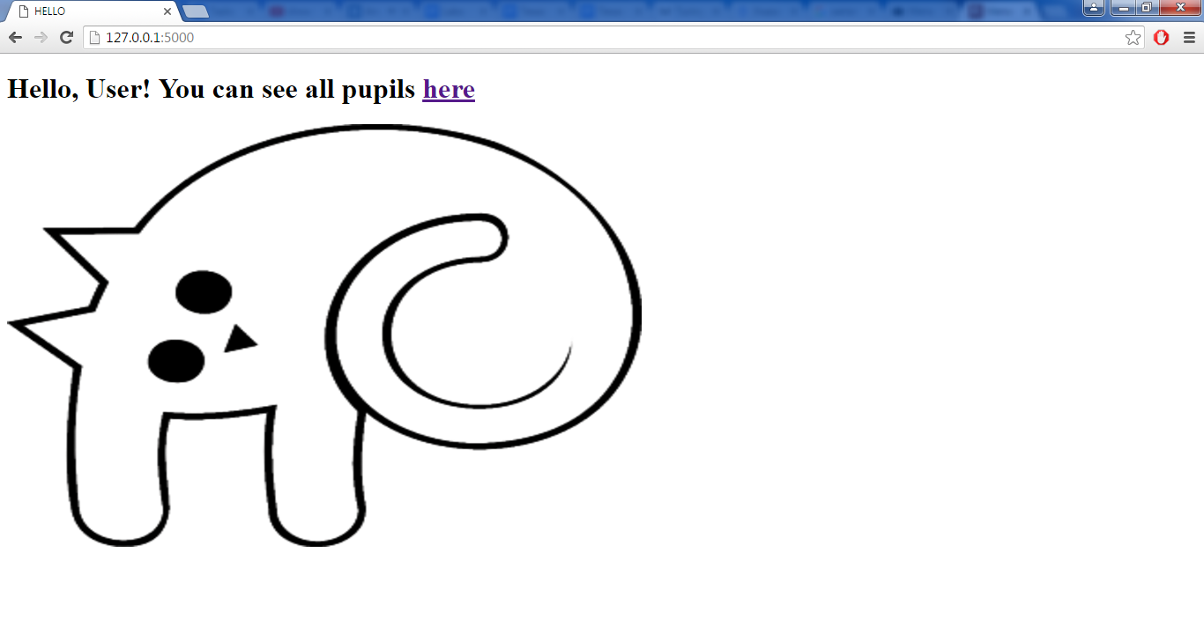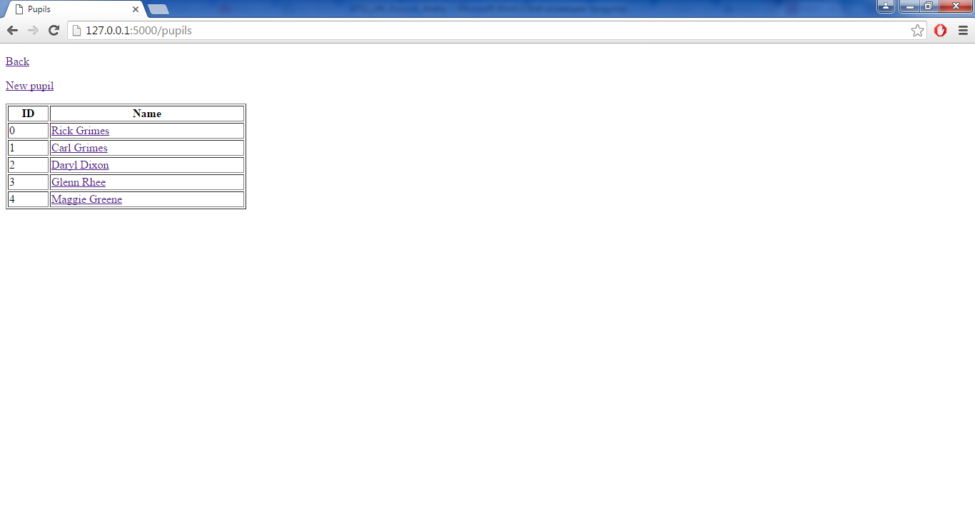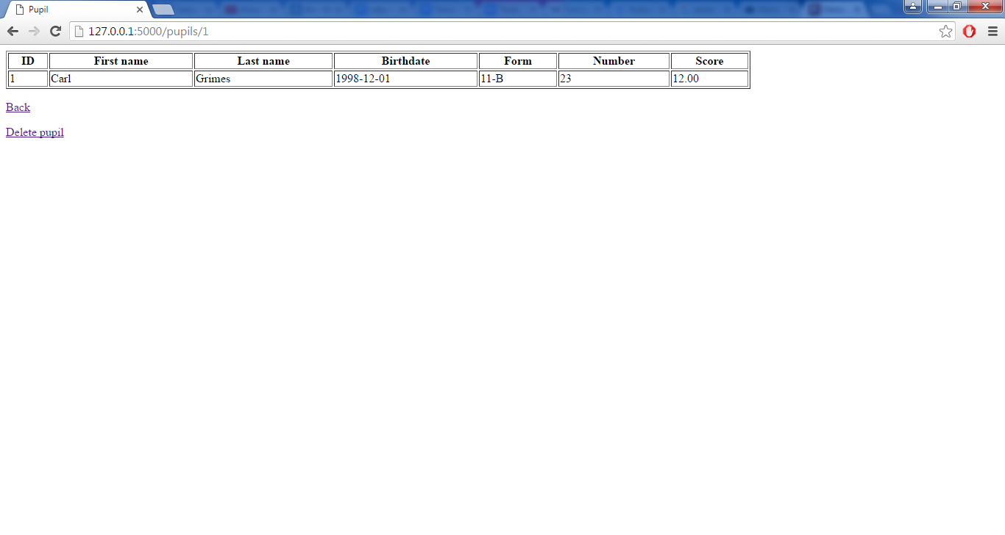

**Висновки**

Я навчився розділяти програми на серверні та клієнтські частини та організовувати доступ клієнтів до ресурсів та функцій серверів за допомогою протоколу взаємодії HTTP.